Standards
MyStandards
For SMPG and NMPG
Rules for the Specification of SMPG & NMPG Market Practice/Message Usage Guidelines
This document provides the rules that must be followed by SMPG and NMPG groups when specifying their message usage guidelines in the MyStandards Usage Guideline Editor. The document may also be useful for institutions creating message usage guidelines.
27 November 2013

Table of Contents
Table of Contents 2
Preface 3
1 Introduction 4
2 Defining a Market Practice or Usage Guideline 5
2.1 The Use of 5
2.2 The different restrictions 5
2.3 The Use of Rules 6
2.4 The Use of Annotations 7
2.4.1 Annotation Types 7
2.4.2 Diagram – annotation and its application 8
2.4.3 Annotation Framework – Format Enumeration 8
2.4.4 Annotation Framework – Format Boolean 9
2.5 Examples 9
2.5.1 Mandatory Field with Format Options – 98a SETT 9
2.5.2 Optional Field with Format Options – 98a PREP 9
2.5.3 Mandatory Field But Some Qualifiers Not Allowed AMT\19A 10
2.6 Summary 1 - Choose The Right Restriction Type 11
2.7 Summary 2 - Market Practice Recommendation – Quick Reference 11
Legal Notices 12

Preface
Purpose of the document
This document provides the rules that must be followed by SMPG and NMPG groups when specifying their message usage guidelines in the MyStandards Usage Guideline Editor. The document may also be useful for institutions creating message usage guidelines.
Audience
This document is for the following audience:
- Users of the MyStandards Usage Guideline Editor
- Creators of SMPG, NMPG and institution-specific message usage guidelines
Pre-requisites
Users of this document are expected to be familiar with the philosophy of MyStandards and knowledgeable about its functionality.
First edition
This is the first edition of the document.
Version Notes
None.
Related documentation
- MyStandards Service Description
- MyStandards Best Practices
- My Standards Usage Guideline Editor User Guide

Introduction
The SMPG working groups and regional/local NMPGs define their use of a message by setting restrictions on the message format using the Usage Guideline Editor
It is imperative that all market practice groups define how they restrict a “base SWIFT message” in a consistent manner in the Usage Guideline Editor so that future processing, such as running a comparison of an SMPG market practice against an NMPG market practice provides a useful result. This document sets out the rules that must be followed for the specification of a market practice.

Defining a Market Practice or Usage Guideline
When setting up its restrictions, because of the formal MyStandards environment, the SMPG or NMPG needs to look at every field in the message and decide what the restriction should be. Basically, this means:
[1] deciding for a mandatory field/element that has format options whether the different options may be recommended or not
[2] deciding for an optional field/sequence, whether it may be recommended or not
[3] if the decision is to allow an optional field, if necessary , there may need to be a decision on whether a specific qualifier, code or format optional may be recommended or not

The Use of
For SMPG, this restriction means that the recommendation is that the field, qualifier, code or format option is not to be used. Of course, an NMPG, when creating its market practice may decide that that particular field/element can be used, that it is necessary for local NMPG.

The different restrictions
# | Restriction Type /SMPG Usage | Description
1 | Is not recommended (Remove) | An optional field or element must not be populated/is NOT part of the recommendation (see 2.1 above).
2 | Make Mandatory | An optional field or element or code or format must be populated.
3 | Reduce Multiplicity | A repeating field or element must repeat fewer times.
4 | Ignore | A field or element could be populated but is ignored by the receiver.  DO NOT USE IN SMPG OR NMPG USAGE GUIDELINES.
5 | Text Rule | A mandatory, unstructured, rule.
6 | Conditional Rule | A mandatory, “if-then-else” rule.
7 | Fixed Value | A field or element must contain a given value.
8 | Comment | Information which cannot be expressed in a more structured way.  AVOID USING. USE A RULE OR ANNOTATION.
9 | Annotation | A user-defined structure if a built in restriction is insufficient.
10 | Change Datatype | A user-defined datatype replaces an existing simple datatype.
10a | Restrict field length | This involves changing the underlying datatype to an existing or to a user-defined data type, for example, change Max35Text to Max16Text.
11 | Create Extension | A user-defined extension. MX SPECIFIC.  SETTLEMENT & RECONCILIATION AND CORPORATE ACTIONS - NO KNOWN USAGE.
12 | Synonym | A field or element has an alternate name.
When all the ‘do not use’ restrictions have been entered, then the fields/elements that remain are the recommendation, although these remaining fields/elements could be subject to other restrictions such as a rule or a format restriction.

The Use of Rules
For restrictions that cannot be expressed as, for example, a simple ‘do not use’ or ‘must be present’ or as a reduction in multiplicity, then:
Rule: determine if the market practice can be expressed as a rule, and whether the rule can be expressed as a conditional rule or a simple rule.
Conditional Rule: an “If .. then” statement.
 | Example market practice | Specification in Usage Guideline Editor
1 | SMPG Funds decides to mandate the use of the requested settlement currency element in an order instruction if the order is specified as a number of units and the settlement currency is to be different from the currency used for pricing (NAV currency). | A rule is added to the Individual Order Details sequence:  “Units and Requested Settlement Currency Rule”  If UnitsNumber is present and the settlement currency differs from the NAV currency, then RequestedSettlementCurrency must be present.
2 | SMPG Funds decides that the optional charge details sequence must be used in an order confirmation if a charge has been applied to a transaction. | A rule is added to the Charge General Details sequence:  "SMPG Charge Rule"  If a charge has been applied to the transaction, then ChargeGeneralDetails / ChargeDetails must be specified.
‘Simple’ Rule (used when the rule cannot be expressed as an “If .. then” statement)
 | Example market practice | Specification in Usage Guideline Editor
1 | SMPG Funds decides to specify the value to use the physical delivery indicator field. | A rule is added to the PhysicalDeliveryIndicator field:  "SMPG Physical Delivery Indicator Rule”  Must be '0' or 'false'.
2 | SMPG Funds decides that charges should only be applied to the order instruction if they deviate from the charges previously agreed. | A rules is added to the Charge Details sequence:  “SMPG ChargeRule”  May only be used to request a variation to the standard charge terms.

The Use of Annotations
For restrictions that cannot be expressed as, for example, a simple ‘do not use’ or ‘must be present’, a reduction in multiplicity, or as a rule, then:
Rule – consider the use of an annotation:
 | Example market practice | Specification in Usage Guideline Editor
1 | SMPG Funds decides for the trade date field that some additional usage information is required that isn’t covered in the definition of the element. | An SMPG Usage Information annotation is added to the Trade Date field:  SMPG Usage Information  TradeDateTime is also the "Reference Value Date" for UCITS purposes in forward priced orders.
2 | SMPG Funds decides that the definition of the Net Amount field needs to be changed in the standard and whilst waiting for the standard to be changed (which is the case of funds orders is a number of years) SMPG needs to make the new definition available. | An SMPG Semantic Redefinition annotation is added to the Net Amount field:  SMPG Semantic Redefinition  Amount of money invested in the fund.Net Amount = Quantity * Price

Annotation Types
Before using the annotation functionality there needs to be a certain amount of analysis to decide which kinds of annotation ‘frameworks’ are required. Some markets may only require one kind of annotation. SMPG Funds has defined frameworks for three annotations and it is suggested to follow re-use same annotation types:
 | Annotation Type | Example
1 | SMPG Usage Information  This specifies additional market practice usage information. | SMPG Usage Information  TradeDateTime is also the "Reference Value Date" for UCITS purposes in forward priced orders.
2 | SMPG Semantic Redefinition.  This specifies the element is being used with a different definition than that defined in ISO 15022/20022.  (This kind of annotation is needed by funds because of the maintenance freeze. A semantic redefinition will result in a change request for the standard.) | SMPG Semantic Redefinition  Amount of money invested in the fund.  Net Amount = Quantity * Price
3 | SMPG Definition Refinement.  This specifies additional definition information.  (The basic definition of an element is good but some additional definition or a more specific definition is required. May or may not result in a change request.) | SMPG Definition Refinement:  For a prepaid order, this is the date when the cash settlement was received.  For a non-prepaid order this is the date when the cash settlement is expected.
All of the Funds annotation frameworks have been ‘formatted’ as multi-line text.

Diagram – annotation and its application
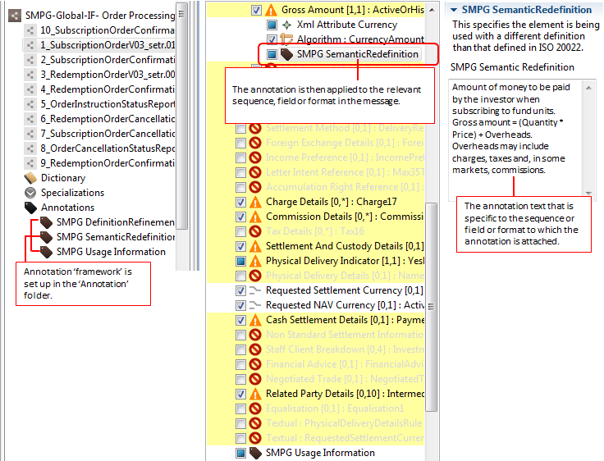

Annotation Framework – Format Enumeration
As said previously, before an annotation ‘framework’ can be created, a certain amount of analysis of what kind of market practice needs to be expressed and best way to express this using the Usage Guideline Editor is required. The following is a fictitious example of the use of an annotation framework with enumerated values.
Example: a single usage guideline is being used for both bonds and shares. The majority of the fields in the message usage guideline are common to both bonds and shares. However, some fields are only relevant for bonds and some only for shares.
Setting up an annotation framework with enumerated values and then using this annotation in the usage guideline might (or might not) be the best way of expressing this kind of market practice.
The annotation framework would have two values, for example, [1] ‘bonds only’ and [2] ‘shares only’.
When the annotation is applied to the field, the enumerated value is selected from a pull down menu containing the two values.

Annotation Framework – Format Boolean
Currently there is no known usage for this type of annotation.

Examples

Mandatory Field with Format Options – 98a SETT
98a SETT is mandatory in the standard. However, the field has three format options, A, B and C.
The market practice needs to state that 98B SETT is not to be used, 98A SETT and 98C SETT are both allowed. 98C is preferred, but because not all institutions can provide the time, 98A is recommended.
 | What to do in the editor
98A | Nothing
98B
98C | Use the annotation functionality.  For example, add the annotation type “SMPG Usage Information” to 98C and specify text such as:  “Not all institutions can provide the time and not all institutions can process the time, so 98A is the recommendation.”  An alternative is to set this element as or as rule depending on the market practice.
It can be seen that a combination of restriction types have been used to express the full market practice for this 98a field.

Optional Field with Format Options – 98a PREP
98a PREP is optional in the standard. However, the market practice specifies that 98a PREP must always be included. The field has three format options, A, C and E.
The market practice needs to state that 98A is not to be used, 98C and 98E are both allowed.
 | What to do in the editor
98a Date/Time
Preparation Date Time
98A
98B | Nothing.
98E | Nothing.

Mandatory Field But Some Qualifiers Not Allowed AMT\19A
In the standard, it is mandatory to include AMT \ 19A SETT in a message instance. However, market practice is to always include the optional 19A DEAL field. Some of the 19A fields (for example, COUN, EXEC, LEVY, OTHR, REGF, SPCN) are not relevant to the specific market practice and are not to be used. The other 19A fields remain as optional in the market practice.
 | What to do in the MyStandards Usage Guideline Editor
ACRU | Nothing.
CHAR | Nothing.
COUN
DEAL | Add a rule:  Deal Amount Rule  19A DEAL must be present in one occurrence of the Amount sequence (E3).
EXEC
ISDI | Nothing.
LEVY
LOCL | Nothing.
LOCO | Nothing.
OTHR
REGF
SETT | Nothing.
SPCN
TRAX | Nothing.
VATA | Nothing.
WITH | Nothing.
(Not all 19A qualifiers are shown in the above example.)

Summary 1 - Choose The Right Restriction Type
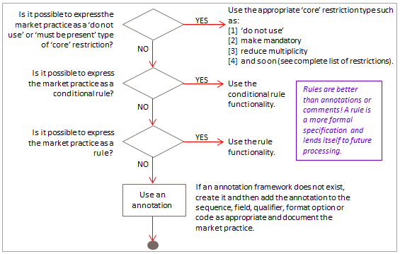

Summary 2 - Market Practice Recommendation – Quick Reference
Base Message | Market Practice Recommendation | MyStandards Usage Guideline Editor | Use of Rule/ Annotation?
Mandatory Field  One qualifier + one format |  | Do nothing.
Mandatory Field  One qualifier + multiple formats: |  | Do nothing (at the level of the field).
Format A | Is allowed. | Do nothing. | If format A is preferred to format B, express this as a (simple) rule or an annotation on B.
Format B | Is recommended. | Do nothing.
Format C | Is not recommended. | Apply “must not be used”
Optional Field | Is recommended. | Do nothing.
 | Is not recommended. | Apply “must not be used”
 | Is mandatory. | Change multiplicity to “Min 1”.
Optional Qualifier | Is recommended. | Do nothing.
 | Is not recommended. | Apply “must not be used”
 | Is mandatory. | Change multiplicity to “Min 1”.
Optional Code | Is recommended. | Do nothing.
 | Is not recommended. | Apply “must not be used”
 | Is mandatory. | Change multiplicity to “Min 1”.

Legal Notices
Copyright
SWIFT © 2013. All rights reserved.
You may copy this publication within your organisation. Any such copy must include these legal notices.
Confidentiality
This publication contains SWIFT or third-party confidential information. Do not disclose this publication outside your organisation without the prior written consent of SWIFT.
Disclaimer
The information in this publication may change from time to time. You must always refer to the latest available version on www.swift.com.
SWIFT Standards Intellectual Property Rights (IPR) Policy - End-User License Agreement
SWIFT Standards are licensed subject to the terms and conditions of the SWIFT Standards IPR Policy - End-User License Agreement, available at www.swift.com > Solutions > Standards > More information.
Translations
The English version of SWIFT documentation is the only official and binding version.
Trademarks
SWIFT is the trade name of S.W.I.F.T. SCRL. The following are registered trademarks of SWIFT: SWIFT, the SWIFT logo, the Standards Forum logo, 3SKey, Innotribe, Sibos, SWIFTNet, SWIFTReady, and Accord. Other product, service, or company names in this publication are trade names, trademarks, or registered trademarks of their respective owners.

