BRAZILIAN DISTRIBUTION EVENTS – SUMMARY

MDPUG/CITI QUESTION:
The main question is how to identify and distinguish between the different types of Brazilian distributions in the MT564 message.
Also required is confirmation of which ISO 15022 Event Type to use for each.
The different types are:
Dividendos
Rendimento do Dividendos (adjustment to dividend)
Juros Sobre Capital Proprio
Rendimento do Juros (adjustment to juros)
There are also fund distributions, called rendimentos also.

CURRENT VENDOR PRESENTATION OF EVENTS
TYPE | MT564 EVENT TYPE | COMMENT
Dividendos | DVCA
Rendimento do Dividendos (adjustment to dividend) | DVCA | Gross rate updated to include adjustment, not a new event
Juros Sobre Capital Proprio | DVCA
Rendimento do Juros (adjustment to juros) | DVCA | Gross rate updated to include adjustment, not a new event
Fund Rendimentos | CAPG/CAPD/DVCA | Vendors use different Event types

QUESTIONS RAISED BY SMPG (JAN 2018 SMPG CALL - Bernard)
Responses from the Brazilian NMPG (Ana Abidor, 20.02.18) are in blue.
- How does a company decide which type of distribution to make – dividendos or juros sobre o capital proprio?
- Juros sobre o Capital Proprio can be favourable to companies and investors as they are considered expenses by the Brazilian Revenue. Therefore, it is a way for companies to reduce their net income and taxes. It’s part of a company’s fiscal and accounting strategy to decide over paying dividendos or juros sobre o capital proprio.
- What are the differentiating factors between dividendos and juros sobre o capital proprio?
- Dividendos is a type of distribution of profits by the company to the investors. By the Brazilian Law 6404/76 , a company should distribute at least 25% of the net income of the fiscal year. They are paid to investors after the payment of taxes by the company.
- Juros sobre o Capital Proprio is another type of distribution of profits to the investor, however, it is optional for the company. The big difference is that Juros sobre o Capital Proprio is deductible from the taxes paid by the company meaning that they are paid before the payment of taxes.
- Can a company pay both dividendos and juros on a security at the same time?
Yes, it depends on the company’s strategy.
- For Rendimentos, what are the volumes in terms of distributions made? Are all distributions adjusted or only a few? They are just looking for a rough percentage here.
Luiz Felipe is helping me gathering the numbers for question number 4.
Response from Citi (02.02.18): “Inflationary adjustment, represents approximately 5% of all INC events created.
Interest/Rendimento for Quotas, represents approximately 10% of all INC events created”

ADDITIONAL QUESTIONS SENT TO BRAZILIAN NMPG
Response to question 1 from the Brazilian NMPG (Ana Abidor, 19.03.18) is in blue.
1. What is the Brazilian Market Practice for announcing Juros Sobre o Capital Proprio in ISO 15022 format? Are these output as DVCA events?
We have done a research about this in the past and actually there are different views on how institutions report Juros Sobre o Capital Proprio. The majority of them report it as INTR (Interest Payment) but some report as DVCA (Cash Dividend).
We are going to hold a meeting of our Foreign Investors Committee on April 3rd and I will include these topics in the agenda so we can discuss with the group (international institutions that use ISO 15022 messages) and get back to you, ok? For now, I can already answer question number one but I can definitely go further and get more details about it.
2. What is the Brazilian Market Practice for announcing Rendimentos (dividendos or juros) in ISO 15022 format? As these are adjustments to the dividend/juros, do you simply update the gross rate when the rendimentos figure is announced?
3. What is the Brazilian Market Practice for announcing Rendimentos on investment funds (for example ISIN BRXPTDCTF002) in ISO 15022 format? Which event type is used?

EXTRACTS FROM INTERNET ARTICLE ON Brazilian interest payments on net equity (Juros sobre o capital próprio): an international perspective
“Brazilian companies have two main instruments for remunerating shareholders for the capital invested in companies: dividends and interest on net equity (“Juros sobre o capital própio”, referred to as “IoNE” in this article). Both instruments can be used at the same time, but their tax treatment will depend on the particular characteristics of each case.”
“IoNE first appeared in the Brazilian legal system in Federal Law no. 9,249, of December 26, 1995, which contains the following provision:
“Article 9. A legal entity can deduct, for the purpose of calculating its actual profit, the interest paid to the owner, members or shareholders, by way of return on net equity, calculated on the net equity accounts and to the extent of the variation in the long-term interest rate (“Taxa de Juros de Longo Prazo”) calculated pro rata per day.””
“IoNE is treated in Brazil as a share in profits under its corporate, stock market, accounting and exchange control legislation. IoNE is a share in corporate earnings that can only be received by owning the company's shares. Despite its name, it bears no relation at all to a return on loaned sums, the legal and economic basis for interest.”

SMPG MINUTES – 08.09.15
Juros Sobre o Capital Proprio presentation was discussed.
NMPG feedback on the SMPG recommendation to use the DVCA code if the distribution is, from an investor tax perspective, treated as a “normal” dividend and If the investor receives the distribution free of tax, or with a reduced tax rate, the CAPD code should be used.
DVCA: ZA, XS
INTR: ES
No preference: UK, SE, MDPUG
Decision: Not enough feedback at this stage, put the open Item on hold.

EXAMPLES
- Exchange and Company announcement of “dividendos” and “rendimento do dividendos”
BB SEGURIDADE PARTICIPAÇÕES S.A.
BRBBSEACNOR5
http://www.bmfbovespa.com.br/en_us/products/listed-equities-and-derivatives/equities/listed-companies.htm Click on the link, click on letter “B” to search, then click on “BB SEGURIDADE PARTICIPAÇÕES S.A”, then click on “Corporate Actions” and “Cash Dividends”.
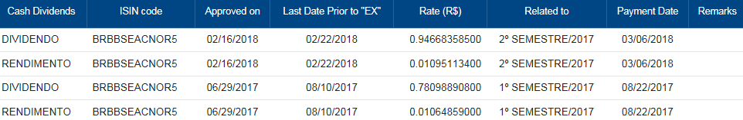
http://www.bbseguridaderi.com.br/en/documentos?Id=1159
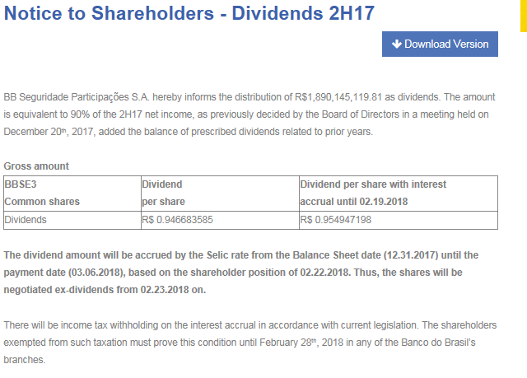
- Exchange and Company announcement of “juros sobre o capital proprio”

TELEFÔNICA BRASIL S.A
BRVIVTACNPR7 – Preferred shares
BRVIVTACNOR0 – Ordinary shares
http://www.bmfbovespa.com.br/en_us/products/listed-equities-and-derivatives/equities/listed-companies.htm Click on the link, click on letter “T” to search, then click on “TELEFÔNICA BRASIL S.A”, then click on “Corporate Actions” and “Cash Dividends”.
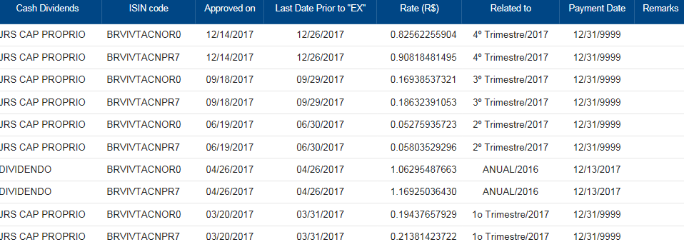
http://ri.telefonica.com.br/en/Download/1572_Notice_to_the_Market_-_Sep_18_2017_IOC_amount_per_share_confirmation.pdf
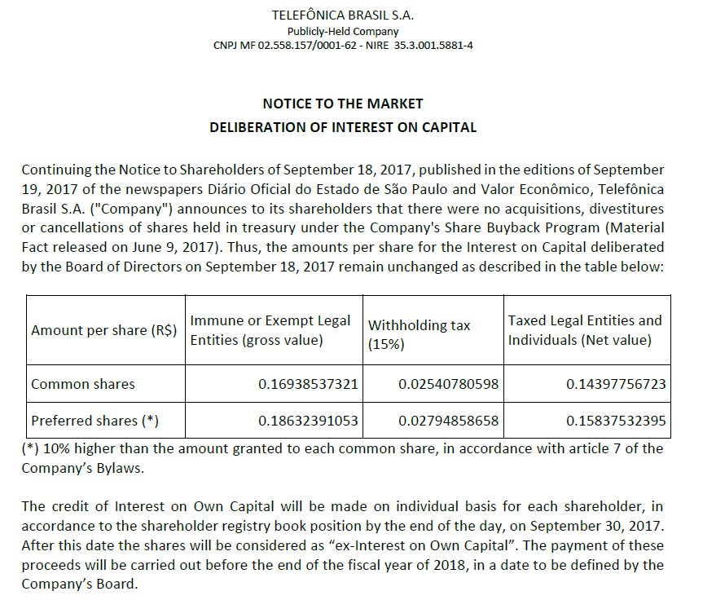
- Exchange announcement of “juros sobre o capital proprio” and “rendimento do juros”

BCO AMAZONIA S.A.
http://www.bmfbovespa.com.br/en_us/products/listed-equities-and-derivatives/equities/listed-companies.htm Click on the link, click on letter “B” to search, then click on “BCO AMAZONIA S.A.”, then click on “Corporate Actions”.

BRBAZAACNOR0

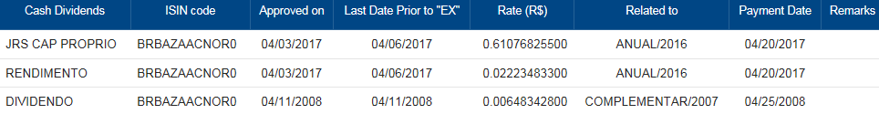

- Exchange announcement of Investment Fund “rendimento”

ALIANZA TRUST RENDA IMOBILIARIA FDO INV IMOB
http://www.bmfbovespa.com.br/pt_br/produtos/listados-a-vista-e-derivativos/renda-variavel/fundos-de-investimentos/fii/fiis-listados/
BRUBSRCTF000

