CA493 - Repetitive 94a Place of Safekeeping (SAFE) in MT564, MT 535

Input from: Mariangela Fumagalli – April 5, 2021

This is to target the ever more complex scenario of clients using investor CSDs and still wanting to know where the assets are held. As an example, as a global custodian I safe-keep some Banco Santander shares for my client in Germany with my German sub-custodian which has them deposited with Clearstream Frankfurt which has them sub-deposited with Clearstream Banking Lux.

In our current scenario, I can only report the BIC of my German sub-custodian as place of safekeeping but this is not enough for my client to understand that the shares are actually in CBL. By making SAFE repetitive, we could provide a better reporting.

This has an impact on both MT535 and MT564 messages.

Initial answer from Robin Leary

So a client wants to see at every step where the securities are held and not just where they’re safekept from a client perspective?

It ties in, in a way, to some discussions we’re having around what is the correct BIC (if using 94F) to populate in different circumstances. Taking the MT535 as an example, technically an IM going through a GC should have the sub-custodian as the PSAFE on the statement from the GC to IM.

The PSAFE on a MT535 from a sub-custodian to the GC would be the CSD. And, using the below example, the MT535 from the CSD to the sub-custodian should have the ICSD.

We’re not really seeing any asks for that level of detail in the statements or CA messages and any asks are more around which BIC so go in (eg some IM’s want to see the CSD BIC and others the sub-custodian BIC) unless there’s something I’m not hearing about but sounds like it’s similar, in a way, to the Settlement Party structure in MT54x messages.

I’ve no objections as such around the ask (other than it may lead to requests we don’t see at the moment which could lead to quite a complex development depending on what information different clients want to see) but if we go down the route of raising a CR, we’d probably need additional Place Codes as well (eg would you use CUST for both the GC and Sub or should a new one be added and the existing one redefined and do we need to the same number of levels as the settlement instructions in case of intermediaries?).

Definitely worth a discussion though to gauge feedback!

Illustration of safekeeping options of Royal Dutch A shares.
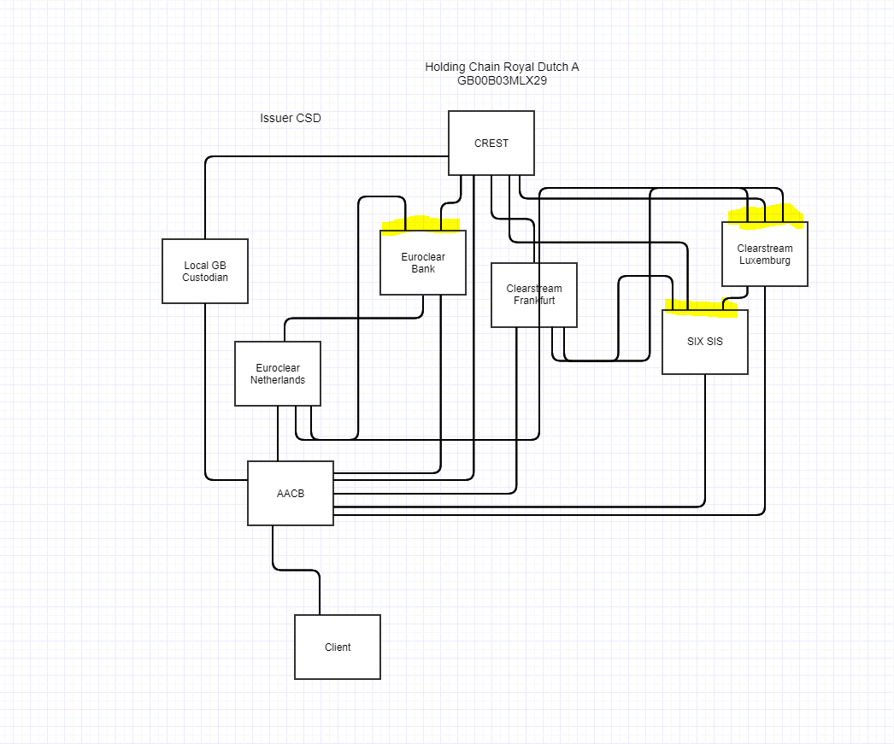

Areas marked yellow are causing issues.
In MT535 we currently only report first level of custodians/CSDs (e.g. EB, CBL and SIX SIS).
For the distinct pools of stock their can be differences in the way CA’s are being handled and if clients want do deliver from a specific pool this has to be indicated in the instruction. This can be mandatory in case of a cross border instruction towards a domestic market.
Basically we have a need to report the underlying safekeeping.

Theoretical option to report second level of Safekeeping in MT535:

Activity flag (sequence A) |  |  | :17B::ACTI//Y |  | :17B::ACTI//Y
Sub-account statement flag |  |  | :17B::CONS//N |  | :17B::CONS//N
End of general sequence A |  |  | :16S:GENL |  | :16S:GENL
Start of sub-safekeeping a/c seq. B |  |  | :16R:SUBSAFE |  | :16R:SUBSAFE
Place of safekeeping |  |  | :94F::SAFE//NCSD/NCSD11XX |  | :94F::SAFE//NCSD/NCSD11XX |  |  | All FIN sequences B1 following have  NCSD11XX for place of safekeeping
 | Start of Financial instr. subseq. B1 |  | :16R:FIN |  | :16R:FIN
 | Identification of the financial inst. |  | :35B:ISIN XX1234567890 |  | :35B:ISIN XX1234567890
 | Aggregate balance |  | :93B::AGGR//UNIT/33000, |  | :93B::AGGR//UNIT/33000,
 | Total Available balance |  | :93B::AVAI//UNIT/24000, |  | :93B::AVAI//UNIT/24000,
 | Total Unavailable balance |  | :93B::NAVL//UNIT/9000, |  | :93B::NAVL//UNIT/9000,
 |  | Start of Sub-balance. subseq. B1b | :16R:SUBBAL |  | :16R:SUBBAL
 |  | Sub-balance use example | :93C::BLOK//UNIT/NAVL/9000, |  | :93C::BLOK//UNIT/NAVL/9000,
 |  | :16S:SUBBAL | End of Sub-balance. subseq. B1b | :16S:SUBBAL
 | End of Financial instr. subseq. B1 |  | :16S:FIN |  | :16S:FIN
 | Start of Financial instr. subseq. B1 |  | :16R:FIN |  | :16R:FIN
 | Identification of the financial inst. |  | :35B:ISIN XX1234567891 |  | :35B:ISIN XX1234567891
 | Aggregate balance |  | :93B::AGGR//UNIT/20000, |  | :93B::AGGR//UNIT/20000,
 | Total Available balance |  | :93B::AVAI//UNIT/20000, |  | :93B::AVAI//UNIT/20000,
 | End of Financial instr. subseq. B1 |  | :16S:FIN |  | :16S:FIN
End of sub-safekeeping a/c seq. B |  |  | :16S:SUBSAFE |  | :16S:SUBSAFE |  |  | End of reporting for holdings held at one  CSD.
Start of sub-safekeeping a/c seq. B |  |  | :16R:SUBSAFE |  | :16R:SUBSAFE |  |  | Start of reporting for holdings with  multiple places of reporting
 |  |  |  |  | :94F::SAFE//ICSD/ICSDLUBE
Start of Financial instr. subseq. B1 |  |  | :16R:FIN |  | :16R:FIN
Identification of the financial inst. |  |  | :35B:ISIN XX1234567892 |  | :35B:ISIN XX1234567892
 | Aggregate balance |  | :93B::AGGR//UNIT/35000, |  | :93B::AGGR//UNIT/35000,
 | Total available balance |  | :93B::AVAI//UNIT/25000, |  | :93B::AVAI//UNIT/25000,
 | Total not available balance |  | :93B::NAVL//UNIT/10000, |  | :93B::NAVL//UNIT/10000,
 |  | Start of Sub-balance. subseq. B1b | :16R:SUBBAL |  | :16R:SUBBAL
 |  | Aggregate balance | :93B::AGGR//UNIT/10000, |  | :93B::AGGR//UNIT/10000,
 |  | Total available balance | :93B::AVAI//UNIT/5000, |  | :93B::AVAI//UNIT/5000,
 |  | Total not available balance | :93B::NAVL//UNIT/5000, |  | :93B::NAVL//UNIT/5000,
 |  | Place of safekeeping | :94F::SAFE//ICSD/ICSDLUBE |  | :94F::SAFE//NCSD/NCSD11XX
 |  | End of Sub-balance. subseq. B1b | :16S:SUBBAL |  | :16S:SUBBAL
 |  | Start of Sub-balance. subseq. B1b | :16R:SUBBAL |  | :16R:SUBBAL
 |  | Sub-balance example | :93C::BLOK//UNIT/NAVL/5000, |  | :93C::BLOK//UNIT/NAVL/5000,
 |  | Place of safekeeping | :94F::SAFE//ICSD/ICSDLUBE |  | :94F::SAFE//ICSD/ICSDLUBE
 |  | End of Sub-balance. subseq. B1b | :16S:SUBBAL |  | :16S:SUBBAL
 |  | Start of Sub-balance. subseq. B1b | :16R:SUBBAL |  | :16R:SUBBAL
 |  | Aggregate balance | :93B::AGGR//UNIT/25000, |  | :93B::AGGR//UNIT/25000,
 |  | Total available balance | :93B::AVAI//UNIT/25000, |  | :93B::AVAI//UNIT/25000,
 |  | Place of safekeeping | :94F::SAFE//NCSD/NCSD22YY |  | :94F::SAFE//NCSD/NCSD22YY
 |  | End of Sub-balance. subseq. B1b | :16S:SUBBAL |  | :16S:SUBBAL
 | End of Financial instr. subseq. B1 |  | :16S:FIN |  | :16S:FIN
End of sub-safekeeping a/c seq. B |  |  | :16S:SUBSAFE |  | :16S:SUBSAFE

