**CA542 CA - SCoRE Questions**

**CAPC usage vs ISO15022**

Background – Current SCoRE Standards About the CAPC

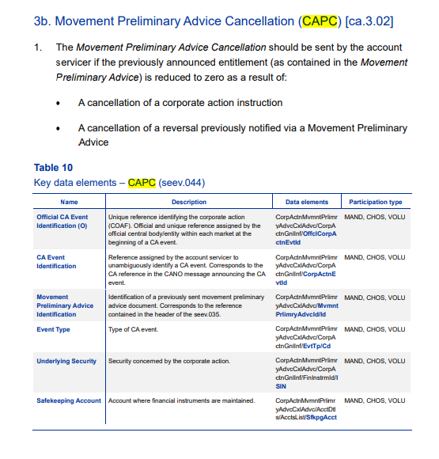

SMPG CA WG Discussion

As agreed in previous SMPG meetings, it was agreed to change the CAPC translation in ISO15022 as “564 REPE + ADDB//CAPA and amounts as zero” and the mapping table in GMP1 updated accordingly:

## ISO 20022 versus ISO 15022 Messages Mapping

The following table illustrate the mapping between the ISO 20022 messages and the ISO15022 messages:

| ISO 20022 Message name | Short Name | ISO 20022 Msg Id. | ISO 15022 MT (Function) |
| --- | --- | --- | --- |
| CA Notification | CANO | seev.031 | **564 + 568** (NEWM, REPL, , RMDR) |
| CA Event Processing Status Advice | CAPS | seev.032 | **567** (EVST + 25D::EPRC) |
| CA Instruction | CAIN | seev.033 | **565** (NEWM) |
| CA Instruction Status Advice | CAIS | seev.034 | **567** (INST + 25D::IPRC) |
| CA Movement Preliminary Advice (Function=ENTL) | CAPA | seev.035 | **564 (REPE)** |
| CA Movement Preliminary Advice (Function = CAPA) | CAPA | seev.035 | **564** (REPE + ADDB//CAPA) or  **564** (NEWM + PROC//ENTL + ADDB//CAPA) or  **564 (REPE + ADDB//CAPA + ADDB//REVR)**  **564** (ADDB + ADDB//CLAI or TAXR) |
| CA Movement Confirmation | CACO | seev.036 | **566** (NEWM) |
| CA Movement Reversal Advice | CARE | seev.037 | **566** (REVR) |
| CA Narrative | CANA | seev.038 | **No equivalent except when MT568** is used as a Stand alone message with NEWM and exclusively with  **+** CAEV//WTRC  + 70a::ADTX or REGI or TAXE |
| CA Cancellation Advice | CACN | seev.039 | **564 + 568** (WITH, CANC) |
| CA Instruction Cancellation Request | CAIC | seev.040 | **565** (CANC) |
| CA Instruction Cancellation Request Status Advice | CACS | seev.041 | **567** (CAST + 25D::CPRC) |
| CA Instruction Statement Report | CAST | seev.042 | NA |
| CA MovementPreliminaryAdviceCancellationAdvice | CAPC | seev.044 | **564** (REPE + ADDB//CAPA + 20C::PREV) with movements set to zero (TBC) |
| Next year: use CA Movement Preliminary Advice (REPL) and delete CAPC ? TBC |  |  | **564** (REPE + ADDB//CAPA + 20C::PREV) with movements set to zero (TBC) followed by new MT564 REPE + ADDB//CAPA |

The two questions left:

1. In light of the changes introduced by SR2023, do we need to keep CAPC in ISO20022 or should it be replaced by a Replacement CA Movement Preliminary Advice (CAPA REPL)?
2. Do we need to further expand the market practice on when and how to issue CAPA REPL messages?