BE NMPG: agenda
Corporate Action Meeting

April 11th, 2008

Table of content

1) Review of SMPG Conference calls: (8:30 am → 10:15 am) 3
2) Review of SMPG agenda for Paris: (10:30 am → 3:15 pm including a 30 minutes sandwich lunch) 3
3) Annex 5
4) Next meeting 6

Review of SMPG Conference calls: (8:30 am → 10:15 am)
  - Conference call January 10th: See annex below

  - Conference call January 23rd: See annex below

  - Conference call March 05th: See annex below

  - Conference call March 06th: See annex below

Review of SMPG agenda for Paris: (10:30 am → 3:15 pm including a 30 minutes sandwich lunch)
Item No | Description | Comment | BE Action/Comments
CA06 | Event Interpretation Grid (EIG) | Any further updates from NMPGs to the EIG. | See the e-mail from Tim Taylor and my answer: still to validate some points (document in annex).
CA06.07 | Event Interpretation Grid (EIG) | Finish consolidated matrix for the date & period and rate & price information for the ‘global grid’. | N/A
CA10.3 | DvE | Finish review of all qualifiers with the purpose of deleting qualifiers that fall outside the D vs E guidelines and proposing CRs for SR2009. See document posted in the working documents folder for Paris meeting. | See document in annex (Consolidated_Feedback_EIG_Date_  Period_Price_Rate_20071005_v1.xls)
CA22 | Rights as Two Events | Update from NMPGs on readiness to move from 1 to 2 event scenarios | BE is in favor of 2 events
CA78.2 | CORP Reference | Update from NMPGs on research into the identity of the ‘official’ body in their market. | Euroclear BE will be able to play this role once the COAF field has been implemented. Before that once EBE is producing ISO messages on CA, the CORP they will send can already be considered as the unique reference.  Still waiting for an answer from the NBB for the Gvt bonds.
CA79.3 | Giovannini Barrier 3 | Update on Giovannini Barrier 3
CA115.6 | Preadvice of reversal | Review of the US proposal. See document posted in the working documents folder for Paris meeting. | Couldn’t find the document in the SMPG folder.
CA116 | Redemption matrix | Define market practice usage and message examples for all redemption events (PCAL, DRAW, PRII, PRED & new SR2008 event for increase without a change in nominal value). See document posted in the working documents folder for Paris meeting. | See document in annex (Redemption Events Matrix DRAFT v1.2 1st feb 08.xls)

Other items:

Item No | Description | Comment | BE Action/Comments
AOB | Telco schedule for remainder of 2008 | Agree on telco schedule for 2008, in addition to the planned 26 June 2008 call.
AOB | Change requests for SR2009 | Discussion on potential CR for SR2009 and any NMPG asking for time to review their proposed submission.
AOB | Update on ISO 15022-ISO 20022 reverse engineering project | SWIFT will give an update on the outcome of the Industry Consultation phase. In addition, we will also discuss the following issues that have been raised during the Industry Consultation meeting on 30-31 Jan.:  - NMPGs to define legitimate use for having a narrative in MT 565 and also for using the MT 568 (eg, tax)  - Timezone discussion: SWIFT to make a proposal  - Rates vs prices: Bernard to find examples of issues  - Check cancel scenarios in Global SMPG CA document and document all cases, eg, withdrawal  - Event stage statuses not all mutually exclusive.  - Discussion around the usage of MT 567 status and codes (Global SMPG MT567 SR2007 Detailed Grid), linked to CRs III.10.1 & III.10.2 (SR2007) & III.51 (SR2008)? new CR be prepared to align ISO 15022 and ISO 20022 messages? | See document in annex related to the ISO 15022-20022 reverse engeneering. (Core_CA_IC_20080130-31_vFinal2.doc)
AOB |  | Further discussion on any items left over from CA SMPG call on 6 March 2008. | See point 1.
AOB | STaQS presentation | Presentation by Max Mansur (SWIFT) on STaQS (Simulation Testing and Qualification Service) for corporate actions. STaQS is a tool built by SWIFT and allows to check compliance with the SMPG EIG and DvsE guidelines.

Annex
- Minutes from SMPG conference call:

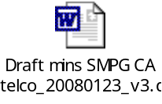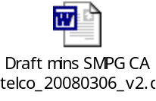
- Documents for the preparation of the Paris SMPG meeting

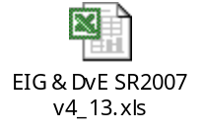

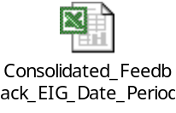

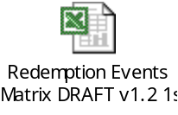

Other documents for Paris:

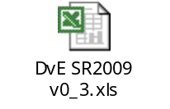

ISO 15022 – 20022: reverse engineering:

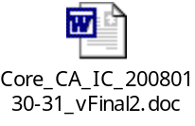

Next meeting

Proposal:

February 1st, 2008 at 9 am
April 11th, 2008 at 9 am
June 13th, 2008 at 8:30 am
September 5th, 2008 at 8:30 am
October 31st, 2008 at 8:30 am
December 12th, 2008 at 8:30 am

