BE NMPG: agenda
Corporate Action Meeting

December 12th, 2008

Table of content

1) Review of outstanding SMPG open action items: (9:00 → 10:30 – 10:45 → 11:45) 4
A) Corporate Action Joint Working Group 4
B) CA06.07 Dates/Rates/Price/Periods Consolidated matrix 6
C) CA125 Standards Proposal for Options 8
D) CA06.10 9
E) CA06.11 EIG - review of N/A entries in Complex Grid 9
F) CA127 UKWN in messages 10
G) CA128 Pre-advice of movement 10
H) CA135 Multi-stage events 10
I) CA137 MT565-MT568 linkage 10
J) CA53.4. Usage of the CA Samples 10
K) CA78.3a COAF - Letter to the EU 10
L) CA78.2 and CA 78.2a COAF Official bodies identification and usage in markets 11
2) Other Topic: (11:45 → 12:00) 11
3) Next meeting 12

Review of outstanding SMPG open action items: (9:00 → 10:30 – 10:45 → 11:45)

Corporate Action Joint Working Group

The group discussed the relationship between the work done by the CA Joint Working Group and by the CA SMPG.
Christine Strandberg, Stephenie Brock and Frank Slagmolen are members of the CA Joint WG. They gave a status update on the progress made by this group. A draft market practice document will be sent by the end of September for market consultation.
The SMPG is not listed in the group or associations to be consulted for comments. The reason for this is that the SMPG is not a European-only association. However, the SMPG will receive the document for information. The document will be sent to all the CA SMPG members to give them the possibility to review it in their national markets.
Christine and Frank produced the below chart to clarify where and how the SMPG is positioned compared to the CA Joint Working Group and the other involved institutions, organisations and associations.

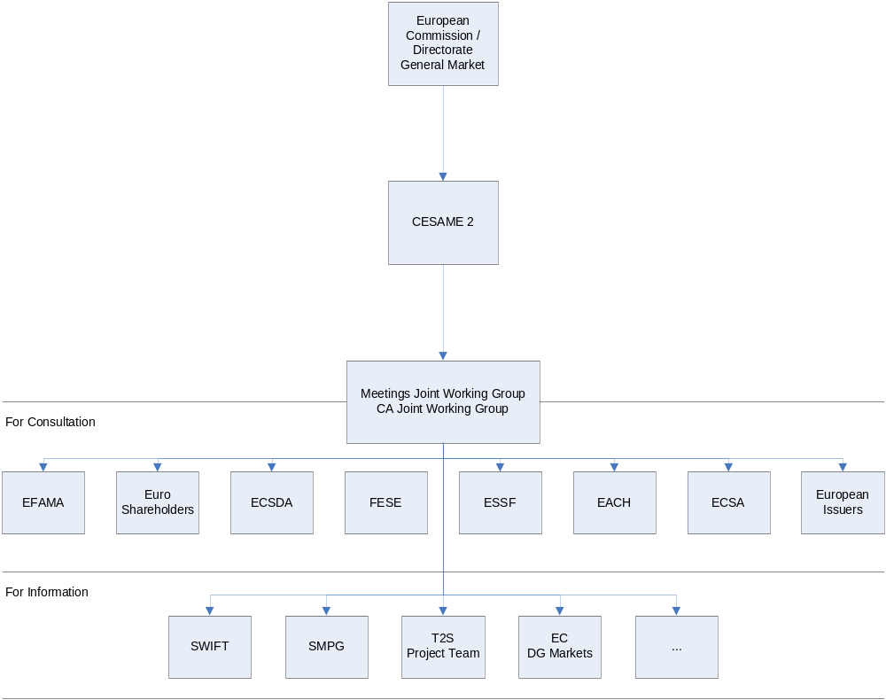

The two CA SMPG co-chairs will talk to Rudolph Siebel to (1) get a better understanding of his role and implications in the CESAME2 group; (2) to determine how potential comments from the SMPG could be relayed to the CA Joint Working Group and be officially taken into account.
The group agreed to review the document for any conflicts with global market practice by 7th November and indicate whether a telco on 13th November would be needed to review any comments.

Action: NMPGs to review the document in their own markets and provide comments to Olivier Connan. All comments will be discussed and consolidated in an SMPG response.

Note: The document’s objectives are to define market practices for CA to be applied by all the 27 EU countries, plus Norway and Switzerland. Contributions from other markets are welcome and will be discussed at the SMPG.

Post-meeting comment: The document “Market Standards for Corporate Actions Processing” has now been officially published and sent to the CA SMPG co-chairs. The document is now distributed to all the CA SMPG members with these minutes.

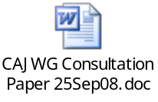

31/10: Véronique and Benoit explained the purpose of the working group. The goal is to harmonize the CA processing by type of events (mandatory distribution, etc.)
The goal is to achieve the removal of the Giovannini barrier 3.
The option proposal solution from this paper is different than what SMPG is thinking for the moment. We will need to follow the evolution of this exercise.
Action: BE NMPG should read the document and send their comments to Charles ASAP (before the end of November).
Template of comment spreadsheet to be used by NMPGs:
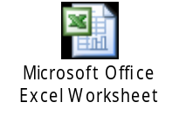

CA06.07 Dates/Rates/Price/Periods Consolidated matrix

See 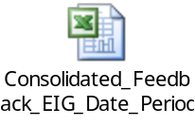
The BE comments are marked with red crosses in the Excel sheet. We stop with LIQU/MAND and we will continue at the next meeting.
The consolidated spreadsheet makes a distinction between:
- X/O - elements mandatory or optional for all countries,
- SX/SO - country specific elements (mandatory or optional),
- C – Conditional elements
It should be noted that the input received is only applicable for the MT 564, i.e., the MT566 review is still to be done.
When finished, the date/period/rate/price information will be integrated to the global EIG grid.
The group reviewed the complete list of event types in the spreadsheet to ensure that the coverage was complete:
- The events already completed are highlighted in yellow. For some events the country specific elements only appear with an S. The X/O indicating whether the element is mandatory or optional is missing.
- The events not to be covered are highlighted in red.
- The events to be completed are highlighted in green. The events specific to one or several markets only are clearly identified in the spreadsheet.

Action: Each NMPG to:
- Discuss and provide input for all the green market-specific events by 17th November - Green events specific to one or several markets should only be completed by those markets,
- Discuss and provide input for all remaining green events by 5th December (except for Italy and Switzerland). Discrepancies will be discussed at a 2009 telco.
- Fill in the mandatory/optional (X/O) indicator for the yellow events specific to their market.
- Input should be sent to SWIFT (Olivier) for consolidation.

The coupon stripping event (CPST) has been deleted from the Consolidated Matrix spreadsheet since it will be removed from the standard in SR2008.
The EIG compiled is updated for event Dividend Option (DVOP): the VOLU line is removed and “n/a” is added for CHOS in the AT column.
The EIG compiled is updated for event Call on Intermediate Securities (EXRI): the VOLU line is removed because it is never used.
The EIG compiled is updated for event Rights Issue/Subscription Rights/Rights Offer (RHTS): the VOLU line is removed.
The EIG Compiled is updated for event Capitalisation (CAPI): NOAC is added as an option. NOAC is typically not used in a MAND event but in this case the deletion of the rate in sequence D (DvE impact) obliged us to create an option.
The ‘Read Me” section of the EIG spreadsheet has been updated as follows: “The purpose of the Compiled Grid is to cover the most commonly known combinations identified by the market listed in the grid.”

Action: US to check whether CLSA (Class Action) should become a mandatory event or remain a voluntary as today.

Action: Véronique Peeters to produce a white paper with the different scenarios of DRIP for discussion a 2009 telco.

31/10: Veronique produced a first draft and Euroclear is providing some feedback.

Action: Full Call/Early Redemption event MCAL: JP to check how the event is handled in the Japanese market and revert to the CA SMPG WG.

Action: Merger (MRGR): Frank Slagmolen to check whether voluntary MRGR occur in The Netherlands.

Action: Partial Redemption With Reduction of Nominal Value (PCAL): Frank Slagmolen to check whether can have CASH and SECU options and for which markets.

Action: Instalment Call (PPMT): This event is listed in the EIG compiled as MAND with NOAC or OTHR options for Switzerland. Adriano Chieffo will check with the Swiss market whether PPMT is effectively used and how.
Action: US to check if event Liquidation Dividend / Liquidation Payment (LIQU) is more appropriate in the US market than event Bankruptcy (BRUP).

CA125 Standards Proposal for Options

The group reached consensus on the fact that the industry faces issues with the way corporate action options are handled today. There is a general agreement that improvements needs to be made and that the SMPG should make a new proposal in that direction.
The group agrees that an SMPG position paper should be prepared to present the current situation and the different alternatives to improve the way CA options are managed. Two possible alternatives are described: (1) Keep the current approach: option numbers are not harmonised and cross reference tables remain necessary and (2a) Build the capability to elect on CA option type only (for events with 1 instance of each option) or (2b) to provide the CA Option type and a (or more) differentiating factor(s) (for events with several instances of a CA Option type).
These alternatives will be described in more details in the SMPG position paper.
The group reviewed the document “Standards Proposal for Options 2 Layer DRAFT 20080626 v1.2.doc”:

Page 2:
Regardless of the possible alternatives the following needs to be agreed.
a) Option classification and Option Status: NMPGs to give feedback whether they should be mandatory or optional.
If mandatory, all the possibility given today should be available. That is,
- for Option Classification: Issuer, Depository or Intermediary Announced
- for Option Status: Active, Inactive or Cancelled
If Optional, Issuer for Option Classification and Active for Option Status will be implicit and the codes available will be:
- for Option Classification: Depository or Intermediary Announced
- for Option Status: Inactive or Cancelled
31/10: BE agrees it is a good idea to classify the options. We believe it should be optional, and it will be implicit.
b) Elected Quantity Requirements: NMPGs to give feedback whether they should be mandatory or optional.
31/10: This should be optional. Having it mandatory will not be user friendly.

Page 11:
The last bullet point of the page is not applicable.

Generic comment:
The placement of Dates, Rates, Prices and Periods throughout the whole proposal will be aligned with the DvE matrix and the SR2009 CR III.5.

Action: Karla will prepare a draft position paper and update the Standards Proposal for Option document by 10 October 2008. The documents will be sent to the NMPGs for review by the first 2009 telco.

Post-meeting comment: The document has been sent with these minutes and is now posted on www.smpg.info in the draft document section.



Action: NMPGs to provide feedback on cardinality of Option Classification, OSTA and QREC by next telco on the topic (Nov. 13th or Jan. 15th).

CA06.10

CAEP/CAEV matrix review.
Interested NMPGs to review the document (CAEP codes against CAEV codes). Feedback to Euroclear by 1st June.
To be discussed during Conference call 19/03/09

CA06.11 EIG - review of N/A entries in Complex Grid

NMPG to check EIG entries for events where 'n/a' occurs and if the event does not occur at all ensure that 'n/a' is entereed for each CAMV occurrence. At present a single 'n/a' entry is made for the event. The action is a clarification … for automation of the EIG.
Submit feedback to SWIFT.

CA127 UKWN in messages

Discuss the presence of UKWN codes. Should this code be added to other fields/qualifiers in MT564 (that is for elements not known at the time of announcement but to be provided at a later stage)?
Deadline: April 09

CA128 Pre-advice of movement

SMPG to review the guidelines to allow to unambiguously identify when an MT 564 is a preadvice of movement (for instance NEWM/REPE + ENTL = preadvice of movement, therefore translation to an CA Movement Preliminary Advice.
Deadline: April 09

CA135 Multi-stage events

Describe scenarios on how multi stage events should be processed. NMPGs to prepare scenarios to describe the different possibilities to communicate and process these events.
Christine will produce an example of the Nordic three step process and distribute it to the group.
Deadline: April 09

CA137 MT565-MT568 linkage

The group discussed the linkages between MT565 and MT568 and confirmed that this possibility should no longer exist. The SMPG guidelines will be amended accordingly.
SWIFT to update the Global market practice document to reflect that linkage between MT565 and MT568 is not a recommended practice by the SMPG.

CA53.4. Usage of the CA Samples

Bernard provided the introduction. The SMPG agrees that the two samples should be renamed templates and that the two separate documents should be merged into one.

 Action: SWIFT to make the changes in the sample documentation, in time for the SR2008 implementation

CA78.3a COAF - Letter to the EU

Bernard prepared a draft letter to the EU but some questions remain about the fact that the letter should be positioned to reflect the issues raised by FISCO and LCG (as discussed at the SWIFT Harmonisation working group.

 Action: Content of the letter and positioning will be re-discussed after the discussion on the CA Joint WG draft paper discussion.

CA78.2 and CA 78.2a COAF Official bodies identification and usage in markets

UK mentions that as an interim solution in the UK market, Euroclear will be the providing the COAF identification. This will be until a more appropriate solution is identified with the UK registrars.

CH mentions that the COAF will be implemented and used in the Swiss market as from SR2008.

US question: How will the implementation of COAF be monitored and how will it be announced when a market is ready to support it? Will the SMPG take responsibility for this?

 Action: A table will be prepared and posted on the website showing the countries that are implementing, when and for what instruments (if applicable).

31/10: Euroclear will be the official body for BE as of the release of SP custody (2010). Charles to check with NBB.

Other Topic: (11:45 → 12:00)
- Blocking of shares

31/10: Veronique drafted a paper to describe the various situations when blocking of shares could happen. There are so far 3 scenarios described. A fourth one will be added based on input from Euroclear.
- Blocking of underlying securities for an elective event. It should not be part of the 564 because it should be general knowledge. Upon receipt of the 565, you would send a 508 linked to the 565 and the corp id of the 564. The 508 would show that you move from an available balance to a block balance due to a corporate action. On payment date, the 566 is sent referring to the 565.
- Drawing: MT 564 will contain the blocking period (if known, with the start date = to record date). MT508 to show the blocking and then a 566 to confirm the debit.
- Blocking of the proceed securities. Often the case in emerging markets. In the MT564 (should be in E, but the current recommendation in the D vs. E is to remove from E), it should already be mentioned that the securities proceed will be subject to a blocking period. Upon the receipt of the 566 showing the credit of the new shares, a MT508 should be sent with a link to the 566 and the corp id.

Next meeting

Proposal:

December 12th, 2008 at 9:00 am
February 20th, 2009 at 9:00 am
March 27th, 2009 at 9:00 am
May 8th, 2009 at 9:00 am
June 12th, 2009 at 9 am
July 10th, 2009 at 9 am
Later is to be determined pending the CA SMPG Conference call schedule to be confirmed.

