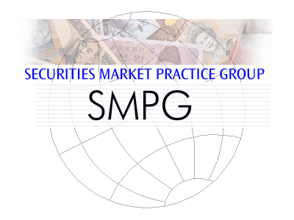
List of CA SMPG WG Attendees – Sorted by NMPG

NMPG | Title | First Name | Last Name | Institutions
BE | Mrs. | Véronique | Peeters | BNY Mellon
CH | Mr. | Michael | Blumer | Credit Suisse AG
DE | Mrs. | Andreana | Pileri | Commerzbank
DK | Mrs. | Charlotte | Ravn | VP Securities
HK | Mrs. | Yek Ling | Yu | HSBC
FI | Mrs. | Sari | Rask | Nordea Bank Plc
FR | Mrs. | Kimchi | Phungtran | BNP Paribas
ISITC US | Mr. | Paul | Fullam | Sungard’s XSP
ISITC US | Mrs. | Karla | Mc Kenna | CITI
JP | Mr. | Hideki | Itou | Mizuho Bank, Ltd.
LU | Mr. | Bernard | Lenelle | Clearstream | Co-chair
MDPUG | Mr. | Peter | Hinds | Interactive Data
MDPUG | Mrs. | Laura | Fuller | SIX Financial Information Ltd
NL | Mr. | Ben | van der Velpen | ING BANK N.V.
NO | Mr. | Alexander | Wathne | Nordea
SE | Mrs. | Christine | Strandberg | SEB | Co-chair
SG | Mr. | Jyi-Chen | Chueh | Standard Chartered Bank
SWIFT | Mr. | Jacques | Littré | SWIFT | Facilitator
UK | Mr. | Matthew | Middleton | LSE Group
UK | Mrs. | Mariangela | Fumagalli | BNP Paribas
XS | Mrs. | Delphine | Haillez | Euroclear
ZA | Mr. | Sanjeev | Jayram | FNB

