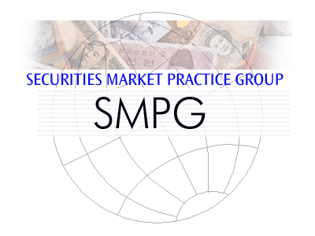
List of CA SMPG WG Attendees – Sorted by NMPG

NMPG | Title | First Name | Last Name | Institutions
FI | Mrs. | Sari | Rask | Nordea Bank
ISITC US | Mrs. | Karla | McKenna | CITI
ISITC US | Mrs. | Malene | McMahon | SWIFT | Observer
ISITC US | Mrs. | Sonda | Pimental | BBH
ISITC US | Mr. | Steve | Sloan | DTCC | Observer
IT | Mrs. | Paola | Deantoni | SGSS
LU | Mr. | Bernard | Lenelle | Clearstream | Co-Chair
MDPUG | Mr. | Peter | Hinds | Interactive Data
NO | Mr. | Alexandre | Wathne | Nordea Bank Norge
SE | Mrs. | Christine | Strandberg | SEB | Co-Chair
UK&IE | Mrs. | Mariangela | Fumagalli | BNP Paribas
XS (Eurobond) | Mrs. | Delphine | Haillez | Euroclear
ZA | Mr. | Sanjeev | Jayram | RMB
SWIFT | Mr. | Jacques | Littré | SWIFT | Facilitator

