SMPG - Corporate Actions
Minutes of Luxembourg Meeting
4 to 6 October, 2017

FINAL Version v1.1 – November 7, 2017
Table of Contents
1. Welcome 4
2. Meeting Agenda 4
3. Next Telco/Meeting Schedule for 2018 Q1/Q2 4
4. Approval of September 12 conf. call minutes 4
5. Notes Taking 4
6. CA375 SR2018 - GMP Part 1,2,3, Samples Updates & MPs Summary of Changes 4
7. CA279 Claims in the T2S context 5
8. CA315 Extending CA MPs to ISO 20022 6
9. CA354 Market usage of "QINS//QALL" on field 36a of MT565 7
10. CA366 Voluntary Rolling Event - Review GMP1 Section 2.2.5 7
11. CA367 INTP and OFFR usage with multiple payment Currencies 9
12. CA372 Reporting Issue with Reverse Market Claims 9
13. CA374 CANADA Representation at CA WG 10
14. CA376 Add section about CAEP in GMP1 10
15. CA377 WITH vs CANC function 10
16. CA378 TNDP Event MP and TNDP Indicator DSS Usage 10
17. CA379 New Charges Related Amount Qualifiers for Rights / Warrants Events 10
18. CA380 Proration Accepted and Unaccepted Balances 12
19. CA381 Usage of Pagination in ISO 20022 13
20. CA382 Message enhancements to provide Options Instructions Details 13
21. Tax Subgroup Report (CA221 / CA373) 13
22. SWIFT DP 187 – SWIFT Board Paper on Fast Track Maintenance Process 14
23. New Regulation Page on MyStandards - Presentation 14
24. Post Trade Risk Alerting Service (PTRA) - Presentation 14
25. How to become candidates for the ISO 20022 Securities SEG (CA ET) 14
26. Local NMPG Market News 14
27. AOB 14

Attendees

NMPG | Title | First Name | Last Name | Institutions
AU | Mrs | Narelle | Rutter | BNP Paribas Securities Services
BE | Mrs | Véronique | Peeters | BNYM
CH | Mr | Michael | Blumer | Credit Suisse AG
DK | Mrs | Charlotte | Ravn | VP Securities
DK | Mrs | Randi | Hattens | VP Securities
FI | Mrs | Sari | Rask | Nordea Bank Plc
FR | Mr | Jean-Pierre | Klak | STATE STREET BANQUE
IT | Mrs | Paola | Deantoni | Société Générale Securities Services spa
LU | Mrs | Bernard | Lenelle | Clearstream | WG co-Chair
NL | Mr | Ben | van der Velpen | ING
NO | Mr | Wathne | Alexander | Nordea Bank
SE | Mrs | Christine | Strandberg | SEB | WG co-Chair
SG | Mr | Jyi-chen | Chueh | Standard Chartered Bank
SWIFT | Mr | Jacques | Littré | SWIFT | WG Facilitator
UK&IE | Mrs | Mariangela | Fumagalli | BNP Paribas
US ISITC | Mr | Paul | Fullam | ISITC
US | Mrs | Karla | McKenna | Citibank, NA | SMPG Chair
US | Mr | Matthew | Schill | DTCC
XS - ICSD | Mrs | Delphine | Haillez | Euroclear Bank
ZA | Mr | Sanjeev | Jayram | RAND MERCHANT BANK

Welcome
Narelle Rutter representing the AU NMPG joins the SMPG CA WG physical meeting for the first time. Matthew Schill (DTCC), representing the US, replaces Steve Sloan who could not join us for this meeting.

Meeting Agenda
These minutes are based on the distributed Luxembourg meeting agenda. See document ”SMPG_Meeting_Luxembourg_4_6_Oct_2017_CA_DetailedAgenda_v1” (also posted on the SMPG web site):

Next Telco/Meeting Schedule for 2018 Q1/Q2
On Tuesday’s January 23, February 20, March 20, May 22, June 19
All teleconferences from 2 to 4 PM CET.
Next physical meeting: Warsaw - 18 to 20 April 2018

Approval of September 12 conf. call minutes
Minutes were approved without changes.

Notes Taking
Charlotte and Randi-Marie have kindly volunteered to takes notes during the meeting to help with the minutes.

CA375 SR2018 - GMP Part 1,2,3, Samples Updates & MPs Summary of Changes
The WG has decided to have a single deadline of December 1 for all update inputs to MPs documents i.e. Event sample updates, EIG+ Global Grid and country columns (GMP Part 2), and any other updates to GMP Part 1, summary of MP Changes for SR2018.
NMPGs are requested to hold their meetings/calls accordingly with this deadline. At least 2 meetings should be required.
How to submit changes to the event samples?
Apply the updates in the event samples with the track changes functionality in the MS Word version of the event samples and send it to Jacques indicating the event samples updated.
Templates review are assigned to Alexander, Ben, Bernard, Christine, Daniel, Delphine, Jean-Pierre, Mari, Matthew, Paul/Steve, Peter, Sanjeev, Sari and Véronique (see template assignment in Open Item file).
How to submit changes to the EIG+ Country Column?
- Download the latest version of the GMP Part 2 from www.smpg.info
- In the Excel Tab “EIG+ Updates since SR20xx”, delete the existing input below the title “Country Specific Updates”
For each country column event to be updated, copy the first 6 columns from the Global Grid and in the following columns, copy your current Country Column data and indicate the added elements in underlined bold blue colour and the removed elements in strikethrough red colour as illustrated below.
Example of a country column updates submission in tab “EIG+ updates since 20xx”
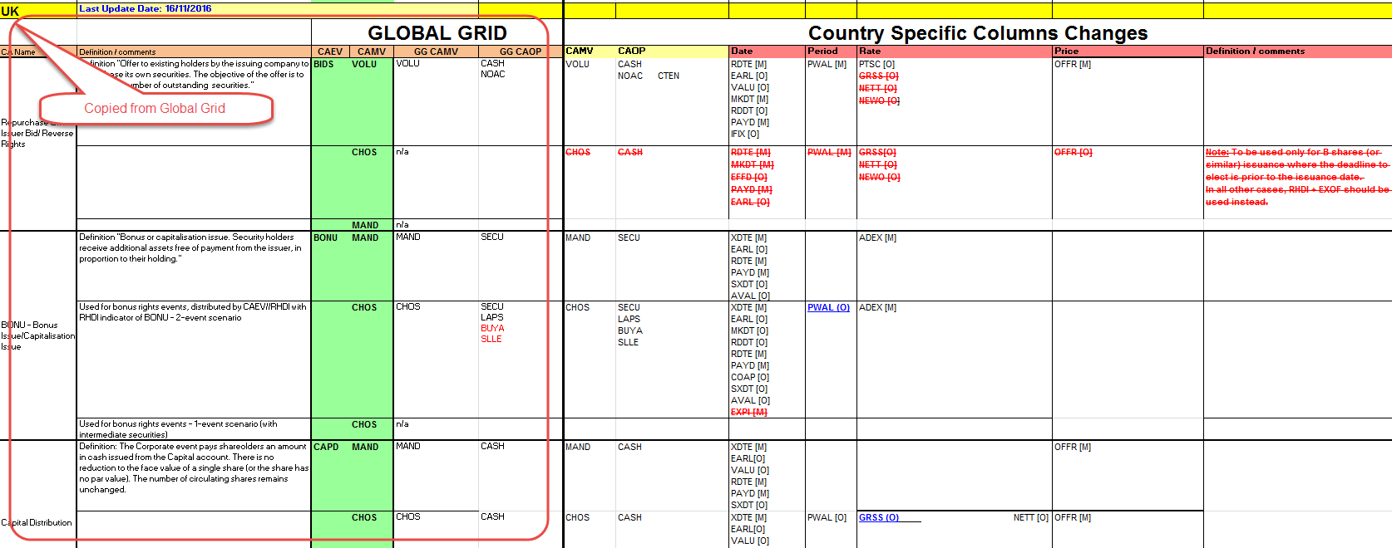
- If you have more than 15 events to be updated, apply all your updates in the country column in the “EIG+” tab so that it can be directly copied into the new version.
Actions:
- Alexander, Ben, Bernard, Christine, Daniel, Delphine, Jean-Pierre, Mari, Matthew, Paul/Steve, Peter, Sanjeev, Sari and Véronique to review their assigned Event Samples as per the list in the “Open Item” file in tab “CA Event Templates list” here below and provide updates input to Jacques for December 1.
- All NMPGs to review their EIG+ country column for correctness or to submit updates and /or proposed change to the EIG Global Grid and provide input to Jacques for December 1.
- Christine to provide first draft of the “SR2018 MP Changes summary” for December 1.

CA279 Claims in the T2S context
Italy is not in the capacity for the moment to provide input for the appendix table due to policy issues although IT supports the whole initiative taken by the group.
Mari asks why the CA on flows “Buyer Protection” and “Transformation” processes are not addressed explicitly in the white paper. The reason is that the white paper should at this stage rather remain at executive level. It can be left on the side for now and addressed later in a requirement type of document.
Matthew Schill (for the US) confirms that market claims is also an issue in the US and that they have a currently a focus group to work on that. The US agrees that new message flows might be necessary and they would support a harmonised solution in that area.
The CCP’s are also concerned by those “CA on flows” and the white paper should also be sent to CCP organisations.
The following securities market organisations have been identified so far to receive the white paper: T2S CASG, CA JWG, ECSDA, AFME, EBF, AGC, EACH, DTCC, SWIFT.
The WG has reviewed the document as well as the appendix (table). A few small changes have been brought to the text and to the table (country input – CH, UK, FR, DK) during the meeting.
Bernard has already spoken recently with the SnR co-Chairs (Axelle Wurmser and Marcin Zawistowski) about our initiative and they agreed that the CA WG goes ahead.
Since the white paper is meant to get the endorsement of various market groups on behalf of the SMPG, the white paper needs to be approved by the SMPG Steering Committee (SC).
Bernard has organized a special SC meeting during lunchtime on Wednesday October 4 so as to get comments / feedback from the SC about the text and their final approval.
SMPG SC meeting outcome:
For the last section “proposed approach” in the white paper the SC recommends to put an indicative date besides “Short term” like 2018 and replace “Long term” by Medium term” with 2020 as a target date. The final approval will be provided by the SC on Wednesday next week at the SC call. Jacques will distribute the final version of the document to the SC end of the week.
Final version of the White Paper as approved by the SC on Wednesday Oct. 11:
Actions:
- Jacques to finalise the white paper version ready to be distributed after the SC approval.
- Christine & Bernard to send out the white paper to the respective securities market groups and organisations.
- SMPG CA WG: to create a BJ for new ISO 20022 messages once we get the endorsement of the relevant groups (medium term).

CA315 Extending CA MPs to ISO 20022
Jacques input:
In a September GMP1 SG call, Véronique and Steve have gone with Jacques through the draft version of the new “ISO20022 enabled” GMP1 document (sections 1, 2, 3) prepared by Jacques.
Both were very happy with the resulting changes for ISO 20022 made by Jacques to the document.
During that review, the following three sections have been identified as “to be discussed” with the whole group:
- Section 3.2.3 - :23G::ADDB - Additional Business Process function
The current section 3.2.3 MP was not correct as it referred to the ADDB//CAPA indicator instead. It has been amended during the review but it is still not clear what the equivalent is in ISO 20022 for the ADDB function.
- Section 3.2.6 – Well Known Events
The definition of “well known events” has been reviewed as “typically redemptions and interest payments with payment occurring according to the terms and conditions of the instrument” as it was not fully correct originally.
- Section 3.11.10 – On Event Options Details and Tax Rates – Omnibus Account
This section on “Omnibus Account” refers only to a “French proposal” although it does not seem that the MT 565 is used in FR.
It is not clear whether this should be considered as a global MP and remain in the document or be removed.
Decisions on section 3.11.10:
The section must be reworded to make it clear that it refers to a French proposal on how to handle reinvestment where the reinvested cash is taxable.
NMPGs are requested to provide feedback if they have the reinvestment issue in their market.
Based on the feedback, the WG will eventually work on a global MP and remove FR reference.
The Tax SG will deal with the more global “tax breakdown” issue.
Actions:
- All NMPGs to provide feedback/comment on the GMP1 “ISO 20022-enabled” version for November 13. Send your comments / feedback directly to Jacques. The document will then be published as a normal SR2018 Draft version with sections 1, 2, 3 made in the syntax neutral format.
- All NMPGs to provide feedback on how different tax rates are applied in the context of an “omnibus account” and if they have reinvestment issues in their market.
- The Tax SG to look at how to tax cash dividend events and reinvest on cash dividend events in the context of an omnibus account.
- GMP1 & Bernard to check what is the equivalent of the ADDB function MP (section 3.2.3) in ISO 20022 messages.

CA354 Market usage of "QINS//QALL" on field 36a of MT565
GMP1 SG’s action still pending.
Action: Véronique to set up a GMP1 SG call before next CA WG conf. call (Nov. 7).

CA366 Voluntary Rolling Event - Review GMP1 Section 2.2.5
Bernard presents to the WG 3 different possible scenario in the context of “Rolling events” and the WG discussed the respective values to be assigned to the “CONV” (Conversion Type), “DITY” (Occurrence Type) in sequence D (CADETL) and to “PAYD” date elements (in E1 and E2 Movement sequences).
The scope of this MP is defined mainly for CONV, BPUT and EXWA events.
The outcome is as follows:

 | Scenario | :22F::CONV | :22F::DITY | :98a::PAYD
1 | One event, one CORP, conversion at any time during the instrument life cycle. Payment at instruction date + “x” day(s) | - | ONGO | ONGO
2 | Conversions during pre-defined periods (ex. Quarterly)
 | 2a. One event, one CORP, several opportunities to convert at fixed dates, Announcement replacement (REPL) after each payment with new dates | - | ROLL | UKWN (until date known)  or YYYYMMDD
 | 2b. One new event per period (multiple events, multiple CORP). | INTE or  LAST (for final event) | - | UKWN (until date known)  or YYYYMMDD
3 | One-Off / Trigger / Ad-hoc event | - |  | UKWN (until date known)  or YYYYMMDD
Note that DITY is also used for Liquidation events with values INTE/FINL (see GMP1 section 8.26)
The definition of the :22F::CONV indicator in CADETL needs to be updated so as to enlarge the scope to BPUT and EXWA events as well.
Scenario illustrations:
Scenario 1:
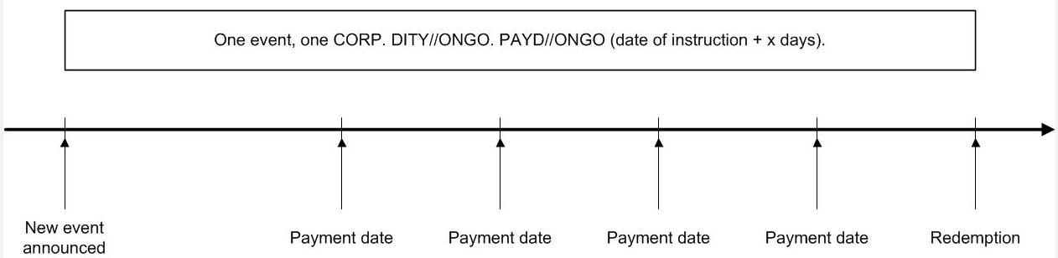
Scenario 2a and 2b:
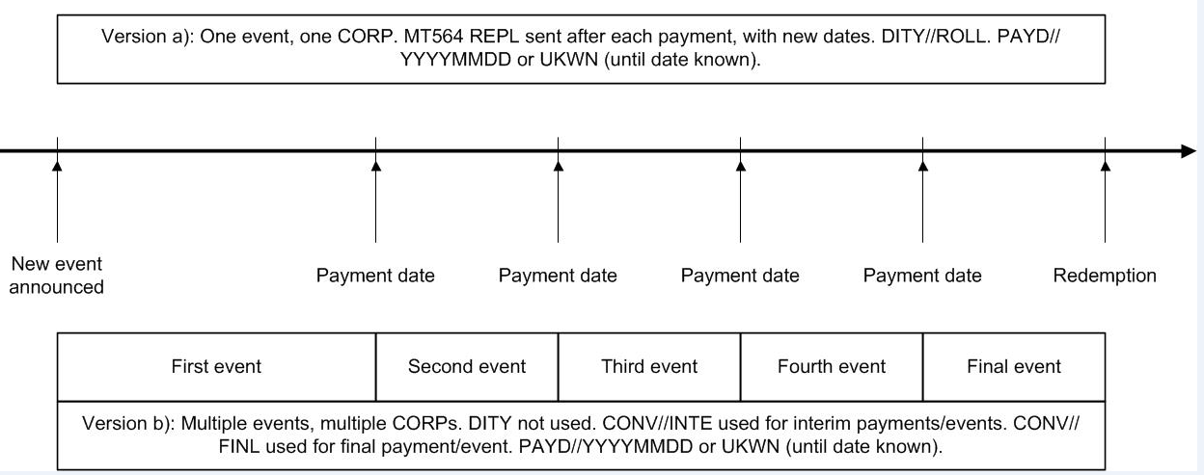
Scenario 3:
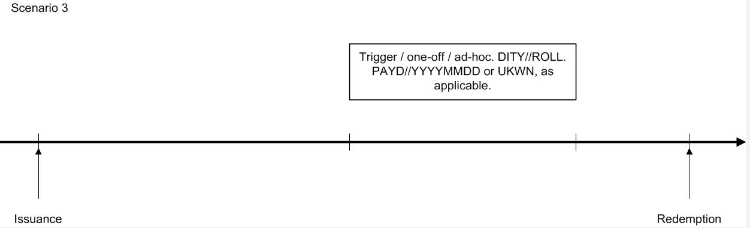

Actions:
- All NMPGs to review and provide feedback/comments.
- CR on the :22F::CONV definition update to be prepared for SR2019.

CA367 INTP and OFFR usage with multiple payment Currencies
Delphine’s input:
- The question from Delphine was whether INTP/OFFR was to be included in the denomination or the payment currency when multiple payment currencies are offered.
Decision:
- INTP/OFFR should be in the denomination currency.
- :11A::OPTN must not be reported at all in case of mandatory event (MAND) paying in multiple currencies.
The INTR CHOS template is correct however in 92B EXCH, the currency codes are in the wrong order. The INTR CHOS template has been updated during the meeting.

The REDM CHOS template is factually correct, but some amount and currencies are wrong: 19B ENTL should be GBP and 19B GRSS should be in EUR and the amounts in the ENTL and GRSS fields have been reversed and 19B RESU is missing. In 92B EXCH, the currency codes are in the wrong order as well. The REDM CHOS template has been updated during the meeting.

- Other question, should 90a OFFR be in A format, per denomination currency, or J format?
Decision: Both are possible. The templates will show 92A.
- Should we remove PRFC [O] from INTP CHOS in the EIG+ and template?
To be addressed at the next call.
Action: All NMPGs to provide final feedback / comments on the above.

CA372 Reporting Issue with Reverse Market Claims
Mike’s input:
Mike presented the situation using the input documents above. There is a need to tell the clients whether or not a claim is a forward or a reverse market claim! Should this be in a MT564 or MT566?
After some discussion, the WG agreed with the business need to have an additional flag to differentiate between a “reverse” and a “forward“ market claim in the MT 566.
Action: CH/Mike to raise a CR to add a field/code to differentiate between standard and reverse market claims in the MT566 in the next release.

CA374 CANADA Representation at CA WG
Jacques has sent in September all the information about the SMPG and CA WG to Ariane Bienvenu from TMX (CA CSD) representing the CA NMPG. Jacques has also met Ariane at the ISITC meeting in Baltimore mid-September and could discuss further about the CA NMPG attending the SMPG CA WG meetings.
Ariane will let Jacques know as soon as possible whether they are in a position to participate more regularly to the conference calls and meetings.

CA376 Add section about CAEP in GMP1
Randi raised the question if a global market practice should be created for the usage of :22F::CAEP (Event Processing Type) as some of our templates include the field.
Decision: No MP should be created for CAEP
Action: Jacques to remove any CAEP field in all templates.

CA377 WITH vs CANC function
Randi’s input:
Randi presented the issue. They have received several questions from customers on the usage of WITH vs CANC, and it seems indeed that the standards and GMP1 MPs section 3.2.4 are not consistent.
The WG agrees with the proposal to clarify the MP.
Decision: The incorrect GMP1 section 3.2.4 regarding WITH vs CANC should be corrected and aligned with the standards. It should also refer to GMP1 sections 3.6.2 and 8.1.2.6 which provides some more information on cancellations as well.
Actions:
- GMP1 SG to review the wording of section 3.2.4.
- CA WG address the issue of message reference in the cancellation at next call

CA378 TNDP Event MP and TNDP Indicator DSS Usage
ISITC has not yet started on the creation of a new MP for the new TNDP event.
ISITC will work with AU on it and will submit it to the SMPG once ready.
Action: ISITC (Paul / Steve) to submit the new TNDP MP to the SMPG CA WG once ready.

CA379 New Charges Related Amount Qualifiers for Rights / Warrants Events
This open item is a follow up of the SR2018 ISITC rejected CR 1311 which requested the creation of three new amounts in the confirmation message:
- Final Adjusted Subscription Amount
- Refunded Subscription Amount
- Oversubscription Amount
Matthew Schill presents the business context of the CR and outlined the detailed message flow with an example. This concerns a security type which is a form of ETF. The subscription price is related to either the NAV or market price, whichever is the highest, and hence the subscription price cannot be determined before exercise.
Scenario 1: Final Adjusted Subscription Amount – MX Message Flow example
A provisional/estimated price is announced and used in the instruction process and the money may be returned or more money debited.

Event: EXRI 1 right = 1 common - ELIG = 100 rights
CANO1: PRPP = $1.00 (Estimated price/flag)
CAIN: Quantity instructed 100
CACO1: Debit 100 rights + Credit 100 common shares + Debit $100
At expiration Date +1:
CANO2: PRPP = $0.95 (Final Price)
CACO2: Debit $5.00 (= “Final Adjusted Subscription Amount”)

Scenario 2: Oversubscription Amount & Refunded Subscription Amount – MX Message Flow example
Input: https://www.sec.gov/Archives/edgar/data/718332/000101054917000300/rave080917.htm
Pro-ration of an over-election, regardless of whether this is performed as a separate option or part of the exercise option.

Event: EXRI 1 right = 1 common - ELIG = 100 rights - Oversubscription into common stock allowed
CANO1: with OVER option
CAIN: Subscribe 100 rights + Oversubscribe 50 common shares (all in same CAIN with OVER in the CAIN Extension because both instructions on EXER and OVER must come at the same time)
CAIS: 100 Rights + 50 common shares = 150 common shares
CACO1: Debit 100 rights + Credit 100 common Shares (Blocked) + Credit 50 common shares (Blocked)
Debit $100 +
Debit $50 (= “Oversubscription Amount”)
At expiration Date +1: Oversubscription is pro-rated at 50%
CANO2: Over option pro-rated 50%
CACO2: Credit 100 common shares (to unblock) + Credit 25 shares (to unblock) + Debit 25 shares (to unblock) + Credit $25 (= “Refunded subscription amount”)
Since there is no equivalent to an MT 508 in ISO 20022 to block/unblock the balances, therefore a second CACO message is used.
Note from SWIFT: The semt.015 message should normally be able to do that.
Decisions:
- The WG agrees with the scenario 1 business case and the need to create a new “Final Adjusted Subscription Amount” for this purpose, however, the name of the amount should be changed. In that case, the SMPG would support the CR.
- The WG agrees in the scenario 2 business case with the need to create a new “Refunded Subscription Amount”, however, the definition should be made more generic and without the word ‘charge’ in it. In that case, the SMPG would support the CR.
- The WG does NOT agree in scenario 2 business case with the need to create an “Oversubscription Amount”. The US should investigate whether they could use instead separate EXER + OVER instruction.
Action: The US to come back with feedback on the capability to instruct on EXER and OVER and with a new CR for SR2019 in due time.

CA380 Proration Accepted and Unaccepted Balances
This open item is a follow up of the SR2018 ISITC rejected CR 1312 which requested the creation of 2 new balances.
Matt’s Input document:
Matt presents the excel spreadsheet and describes the process and flows.

Scenario – MRGR VOLU X – Eligibility 110 – A & B: Contra CUSIP
STEP 1:
Option # | Option Code |  | Quantity
001 | CASH | Debit X + Credit A | 60
002 | SECU | Debit X + Credit B | 40
999 | NOAC

STEP 2: Pro-ration / New option 003 announced
Option # | Option Code |  | Quantity
001 | CASH | Debit A + Credit C (Not accepted in pro-ration) | 0
001 | CASH | Debit A + Credit $ (Acccepted) | 5
002 | SECU | Debit B + Credit Y (New company) | 40
003 | SECU | Debit C + Credit Y | 10

STEP 3:
MRGR MAND – ELIG 10
Option # | Option Code
001 | SECU | Debit 10X + Credit 10Y

Decision: The CA WG would recommend reusing the Affected and Unaffected Balances which are already used for lottery events today in the US.
Actions:
- US/Matthew to provide a high level view of the message flow and associated movements with security & contra CUSIP.
- DTCC to seek an agreement with ISITC to re-use Affected and Unaffected Balance elements for this process. If agreed, ISITC to submit a CR for SR2019 to amend the definitions of these 2 balances.

CA381 Usage of Pagination in ISO 20022
A global market practice for the Pagination of the CACO (seev.036) message is not necessary. This is purely a local US market practice and it does not need to be discussed by the SMPG.
A Pagination MP for CANO messages should be created either by “translating” the MP for multiple MT564s or by copying the US market practice once they have created one and this is not an urgent issue.
Decision: wait for the US MP on CANO pagination and make it global afterwards.

CA382 Message enhancements to provide Options Instructions Details
This open item is a follow up of the SR2018 ISITC rejected CR 1358 which requested the creation of new options details elements in the CAST message.

This Open Item postponed due to lack of time. This needs to be discussed thoroughly, probably in a workshop mode at the Warsaw meeting. Nonetheless, the item can be started in a conference call if the US provides the input.
Action: US to provide input to be discussed at a next call or in Warsaw.

Tax Subgroup Report (CA221 / CA373)
Jean-Pierre and Jyi-Chen summarize the status of the Tax SG Open Items:
All the Tax SG’s CRs were accepted by the MWG for SR2018, and they are now moving on to other issues on their list.

CA221: Tax Certification Process
Should the tax certification process be performed within the event, or as a separate event/process?
No consensus could be reached in the tax SG, but most markets which have responded, or did so at the meeting, perform tax certification within the event. At this time however, it would be difficult to create a global market practice for an area which is so very dependent on local rules and regulations, therefore it is proposed to put the item on hold for a few years.

CA 373: Usage of COIN in ZA
Sanjeev briefly presented the COIN issue from ZA. Jean-Pierre stated that the original use of COIN would be misused if ZA uses COIN the way it was explained here.
However, there was not sufficient time to discuss the issue. Further discussion at the next conference call.
Action: Jacques to schedule the open item for next CA WG conf. call.

SWIFT DP 187 – SWIFT Board Paper on Fast Track Maintenance Process
SWIFT’s input document:
Jacques briefly presented the June board discussion paper. Not enough time to ask for feedback or to discuss at the meeting.
It will be put at the next call agenda.
Action: Jacques to schedule the open item for next CA WG conf. call.

New Regulation Page on MyStandards - Presentation
Charles Boniver presented the future “Regulatory reporting” page on MyStandards, which will correspond to S&R, CA etc.

Remark on MyStandards availability:
Several WG members took the opportunity to report on the instability of MyStandards, and the lack of information when this occurs.
Action: Charles will relay the complaint to MyStandards management.

Post Trade Risk Alerting Service (PTRA) - Presentation
Presentation cancelled due to Jonathan Ehrenfeld’s absence.

How to become candidates for the ISO 20022 Securities SEG (CA ET)
Jacques explained briefly the advantage for the SMPG members to participate to the ISO 20022 Securities SEG (Standards Evaluation Group) and more particularly in the ISO SEG CA Evaluation Team (CA ET) so as to have an active participation into the CA maintenance process.
On page 4 of the attached document above, you will find the information on how to become an ISO SEG member or a CA ET member. On the last page, highlighted in yellow, you will find the countries and SMPG CA WG people which are already member of the Securities SEG today.
Action: Contact Jacques if you are interested to join the Securities SEG and CA ET or if you have further questions on the topic.

Local NMPG Market News
Skipped because of lack of time.

AOB
Facilitate access to the GMP Documents on the web site
Jyi-Chen raises the point that, today, the access to the GMP documents on the SMPG web site as well as searching for specific CA MPs in our GMP documents is not very straightforward for CA practitioners that are not SMPG members and that is certainly detrimental to the adoption of our MPs.
An ideal solution would be to have our market practices available on kind of “Wiki” pages on which the user could easily find MPs based on some keywords searches.
More practically, short term, we could already create a specific page on our SMPG Website for newcomers to explain what is the High Level Structure of our MPs and where to find easily the information.
Action:
- Jyi-Chen/Jacques to raise the point to the SMPG SC.
- Jacques to investigate what is possible to do on the Web site

------------------------ End of the Meeting Minutes ---------------

