Johannesburg
Global SMPG Meeting
March 10 – 12, 2020

Sponsored by: South African NMPG members
Meeting Venue:
FNB Conference & Learning Centre
114 Grayston Drive, Sandown, Sandton, South Africa
Dress Code: Business casual

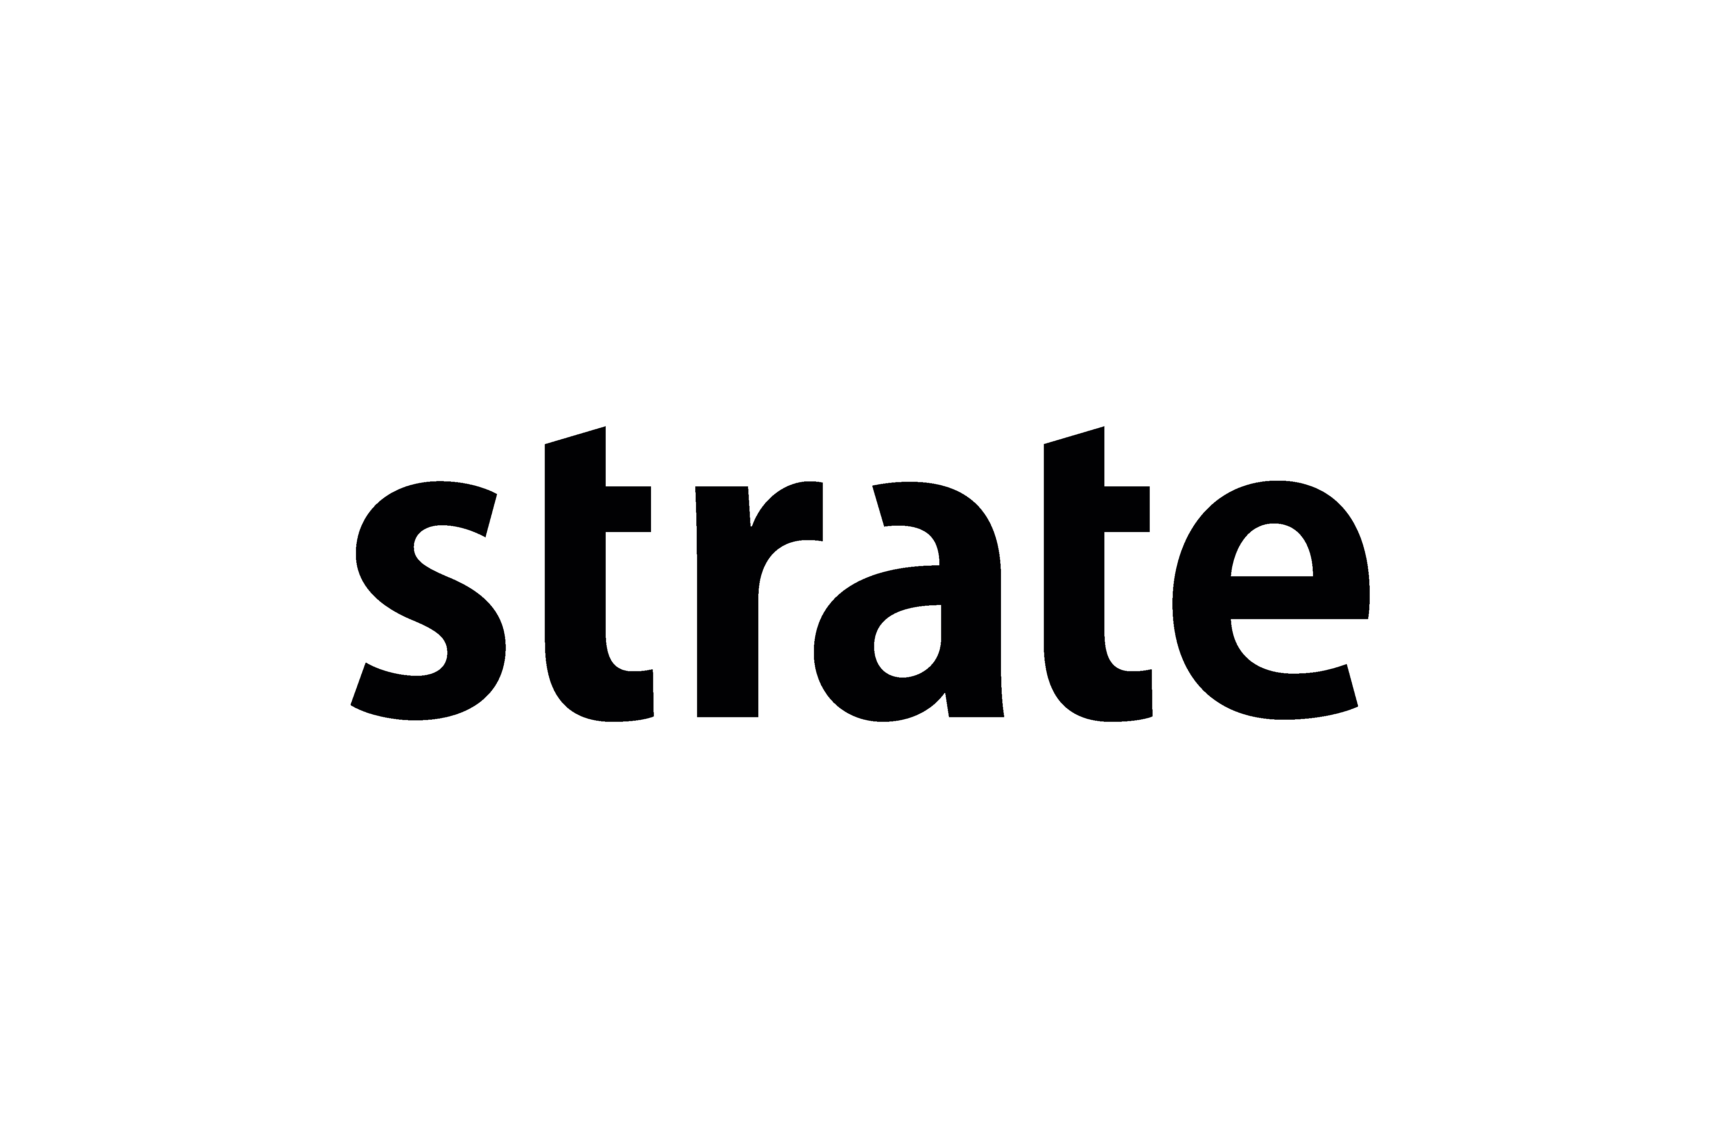

Meeting Global Agenda

Tuesday 10th of March
 |  | 09:00 – 09:30 | Arrival & Check-in at FNB Premises
 |  | 09:30 | Plenary Session Opening
 |  | 09:30 – 10:40 | - Strate Strategy Taking South Africa Forward (Andre Nortje, CEO, Strate) – 30´  - Welcome Address by ZA NMPG  - SMPG Welcome Address (Armin Borries, SMPG Chair, DE NMPG) – 5´  - Global Meeting Schedule (Jacques Littré, SMPG General Secretary) – 5´  - South African modernisation project using ISO 20022 ()
 |  | 10:50 – 11:10 | Coffee break
 |  | 11:10 – 12:30 | - AMEDA Keynote Speaker ?  - ISO 20022 Program Update
 |  | 12:30 – 13:30 | Lunch
 | Afternoon Session
 |  | 13:30 – 15:30 | Corporate Action WG |  | Settlement and Reconciliation WG
Coffee Break
 |  | 16:00 – 17:30 | Corporate Action WG |  | Settlement and Reconciliation WG

 | Wednesday 11th of March
 |  |  | 8:30 – 9:00 |  |  | Arrival & Check-in at FNB Premises
 | Morning Session
 |  |  | 09:00 – 10:45 |  |  | Corporate Action WG |  | Settlement and Reconciliation WG
 |  |  | 10:45 – 11:00 |  |  | Coffee Break
 |  |  | 11:00 – 12:30 |  |  | Corporate Action WG |  | Settlement and Reconciliation WG
 |  |  | 12:30 – 13:30 |  |  | Lunch
 | Afternoon Session
 |  |  | 13:30 – 15:30 |  |  | Corporate Action WG |  | Settlement and Reconciliation WG
 |  |  | 15:30 – 16:00 |  |  | Coffee Break
 |  |  | 16:00 – 17:30 |  |  | Corporate Action WG |  | Settlement and Reconciliation WG
Evening
 |  |  |  |  | Event TBC

 | Thursday 12th of September
 |  |  | 8:30 – 9:00 |  | Arrival & Check-in at FNB Premises
 | Morning session
 |  |  |  | 09:00 – 10:45 | Corporate Action WG |  | Settlement and Reconciliation WG
 |  |  | 10:45 – 11:00 |  | Coffee Break
 |  |  | 11:00 – 12:30 |  | Corporate Action WG |  | Settlement and Reconciliation WG
 |  |  |  | 12:30 – 13:30 | Lunch
 |  | Afternoon Session
 |  |  | 13:30 – 15:30 |  | Corporate Action WG |  | Settlement and Reconciliation WG
 |  |  | 15:30 – 16:00 |  | Coffee Break
 |  |  | 16:00 – 17:30 |  | Corporate Action WG |  | Settlement and Reconciliation WG
End of meeting

SMPG Corporate Actions WG Detailed Agenda – March 10 - 12, 2020
Item No | Short Description | Description and Pending Actions | Owner | Comment
Tuesday March 10 / Thursday March 12
1 | 2020 Meeting dates | Schedule Conference calls for Q3 / Q4 2020 | Christine/ Mari
2 | February meeting Minutes Approval | Comments / Approval of February webex / conf. call Minutes | Jacques
3 | Co-Chair (Christine) election |  | Jacques
CA405 | New flag for securities being Blocked | Should there be an indicator at securities movement level that the securities will be blocked?  Action: Each NMPG to provide input on the events requiring securities blocking in their market on the consolidated input file. | Daniel | Telco February 18, 2020:  Input file: Consolidated NMPG input with DE & FI inputs (see minutes)  The remaining NMPGs are requested to provide a market “common” feedback, not taking into account specificities of particular actor or what is covered by SLAs. Mari suggests to add a disclaimer in the document to warn about that.  Telco January 21, 2020:  BE has filled in the spreadsheet as per Germany’s input and will send it to Jacques.  FI has provided feedback for each event along the same lines.  Each NMPG to review the consolidated spreadsheet that will be prepared by Jacques and comment on it.  Telco December 17, 2019:  RU (Elena): Supportive of a new flag, but the NMPG would like to keep the blocking period.  LU (Catarina) voiced a concern that ECMS will not like that we cannot provide any information regarding the blocking indicator until spring.  UK (Matthew) will resend the UK feedback to Jacques.  Telco November 27, 2019:  FR reminds that we need to link this discussion with the AMI-SeCo CMH CA issue on a securities blocking flag.  Despite the decision taken in Brussels in September, DE would rather prefer to go through a more extensive analysis of the uses cases going to all CA event and analyse what is the need for blocking, which securities need blocking (underlying, new proceeds), at what level of the message (option,..) and the need for an end of blocking date.  The DE NMPG will start the analysis for their event based on the EIG and will provide input to the CA WG.  The WG agrees with this approach proposed by DE.  DE has provided their initial analysis in the following document (see minutes).  Telco October 22, 2019:  Christine (SE) explained the decision taken at the Brussels meeting last month. With the minutes sent only last week, it was difficult for NMPGs to discuss and respond. No NMPG reported feedback at this time.
CA418 | SR2019 GMP1-3 updates - TNDP | Actions:  1. 1. Daniel, Narelle and Steve to agree how to integrate the German remarks in the TNPD market practice and adapt its structure to be easier to integrate country specificities.  2. ISITC/Steve/Paul to justify why GRSS and NETT are present. | Jacques / Christine | Telco February 18, 2020:  Input from AU (Narelle) + Input from DE (Daniel) - see minutes.  Narelle provided feedback and the AU NMPG confirmed the messages are used according to market practice, although the usage is very limited. Some of the elements in the message example provided by AU are not clear (consistency with the usage of TAXR and DEEM rates). Christine will send some questions to Narelle.  Steve to check with the US market whether the usage is aligned to market practice.  Daniel has provided the DE input in the TNDP draft MP. However Daniel thinks that the document becomes a bit difficult and that we should give a better structure with tables for the different market variations.  Daniel, Narelle and Steve to agree how to integrate the German remarks in the TNPD market practice.  Telco January 21, 2020:  It seems the event has been used with a more granular detail by the issuer. Narelle has provided the following feedback via email:  “There are no concerns with the current fields available for the processing of the TNDP events or the fact that new fields are optional. Based on what we have seen to date AMITs will have a variation of tax components, hence you will not necessarily include all of the new component qualifiers in a TNDP event. Ultimately the event type itself is what defines that the event is a deemed distribution and you may end up using a variation of component qualifiers.”  TNDP input from AU/Narelle: see minutes.  Telco December 17, 2019:  As neither US nor AU were present at the call, actions 1 and 2 are postponed.  RU does not have TNDP events.  Telco November 27, 2019:  Steve is not at the call. Steve/Paul to revert at the next call.  Narelle reports that the AU EIG+ column mentions all data as optional simply because it was not clear initially what needed to be mandatory or optional. Narelle will reach out to the NMPG to see how the data are used now for TNDP.  Daniel mentioned that DE may also start to use TNDP, but not at this time.
CA419 | Definition of Instructed and Uninstructed Balances | Definition of Instructed and Uninstructed Balances.  Action:  1. Mari will review the wording of the MP.  2. Remaining NMPG’s to review and revert with feedback before next meeting. | Jacques/Christine | Telco February 18, 2020:  Mari will put together a proposal to reflect comments of last month.  Telco January 21, 2020:  NMPGs feedback: DE, ES, FI, FR, CH, JP, LU, SE, UK, ZA NMPGs approve the proposed definitions.  However, the ICSDS have a concern in case the account servicer accepts instructions on the pending balance as this could result in a negative balance.  Therefore, we need to review the MP and be more precise and provide examples to describe the different scenarios in the MP text:  • Instructions can only be provided on the settled position (some CSDs)  • Instructions on eligible position with PENRs accepted (PACK) and so balance reported as INBA  • Instructions on eligible position with PENRs kept on hold (PEND) and so balance reported as UNBA  Mike will put together a proposal to reflect the above.  Telco December 17, 2019:  NMPGs feedback: DE, ES, FI, FR, CH, JP, LU, XS, SE, UK, ZA NMPGs approve the proposed definitions.  Telco November 27, 2019:  NMPGs feedback: DE, ES, FR, CH, XS, SE, UK NMPGs approve the proposed definitions.  Telco October 22, 2019:  DE and ES NMPGs approve the proposed definitions.
CA422 | SRD2 TF Progress Update | Actions:  1. Mari to formulate a proposal in the GM market practice to support multi-lingual announcements. | Christine / Mari | Telco February 18, 2020:  Input: Draft market Standard for Shareholder Identification Disclosure (see minutes)  The above document from SRDII SI Task Force is still under review for endorsement by the SRD II Steering Group.  General Meeting  SRDII imposes an obligation on issuers to announce an event in both local language and English.  The GOR taskforce asked SMPG to provide a solution on how the information in both languages should be passed on along the chain.  The preferred solution should be to send only one message with narratives/resolutions in both languages with an ISO code to identify the language.  SRD II supported by ISO 15022  Input from Jean-Paul: Proposal made to ECSDA to support SRD II SI and GM information flow with ISO 15022 (see minutes)  Telco January 21, 2020:  ECSDA had a call last week on SRDII readiness of their members and it came out that some ECSDA members would still like to have an alternative ISO 15022 solution for SI and GM.  ECSDA will likely put together an ISO 15022 proposal for using structured narratives (for general meetings and shareholder identification).  In that case, the SMPG would like to review the proposed solution and provide feedback.  The market practice document for the SI messages progress very well. The next call is on January 24 and we will try to finalise it. A first draft GM MP will be for later in February.  Telco December 17, 2019:  Jean-Paul was not present on the call therefore we have not received feedback on the action item (a workaround for an ISO 15022 solution for GM).  Christine questioned the scope of such a workaround and whether the SMPG can determine this. The question should be asked to the General Meeting TF and what the scope of the workaround shoud be since fitting all SRDII GM requirements in the ISO 15022 existing CA messages does not seem feasible.  Jacques had a call recently with Ana Kulic (ECSDA general secretary). ECSDA is asking the industry participants trough the SRD II SteerCo to express its views on whether a delay in compliance with the SRD II is felt as needed by the industry. The results of the consultation should be known by January.  Christine will ask Edwin for a steering group call before end of year to discuss about that.
CA457 | GMP1 Section 8.17 on Usage of DateTime with Format Option E (UTC) | Add something about UTC for events subject to SRD II compliance as SRDII compliance requires to use UTC time for SRDII datetime elements. | Mari | Telco February 18, 2020:  Not covered during this call by lack of time.
CA458 | Add Format Option E (UTC) for ANOU date and ECPD, ECRD Deadlines ? | ANOU: Since in SRDII we have the obligation of ensuring announcements are processed in a certain timeframe, I think knowing in which time zone the announcement time is makes sense to allow people to calculate some meaningful MIs on their regulatory compliance.  I know that the recommendation we have previously given is that ANOU should always be in the time zone of the issuer but allowing for option E in this qualifier would ensure people have certainty on the time zone.  ECPD, ECRD are often derived from the issuer deadline, which (at least for SRDII in scope issuers) should be expressed in UTC, I think they should both also allow for option E.  They should also be added to GMP1 8.17. | Mari | Telco February 18, 2020:  Not covered during this call by lack of time.
CA459 | ShareholderRightsDirective flag market practice (Fast Track CR 1616) | A new MP is required for the usage of the SRDII flag in MT564/seev.034/seev.001 and seev.045 | Mari | Telco February 18, 2020:  Not covered during this call by lack of time.
CA437 | Auto-FX - Update of GMP1 Section 8.6 | Action: NMPG’s to review and revert | Christine/Mari | Telco February 18, 2020:  Not covered during this call by lack of time.  Telco January 21, 2020:  Véronique (BE) input received:  Proposal for the GMP1 update, to replace the current section 8.6.  Question: How to report a forex in a confirmation of payment message?  The FX rate should be indicated in the confirmation of payment message (MT566/seev.xxx).  The MT566 should contain the following information :  · Original amount and CCY (19B GRSS and/or NETT or iso20022 equivalent)  · Exchange rate (92B EXCH//original currency/resulting currency/rate)  · Posting amount with new CCY and amount (19B POST)  For the review at SMPG level, here is an example (that should not be included in GMP1): (see minutes)
CA444 | Usage of QINS as requested quantity | GMP1 - Section 5.1 Instruction QINS - refer also to 5.5 for the requested quantity  Action: Remaining NMPGs are requested to provide input from similar event in their markets when meaning of QINS might not be clear. | Mari | Telco February 18, 2020:  Not covered during this call by lack of time.  Telco January 21, 2020:  No additional feedback received at the call.  Telco December 17, 2019:  Feedback received:  RU: No issue with QINS as Requested Quantity.  ES: Same feedback as SE NMPG (do not believe there is a business case for this).  Telco November 27, 2019:  FR feedback: France still has an issue with the management of QINS related to underlying securities and the Quantity of New shares to receive despite of the RDUQ qualifier implementation. It means that the quantity of new shares to receive results from a combination / calculation based on two other qualifiers QINS + RDUQ. Consequently an indicator will not necessarily resolve this issue and consequently an indicator only could be not enough for the UK / IE Market.  DE: There are a couple of cases in the German market: for oversubscription and Capital increase as PRIO event. It is not absolutely clear on how to instruct, but it is not really a problem either. That said, the DE NMPG would not object to a solution.  SE: The Swedish NMPG did not believe there is a business case for this.  Telco October 22, 2019:  Mari (UK) indicates that the request to eventually create a new OPTF code comes mainly from the Irish market only.  Is this also a problem in another market than just IE?  If not, maybe the narrative should be used for that.  Jean-Pierre (FR) notes that the QINS quantity should be understood by event and that an OPTF indicator could help.  No other NMPG feedback yet at this time.  Brussels - Sep. 18, 2019:  A question was raised in the UK NMPG as to whether there may be any interest in put forward a change request to introduce a OPTF code in the MT564 (similarly to what we did for QCAS) to raise awareness that the quantity to be quoted in QINS in the MT565 is the one of the shares requested.  Typically for Buy-Back / Repurchase offer events.
CA448 | Have repeatable WEBB URL addresses in MT564 and add URL addresses associated to all narratives (SR2020 - CR1529 from HK) | Better define what are the business needs globally and then look for the best solution.  Action: Remaining NMPG’s (CH and US) to review and revert on whether it believes there is a business case for repeatable URLs in CA messages. |  | Telco February 18, 2020:  Not covered during this call by lack of time.  Telco January 21, 2020:  AU, DE, FR, ES: There are situations where this may be good, but not enough to justify the investment. Today, the same field is used for several URL if needed.  SE, XS, FI, LU, JP, UK: do not see any business cases for repeatable URL fields.  Telco December 17, 2019:  DE, FR, ES: There are situations where this may be good, but not enough to justify the investment. Today, the same field is used for several URL if needed.  SE, XS, FI, LU, JP, UK: do not see any business cases for repeatable URL fields.  Telco November 27, 2019:  DE, FR, ES: There are situations where this may be good, but not enough to justify the investment. Today, the same field is used for several URL if needed.  SE, XS, FI: do not see any business cases for repeatable URL fields.  Telco October 22, 2019:  No NMPG feedback yet received at this time.  Brussels - Sep. 18, 2019:  Mike pointed out that in the general SWIFT rule for narratives, lines cannot start with a dash (“-“) character. This may well create issues with long URLs since there is a high chance that a dash is present in the URL. Also, how will the receiver be able to distinguish what the different URLs are for?
CA450 | Usage of TBSP and UNSP for DTCH events (SR2020 - CR1533) | Create a new market practice to specify the usage of the TBSP and UNSP price codes for DTCH events.  Action: ISITC is requested to provide the SMPG CA-WG with the US market practice for DTCH events, in case it has already solved the problem. |  | Telco February 18, 2020:  Not covered during this call by lack of time.
CA451 | Create CR for MITI in Confirmation (SR2020 - CR1517) | Create a new MP describing the MITI usage in CA  Action: NMPG's to review and revert. |  | Telco February 18, 2020:  Not covered during this call by lack of time.  Telco January 21, 2020:  DE proposal to be circulated for discussion - see input doc in minutes.  Telco October 22, 2019:  Daniel (DE) reported that the DE NMPG plans to have a draft CR ready by end of November.  Brussels - Sep. 18, 2019:  See action item.
CA453 | Key data for TEND with early tender premium | correct presentation of options and offer prices/rates for a debt tender offer/repurchase/exchange offer that includes an early tender premium.  Action: Paul will ask Steve to find out about what DTCC is sending for this type of event | Laura | Telco February 18, 2020:  Not covered during this call by lack of time.  Telco January 21, 2020:  No input received from the US.  Telco December 17, 2019:  No input received from the US.  Telco November 27, 2019:  Laura presents the case with the following input (see minutes)
CA454 | SR2020 MP updates | Action:  1. EIG+: All NMPGs to review their country column in the EIG+ (and other tabs in GMP2) and send the changes, or confirmation that there are no changes, to Jacques as soon as possible.  2. Event Templates: Everyone to review the event templates for which they are responsible (see the Open Items File in the tab “CA Event Templates List”) and send the changes, or confirmation that there are no changes, to Jacques as soon as possible.  3. Jacques to check if SR2020 impact on GMP1 MPs | Jacques | Telco February 18, 2020:  Not covered during this call by lack of time.  Telco January 21, 2020:  The goal is to have draft SR2020 versions published no later than early February.  Telco December 17, 2019:  The goal is to have draft SR2020 versions published no later than early February.  Telco November 27, 2019:  See actions.
CA460 | Move Index Factor for INT and Redemptions to CADTL | Should we not move the index factor to CADETL, since it is not directly used in the payment calculation?. | Alexander | Telco February 18, 2020:  Not covered during this call by lack of time.
 | Tax Subgroup Update |  | Jean-Pierre / Jyi-Chen
 | SRD - GoR TF GM template review |  | Mari
 | AOB

