

SMPG - Corporate Actions

Telephone Conference Minutes

26 January, 2016

FINAL Version v1.0 – February 24, 2016

Table of Contents

[1. Approval of December 8 Minutes 3](#_Toc444173829)

[2. CA203 SR2016 Yearly GMP Part 1,2,3 and samples alignment 3](#_Toc444173830)

[3. CA289 MAND event with Required Owner Action 4](#_Toc444173831)

[4. CA298 Capital Gain - cash distribution components 5](#_Toc444173832)

[5. CA300 Usage of :92a::INTR for Variable/Floating Rate Bonds/Notes and :92F::INTP 6](#_Toc444173833)

[6. CA303 Usage of PWAL for DVOP & DRIP 7](#_Toc444173834)

[7. CA308 Question on Multi listed securities MP 7](#_Toc444173835)

[8. CA316 MPs specific for Issuer announcements ? 8](#_Toc444173836)

[9. CA317 Should a MP enforce a mandatory Default Option (DFLT) ? 9](#_Toc444173837)

[10. CA318 MP for new :94a::COIN qualifier 10](#_Toc444173838)

[11. CA319 New MP for QINS usage in DVOP/PRIO events 10](#_Toc444173839)

[12. CA320 New MP for TXAP code list 11](#_Toc444173840)

[13. CA321 Create a more robust MP on narrative update information and update date 11](#_Toc444173841)

[14. CA322 Create new MINO Format Option in cash amount 11](#_Toc444173842)

[15. CA323 Amend name and definition of PCAL event 14](#_Toc444173843)

[16. CA324 Usage of NSIS and NEIS for SOFF, DVSE and BONU 15](#_Toc444173844)

[17. CA326 Usage of PROR (Pro-Ration rate) 16](#_Toc444173845)

Attendees

|  |  |  |  |  |  |
| --- | --- | --- | --- | --- | --- |
| **NMPG** |  | **First Name** | **Last Name** | **Institution** | **🗸 = Present** |
| AT | Mr. | Stefan | Ribisch | Unicredit |  |
| AT | Ms. | Karin | Wachter | Unicredit |  |
| BE | Ms. | Veronique | Peeters | BNY Mellon | Excused |
| CH | Mr. | Michael | Blumer | Credit Suisse | 🗸 |
| DE | Mr | Schaefer | Daniel | HSBC | Excused |
| DK | Ms | Ravn | Charlotte | VP Securities A/S |  |
| ES | Ms. | Cinta | Cristobal | BBVA | Excused |
| ES | Mrs | Diego | Garcia | DB | 🗸 |
| FI | Ms | Rask | Sari | Nordea Bank Plc | 🗸 |
| FR | Mr | Jean-Pierre | Klak | Statestreet | 🗸 |
| GR | Ms. | Angela | Katopodi | Eurobank | 🗸 |
| HK |  |  |  |  |  |
| IT | Ms | Deantoni | Paola | SGSS spa |  |
| JP | Mr | Hideki | Ito | Mizuho Bank | 🗸 |
| JP | Mr | Hisashi | Hotta | Mizuho Bank | 🗸 |
| LU | Mr. | Bernard | Lenelle | Clearstream | 🗸 |
| MDPUG | Mr. | Peter | Hinds | MDPUG / Interactive Data | 🗸 |
| MDPUG | Ms. | Laura | Fuller | Telekurs | 🗸 |
| NL | Mr | van der Velpen | Ben | ING Bank N.V. | Excused |
| NO | Mr. | Hans Martin | Aulie | DNB Bank | Excused |
| NO | Mr. | Alexander | Wathne | Nordea |  |
| PL | Mr. | Michal | Krystkiewicz | CSD Of Poland (KDPW S.A.) | Excused |
| RU | Ms | Elena | Solovyeva | ROSSWIFT | Excused |
| RU | Ms | Sofia | Prokofeva | Rosbank |  |
| SE | Ms. | Christine | Strandberg | SEB | Excused |
| SG | Mr. | Jyi-Chen | Chueh | SC |  |
| UK & IE | Ms. | Mariangela | Fumagalli | BNP Paribas | 🗸 |
| UK & IE | Mr. | Matthew | Middleton | LSE | 🗸 |
| US ISITC | Ms. | Sonda | Pimental | BBH | 🗸 |
| US ISITC | Mr. | Paul | Fullam | Sungard | Excused |
| XS | Ms | Haillez | Delphine | Euroclear | Excused |
| ZA | Mr. | Sanjeev | Jayram | First National Bank | 🗸 |
| ZA | Mr. | Ridhwaan | Williams | Strate |  |
| ZA | Mr. | Nita | David | Strate |  |
| SWIFT | Mr. | Jacques | Littré | SWIFT | 🗸 |
| SWIFT | Ms. | Mieko | Morioka | SWIFT APAC | 🗸 |

# Approval of December 8 Minutes

No comments received. Minutes are approved.

# CA203 SR2016 Yearly GMP Part 1,2,3 and samples alignment

See individual or NMPGs action lists here below:

**Actions review**:

1. One pager on SR2016 MP updates:

The document was distributed for review on December 17.

No comments received so far.

The document ca now be made “Final version”.

2. GMP1 update:

Status of new MPs

- MP on Over-election (CA319) still pending solving FR issue (Véronique / Jean-Pierre)

- MP on TAXR/WITL (CA318) still pending tax subgroup proposal (next call is on January 28)

- MP on MAND Event with required Owner’s Action – pending approval of EXWA case added (see CA289)

3. GMP2 updates:

Received input from SG, DE and FI for the country column update.

Christine’s question:

*EXWA CHOS: Why [LAPS or NOAC]? This is a CHOS event, hence NOAC should not be applicable. If the warrant is not at maturity, the event should be VOLU.*

4. SMPG Templates:

Pending remaining input from:

Sonda: DTCH VOLU US

Véronique: PPMT CHOS, TEND MAND & VOLU

Alexander : PRIO VOLU

**Actions:**

1.: Véronique, Sonda and Alexander to provide input on Event Templates for NEW Deadline **February 10**

2. Tax SG (Jean-Pierre/Jyi-Chen)to provide a WHT (TAXR/WITF) MP for the next call in February.

3. Véronique and Jean-Pierre to solve pending QINS issue for CA319

4. Bernard to answer to Christine’s question on EXWA CHOS [LAPS or NOAC]

# CA289 MAND event with Required Owner Action

SE Feedback: Scenario 1 is most likely not applicable to the Swedish market.

Input from XS: Scenario 1 does not apply to XS.

ZA Feedback : The ZA market has not had an instance of scenario 1 and therefore is not in a position to comment. The lapsing of entitlement however seems concerning as normally when there is distribution of entitlement every eligible shareholder is entitled to the distribution. Thus where details of the other CSD is not provided then the entitlement could possibly be held in an escrow account pending a claim otherwise entitlements could be disposed of and proceeds (less costs) could be paid to defaulting shareholder (non-instructing clients).

DE Feedback: Germany agrees with the proposal

Bernard has provided a sixth scenario to the table for EXWA MAND events for which certification is often required.

The group agrees also to remove the scenario 1 (Securities to be distributed cannot be held in the CSD) since it does not seem to be an existing business case.

The latest MP proposal is as follows:



**Action**:

1. All NMPGs to provide feedback on new added scenario 5 (EXWA related) for next call in February as it must be included in the SR2016 GMP1 doc..

2. Jacques to reformat the information more clearly in the third column and remove column 2 and resend it to all in a specific email.

# CA298 Capital Gain - cash distribution components

Input from SE

The Swedish market does not use CAPG. Events are not split into two or more depending on source of income. The source is not specified by the issuer.

Input from XS

This type of event does not apply to the XS market.  
ZA Feedback

Does this kind of event take place in your market ?

A CAPG has not occurred in the ZA market

If so, how are they announced and treated ?

There has been no capital gain distribution events in the ZA market however the nature of the distribution would be capital in nature. Thus whether the distribution is long or short term it will still be capital in nature so possibly one pay-out. In the event there is a need to differentiate between long and short then we would suggest 2 events (cleaner) otherwise one event with 2 pay outs.

And also, are other types of events with multiple sources/components announced and treated as one or multiple events ?

Exchange Traded Funds (ETF) and Exchange Traded Notes (ETN) have multiple distributions (e.g. local dividend, foreign dividend, interest, etc) and thus multiple events are processed – each nature of distribution is processed separately, i.e. cash dividend, interest, etc.

DE Feedback

We don't use CAPD + CAPG. EIG+ says "n/a".   
If a German company pays cash out of the company reserve, we announce a "SHPR".   
In case a company pays out a dividend at the same time, we always treat the two as separate events (DVCA + SHPR)

In conclusion, it seems that this kind of event is rather US specific.

**Action:**

1. ISITC to clarify their MP 2.2.1.4.2.3

# CA300 Usage of :92a::INTR for Variable/Floating Rate Bonds/Notes and :92F::INTP

Bernard has provided the following input and example:

-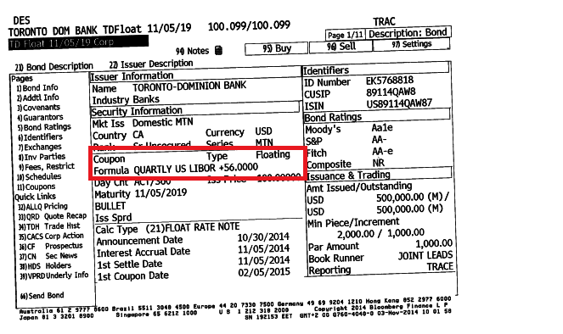

<http://www.raymondjames.com/fixed_income_floating_rate.htm>

Proposed alternative definition for INTR: *“Interest rate of an instrument taken as a basis to calculate the actual interest rate of the coupon.”*

Description of the usage in the global market practice would be illustrated with the following example:

Example:



Input from SE

The WG approved the proposed market practice.

ZA Feedback

ZA agrees with the proposed definition for INTR “Interest rate of an instrument taken as a basis to calculate the actual interest of the coupon.” In order to calculate interest for the period (INTP) INTR, DAAC & MICO will be used.

CH and IUK&IE agrees with the proposed MP.

Decision: the new MP to be added to GMP1 with the Excel table as an illustration and the SMPG submit a CR for SR2017 to update the INTR definition as proposed here above.

**Action**: Jacques to add new MP in GMP1 and to prepare CR for SR2017.

# CA303 Usage of PWAL for DVOP & DRIP

Christine’s MP proposal received:

*The definition of market deadline is ‘Issuer or issuer's agent deadline to respond, with an election instruction, to an outstanding offer or privilege.’. When election instructions may or must be sent to the issuer or issuer’s agent via the issuer CSD, the deadline in the issuer CSD system by which such instructions must be sent must be the market deadline as set by the issuer. In case the CSD system cannot receive election instructions up until market deadline, the notification sent by the CSD must include both the market deadline date and time set by the issuer as well as the CSD’s own response deadline date and time. This also applies to events where the CSD is acting as an investor CSD.*

Input from SE: The WG approved the proposed market practice.

ZA Feedback : ZA has proposed 2 minor changes (see above in the MP) and agrees that PWAL must end on market deadline.

CH, FR, UK&IE, DE and FI NMPG’s agrees with the above proposal.

Decision: The new MP to be added in GMP1 as proposed by Christine with ZA minor updates

**Action**: Jacques to add MP in section 3.11.9 of GMP1.

# CA308 Question on Multi listed securities MP

Christine’s input received for the updated COAF MP (updated part in blue):

*“8.1.2.4 Relationship between CORP and COAF*

*The Market Practice is to have a one-to-one relationship between CORP and COAF in the context of a bilateral relationship account servicer/account owner, provided all principles are adhered to. Account servicers should give a unique CORP to each event that has been given a unique COAF by the official body.* ***In the case of intermediaries which have more than one place of safekeeping for affected client holdings (e.g. a global custodian with two or more sub-custodians in a market), more than one event/CORP may be used for one COAF, in order to reflect different options, deadlines or the like provided by/resulting from the different account servicers/places of safekeeping.“***

Input from SE: The WG approved the proposed market practice.

Input from XS: I am fine with the text but does this situation occur? Wouldn't a global custodian align the options it offers to the common options offered by its agents on the market?

ZA Feedback : ZA agrees.

DE Feedback : I wanted to mention also that section 8.1.2.7. would need clarification, how the MT565 must look like, if we follow Christine's suggestion.   
e.g.        Event 1                Event 2   
        COAF=123        COAF=123   
        CORP=456        CORP=789   
  
MT565        COAF=123        COAF=123   
        CORP=optional        CORP=optional                can be NONREF.

This means that clients would always be forced to use the CORP in their MT565. We had a representative from an Asset Manager as guest to out meeting who also mentioned that this would mean that he would not want to distinguish between cases where a CORP is needed and cases where it is not.   
Plus: What if the is a multi-listed security, where a custodian issues several CORPs for one COAF, but one client is only holding one position. The custodian would probably expect to have a CORP because of the multi listings, but the client would not be aware that they should potentially send a CORP.   
I.E.: This would mean that everybody would always send a CORP - just to be sure that nothing goes wrong, so we could delete section 8.1.2.7. and we would never be able to delete the CORP from the messages.   
In our opinion, we should think more about the side effects and discuss in more detail, before changing the MP.

CH, FR, ES, UK&IE NMPG’s agrees with the above proposal.

Decision: No update to GMP1 for the moment. To be rediscussed at the call in March.

**Actions**: Christine to propose an amendment to the text above.

# CA316 MPs specific for Issuer announcements ?

Summary of proposal

*Issue 1: What happens when the issuer (or the CSD as official source of the COAF) changes the event after the CSD has announced it?*

***Decision****: The three key elements are applicable also for the COAF, not only the CORP. In this example, and provided the change relates to one or more the three key elements (CAEV, CAMV, ISIN), the CSD should announce a new COAF. The first event is regarded as withdrawn.*

*Issue 2: Can the options be changed (replaced and/or removed)?*

* *The issuers must not replace any options; they are to adhere to the rules that have been defined by the SMPG regarding the option numbering (section 3.11.11);*
* *All official options have to be passed on stating the correct option number throughout the chain. E.g. there are 001/EXER and 002/LAPS issuer options. 003/SLLE is an account servicer option. Then the issuer announces 003/OVER. What to do?*

***Decision****:*

*a. CSDs are not to allow issuers/issuer agents to change the order/number/code of options, but instead use the OSTA//INTV (Inactive) or CANC (Cancelled) indicator codes (easier said than done)*

*b. Propose to resurrect the old market practice proposal to assign account servicer options option numbers starting with 9, e.g. 9nn, to prevent conflict between issuer and account servicer option numbers*

*Issue 3: What if the issuer CSD makes an incorrect interpretation of the event at the same time it assigns a COAF? Can intermediaries use the same COAF but with the correct CAEV?*

***Decision****: The least bad solution was agreed to use the correct CAEV code but still include the same COAF. This will assist in reconciliation between different information sources.*

NMPGs Feedback:

Input from XS

OK with issues 1 and 3. Regarding the decision on issue 2 to reuse option numbers starting with 9 for account servicers, Jacques can you please remind me why this solution was not implemented in the past? I personally don't think my system can handle it.

ZA Feedback

Issue 1: ZA agrees

Issue 2a: Issuers do not necessarily provide/announce option numbers. The option numbers are provided by the CSD. ZA agrees with the usage of option status (OSTA)

Issue 2b: The numbering change could be a huge code change and ZA would thus propose using option features for account servicer options (OPTF//ASVO)

Issue 3: The simple changing of CAEV will not necessarily change fields further down in the message. Thus ZA suggests that the event must be withdrawn and replaced with the correct CAEV.

ISITC Feedback:

Issue 1: Likely impossible to cancel and re-issue a COAF for the CSD.

Issue 2: In favor of using “Inactive” or “cancelled” option feature. No 9xx option numbering.

Issue 3: Agree with the proposal only if the event cannot be withdrawn by the issuer/Issuer Agent.

FR feedback

Issue 1: Agree

Issue 2: Use rather CANC option feature. No 9xx option numbering.

Issue 3: Need more information to take a decision. It is not clear who is providing the CAEV code since it cannot be the issuer.

Summary of feedback

|  |  |  |  |  |  |  |  |  |  |
| --- | --- | --- | --- | --- | --- | --- | --- | --- | --- |
| **#** | **DE** | **UK&IE** | **FR** | **FI** | **CH** | **ZA** | **US** | **CH** | **JP** |
| Issue 1 | NA | Ok | Ok | ? | Ok | Ok | No | Ok | Ok |
| Issue 2a | NA | Ok | OSTA/CANC | ? | Ok | Ok | Ok | Ok | NA |
| Issue 2b | NA | OPTF//ASVO | No | ? | No | OPTF//ASVO | No | No | NA |
| Issue 3 | NA | CANC and replace | Not sure about the flow | Ok | Ok | Ok | Ok | Ok | CAnC and replace |

Decision: Item to be finalized in Helsinki.

**Actions**:

1. Remaining NMPGs are requested to review and revert on the above proposals

2. Jyi-Chen to raise the question at (and coordinate the discussion with) the ISSA committee.

# CA317 Should a MP enforce a mandatory Default Option (DFLT) ?

Christine has sent the following MP update proposal for section 3.11.11.2 in GMP1:

*“3.11.11.2 Default Option and Standing Instruction*

##### *Default option*

*The default option identified is the default decided by the sender of the message, i.e. the account servicer. It may or may not be the default option of the issuer.  ~~Whether default options will be provided by account servicer should be specified by SLA.~~*

*~~Technically, the default action flag of each sequence E could be set to N. There is no obligation to~~ The sender of the message should always specify which option is the default option, by ~~have~~ including one option with a flag set to Y, even for MAND events where there is only one option in the event. For MAND events with two or more options (see 8.25) and thus including the CA Option Feature Option Applicability field, either all or no options may be specified as the default option.*

*~~except i~~In the case of VOLU events, ~~for which~~ the default option is always NOAC (see section 8.23).”*

Input from SE

The WG approved the proposed market practice.

ZA Feedback

The group was of opinion that should there be more than one option then event would most probably be elective thus clarification will be appreciated as to when a mandatory event have more than one option. Furthermore, normally one option must be annotated as the default option, thus kindly clarify the statement *“either all or no options may be specified as the default option”.*

DE Feedback

We'll hopefully discuss on Thursday meeting.   
As a note: OPTF//CAOS for MAND events with one or more options: it does not seem to make it very clear, what exactly will happen, when the MAND event is booked.

CH, ES still to be discussed

ISITC: There is a risk for a custodian to enforce a default option.

**FR: Agree**

**Actions**: Remaining NMPGs to provide feedback on the proposal for next meeting.

# CA318 MP for new :94a::COIN qualifier

Item is postponed to next call due to lack of time.

**Action: The tax SG** to provide an MP proposal for TAXR/WITL asap.

# CA319 New MP for QINS usage in DVOP/PRIO events

Item is postponed to next call due to lack of time.

**Written input received:**

Input from SE

The WG approved the proposed market practice.

Input from XS

OK with proposed MP, Bernard, do you agree?

ZA Feedback

ZA agrees with the QINS MP proposal.

**Action**:

1. **All NMPGs t**o provide feedback on MP at next call.

# CA320 New MP for TXAP code list



Item is postponed to next call due to lack of time.

**Written input received:**

FR Input

In the case, we don’t have enough time to cover this topic, please note that neither the French CSD nor French participants use or plan to use the ITYP as previously stated in the document.

As a consequence, you can delete the part related to the French Market : no Market Practice expected on that point.

DE Feedback

Not applicable in the German market.

**Actions:**

1. ISITC to come up with a TXAP code list proposal for the January 19 conference call.

2. ISITC NMPGs to validate the updated draft ETYP/ITYP MP.

# CA321 Create a more robust MP on narrative update information and update date

Item is postponed to next call due to lack of time.

**Written input received:**

Input from XS

I am in favour of option 2, Bernard, do you agree?

ZA Feedback

ZA agrees with Germany, do not define a MP for update information.

FR feedback: No MP is preferred

**Action**: Remaining NMPG’s to provide their option of choice and comments/feedback on the proposal.

# CA322 Create new MINO Format Option in cash amount

Item is postponed to next call due to lack of time.

**Written input received:**

Input From UK

**International Public Partnership Offer November 2015**

ISIN GB00B188SR50

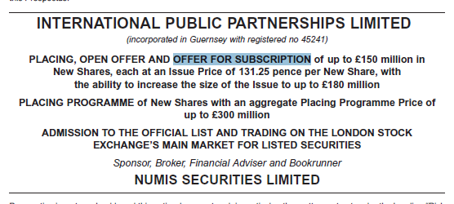

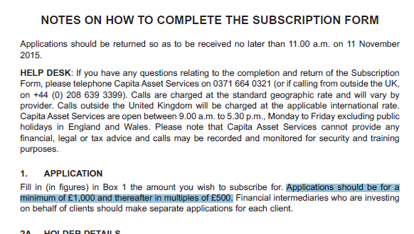

**Bluefield Solar Income Fund November 2015**

ISIN GG00BB0RDB98

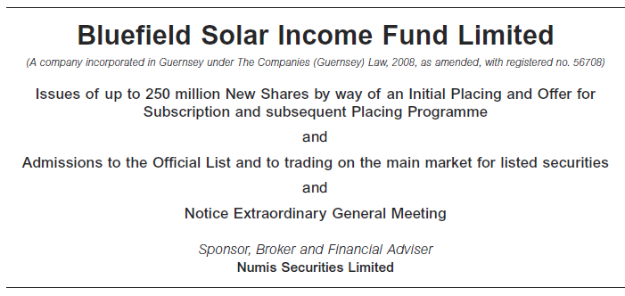

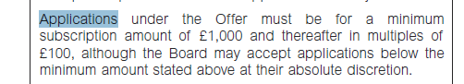



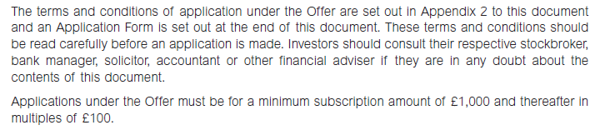

**Custodian Reit Offer November 2015**

ISIN GB00BJFLFT45

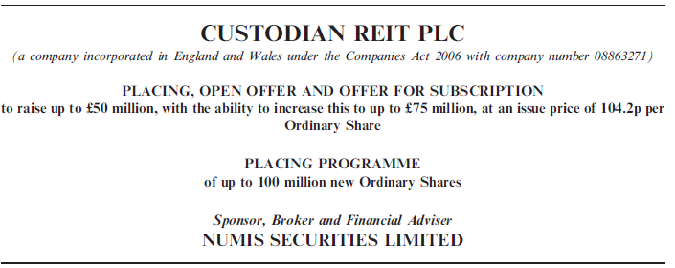

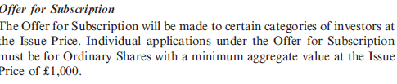

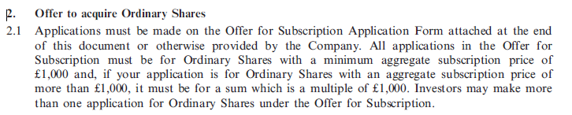

**Action**:.

# CA323 Amend name and definition of PCAL event

Item is postponed to next call due to lack of time.

**Written input received:**

Bernard Input – reviewed defs of PCAL / PRED / DRAW

|  |  |  |
| --- | --- | --- |
| PCAL | Partial Redemption With Reduction of Nominal Value | C:\No_Backup\DOCUMENTATION\SR2016\us5mc\cursor0.gifSecurities are redeemed in part before their scheduled final maturity date with reduction of the nominal value of the securities. The outstanding amount of securities will be reduced proportionally. |
| PCAL NEW | Partial Redemption without pool factor reduction | Securities are redeemed in part before their scheduled final maturity date. It is done without any pool factor reduction. The redemption out-turn is reflected with a face amount reduction. |

|  |  |  |
| --- | --- | --- |
| PRED | C:\No_Backup\DOCUMENTATION\SR2016\us5mc\cursor0.gifPartial Redemption Without Reduction of Nominal Value | C:\No_Backup\DOCUMENTATION\SR2016\us5mc\cursor0.gifSecurities are redeemed in part before their scheduled final maturity date without reduction of the nominal value of the securities. This is commonly done by pool factor reduction. |
| PRED NEW | Partial Redemption with pool factor reduction | Securities are redeemed in part before their scheduled final maturity date. The redemption out-turn is reflected with a pool factor reduction. No movement of securities occurs. |

|  |  |  |
| --- | --- | --- |
| DRAW | Drawing | C:\No_Backup\DOCUMENTATION\SR2016\us5mc\cursor0.gifRedemption in part before the scheduled final maturity date of a security. Drawing is distinct from partial call since drawn bonds are chosen by lottery and with no reduction in nominal value. |
| DRAW  NEW | Drawing | Securities are redeemed in part before the scheduled final maturity date of a security. It is done without any pool factor reduction. The redemption out-turn is reflected with a face amount reduction. Drawing is distinct from other partial redemptions since drawn bonds are chosen by lottery. |

Input from SE

The WG had no comments to provide and hence agreed with the description.

Input from XS

I am ok with the scenarios but we should add the specific qualifiers of each case, e.g. for PCAL pro-rata we decided to report OPTF//PROR

ZA Feedback

ZA agrees

FR feedback: Agree with new definitions

**Actions**:

1. All NMPGs to provide feedback if they agree with the description as a basis for the discussions for a change of the PCAL definition.

2. Bernard to provide the description of PCAL (with reduction of nominal) and PCAL (as pro-rata).

# CA324 Usage of NSIS and NEIS for SOFF, DVSE and BONU

Item is postponed to next call due to lack of time.

**Written input received:**

ZA Feedback

ZA also fails to see the benefit based on the above table.

Input from XS

Wasn't there a taxation reason to be able to clearly distinguish the 2?

Input from SE

Please see Swedish comments in bold in table below.

|  |  |  |  |  |
| --- | --- | --- | --- | --- |
|  | Issuer of distributed securities same as issuer of underlying securities? | Dividend event? | Capitalisation event? | Issuance of new shares?  **Not relevant for SE** |
| BONU | Y | N | Y | Y |
| DVSE | Y | Y | N (TBC) **Confirmed** SE | Y or N ? (TBC) **Both possible in SE** |
| SOFF | N | N | N | N |

A Swedish version of the table would thus be as below, with three unique combinations:

|  |  |  |  |
| --- | --- | --- | --- |
|  | Issuer of distributed securities same as issuer of underlying securities? | Dividend event? | Capitalisation event? |
| BONU | Y | N | Y |
| DVSE | Y | Y | N |
| SOFF | N | N | N |
|  |  |  |  |

DE Feedback

As above, we'll hopefully discuss on Thursday.   
I agree with Christine's comment in that I also don't see the benefit of the indicator in these cases.

FR feedback: NSIS / NEIS is used on spin-off events for FTT process.

**Action**: NMPGs to provide feedback on the above input

# CA326 Usage of PROR (Pro-Ration rate)

Item is postponed to next call due to lack of time.

**Written input received:**

Input from SE

The WG could not provide feedback since no pro-ration rate per event is provided in the Swedish market.

Input from XS

I agree with Daniel, Bernard, do you agree?

ZA Feedback

ZA agrees with Germany in that the pro-ration rate will be applied to the actual number of shares, i.e. 45 shares of the 100 shares will be tendered as stated in the example.

FR feedback: Agree with change of defs

**------------------------ End of the Meeting Minutes ---------------**