SMPG - Corporate Actions
Telephone Conference Minutes
13 December, 2016

FINAL Version v1.0 – January 30, 2017
Table of Contents
1. Approval of November Conference Call Minutes 3
2. CA203 SR2017 - Yearly GMP Part 1,2,3 and samples alignment and yearly summary of changes to MPs (Action: All NMPGs) 3
3. CA279 Claims and Transformations in the T2S context (Action: All NMPGs) 5
4. CA315 Extending CA MPs to ISO 20022 (Action: Bernard) 5
5. CA338 Create a more robust MP on narrative update information and update date for ISO 20022 seev.031 (Action: All NMPGs) 6
6. CA344 Analyse impact of creating new "Interest Period Inclusive" element besides INPE (Action: Mike) 6
7. CA345 Create new MP for the usage of the new QCAS "Instructed Amount" field in MT 565 (Action: Matthew) 6
8. CA353 New Rolling mode (MR) & Accounting mode (MA) for capital increases in Italy (Paola) 7
9. CA354 Market usage of "QINS//QALL" on field 36a of MT565 (Action: NMPGs) 7
10. CA356 How to report the actual Interest rate used for payment (INTP) in another currency than the issuing currency ? (Action: Bernard) 7
11. CA357 Usage of the :22F::OPTF//BOIS and :22F::CETI//FULL codes in the MT567 (Action: Bernard) 7
12. AOB 8
Attendees
NMPG |  | First Name | Last Name | Institution | = Present
AT | Mr. | Stefan | Ribisch | Unicredit
AT | Ms. | Karin | Wachter | Unicredit
BE | Ms. | Véronique | Peeters | BNY Mellon
CH | Mr. | Michael | Blumer | Credit Suisse
DE | Mr | Schaefer | Daniel | HSBC | Excused
DK | Ms | Ravn | Charlotte | VP Securities A/S
ES | Ms. | Cinta | Cristobal | BBVA
ES | Mrs | Diego | Garcia | DB
FI | Ms | Rask | Sari | Nordea Bank Plc | Excused
FR | Mr | Jean-Pierre | Klak | Statestreet
GR | Ms. | Angela | Katopodi | Eurobank
IL | Mr. | Gilad | Grayevsky | Bank Leumi
IT | Ms | Deantoni | Paola | SGSS spa | Excused
JP | Mr | Hideki | Ito | Mizuho Bank
JP | Mr | Hisashi | Hotta | Mizuho Bank
LU | Mr. | Bernard | Lenelle | Clearstream | Excused | Co-Chair
MDPUG | Mr. | Peter | Hinds | MDPUG / Interactive Data | Excused
MDPUG | Ms. | Laura | Fuller | Telekurs
NL | Mr | van der Velpen | Ben | ING Bank N.V. | Excused
NO | Mr. | Alexander | Wathne | Nordea
PL | Mr. | Michal | Krystkiewicz | CSD of Poland (KDPW S.A.)
RU | Ms | Elena | Solovyeva | ROSSWIFT
RU | Ms | Sofia | Prokofeva | Rosbank
SE | Ms. | Christine | Strandberg | SEB |  | Co-Chair
SG | Mr. | Jyi-Chen | Chueh | SC
UK & IE | Ms. | Mariangela | Fumagalli | BNP Paribas | Excused
UK & IE | Mr. | Matthew | Middleton | LSE
US ISITC | Mr. | Paul | Fullam | Sungard | Excused
XS | Ms | Haillez | Delphine | Euroclear
ZA | Mr. | Sanjeev | Jayram | First National Bank
ZA | Mr. | Ridhwaan | Williams | Strate
ZA | Mr. | Nita | David | Strate
SWIFT | Mr. | Jacques | Littré | SWIFT |  | Facilitator
SWIFT | Ms. | Mieko | Morioka | SWIFT APAC

Approval of November Conference Call Minutes
No comments have been received for the November conference call minutes. Those minutes are therefore approved.

CA203 SR2017 - Yearly GMP Part 1,2,3 and samples alignment and yearly summary of changes to MPs (Action: All NMPGs)
Status:
- Templates: Input received from Alexander, Ben, Christine, Daniel, Delphine, Jean-Pierre, Matthew, Peter, Sanjeev, Sari.
Input still missing from Bernard, Paul, Véronique.
Actions 1: Remaining CA Templates updates should be sent to Jacques for January 20.
The following changes/ validations actions must also be applied on all samples systematically:
a) Ensure templates are aligned with EIG+
b) Validate that the description of the event is fully aligned with the actual template.
Please refer to the “CA Event Template list” tab in the “Open Items” file for a full status of the template updates.
- EIG+ CC: Input received from JP, South KR, UK, IE, SE, DE, ZA, NO, XS and CH no update for this year!
Action 2: NMPGs to send their EIG+ Country Column updates to Jacques for January 20.
- Review Voluntary Rolling Event GMP1 Section 2.2.5:
Christine’s Input document:
LU Feedback (Received via email):
“In order to be more complete we should distinguish between 3 rather than 2 scenarios:
a) A real rolling event as specified in the case one of the document. We suggest to keep calling “Rolling” (as in the market). We would have ROLL and PAYD/ONGO.
b) Event with periods (let’s use the word period instead of phase) and the payment occurs at the end of the period for everybody. In this case we do not consider it as ROLL and have a normal PAYD. It is quite usual as a scenario.
c) Event with periods where the payment will happen a number of days after the instruction. It is similar to the case a) in the end.
We propose to change the text above the second graph as follows:
“It is also possible that though the event is rolling, the issuer only executes the payment at certain dates for instructions received within defined instruction periods.”
It seems that the concept of ongoing events is not well accepted and creates more confusion than anything else…”
ZA Feedback (Received via email post meeting):
The ZA market processes multiple events where there is multiple acceptance and payment dates. A record date will be derived for each event – i.e. each event will have its own timeline. Furthermore where the terms of security provides the holder thereof with the option convert or exchange anytime during the life span of the security, the market will not necessarily process an event but rather facilitate the exchange/conversion through the settlements module by way of off-market trades.
Kindly clarify whether for rolling events the practice would be to communicate multiple options for each acceptance and pay date. We should consider firming the draft document in clarifying the usage of ONGO for acceptance and pay dates for rolling events. The rest of the document seems fine.
Action 3: Bernard & Christine to amend the MP draft proposal accordingly and distribute early in January before next conference call.
4) Add AVAL to EIG+ relevant events:
GMP1 SG proposes to add a new section in GMP1 on the usage of the AVAL date (also known as “first trading/dealing date”) stating that “AVAL should only be used for newly issued securities (with new ISIN) received in a distribution or re-organisation event with option SECU”.
NMPGs Feedback:
ZA & SE Agree.
NO: not applicable.
FR, UK DK will address the question at their next meeting.
Action 4: Remaining NMPGs are requested to review the proposal and revert by the next call.
5) New EXWA MAND event template
Véronique is not attending the call.

CA279 Claims and Transformations in the T2S context (Action: All NMPGs)
No new input received this month.
Please be reminded of the deadline of sending the filled spreadsheet before year end.
Action: NMPGs/CSDs/CCPs joining T2S to fill in the document based on how the CSD/CCP will act once they join T2S. To be filled in as soon as possible (preferably before end of year 2016).

CA315 Extending CA MPs to ISO 20022 (Action: Bernard)
The review groups are formed as follows:
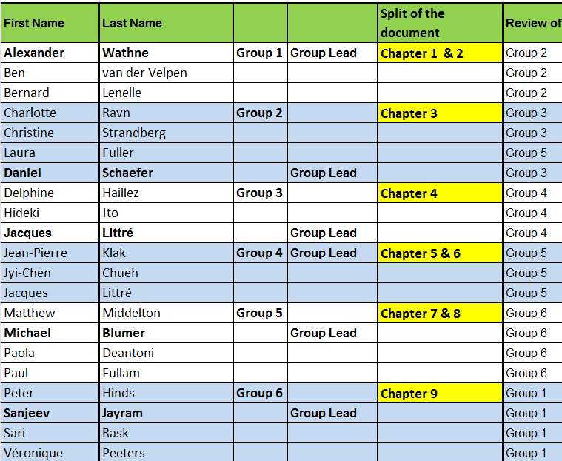
Progress Status
Group 1, 2, 3 and 4 have progressed in the review of their respective chapters and have already sent a partial result of their review to Jacques (Post meeting - on December 15)
Group 5 and 6 did not have time to meet yet due to other heavy commitment at this time of the year.
Group 2 has 3 different review proposals that still need to be consolidated. Some sections might also need to be split and moved into different chapters.
The various inputs received from Groups 1, 2, 3 and 4 show that different ISO 150222 / 20022 (table) notations have been tried during the review. It now becomes urgent to try to all agree asap (January?) on a single notation so that the new notation can be applied consistently by all groups during their review.
Action: All groups to progress in the review of their assigned chapters.

CA338 Create a more robust MP on narrative update information and update date for ISO 20022 seev.031 (Action: All NMPGs)
Updates in section 3.15 of GMP1 read as follows:
“In case of a narrative being updated in the MTs, it is recommended optional to indicate the change and the date at the top of this narrative.
In case of a narrative being updated in the ISO 20022 seev.031 (Notification) and seev.035 (Movement Preliminary Advice) messages, although these elements are optional, it is not recommended to fill in the “Update Description” and “Update Date” elements.”
NMPGs Feedback:
ZA, SE: Approved.
FR: Some institutions would prefer to keep “recommended” for MT. Why changing the 15022 MP to align with 20022? FR is not convinced by the reasons why we want to change this paragraph.
UK&IE: Approved
XS: the proposed MP seems weird for 20022 but not having the messages it is difficult to judge.
Action:
- Jacques to include the proposed MP in the preliminary version of GMP1 SR2017.
- Remaining NMPGs are requested to review the proposed MT change and revert by next conference call.

CA344 Analyse impact of creating new "Interest Period Inclusive" element besides INPE (Action: Mike)
Mike’s action is still pending.
Action: Mike to find a multi-deposited bond and show how INPE is used for it in different markets

CA345 Create new MP for the usage of the new QCAS "Instructed Amount" field in MT 565 (Action: Matthew)
Proposed UK draft MP received:
Action: Jacques to draft a brief text based on the UK input regarding the usage of the new fields for inclusion in GMP1 (and with a reference to UK&IE MP), in order to avoid misuse of them.

CA353 New Rolling mode (MR) & Accounting mode (MA) for capital increases in Italy (Paola)
Input Provided by Paola:
FR Feedback: FR does not understand why the response deadline (RDDT) is set to “ONGO” in the provided example whilst there is a set date for the market deadline (MKDT). The AS should always put a definite date in RDDT as well. It looks rather inconsistent.
ZA Post meeting feedback: ZA has not had an occurrence of this nature and therefore agrees that the market practice should be a local market practice rather than a global one. In the event this practice extends to other markets then we may consider a global practice.
Action: Close item, since IT local MP.

CA354 Market usage of "QINS//QALL" on field 36a of MT565 (Action: NMPGs)
Feedback on usage of the QINS/QALL code in instruction:
FR, SE, UK&IE: QALL not used
XS: QALL is used
Actions: Remaining NMPGs are requested to report usage of QALL (what the meaning is, and when positions are struck?) and provide input by the next conference call.

CA356 How to report the actual Interest rate used for payment (INTP) in another currency than the issuing currency? (Action: Bernard)
Postponed, Bernard not present at the call.
Action: Bernard to check his Zurich notes and revert to Jacques if the template contains errors.

CA357 Usage of the :22F::OPTF//BOIS and :22F::CETI//FULL codes in the MT567 (Action: Bernard)
Bernard’s input proposal:
NMPGs feedback: ZA, SE, XS -> Approved.
No other feedback so far.
Action: Jacques will include the proposed MP in the preliminary version of GMP1 SR2017.

AOB
(Received from Sanjeev post meeting):
The ZA market is in the process revamping debt instrument clearing & settlement and corporate action processing by way of a Debt Instrument Solution Project (DIS). During analysis it was identified that through partial redemptions fractional holdings, e.g. 1,433,587.25, have crept into the system.
Whilst the Issuer may be redeeming a whole number of debt instruments in issue, when the partial redemption terms are applied at beneficial owner level it results in fractions. It is the intention of the market to eliminate such fractions going forward and is thus enquiring how other markets are contending with this issue.
We are eager to know whether a rounding principle is being applied to eliminate such fractions, e.g. standard rounding. The market would like to align itself to global practice.
Feedback from other markets or SMPG guidance will be appreciated.

------------------------ End of the Meeting Minutes ---------------

