**CA385 (New) MiFID II and Impact on the GMP1 / Templates about BUYA/SLLE and MT566 section 9.1.6 (sales of rights)**

a) should we still have anything in GMP1/templates about BUYA/SLLE options, although I agree we have already used some caveats that these are account servicer options? Isn't it more prudent to remove them and just say they are at the discretion of the account servicer?   
  
b) I have some doubts on the validity of this recommendation:   
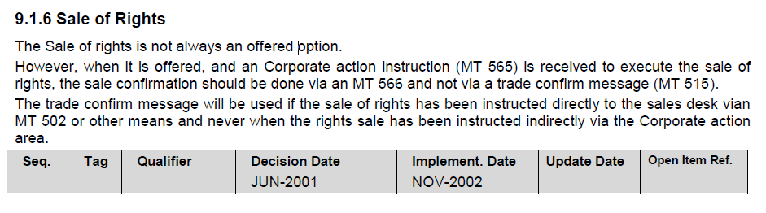In my opinion, this recommendation was valid at the time it was made, well before MIFID I, MIFID II, etc. However, looking at the long list of items that MIFID II requires to be confirmed at the time an order is executed:   
  
*The notice referred to in point (b) of paragraph 1 shall include such of the following information as is applicable and, where relevant, in accordance with the regulatory technical standards on reporting obligations adopted in accordance with Article 26 of Regulation (EU) No 600/2014:*   
  
*(a) the reporting firm identification;*   
*(b) the name or other designation of the client;*

*(c) the trading day;*

*(d) the trading time;*

*(e) the type of the order;*

*(f) the venue identification;*

*(g) the instrument identification;*

*(h) the buy/sell indicator;*

*(i) the nature of the order if other than buy/sell;*

*(j) the quantity;*

*(k) the unit price;*

*(l) the total consideration;*

*(m) a total sum of the commissions and expenses charged and, where the client so requests, an itemised breakdown including, where relevant, the amount of any mark-up or mark-down imposed where the transaction was executed by an investment firm when dealing on own account, and the investment firm owes a duty of best execution to the client;*

*(n) the rate of exchange obtained where the transaction involves a conversion of currency;*

*(o) the client's responsibilities in relation to the settlement of the transaction, including the time limit for payment or delivery as well as the appropriate account details where these details and responsibilities have not previously been notified to the client;*

*(p) where the client's counterparty was the investment firm itself or any person in the investment firm's group or another client of the investment firm, the fact that this was the case unless the order was executed through a trading system that facilitates anonymous trading.*   
  
*For the purposes of point (k), where the order is executed in tranches, the investment firm may supply the client with information about the price of each tranche or the average price. Where the average price is provided, the investment firm shall supply the client with information about the price of each tranche upon request.*

I cannot see how you can confirm anything using an MT566!   
I agree that we should recommend that the rights are debited/credited and the cash is credited/debited via MT566 but I disagree we should recommend to confnirm an order via MT566, especially when the message is not fit for purpose.