**CA470 - Question from Randi on DVOP (DK)**

We have run into issues with our DVOP MT564, which is why we are asking you for advice on how to solve it to best meet SMPG standards.

If looking at the templates for DVOP, there is an example on how to “fill in” a DVOP with no interim securities 30. DVOP dividend option (CHOS) – no Interim Securities.

However, this example does not show

1: CINL (if in doubt, there are other examples that cover this though)

2: how to inform clients that tax is deducted even if your choice is securities.

Furthermore, the EIG Global Grid states “DVOP without intermediate securities Include PRPP in E1, when issuer announces GRSS and PRPP for SECU **instead of ADEX,** but the template shows that ADEX is a mandatory field and PRPP is optional.

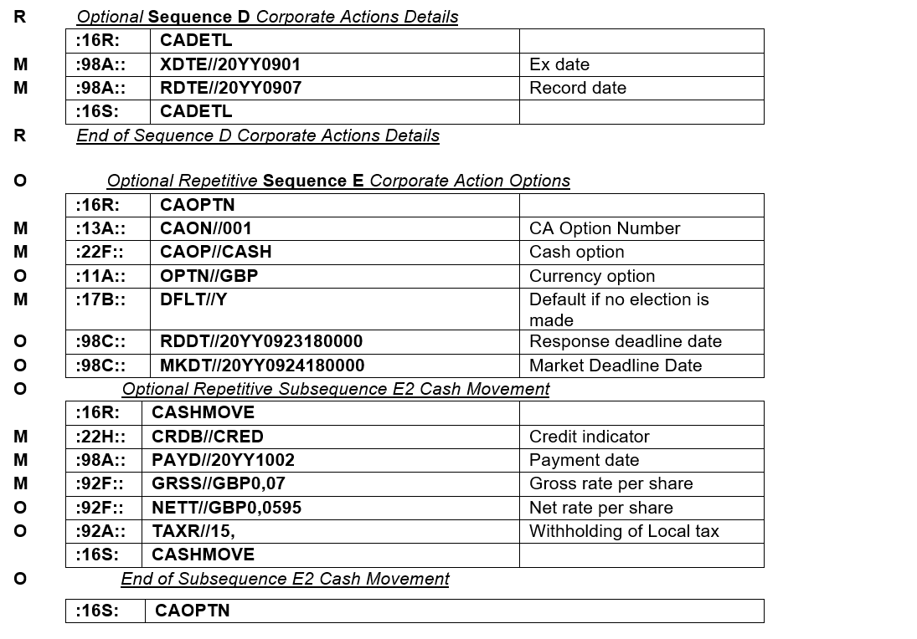

cid:image002.png@01D6463B.97841980

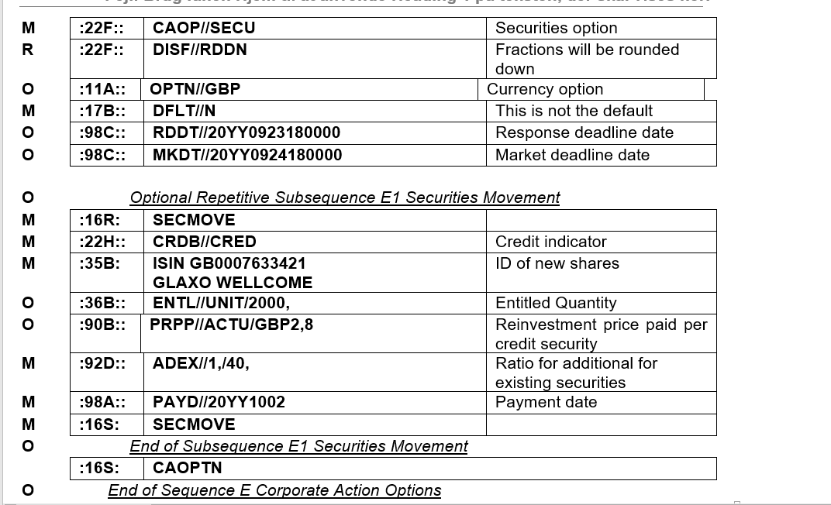

Would the below scenario be the best way to inform the clients of cash being paid for their fractions keeping in mind that securities are also taxable?

Or what would be the best message to meet the standards?

**I have highlighted 3 fields in red**

**TXAP//TXBL – is this a way to show clients that even if you choose secu you are being taxed, and the cash in lieu is also taxed?**

**Or should it be stated in local market practice that PRPP is net?**

|  |
| --- |
| :16R:CADETL |
| :98A::RDTE//20190130 |
| :98A::XDTE//20190129 |
| :22F::DIVI//INTE |
| :22F::ESTA//APPD |
| :16S:CADETL |
| :16R:CAOPTN |
| :13A::CAON//001 |
| :22F::CAOP//CASH |
| :11A::OPTN//DKK |
| :17B::DFLT//Y |
| :98C::MKDT//20190130175959 |
| :16R:CASHMOVE |
| :22H::CRDB//CRED |
| :98A::PAYD//20190131 |
| :92F::GRSS//DKK16,1 |
| :92A::TAXR//27, |
| :16S:CASHMOVE |
| :16S:CAOPTN |
| :16R:CAOPTN |
| :13A::CAON//002 |
| :22F::CAOP//SECU |
| :22F::DISF//CINL |
| :17B::DFLT//N |
| Totto:98C::MKDT//20190130175959 |
| :16R:SECMOVE |
| :22H::CRDB//CRED |
| :22F::TXAP//TXBL |
| :35B:ISIN DK0010251396 |
| JI USA Akt KL/- |
| :16R:FIA |
| :12C::CLAS//CEOIES |
| :16S:FIA |
| :22F::DISF//CINL |
| :90E::PRPP//ACTU/DKK85,0827 |
| :92D::ADEX//1,/7,239232 |
| :98A::PAYD//20190131 |
| :16S:SECMOVE |

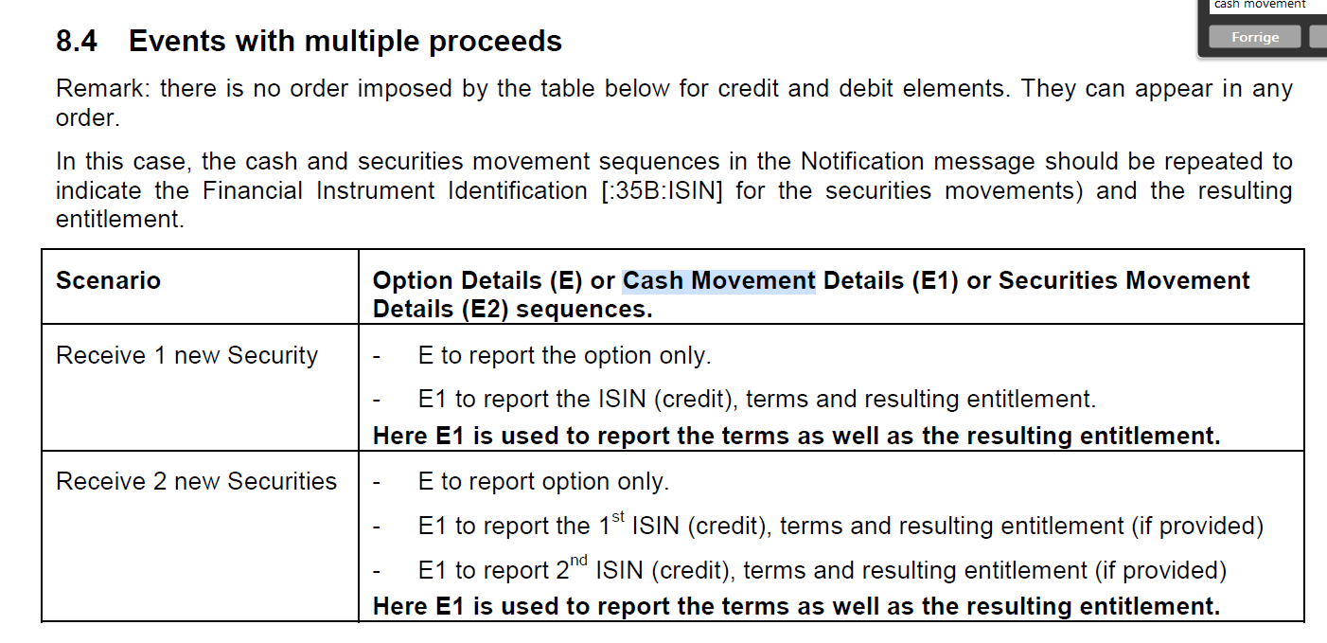

Should there be a scenario stating where to report the cash for fractions?