SMPG Corporate Actions
Tax Breakdown Market Practice
For ISO 15022 and ISO 20022 Standards
SR 2022

Disclaimer

The Securities Market Practice Group is a group of experts who devote their time on a voluntary basis to define global and local market practices for the benefit of the securities industry. The market practice documentation and recommendations produced by this organization are intended to solve common problems across the securities industry, from which financial institutions can derive clear benefits, to harmonize business processes and to facilitate the usage of message protocols ISO 15022 and ISO 20022. While the Securities Market Practice Group encourages the implementation of the market practices it develops, it is up to the financial institutions within each market to implement the market practices according to their needs and agreements with their business counterparts to support their businesses as efficient as possible.

Although the SMPG has used all reasonable efforts to ensure accuracy of the contents of this document, the SMPG assumes no liability whatsoever for any inadvertent errors or omissions that may appear thereon.
Moreover, the information is provided on an "as is" basis. The SMPG disclaims all warranties and conditions, either express or implied, including but not limited to implied warranties of merchantability, title, non-infringement and fitness for a particular purpose.
Neither the SMPG, nor any of its members and/or contributors shall be liable for any direct, indirect, special or consequential damages arising out of the use of the information published in this document, even if the SMPG or any of its members have been advised of the possibility of such damages.

Status: Draft
Publication Date: xx September 2022
Update Implementation Date: 21 November 2022
Version: v0.1
Author: SMPG CA WG
Table of Contents

1 Introduction 3
1.1 Revision Record 3
1.2 Scope of this document 3
2 Management of Tax Breakdown Instructions on Mandatory Income Distribution Events 4
2.1 Relief at source 4
2.1.1 Scenario 1 – Using WRTC Event 4
2.1.2 Scenario 2 – Using Multiple Options 5
2.1.3 Message templates 7
2.1.3.1 Scenario 1 - Using WRTC Event 7
2.1.3.2 Scenario 2 – Using Multiple Options 10
2.2 Tax refund 13
2.2.1 Scenario 1 – Using WRTC Event 13
2.2.2 Scenario 2 – Using Multiple Options 14
2.2.3 Message templates: 15
2.2.3.1 Scenario 1 – Using WRTC Event 15
2.2.3.2 Scenario 2 – Using Multiple Options 18
3 Management of Tax Breakdown Instructions on Optional Income Distribution Events 21
3.1 Relief at source 21
3.1.1 Process flow – Using WRTC Event 21
3.1.2 Message templates 22

Introduction

Revision Record
Version | Publication Date | Sections Affected | Description
V0.1 | XX Sep. 2022 |  | Merged with new MP on Tax Breakdown on optional income distribution event (DVOP).
V1.2 | 19 Nov. 2021 | All | Various slight amendments
V1.1 | May 2021 | All | SR2021 version and ISO 20022 enabled
V1.0 | 15 Dec. 2020 | n/a | Initial version

Scope of this document
Based on previous discussions at the SMPG Tax Working Group, we have identified two methods currently used by account servicers to collect tax breakdown information, either prior to (relief at source method) or after (tax refund method) an income distribution.
In both methods, two processing scenario can be distinguished
- Scenario 1: Using a Withholding Tax Relief Certification (WTRC) event, linked to the income distribution event;
- Scenario 2: Including multiple options, one per tax rate, in the income distribution event.
Although the SMPG Tax Working Group was unable to reach consensus on the method to be recommended, it agreed that scenario 1 should be the preferred method for any institution that is approaching this process ex-novo.
Account owners can provide a tax breakdown using a MT565 message, whose content depends on the event type that was used in the breakdown request.
This document covers the management of tax breakdown instructions for mandatory events (DVCA and INTR) in section 2 and for optional events in section 3.
For optional events, the primary focus is on the scenario using a Withholding Tax Relief Certification (WTRC) event, linked to the income distribution event.

Management of Tax Breakdown Instructions on Mandatory Income Distribution Events

Relief at source
In some source investment countries that allow for a relief at source procedure (e.g. Italy), where the account owner has an omnibus account, prior to the income distribution record date/pay date, it has to inform the account servicer of the tax rates and breakdown of the eligible balance to be used to pay the income proceeds.
We have provided an overview of the way the income and tax breakdown should be managed, according to both methods described in the introduction to this market practice, in case of mandatory income distribution events (Interest Payment [INTR] or Cash Distribution [DVCA]):

Scenario 1 – Using WRTC Event
  - the account servicer will:
    - announce a mandatory income distribution event (Interest Payment [INTR] or Cash Distribution [DVCA]);
    - for account owners having an omnibus account, a WTRC voluntary event will also be announced with a link to the mandatory income distribution. The WTRC event will have a “No Action” (NOAC) and a “Beneficial Owner Breakdown Request” (BOBD) option code indicator to request the tax rates to be used to pay the income proceeds (e.g. statutory rate, DTT rates, etc…);
  - the account owner will send the tax breakdown via MT565/seev.033 quoting the event details ([:22F::CAEV <> seev.031 – A / EventType] and [:20C::CORP <> seev.031 – A / CorporateActionEventIdentification], etc…) of the WTRC event;
  - based on the SLA in place between the account servicer and account owner, the receipt of the instruction will be confirmed via MT567/seev.034;
  - on pay date, the account servicer will pay the income proceeds using the tax rates provided by the account owner. The credit of the proceeds will be confirmed via a MT566/seev.036 reporting the INTR/DVCA event details.
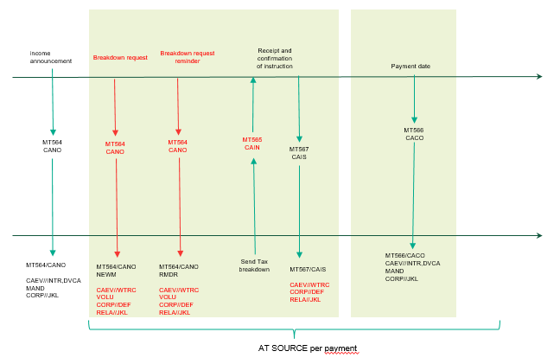

Scenario 2 – Using Multiple Options
  - the account servicer will announce a choice income distribution event (Interest Payment [INTR] or Cash Distribution [DVCA]) with as many CASH options as the tax rates that can be used to pay the income proceeds (e.g. statutory rate, DTT rates, etc);
  - the account owner will send the tax breakdown via MT565 / seev.033 quoting the event details (:22F::CAEV <> seev.031 – A / EventType] and [:20C::CORP <> seev.031 – A / CorporateActionEventIdentification],, etc) of the income event;
  - based on the SLA in place between the account servicer and account owner, the receipt of the instruction will be confirmed via MT567/seev.034;
  - on pay date, the account servicer will pay the income proceeds using the tax rates provided by the account owner. The credit of the proceeds will be confirmed via a MT566/seev.036 reporting the INTR/DVCA event details.
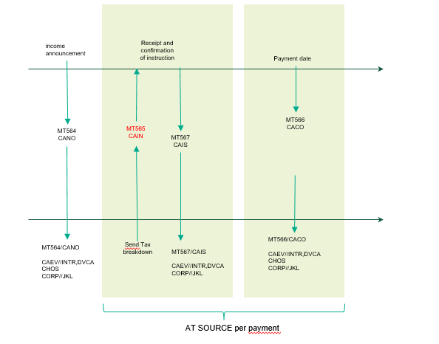
Recommendation for the usage of the new reason codes added to the “Pending” and “Rejected” statuses in the MT567/seev.034 Instruction Status Advice:
ITAX | Incorrect Tax Rate | Tax rate provided is incorrect. It falls outside the acceptable values for that investment country. | It should be used to inform the account owner that any of the tax rate indicated for a beneficial owner in the Beneficial Owner Details/BENODET sequence is incorrect.  As an example, with reference to our MT565 below, if the account owner reported a rate of 30%.
MTAX | Missing Tax Rate | Tax rate is missing. | It should be used to inform the account owner that any of the tax rate indicated for a beneficial owner in the Beneficial Owner Details/BENODET sequence is missing.  As an example, with reference to our MT565 below, if the account owner had reported no tax rate.
NTAX | Inconsistent Tax Rate | Tax rate is not consistent with the documentation in place. | It should be used to inform the account owner that any of the tax rate indicated for a beneficial owner in the Beneficial Owner Details/BENODET sequence is not aligned to the documentation in place.  As an example, with reference to our MT565 below, if the documentation in place for ABC123 made it entitled to a rate of 0% instead of 15%.

Message templates

Scenario 1 - Using WRTC Event
  - MT564 DVCA to announce the mandatory dividend to all clients
:16R: |  | GENL
:20C:: |  | CORP//DIV3437592
:20C:: |  | SEME//253147815
:23G: |  | NEWM
:22F:: |  | CAEV//DVCA
:22F:: |  | CAMV//MAND
:25D:: |  | PROC//COMP
:16S: |  | GENL
:16R: |  | USECU
:35B: |  | ISIN IT0004982242
:16R: |  | ACCTINFO
:97A:: |  | SAFE//98-0112441-05
:93B:: |  | SETT//UNIT/4600,
:16S: |  | ACCTINFO
:16S: |  | USECU
:16R: |  | CADETL
:98A:: |  | XDTE//20YY0323
:98A:: |  | RDTE//20YY0324
:16S: |  | CADETL
:16R: |  | CAOPTN
:13A:: |  | CAON//001
:22F:: |  | CAOP//CASH
:11A:: |  | OPTN//EUR
:17B:: |  | DFLT//Y
:16R: |  | CASHMOVE
:22H:: |  | CRDB//CRED
:98A:: |  | PAYD//20YY0325
:92A:: |  | TAXR//26,
:92F:: |  | GRSS//EUR1,
:16S: |  | CASHMOVE
:16S: |  | CAOPTN
  - MT564 WTRC to announce the breakdown event to account owners having an omnibus account
:16R: | GENL
:20C:: | CORP//WTRC12345
:20C:: | SEME//253147816
:23G: | NEWM
:22F:: | CAEV//WTRC
:22F:: | CAMV//VOLU
:25D:: | PROC//COMP
:16R: | LINK
:13A:: | LINK//564
:20C:: | CORP//DIV3437592
:16S: | LINK
:16S: | GENL
:16R: | USECU
:35B: | ISIN IT0004982242
:16R: | ACCTINFO
:97A:: | SAFE//98-0112441-05
:93B:: | SETT//UNIT/4600,
:16S: | ACCTINFO
:16S: | USECU
:16R: | CAOPTN
:13A:: | CAON//001
:22F:: | CAOP//NOAC
:17B:: | DFLT//Y
:98E:: | RDDT//20YY0324160000/00
:16S: | CAOPTN
:16R: | CAOPTN
:13A:: | CAON//002
:22F:: | CAOP//BOBD
:17B:: | DFLT//N
:98E:: | RDDT//20YY0324160000/00
:70E:: | ADTX//blablabla
:16S: | CAOPTN

  - MT565 sent by the account owner to instruct the tax breakdown – the account owner may send an MT565 per beneficial owner/tax rate or an MT565 repeating the beneficial owners in the BENODET sequence:
:16R: | GENL
:20C:: | CORP//WTRC12345
:20C:: | SEME//253147888
:23G: | NEWM
:22F:: | CAEV//WTRC
:16S: | GENL
:16R: | USECU
:35B: | ISIN IT0004982242
:16R: | ACCTINFO
:97A:: | SAFE//98-0112441-05
:93B:: | ELIG//UNIT/4600,
:16S: | ACCTINFO
:16S: | USECU
:16R: | BENODET
:95S:: | OWND//TXID/BE/ ABCDEF1234567
:36B:: | OWND//UNIT/2600,
:92A:: | TAXR//15,
:16S: | BENODET
:16R: | BENODET
:95S:: | OWND// TXID/BE/GHIJKLM8901234
:36B:: | OWND//UNIT/2000,
:92A:: | TAXR//26,
:16S: | BENODET
:16R: | CAINST
:13A:: | CAON//002
:22F:: | CAOP//BOBD
:36B: | QINS//UNIT/4600,
:16S: | CAINST

Depending on the tax requirements per source investment country, the breakdown may be:
- Full Disclosure Breakdown – the account owner should provide (as illustrated in the above MT565 template):
  - details of the beneficial owner (e.g. name and address, tax ID, etc) – it is recommended that either all details are reported by repeating :95S::OWND or a unique reference pre-agreed with the account servicer is used instead,
  - quantity per beneficial owner,
  - applicable tax rate;

- Rate Breakdown – the account owner should provide (see below template):
  - quantity per tax rate,
  - tax rate:
:16R: | BENODET
:95V:: | OWND//NONREF
:36B:: | OWND//UNIT/2600,
:92A:: | TAXR//15,
:16S: | BENODET

In a full disclosure breakdown scenario, the account owner may not want to disclose beneficial owners that are taxable at statutory rate. However, to facilitate the reconciliation process, it is recommended the account owner provide an instruction for their total holding without disclosing their details, as per the below example:
:16R: | BENODET
:95V:: | OWND//NONREF
:36B:: | OWND//UNIT/2000,
:92A:: | TAXR//26,
:16S: | BENODET
  - The account servicer will pay the income proceeds using the quantities and tax rates provided by the account owner in the MT565.

The MT566 should be issued using the event details of the DVCA (e.g. CORP//DIV3437592). The account servicer issues:
- either one MT566 per tax rate, or
- one MT566 with repeating movements, one movement per tax rate.

Scenario 2 – Using Multiple Options
        - MT564 DVCA to announce the dividend with several options depending on the tax rates applicable to that event and security type:
:16R: | GENL
:20C:: | CORP//DIV3437592
:20C:: | SEME//253147815
:23G: | NEWM
:22F:: | CAEV//DVCA
:22F:: | CAMV//CHOS
:25D:: | PROC//COMP
:16S: | GENL
:16R: | USECU
:35B: | ISIN IT0004982242
:16R: | ACCTINFO
:97A:: | SAFE//98-0112441-05
:93B:: | SETT//UNIT/4600,
:16S: | ACCTINFO
:16S: | USECU
:16R: | CADETL
:98A:: | XDTE//20YY0323
:98A:: | RDTE//20YY0324
:16S: | CADETL
:16R: | CAOPTN
:13A:: | CAON//001
:22F:: | CAOP//CASH
:11A:: | OPTN//EUR
:17B:: | DFLT//Y
:98E:: | RDDT//20YY0324160000/00
:16R: | CASHMOVE
:22H:: | CRDB//CRED
:98A:: | PAYD//20YY0325
:92A:: | TAXR//26,
:92F:: | GRSS//EUR1,
:16S: | CASHMOVE
:16S: | CAOPTN
:16R: | CAOPTN
:13A:: | CAON//002
:22F:: | CAOP//CASH
:11A:: | OPTN//EUR
:17B:: | DFLT//N
:98E:: | RDDT//20YY0324160000/00
:16R: | CASHMOVE
:22H:: | CRDB//CRED
:98A:: | PAYD//20YY0325
:92A:: | TAXR//15,
:92F:: | GRSS//EUR1,
:16S: | CASHMOVE
:16S: | CAOPTN
:16R: | CAOPTN
:13A:: | CAON//003
:22F:: | CAOP//CASH
:11A:: | OPTN//EUR
:17B:: | DFLT//N
:98E:: | RDDT//20YY0324160000/00
:16R: | CASHMOVE
:22H:: | CRDB//CRED
:98A:: | PAYD//20YY0325
:92A:: | TAXR//0,
:92F:: | GRSS//EUR1,
:16S: | CASHMOVE
:16S: | CAOPTN

        - MT565 sent by the account owner to instruct the tax breakdown (under the assumption we need a full disclosure breakdown)

:16R: | GENL
:20C:: | CORP// DIV3437592
:20C:: | SEME//253147888
:23G: | NEWM
:22F:: | CAEV//DVCA
:16S: | GENL
:16R: | USECU
:35B: | ISIN IT0004982242
:16R: | ACCTINFO
:97A:: | SAFE//98-0112441-05
:93B:: | ELIG//UNIT/4600,
:16S: | ACCTINFO
:16S: | USECU
:16R: | BENODET
:95S: | OWND//TXID/BE/ ABCDEF1234567
:36B: | OWND//UNIT/2600,
:92A:: | TAXR//15,
:16S: | BENODET
:16R: | CAINST
:13A:: | CAON//002
:22F:: | CAOP//CASH
:36B: | QINS//UNIT/2600,
:16S: | CAINST

:16R: | GENL
:20C:: | CORP// DIV3437592
:20C:: | SEME//253147888
:23G: | NEWM
:22F:: | CAEV//DVCA
:16S: | GENL
:16R: | USECU
:35B: | ISIN IT0004982242
:16R: | ACCTINFO
:97A:: | SAFE//98-0112441-05
:93B:: | ELIG//UNIT/4600,
:16S: | ACCTINFO
:16S: | USECU
:16R: | BENODET
:95S:: | OWND// TXID/BE/GHIJKLM8901234
:36B:: | OWND//UNIT/2000,
:92A:: | TAXR//26,
:16S: | BENODET
:16R: | CAINST
:13A:: | CAON//001
:22F:: | CAOP//CASH
:36B: | QINS//UNIT/2000,
:16S: | CAINST

        - The account servicer will pay the income proceeds using the quantities and tax rates provided by the account owner in the MT565.
The MT566 should be issued using the event details of the DVCA (e.g. CORP//DIV3437592) with payments per option.

Tax refund
In those source investment countries that allow for a tax refund procedure (e.g. Austria), when submitting a tax refund application to the account servicer, where the account owner has an omnibus account, it has to inform the account servicer of how the eligible balance should be broken down amongst all end investors, to process the tax refund applications.
We have provided an overview of the way the tax breakdown should be managed according to both methods described in the introduction to this market practice:

Scenario 1 – Using WRTC Event
  - the account servicer will:
    - announce a tax refund event (Tax Reclaim [TREC]);
    - for account owners having an omnibus account, a WTRC voluntary event will also be announced with a link to the tax refund event. The WTRC event will have a “No Action” (NOAC) and a “Beneficial Owner Breakdown Request” (BOBD) option code indicator to request the tax rates to be used to pay the income proceeds (e.g. statutory rate, DTT rates, etc);
  - the account owner will send the tax breakdown via MT565/seev.033 quoting the event details ([:22F::CAEV <> seev.031 – A / EventType] and [:20C::CORP <> seev.031 – A / CorporateActionEventIdentification], etc) of the WTRC event;
  - based on the SLA in place between the account servicer and account owner, the receipt of the instruction will be confirmed via MT567/seev.034;
  - if and when the tax refund has been paid by the tax authorities, the account servicer will pay the refund. The credit of the proceeds will be confirmed via a MT566/seev.036 reporting the TREC event details.
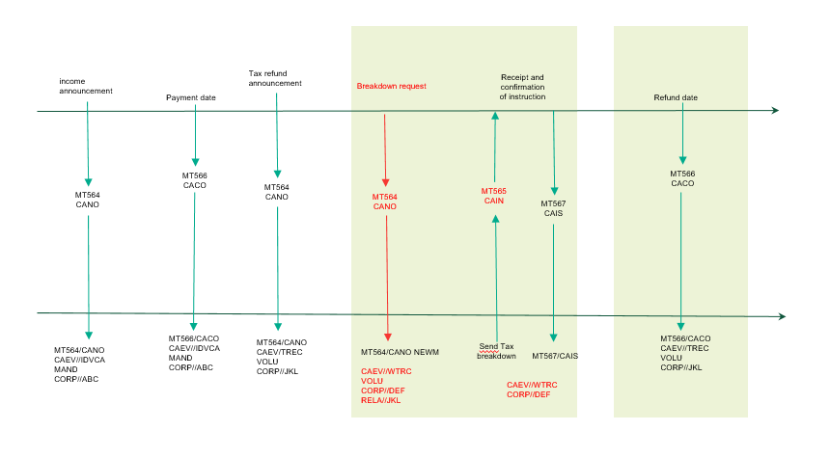

Scenario 2 – Using Multiple Options
  - the account servicer will announce a voluntary tax refund event (TREC) with as many CASH options as the tax rates that can be used to pay the refund (e.g. statutory rate, DTT rates, etc);
  - the account owner will send the tax breakdown via MT565/seev.033 quoting the event details (:22F::CAEV <> seev.031 031 – A / EventType] and [:20C::CORP <> seev.031 – A / CorporateActionEventIdentification], etc) of the tax refund event;
  - based on the SLA in place between the account servicer and account owner, the receipt of the instruction will be confirmed via MT567/seev.034;
  - if and when the tax refund has been paid by the tax authorities, the account servicer will pay the refund. The credit of the proceeds will be confirmed via a MT566/seev.036 reporting the TREC event details.

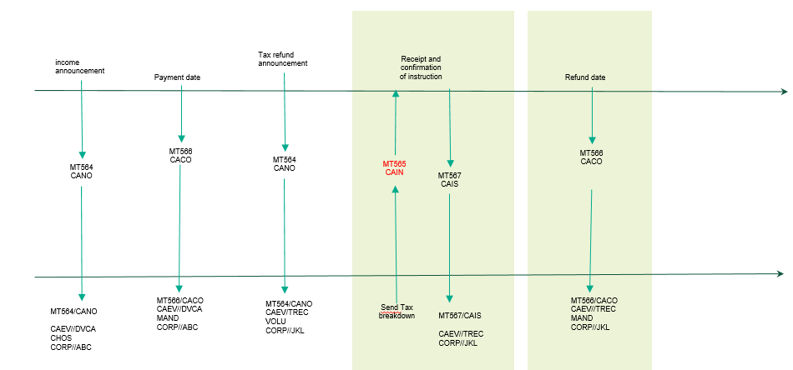

Recommendation for the usage of the new reason codes added to the “Pending” and “Rejected” statuses in the MT567/seev.034 Instruction Status Advice:
ITAX | Incorrect Tax Rate | Tax rate provided is incorrect. It falls outside the acceptable values for that investment country. | It should be used to inform the account owner that any of the tax rate indicated for a beneficial owner in the Beneficial Owner Details/BENODET sequence is incorrect.  As an example, with reference to our MT565 below, if the account owner reported a rate of 30%.
MTAX | Missing Tax Rate | Tax rate is missing. | It should be used to inform the account owner that any of the tax rate indicated for a beneficial owner in the Beneficial Owner Details/BENODET sequence is missing.  As an example, with reference to our MT565 below, if the account owner had reported no tax rate.
NTAX | Inconsistent Tax Rate | Tax rate is not consistent with the documentation in place. | It should be used to inform the account owner that any of the tax rate indicated for a beneficial owner in the Beneficial Owner Details/BENODET sequence is not aligned to the documentation in place.  As an example, with reference to our MT565 below, if the documentation in place for ABC123 made it entitled to a rate of 0% instead of 15%.

Message templates:

Scenario 1 – Using WRTC Event
  - MT564 TREC to announce the tax refund opportunity to all clients
:16R: |  | GENL
:20C:: |  | CORP//TRE3437592
:20C:: |  | SEME//253147815
:23G: |  | NEWM
:22F:: |  | CAEV//TREC
:22F:: |  | CAMV//VOLU
:25D:: |  | PROC//COMP
:16S: |  | GENL
:16R: |  | USECU
:35B: |  | ISIN IT0004982242
:16R: |  | ACCTINFO
:97A:: |  | SAFE//98-0112441-05
:93B:: |  | SETT//UNIT/4600,
:16S: |  | ACCTINFO
:16S: |  | USECU
:16R: |  | CADETL
:98A:: |  | RDTE//20YY0325
:16S: |  | CADETL
:16R: |  | CAOPTN
:13A:: |  | CAON//001
:22F:: |  | CAOP//CASH
:11A:: |  | OPTN//EUR
:17B:: |  | DFLT//N
:98B:: |  | RDDT//ONGO
:16R: |  | CASHMOVE
:22H:: |  | CRDB//CRED
:98B:: |  | PAYD//ONGO
:16S: |  | CASHMOVE
:16S: |  | CAOPTN
:16R: |  | CAOPTN
:13A:: |  | CAON//002
:22F:: |  | CAOP//NOAC
:17B:: |  | DFLT//Y
:98B:: |  | RDDT//ONGO
:16S: |  | CAOPTN

  - MT564 WTRC to announce the breakdown event to account owners having an omnibus account
:16R: | GENL
:20C:: | CORP//WTRC12345
:20C:: | SEME//253147816
:23G: | NEWM
:22F:: | CAEV//WTRC
:22F:: | CAMV//VOLU
:25D:: | PROC//COMP
:16R: | LINK
:13A:: | LINK//564
:20C:: | CORP// TRE3437592
:16S: | LINK
:16S: | GENL
:16R: | USECU
:35B: | ISIN IT0004982242
:16R: | ACCTINFO
:97A:: | SAFE//98-0112441-05
:93B:: | SETT//UNIT/4600,
:16S: | ACCTINFO
:16S: | USECU
:16R: | CAOPTN
:13A:: | CAON//001
:22F:: | CAOP//NOAC
:17B:: | DFLT//Y
:98B:: | RDDT//ONGO
:16S: | CAOPTN
:16R: | CAOPTN
:13A:: | CAON//002
:22F:: | CAOP//BOBD
:17B:: | DFLT//N
:98B:: | RDDT//ONGO
70E:: | ADTX//blablabla
:16S: | CAOPTN

  - MT565 sent by the account owner to instruct the tax breakdown on the WTRC
:16R: | GENL
:20C:: | CORP//WTRC12345
:20C:: | SEME//253147888
:23G: | NEWM
:22F:: | CAEV//WTRC
:16S: | GENL
:16R: | USECU
:35B: | ISIN IT0004982242
:16R: | ACCTINFO
:97A:: | SAFE//98-0112441-05
:93B:: | ELIG//UNIT/4600,
:16S: | ACCTINFO
:16S: | USECU
:16R: | BENODET
:95S:: | OWND/ /TXID/BE/ABCDEF1234567
:36B:: | OWND//UNIT/2600,
:92A:: | TAXR//15,
:16S: | BENODET
:16R: | BENODET
:95S:: | OWND/ /TXID/BE/GHIJKLM8901234
:36B:: | OWND//UNIT/2000,
:92A:: | TAXR//26,
:16S: | BENODET
:16R: | CAINST
:13A:: | CAON//002
:22F:: | CAOP//BOBD
:36B: | QINS//UNIT/4600,
:16S: | CAINST

Depending on the tax requirements per source investment country, the breakdown may be:
- Full disclosure breakdown – the account owner should provide (as illustrated in the above MT565 template):
  - details of the beneficial owner (e.g. name and address, tax ID, etc) – it is recommended that either all details are reported by repeating :95S::OWND or a unique reference pre-agreed with the account servicer is used instead,
  - quantity per beneficial owner,
  - applicable tax rate;
- rate breakdown – the account owner should provide (see below template):
  - quantity per tax rate,
  - tax rate:
:16R: | BENODET
:95V:: | OWND//NONREF
:36B:: | OWND//UNIT/2600,
:92A:: | TAXR//15,
:16S: | BENODET

Scenario 2 – Using Multiple Options
  - MT564 TREC to announce the refund with several options depending on the refund rates applicable to that event and security type:
:16R: | GENL
:20C:: | CORP//TRE3437592
:20C:: | SEME//253147815
:23G: | NEWM
:22F:: | CAEV//TREC
:22F:: | CAMV//VOLU
:25D:: | PROC//COMP
:16S: | GENL
:16R: | USECU
:35B: | ISIN IT0004982242
:16R: | ACCTINFO
:97A:: | SAFE//98-0112441-05
:93B:: | SETT//UNIT/4600,
:16S: | ACCTINFO
:16S: | USECU
:16R: | CAOPTN
:13A:: | CAON//001
:22F:: | CAOP//NOAC
:17B:: | DFLT//Y
:98B:: | RDDT//ONGO
:16S: | CAOPTN
:16R: | CAOPTN
:13A:: | CAON//002
:22F:: | CAOP//CASH
:11A:: | OPTN//EUR
:17B:: | DFLT//N
:98B:: | RDDT//ONGO
:16R: | CASHMOVE
:22H:: | CRDB//CRED
:98B:: | PAYD//ONGO
:92A:: | TXRC//11,
:16S: | CASHMOVE
:16S: | CAOPTN
:16R: | CAOPTN
:13A:: | CAON//003
:22F:: | CAOP//CASH
:11A:: | OPTN//EUR
:17B:: | DFLT//N
:98B:: | RDDT//ONGO
:16R: | CASHMOVE
:22H:: | CRDB//CRED
:98B:: | PAYD//ONGO
:92A:: | TXRC//26,
:16S: | CASHMOVE
:16S: | CAOPTN

  - MT565 sent by the account owner to instruct the tax breakdown (under the assumption we need a full disclosure breakdown)
:16R: | GENL
:20C:: | CORP// TRE3437592
:20C:: | SEME//253147888
:23G: | NEWM
:22F:: | CAEV//TREC
:16S: | GENL
:16R: | USECU
:35B: | ISIN IT0004982242
:16R: | ACCTINFO
:97A:: | SAFE//98-0112441-05
:93B:: | ELIG//UNIT/4600,
:16S: | ACCTINFO
:16S: | USECU
:16R: | BENODET
:95S: | OWND//TXID/BE/ ABCDEF1234567
:36B:: | OWND//UNIT/2600,
:92A:: | TAXR//15,
:16S: | BENODET
:16R: | CAINST
:13A:: | CAON//002
:22F:: | CAOP//CASH
:36B: | QINS//UNIT/2600,
:16S: | CAINST

:16R: | GENL
:20C:: | CORP// TRE3437592
:20C:: | SEME//253147899
:23G: | NEWM
:22F:: | CAEV//TREC
:16S: | GENL
:16R: | USECU
:35B: | ISIN IT0004982242
:16R: | ACCTINFO
:97A:: | SAFE//98-0112441-05
:93B:: | ELIG//UNIT/4600,
:16S: | ACCTINFO
:16S: | USECU
:16R: | BENODET
:95S:: | OWND/ /TXID/BE/GHIJKLM8901234
:36B:: | OWND//UNIT/2000,
:92A:: | TAXR//26,
:16S: | BENODET
:16R: | CAINST
:13A:: | CAON//003
:22F:: | CAOP//CASH
:36B: | QINS//UNIT/2000,
:16S: | CAINST

Management of Tax Breakdown Instructions on Optional Income Distribution Events

Relief at source
In some source investment countries that allow for a relief at source procedure (e.g. Italy), where the account owner has an omnibus account, prior to the income distribution record date/pay date, it has to inform the account servicer of the tax rates and breakdown of the eligible balance to be used to pay the income proceeds.
We have provided an overview of the way the income and tax breakdown should be managed in case of optional income distribution events (DVOP).

Process flow – Using WRTC Event
  - the account servicer will:
    - announce an optional income distribution event (DVOP);
    - for account owners having an omnibus account, a WTRC voluntary event will also be announced with a link to the income distribution. The WTRC event will have a “No Action” (NOAC) and a “Beneficial Owner Breakdown Request” (BOBD) option code indicator to request the tax rates to be used to pay the income proceeds (e.g. statutory rate, DTT rates, etc…);
  - the account owner will send the tax breakdown via MT565/seev.033 quoting the event details ([:22F::CAEV <> seev.031 – A / EventType] and [:20C::CORP <> seev.031 – A / CorporateActionEventIdentification], etc…) of the WTRC event;
  - the account owner will send the choice of income distribution via MT565/seev.033 quoting the event details ([:22F::CAEV <> seev.031 – A / EventType] and [:20C::CORP <> seev.031 – A / CorporateActionEventIdentification], etc…) of the DVOP event;
  - based on the SLA in place between the account servicer and account owner, the receipt of the instruction will be confirmed via MT567/seev.034;
  - on pay date, the account servicer will pay the income proceeds using the tax rates provided by the account owner. The credit of the proceeds will be confirmed via a MT566/seev.036 reporting the DVOP event details.

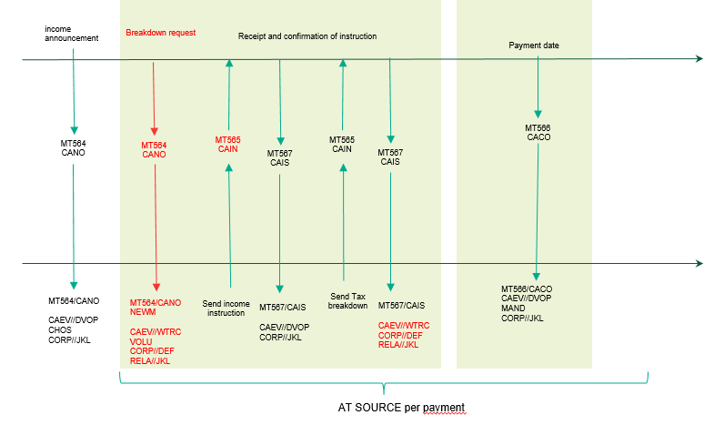

Message templates

  - MT564 DVOP to announce the optional dividend to all clients
:16R: | GENL
:20C:: | CORP//DIV3437599
:20C:: | SEME//253147815
:23G: | NEWM
:22F:: | CAEV//DVOP
:22F:: | CAMV//CHOS
:25D:: | PROC//COMP
:16S: | GENL
:16R: | USECU
:35B: | ISIN IT0005440877
:16R: | ACCTINFO
:97A:: | SAFE//98-0112441-05
:93B:: | SETT//UNIT/4600,
:16S: | ACCTINFO
:16S: | USECU
:16R: | CAOPTN
:13A:: | CAON//001
:22F:: | CAOP//CASH
:11A:: | OPTN//EUR
:17B:: | DFLT//Y
:98E:: | MKDT//20YY0321160000/00
:98E:: | RDDT//20YY0320160000/00
:16R: | SECMOVE
:22H:: | CRDB//DEBT
:35B: | ISIN IT0005440877
:98A:: | PAYD//20YY0325
:16S: | SECMOVE
:16R: | CASHMOVE
:22H:: | CRDB//CRED
:98A:: | PAYD//20YY0325
:92A:: | TAXR//26,
:92F:: | GRSS//EUR1,
:16S: | CASHMOVE
:16S: | CAOPTN
:16R: | CAOPTN
:13A:: | CAON//002
:22F:: | CAOP//SECU
:17B:: | DFLT//N
:98E:: | MKDT//20YY0321160000/00
:98E:: | RDDT//20YY0320160000/00
:92A:: | TAXR//26,
:16R: | SECMOVE
:22H:: | CRDB//DEBT
:35B: | ISIN IT0005440877
:98A:: | PAYD//20YY0325
:16S: | SECMOVE
:16R: | SECMOVE
:22H:: | CRDB//CRED
:35B: | ISIN IT0000218401
:22F:: | DISF/CINL
:90B:: | PRPP//EUR4,44
:90B:: | CINL//EUR4,44
:92K:: | NEWO//1/6
:98A:: | PAYD//20YY0325
:16S: | SECMOVE
:16S: | CAOPTN

Where the MT564 is sent to an account owner who has a proprietary or individually segregated account, where the tax status of the beneficial owner is known, the ratio to be reported in the NEWO should be the one calculated based on the tax treatment of the beneficial owner.
Instead, when the MT564 is sent to an account owner who has an omnibus account, the ratio to be reported in the NEWO should be the one calculated based on maximum tax rate applicable in that source investment country (in the above example, 26%).

  - MT564 WTRC to announce the breakdown event to account owners having an omnibus account
:16R: | GENL
:20C:: | CORP//WTRC12345
:20C:: | SEME//253147816
:23G: | NEWM
:22F:: | CAEV//WTRC
:22F:: | CAMV//VOLU
:25D:: | PROC//COMP
:16R: | LINK
:13A:: | LINK//564
:20C:: | CORP//DIV3437599
:16S: | LINK
:16S: | GENL
:16R: | USECU
:35B: | ISIN IT0005440877
:16R: | ACCTINFO
:97A:: | SAFE//98-0112441-05
:93B:: | SETT//UNIT/4600,
:16S: | ACCTINFO
:16S: | USECU
:16R: | CAOPTN
:13A:: | CAON//001
:22F:: | CAOP//NOAC
:17B:: | DFLT//Y
:98E:: | RDDT//20YY0320160000/00
:16S: | CAOPTN
:16R: | CAOPTN
:13A:: | CAON//002
:22F:: | CAOP//BOBD
:17B:: | DFLT//N
:98E:: | RDDT//20YY0320160000/00
:16S: | CAOPTN

  - MT565s sent by the account owner to instruct the choice between cash and/or securities
:16R: | GENL
:20C:: | CORP//DIV3437599
:20C:: | SEME//253147888
:23G: | NEWM
:22F:: | CAEV//DVOP
:16S: | GENL
:16R: | USECU
:35B: | ISIN IT0005440877
:16R: | ACCTINFO
:97A:: | SAFE//98-0112441-05
:93B:: | ELIG//UNIT/4600,
:16S: | ACCTINFO
:16S: | USECU
:16R: | CAINST
:13A:: | CAON//002
:22F:: | CAOP//SECU
:36B: | QINS//UNIT/2600,
:16S: | CAINST

Based on the SLA in place between the account servicer and account owner, the receipt of the instruction will be confirmed via MT567/seev.034.

  - MT565 sent by the account owner to instruct the tax breakdown – the account owner may send an MT565 per beneficial owner/tax rate or an MT565 repeating the beneficial owners in the BENODET sequence:
:16R: | GENL
:20C:: | CORP//WTRC12345
:20C:: | SEME//253147880
:23G: | NEWM
:22F:: | CAEV//WTRC
:16S: | GENL
:16R: | USECU
:35B: | ISIN IT0005440877
:16R: | ACCTINFO
:97A:: | SAFE//98-0112441-05
:93B:: | ELIG//UNIT/4600,
:16S: | ACCTINFO
:16S: | USECU
:16R: | BENODET
:95S:: | OWND//TXID/BE/ ABCDEF1234567
:36B:: | OWND//UNIT/2600,
:92A:: | TAXR//15,
:16S: | BENODET
:16R: | BENODET
:95S:: | OWND// TXID/BE/GHIJKLM8901234
:36B:: | OWND//UNIT/2000,
:92A:: | TAXR//26,
:16S: | BENODET
:16R: | CAINST
:13A:: | CAON//002
:22F:: | CAOP//BOBD
:36B: | QINS//UNIT/4600,
:16S: | CAINST

Based on the SLA in place between the account servicer and account owner, the receipt of the instruction will be confirmed via MT567/seev.034.

  - MT566 sent by the account servicer to confirm payment of the income proceeds using the tax rates provided by the account owner in the tax breakdown
Based on the instructions received, the account owner elected to:
- receive CASH for 2,000 securities to be taxed at 26%
  - gross dividend: €2,000.00 (2000 * €1 per share)
  - taxation: €520.00 (2000*€0.26 per share)

- re-invest in new securities for 2,600 interim securities, to be taxed at 15%
  - new securities: (2,600*€1*0.85)/4.44€ = 497.747748
  - tax applied: €390.00 (2,600*€1*0.15)
  - fractions: (497.747748-497)*€4.44 = €3.32

  - Payment of cash proceeds
:16R: | GENL
:20C:: | CORP//DIV3437599
:20C:: | SEME//253147820
:23G: | NEWM
:22F:: | CAEV//DVOP
:16S: | GENL
:16R: | USECU
:97A:: | SAFE//98-0112441-05
:35B: | ISIN IT0005440877
:93B:: | ELIG//UNIT/4600,
:93B:: | CONB//UNIT/2000,
:16S: | USECU
:16R: | CACONF
:13A:: | CAON//001
:22F:: | CAOP//CASH
:11A:: | OPTN//EUR
:16R: | SECMOVE
:22H:: | CRDB//DEBT
:35B: | ISIN IT0005440877
:36B:: | PSTA// UNIT/2000,
:98A:: | POST//20YY0325
:16S: | SECMOVE
:16R: | CASHMOVE
:22H:: | CRDB//CRED
:19B:: | GRSS//EUR2000,
:19B:: | TAXR//EUR520,
:19B:: | NETT//EUR1480,
:98A:: | POST//20YY0325
:92F:: | GRSS//EUR1,
:92A:: | TAXR//26,
:16S: | CASHMOVE
:16S: | CACONF

  - Payment of securities proceeds
:16R: | GENL
:20C:: | CORP//DIV3437599
:20C:: | SEME//253147820
:23G: | NEWM
:22F:: | CAEV//DVOP
:16S: | GENL
:16R: | USECU
:97A:: | SAFE//98-0112441-05
:35B: | ISIN IT0005440877
:93B:: | ELIG//UNIT/4600,
:93B:: | CONB//UNIT/2600,
:16S: | USECU
:16R: | CACONF
:13A:: | CAON//002
:22F:: | CAOP//SECU
:16R: | SECMOVE
:22H:: | CRDB//DEBT
:35B: | ISIN IT0005440877
:36B:: | PSTA// UNIT/2600,
:98A:: | POST//20YY0325
:16S: | SECMOVE
:16R: | SECMOVE
:22H:: | CRDB//CRED
:35B: | ISIN IT0000218401
:36B: | PSTA//UNIT/497,
:22F:: | DISF/CINL
:90B:: | PRPP//EUR4,44
:90B:: | CINL//EUR4,44
:92K:: | NEWO//1/5,22
:98A:: | POST//20YY0325
:16S: | SECMOVE
:16R: | CASHMOVE
:22H:: | CRDB//CRED
:19B:: | CINL//EUR3,32
:98A:: | POST//20YY0325
:16S: | CASHMOVE
:16S: | CACONF

In the MT566, the ratio to be reported in the NEWO should be the one calculated based on the tax treatment of the beneficial owner or the tax treatment defined by the account owner in the tax breakdown.

END OF DOCUMENT

Rules vary depending on the source investment country.
In some source investment countries, the tax rates are enough. In others, the details of the beneficial owners are also to be disclosed.
Account owners identify ultimate beneficial owners by virtue of their tax ID.
In this case, option R should be used along with an agreed DSS.
No tax refund rate has been indicated to allow the account servicer to manage all refunds, both under DTT and, where applicable, domestic law in the same event.
The record date of the TREC is intended as the pay date of the original taxable event.
Account owners identify ultimate beneficial owners by virtue of their tax ID.
Rules vary depending on the source investment country.
In some source investment countries, the tax rates are enough. In others, the details of the beneficial owners are also to be disclosed.
We only provide the announcement of the optional part of the DVOP where the interim securities (IT0005440877) are debited either against cash or securities (IT0000218401). Please refer to the general DVOP templates for the details of the distribution of entitlement (RHDI)

