CA476 – Joint Funds & CA Sub-Group

In the recent global SMPG, the investment funds working group had corporate actions on the agenda. In our discussions, it was agreed that the scope of the work is two-fold:

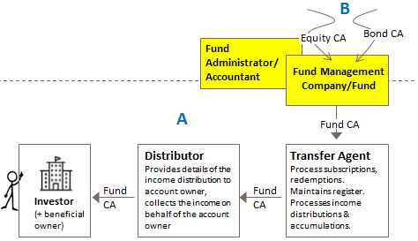

**Work Stream A**

This work was started several years ago, namely, the definition of the life-cycle of the agreed investment funds events, the assessment of the data requirement for each event, the comparison against the SMPG CA group's message usage guidelines. The first events in scope are the income events (cash dividend, stock dividend, dividend reinvestment, dividend option, accumulation.

**Work Stream B**

Within respect to income events (cash dividend, stock dividend, dividend reinvestment, dividend option, accumulation), the scope of the work in (B) is to:

* Look at the data received by the fund management company/fund administrator from the global custodian
* Look at the data required by the fund management company/fund administrator from the global custodian
* If necessary write guidelines on how to interpret corporate actions messages received by the fund management company so that there is correct interpretation of the data and of, therefore, the impact on the fund calculations, the correct differentiation of 'capital' and 'income/revenue' and ensuing corporate actions on the fund.
* If necessary, make suggestions to the SMPG CA working group on the relevant message usage guidelines published by the SMPG CA group for fine-tuning.

It quickly became apparent that the SMPG IF working group does not have the right resources to cover ‘work stream B’ and so we think we should set up a task-force. The delegates in such a task force will be comprised of representatives from the SMPG IF working group, and we would like to invite representatives from the SMPG CA WG working group. At least one or two fund management company/fund administrator type roles need to be part of this group (we have one such representative already).

The proposed name for this new group is 'Joint Funds & CA Sub-Group' and I will facilitate it. Could you propose some people that would be willing to sit on such a group, please. The group would meet for a finite number of sessions and then be disbanded. Ideally, if they have some knowledge on fund management, that would be very useful.