# CA480   GM seev.001 MP - "Reconfirm instructions" Indicator (Dan)

In the German Proxy Subgroup, we discussed, if a rejection of instructions by an Instruction Status Advice is necessary, in case of changes to an event whereby a reconfirmation of instructions is required:

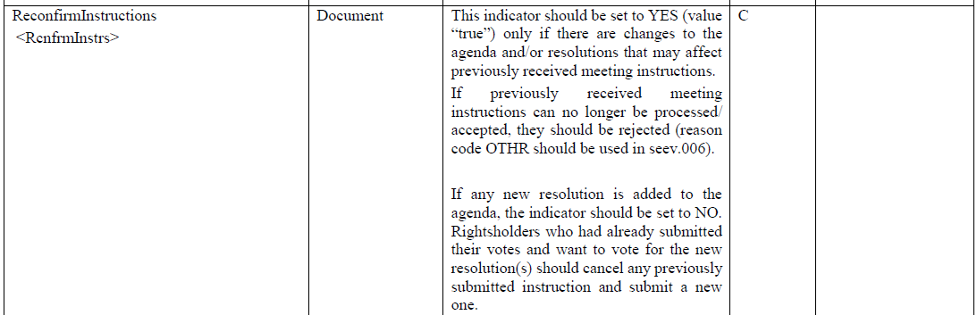

In the GMP I find that it is optional to send an Instruction Status Advice, but I could not find anything for a reconfirmation of instructions:

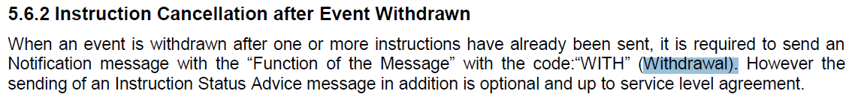

I would think that in case of a replacement a rejection of previous instructions should be send, as otherwise you could not be entirely sure which instructions that are sent shortly before/after the replacement remain valid (which is no question in case of a withdrawal of the event, of course).

But do you know, if there is anything in the GMP?