SMPG Corporate Actions
Tax Breakdown Market Practice
For ISO 15022 and ISO 20022 Standards

Disclaimer

The Securities Market Practice Group is a group of experts who devote their time on a voluntary basis to define global and local market practices for the benefit of the securities industry. The market practice documentation and recommendations produced by this organization are intended to solve common problems across the securities industry, from which financial institutions can derive clear benefits, to harmonize business processes and to facilitate the usage of message protocols ISO 15022 and ISO 20022. While the Securities Market Practice Group encourages the implementation of the market practices it develops, it is up to the financial institutions within each market to implement the market practices according to their needs and agreements with their business counterparts to support their businesses as efficient as possible.

Although the SMPG has used all reasonable efforts to ensure accuracy of the contents of this document, the SMPG assumes no liability whatsoever for any inadvertent errors or omissions that may appear thereon.
Moreover, the information is provided on an "as is" basis. The SMPG disclaims all warranties and conditions, either express or implied, including but not limited to implied warranties of merchantability, title, non-infringement and fitness for a particular purpose.
Neither the SMPG, nor any of its members and/or contributors shall be liable for any direct, indirect, special or consequential damages arising out of the use of the information published in this document, even if the SMPG or any of its members have been advised of the possibility of such damages.

Version: 1.1 DRAFT
Publication Date: November 2021
Update Implementation Date: 21 November 2021
Author: SMPG CA WG
Table of Contents
1 Introduction 3
1.1 Revision Record 3
1.2 Scope of this document 3
2 Relief at source 3
2.1 Scenario 1 3
2.2 Scenario 2 4
2.3 Message templates 6
2.3.1 Scenario 1: 6
2.3.2 Scenario 2: 9
3 Tax refund 12
3.1 Scenario 1 12
3.2 Scenario 2 13
3.3 Message templates: 14
3.3.1 Scenario 1 14
3.3.2 Scenario 2 17

Introduction

Revision Record
Version | Publication Date | Sections Affected | Description
V1.1 | May 2021 | All | SR2021 version and ISO 20022 enabled
V1.0 | 15 Dec. 2020 | n/a | Initial version

Scope of this document
Based on previous discussions at the SMPG Tax Working Group, we have identified two methods currently used by account servicers to collect tax breakdown information, either prior to (relief at source scenario) or after (tax refund scenario) an income distribution:
- Using a Withholding Tax Relief Certification (WTRC) event, linked to the income distribution event;
- Including multiple options, one per tax rate, in the income distribution event.
Although the SMPG Tax Working Group was unable to reach consensus on the method to be recommended, it agreed that scenario 1 should be the preferred method for any institution that is approaching this process ex-novo.
Account owners can provide a tax breakdown using a MT565 message, whose content depends on the event type that was used in the breakdown request.

Relief at source
In some source investment countries that allow for a relief at source procedure (e.g. Italy), where the account owner has an omnibus account, prior to the income distribution record date/pay date, it has to inform the account servicer of the tax rates and breakdown of the eligible balance to be used to pay the income proceeds.
We have provided an overview of the way the income and tax breakdown should be managed, according to both methods described in the introduction to this market practice, in case of mandatory income distribution events (Interest Payment [INTR] or Cash Distribution [DVCA]):

Scenario 1
  - the account servicer will:
    - announce a mandatory income distribution event (Interest Payment [INTR] or Cash Distribution [DVCA]);
    - for account owners having an omnibus account, a WTRC voluntary event will also be announced with a link to the mandatory income distribution. The WTRC event will have a “No Action” (NOAC) and a “Beneficial Owner Breakdown Request” (BOBD) option code indicator to request the tax rates to be used to pay the income proceeds (e.g. statutory rate, DTT rates, etc…);
  - the account owner will send the tax breakdown via MT565/seev.033 quoting the event details ([:22F::CAEV <> seev.031 – A / EventType] and [:20C::CORP <> seev.031 – A / CorporateActionEventIdentification], etc…) of the WTRC event;
  - based on the SLA in place between the account servicer and account owner, the receipt of the instruction will be confirmed via MT567/seev.034;
  - on pay date, the account servicer will pay the income proceeds using the tax rates provided by the account owner. The credit of the proceeds will be confirmed via a MT566/seev.036 reporting the INTR/DVCA event details.
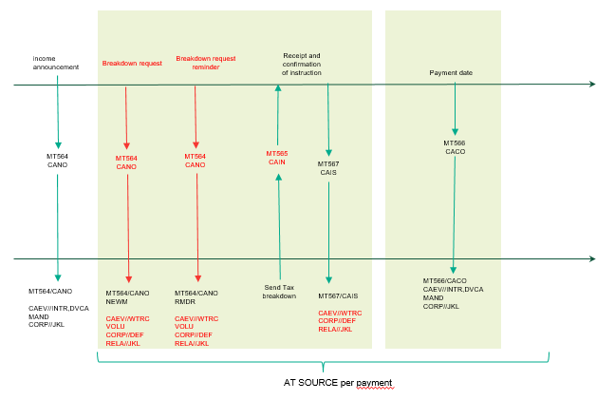

Scenario 2
  - the account servicer will announce a choice income distribution event (Interest Payment [INTR] or Cash Distribution [DVCA]) with as many CASH options as the tax rates that can be used to pay the income proceeds (e.g. statutory rate, DTT rates, etc);
  - the account owner will send the tax breakdown via MT565 / seev.033 quoting the event details (:22F::CAEV <> seev.031 – A / EventType] and [:20C::CORP <> seev.031 – A / CorporateActionEventIdentification],, etc) of the income event;
  - based on the SLA in place between the account servicer and account owner, the receipt of the instruction will be confirmed via MT567/seev.034;
  - on pay date, the account servicer will pay the income proceeds using the tax rates provided by the account owner. The credit of the proceeds will be confirmed via a MT566/seev.036 reporting the INTR/DVCA event details.

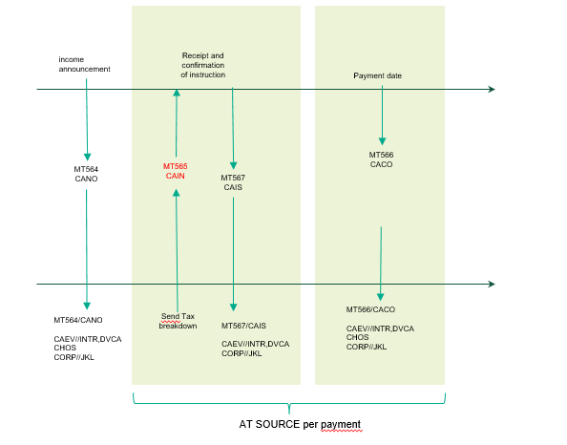

Recommendation for the usage of the new reason codes added to the “Pending” and “Rejected” statuses in the MT567/seev.034 Instruction Status Advice:
ITAX | Incorrect Tax Rate | Tax rate provided is incorrect. It falls outside the acceptable values for that investment country. | It should be used to inform the account owner that any of the tax rate indicated for a beneficial owner in the Beneficial Owner Details/BENODET sequence is incorrect.  As an example, with reference to our MT565 below, if the account owner reported a rate of 30%.
MTAX | Missing Tax Rate | Tax rate is missing. | It should be used to inform the account owner that any of the tax rate indicated for a beneficial owner in the Beneficial Owner Details/BENODET sequence is missing.  As an example, with reference to our MT565 below, if the account owner had reported no tax rate.
NTAX | Inconsistent Tax Rate | Tax rate is not consistent with the documentation in place. | It should be used to inform the account owner that any of the tax rate indicated for a beneficial owner in the Beneficial Owner Details/BENODET sequence is not aligned to the documentation in place.  As an example, with reference to our MT565 below, if the documentation in place for ABC123 made it entitled to a rate of 0% instead of 15%.

Message templates

Scenario 1:
  - MT564 DVCA to announce the mandatory dividend to all clients
:16R: |  | GENL
:20C:: |  | CORP//DIV3437592
:20C:: |  | SEME//253147815
:23G: |  | NEWM
:22F:: |  | CAEV//DVCA
:22F:: |  | CAMV//MAND
:25D:: |  | PROC//COMP
:16S: |  | GENL
:16R: |  | USECU
:35B: |  | ISIN IT0004982242
:16R: |  | ACCTINFO
:97A:: |  | SAFE//98-0112441-05
:93B:: |  | SETT//UNIT/4600,
:16S: |  | ACCTINFO
:16S: |  | USECU
:16R: |  | CADETL
:98A:: |  | XDTE//20YY0323
:98A:: |  | RDTE//20YY0324
:16S: |  | CADETL
:16R: |  | CAOPTN
:13A:: |  | CAON//001
:22F:: |  | CAOP//CASH
:11A:: |  | OPTN//EUR
:17B:: |  | DFLT//Y
:16R: |  | CASHMOVE
:22H:: |  | CRDB//CRED
:98A:: |  | PAYD//20YY0325
:92A:: |  | TAXR//26,
:92F:: |  | GRSS//EUR1,
:16S: |  | CASHMOVE
:16S: |  | CAOPTN
  - MT564 WTRC to announce the breakdown event to account owners having an omnibus account
:16R: | GENL
:20C:: | CORP//WTRC12345
:20C:: | SEME//253147816
:23G: | NEWM
:22F:: | CAEV//WTRC
:22F:: | CAMV//VOLU
:25D:: | PROC//COMP
:16R: | LINK
:13A:: | LINK//564
:20C:: | CORP//DIV3437592
:16S: | LINK
:16S: | GENL
:16R: | USECU
:35B: | ISIN IT0004982242
:16R: | ACCTINFO
:97A:: | SAFE//98-0112441-05
:93B:: | SETT//UNIT/4600,
:16S: | ACCTINFO
:16S: | USECU
:16R: | CAOPTN
:13A:: | CAON//001
:22F:: | CAOP//NOAC
:17B:: | DFLT//Y
:98E:: | RDDT//20YY0324160000/00
:16S: | CAOPTN
:16R: | CAOPTN
:13A:: | CAON//002
:22F:: | CAOP//BOBD
:17B:: | DFLT//N
:98E:: | RDDT//20YY0324160000/00
:70E:: | ADTX//blablabla
:16S: | CAOPTN

  - MT565 sent by the account owner to instruct the tax breakdown – the account owner may send an MT565 per beneficial owner/tax rate or an MT565 repeating the beneficial owners in the BENODET sequence:
:16R: | GENL
:20C:: | CORP//WTRC12345
:20C:: | SEME//253147888
:23G: | NEWM
:22F:: | CAEV//WTRC
:16S: | GENL
:16R: | USECU
:35B: | ISIN IT0004982242
:16R: | ACCTINFO
:97A:: | SAFE//98-0112441-05
:93B:: | ELIG//UNIT/4600,
:16S: | ACCTINFO
:16S: | USECU
:16R: | BENODET
:95S:: | OWND//TXID/BE/ ABCDEF1234567
:36B:: | OWND//UNIT/2600,
:92A:: | TAXR//15,
:16S: | BENODET
:16R: | BENODET
:95S:: | OWND// TXID/BE/GHIJKLM8901234
:36B:: | OWND//UNIT/2000,
:92A:: | TAXR//26,
:16S: | BENODET
:16R: | CAINST
:13A:: | CAON//002
:22F:: | CAOP//BOBD
:36B: | QINS//UNIT/4600,
:16S: | CAINST

Depending on the tax requirements per source investment country, the breakdown may be:
- Full Disclosure Breakdown – the account owner should provide (as illustrated in the above MT565 template):
  - details of the beneficial owner (e.g. name and address, tax ID, etc) – it is recommended that either all details are reported by repeating :95S::OWND or a unique reference pre-agreed with the account servicer is used instead,
  - quantity per beneficial owner,
  - applicable tax rate;

- Rate Breakdown – the account owner should provide (see below template):
  - quantity per tax rate,
  - tax rate:
:16R: | BENODET
:95V:: | OWND//NONREF
:36B:: | OWND//UNIT/2600,
:92A:: | TAXR//15,
:16S: | BENODET

In a full disclosure breakdown scenario, the account owner may not want to disclose beneficial owners that are taxable at statutory rate. However, to facilitate the reconciliation process, it is recommended the account owner provide an instruction for their total holding without disclosing their details, as per the below example:
:16R: | BENODET
:95V:: | OWND//NONREF
:36B:: | OWND//UNIT/2000,
:92A:: | TAXR//26,
:16S: | BENODET
  - The account servicer will pay the income proceeds using the quantities and tax rates provided by the account owner in the MT565.

The MT566 should be issued using the event details of the DVCA (e.g. CORP//DIV3437592). The account servicer issues:
- either one MT566 per tax rate, or
- one MT566 with repeating movements, one movement per tax rate.

Scenario 2:
  - MT564 DVCA to announce the dividend with several options depending on the tax rates applicable to that event and security type:
:16R: | GENL
:20C:: | CORP//DIV3437592
:20C:: | SEME//253147815
:23G: | NEWM
:22F:: | CAEV//DVCA
:22F:: | CAMV//CHOS
:25D:: | PROC//COMP
:16S: | GENL
:16R: | USECU
:35B: | ISIN IT0004982242
:16R: | ACCTINFO
:97A:: | SAFE//98-0112441-05
:93B:: | SETT//UNIT/4600,
:16S: | ACCTINFO
:16S: | USECU
:16R: | CADETL
:98A:: | XDTE//20YY0323
:98A:: | RDTE//20YY0324
:16S: | CADETL
:16R: | CAOPTN
:13A:: | CAON//001
:22F:: | CAOP//CASH
:11A:: | OPTN//EUR
:17B:: | DFLT//Y
:98E:: | RDDT//20YY0324160000/00
:16R: | CASHMOVE
:22H:: | CRDB//CRED
:98A:: | PAYD//20YY0325
:92A:: | TAXR//26,
:92F:: | GRSS//EUR1,
:16S: | CASHMOVE
:16S: | CAOPTN
:16R: | CAOPTN
:13A:: | CAON//002
:22F:: | CAOP//CASH
:11A:: | OPTN//EUR
:17B:: | DFLT//N
:98E:: | RDDT//20YY0324160000/00
:16R: | CASHMOVE
:22H:: | CRDB//CRED
:98A:: | PAYD//20YY0325
:92A:: | TAXR//15,
:92F:: | GRSS//EUR1,
:16S: | CASHMOVE
:16S: | CAOPTN
:16R: | CAOPTN
:13A:: | CAON//003
:22F:: | CAOP//CASH
:11A:: | OPTN//EUR
:17B:: | DFLT//N
:98E:: | RDDT//20YY0324160000/00
:16R: | CASHMOVE
:22H:: | CRDB//CRED
:98A:: | PAYD//20YY0325
:92A:: | TAXR//0,
:92F:: | GRSS//EUR1,
:16S: | CASHMOVE
:16S: | CAOPTN

  - MT565 sent by the account owner to instruct the tax breakdown (under the assumption we need a full disclosure breakdown)
:16R: | GENL
:20C:: | CORP// DIV3437592
:20C:: | SEME//253147888
:23G: | NEWM
:22F:: | CAEV//DVCA
:16S: | GENL
:16R: | USECU
:35B: | ISIN IT0004982242
:16R: | ACCTINFO
:97A:: | SAFE//98-0112441-05
:93B:: | ELIG//UNIT/4600,
:16S: | ACCTINFO
:16S: | USECU
:16R: | BENODET
:95S: | OWND//TXID/BE/ ABCDEF1234567
:36B: | OWND//UNIT/2600,
:92A:: | TAXR//15,
:16S: | BENODET
:16R: | CAINST
:13A:: | CAON//002
:22F:: | CAOP//CASH
:36B: | QINS//UNIT/2600,
:16S: | CAINST

:16R: | GENL
:20C:: | CORP// DIV3437592
:20C:: | SEME//253147888
:23G: | NEWM
:22F:: | CAEV//DVCA
:16S: | GENL
:16R: | USECU
:35B: | ISIN IT0004982242
:16R: | ACCTINFO
:97A:: | SAFE//98-0112441-05
:93B:: | ELIG//UNIT/4600,
:16S: | ACCTINFO
:16S: | USECU
:16R: | BENODET
:95S:: | OWND// TXID/BE/GHIJKLM8901234
:36B:: | OWND//UNIT/2000,
:92A:: | TAXR//26,
:16S: | BENODET
:16R: | CAINST
:13A:: | CAON//001
:22F:: | CAOP//CASH
:36B: | QINS//UNIT/2000,
:16S: | CAINST

  - The account servicer will pay the income proceeds using the quantities and tax rates provided by the account owner in the MT565.
The MT566 should be issued using the event details of the DVCA (e.g. CORP//DIV3437592) with payments per option.

Tax refund
In those source investment countries that allow for a tax refund procedure (e.g. Austria), when submitting a tax refund application to the account servicer, where the account owner has an omnibus account, it has to inform the account servicer of how the eligible balance should be broken down amongst all end investors, to process the tax refund applications.
We have provided an overview of the way the tax breakdown should be managed according to both methods described in the introduction to this market practice:

Scenario 1
  - the account servicer will:
    - announce a mandatory tax refund event (Tax Reclaim [TREC]);
    - for account owners having an omnibus account, a WTRC voluntary event will also be announced with a link to the tax refund event. The WTRC event will have a “No Action” (NOAC) and a “Beneficial Owner Breakdown Request” (BOBD) option code indicator to request the tax rates to be used to pay the income proceeds (e.g. statutory rate, DTT rates, etc);
  - the account owner will send the tax breakdown via MT565/seev.033 quoting the event details ([:22F::CAEV <> seev.031 – A / EventType] and [:20C::CORP <> seev.031 – A / CorporateActionEventIdentification], etc) of the WTRC event;
  - based on the SLA in place between the account servicer and account owner, the receipt of the instruction will be confirmed via MT567/seev.034;
  - if and when the tax refund has been paid by the tax authorities, the account servicer will pay the refund. The credit of the proceeds will be confirmed via a MT566/seev.036 reporting the TREC event details.
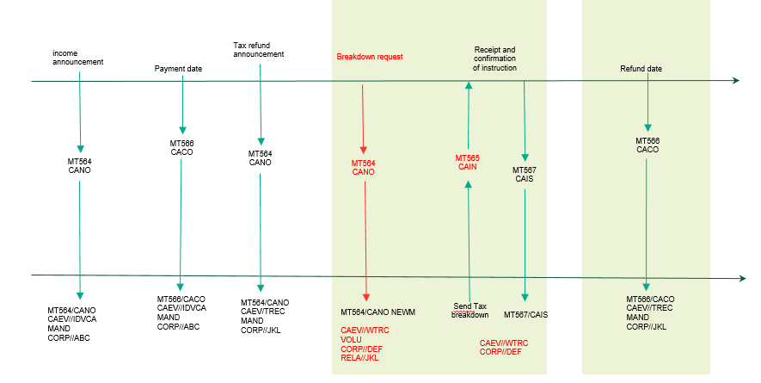

Scenario 2
  - the account servicer will announce a voluntary tax refund event (TREC) with as many CASH options as the tax rates that can be used to pay the refund (e.g. statutory rate, DTT rates, etc);
  - the account owner will send the tax breakdown via MT565/seev.033 quoting the event details (:22F::CAEV <> seev.031 031 – A / EventType] and [:20C::CORP <> seev.031 – A / CorporateActionEventIdentification], etc) of the tax refund event;
  - based on the SLA in place between the account servicer and account owner, the receipt of the instruction will be confirmed via MT567/seev.034;
  - if and when the tax refund has been paid by the tax authorities, the account servicer will pay the refund. The credit of the proceeds will be confirmed via a MT566/seev.036 reporting the TREC event details.

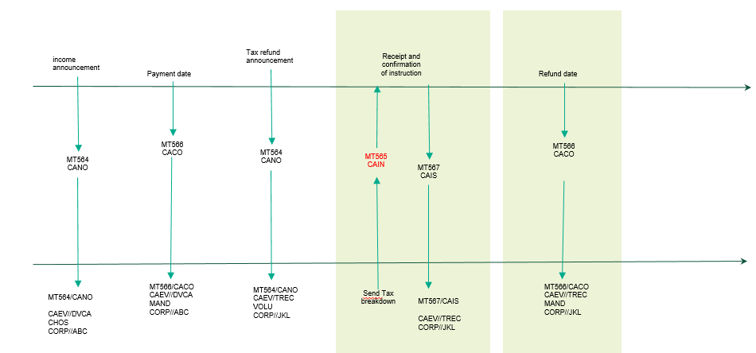

Recommendation for the usage of the new reason codes added to the “Pending” and “Rejected” statuses in the MT567/seev.034 Instruction Status Advice:
ITAX | Incorrect Tax Rate | Tax rate provided is incorrect. It falls outside the acceptable values for that investment country. | It should be used to inform the account owner that any of the tax rate indicated for a beneficial owner in the Beneficial Owner Details/BENODET sequence is incorrect.  As an example, with reference to our MT565 below, if the account owner reported a rate of 30%.
MTAX | Missing Tax Rate | Tax rate is missing. | It should be used to inform the account owner that any of the tax rate indicated for a beneficial owner in the Beneficial Owner Details/BENODET sequence is missing.  As an example, with reference to our MT565 below, if the account owner had reported no tax rate.
NTAX | Inconsistent Tax Rate | Tax rate is not consistent with the documentation in place. | It should be used to inform the account owner that any of the tax rate indicated for a beneficial owner in the Beneficial Owner Details/BENODET sequence is not aligned to the documentation in place.  As an example, with reference to our MT565 below, if the documentation in place for ABC123 made it entitled to a rate of 0% instead of 15%.

Message templates:

Scenario 1
  - MT564 TREC to announce the tax refund opportunity to all clients
:16R: |  | GENL
:20C:: |  | CORP//TRE3437592
:20C:: |  | SEME//253147815
:23G: |  | NEWM
:22F:: |  | CAEV//TREC
:22F:: |  | CAMV//VOLU
:25D:: |  | PROC//COMP
:16S: |  | GENL
:16R: |  | USECU
:35B: |  | ISIN IT0004982242
:16R: |  | ACCTINFO
:97A:: |  | SAFE//98-0112441-05
:93B:: |  | SETT//UNIT/4600,
:16S: |  | ACCTINFO
:16S: |  | USECU
:16R: |  | CADETL
:98A:: |  | RDTE//20YY0325
:16S: |  | CADETL
:16R: |  | CAOPTN
:13A:: |  | CAON//001
:22F:: |  | CAOP//CASH
:11A:: |  | OPTN//EUR
:17B:: |  | DFLT//N
:98B:: |  | RDDT//ONGO
:16R: |  | CASHMOVE
:22H:: |  | CRDB//CRED
:98B:: |  | PAYD//ONGO
:16S: |  | CASHMOVE
:16S: |  | CAOPTN
:16R: |  | CAOPTN
:13A:: |  | CAON//002
:22F:: |  | CAOP//NOAC
:17B:: |  | DFLT//Y
:98B:: |  | RDDT//ONGO
:16S: |  | CAOPTN

  - MT564 WTRC to announce the breakdown event to account owners having an omnibus account
:16R: | GENL
:20C:: | CORP//WTRC12345
:20C:: | SEME//253147816
:23G: | NEWM
:22F:: | CAEV//WTRC
:22F:: | CAMV//VOLU
:25D:: | PROC//COMP
:16R: | LINK
:13A:: | LINK//564
:20C:: | CORP// TRE3437592
:16S: | LINK
:16S: | GENL
:16R: | USECU
:35B: | ISIN IT0004982242
:16R: | ACCTINFO
:97A:: | SAFE//98-0112441-05
:93B:: | SETT//UNIT/4600,
:16S: | ACCTINFO
:16S: | USECU
:16R: | CAOPTN
:13A:: | CAON//001
:22F:: | CAOP//NOAC
:17B:: | DFLT//Y
:98B:: | RDDT//ONGO
:16S: | CAOPTN
:16R: | CAOPTN
:13A:: | CAON//002
:22F:: | CAOP//BOBD
:17B:: | DFLT//N
:98B:: | RDDT//ONGO
70E:: | ADTX//blablabla
:16S: | CAOPTN

  - MT565 sent by the account owner to instruct the tax breakdown on the WTRC
:16R: | GENL
:20C:: | CORP//WTRC12345
:20C:: | SEME//253147888
:23G: | NEWM
:22F:: | CAEV//WTRC
:16S: | GENL
:16R: | USECU
:35B: | ISIN IT0004982242
:16R: | ACCTINFO
:97A:: | SAFE//98-0112441-05
:93B:: | ELIG//UNIT/4600,
:16S: | ACCTINFO
:16S: | USECU
:16R: | BENODET
:95S:: | OWND/ /TXID/BE/ABCDEF1234567
:36B:: | OWND//UNIT/2600,
:92A:: | TAXR//15,
:16S: | BENODET
:16R: | BENODET
:95S:: | OWND/ /TXID/BE/GHIJKLM8901234
:36B:: | OWND//UNIT/2000,
:92A:: | TAXR//26,
:16S: | BENODET
:16R: | CAINST
:13A:: | CAON//002
:22F:: | CAOP//BOBD
:36B: | QINS//UNIT/4600,
:16S: | CAINST

Depending on the tax requirements per source investment country, the breakdown may be:
- Full disclosure breakdown – the account owner should provide (as illustrated in the above MT565 template):
  - details of the beneficial owner (e.g. name and address, tax ID, etc) – it is recommended that either all details are reported by repeating :95S::OWND or a unique reference pre-agreed with the account servicer is used instead,
  - quantity per beneficial owner,
  - applicable tax rate;
- rate breakdown – the account owner should provide (see below template):
  - quantity per tax rate,
  - tax rate:
:16R: | BENODET
:95V:: | OWND//NONREF
:36B:: | OWND//UNIT/2600,
:92A:: | TAXR//15,
:16S: | BENODET

Scenario 2
  - MT564 TREC to announce the refund with several options depending on the refund rates applicable to that event and security type:
:16R: | GENL
:20C:: | CORP//TRE3437592
:20C:: | SEME//253147815
:23G: | NEWM
:22F:: | CAEV//TREC
:22F:: | CAMV//VOLU
:25D:: | PROC//COMP
:16S: | GENL
:16R: | USECU
:35B: | ISIN IT0004982242
:16R: | ACCTINFO
:97A:: | SAFE//98-0112441-05
:93B:: | SETT//UNIT/4600,
:16S: | ACCTINFO
:16S: | USECU
:16R: | CAOPTN
:13A:: | CAON//001
:22F:: | CAOP//NOAC
:17B:: | DFLT//Y
:98B:: | RDDT//ONGO
:16S: | CAOPTN
:16R: | CAOPTN
:13A:: | CAON//002
:22F:: | CAOP//CASH
:11A:: | OPTN//EUR
:17B:: | DFLT//N
:98B:: | RDDT//ONGO
:16R: | CASHMOVE
:22H:: | CRDB//CRED
:98B:: | PAYD//ONGO
:92A:: | TXRC//11,
:16S: | CASHMOVE
:16S: | CAOPTN
:16R: | CAOPTN
:13A:: | CAON//003
:22F:: | CAOP//CASH
:11A:: | OPTN//EUR
:17B:: | DFLT//N
:98B:: | RDDT//ONGO
:16R: | CASHMOVE
:22H:: | CRDB//CRED
:98B:: | PAYD//ONGO
:92A:: | TXRC//26,
:16S: | CASHMOVE
:16S: | CAOPTN

  - MT565 sent by the account owner to instruct the tax breakdown (under the assumption we need a full disclosure breakdown)
:16R: | GENL
:20C:: | CORP// TRE3437592
:20C:: | SEME//253147888
:23G: | NEWM
:22F:: | CAEV//TREC
:16S: | GENL
:16R: | USECU
:35B: | ISIN IT0004982242
:16R: | ACCTINFO
:97A:: | SAFE//98-0112441-05
:93B:: | ELIG//UNIT/4600,
:16S: | ACCTINFO
:16S: | USECU
:16R: | BENODET
:95S: | OWND//TXID/BE/ ABCDEF1234567
:36B:: | OWND//UNIT/2600,
:92A:: | TAXR//15,
:16S: | BENODET
:16R: | CAINST
:13A:: | CAON//002
:22F:: | CAOP//CASH
:36B: | QINS//UNIT/2600,
:16S: | CAINST

:16R: | GENL
:20C:: | CORP// TRE3437592
:20C:: | SEME//253147899
:23G: | NEWM
:22F:: | CAEV//TREC
:16S: | GENL
:16R: | USECU
:35B: | ISIN IT0004982242
:16R: | ACCTINFO
:97A:: | SAFE//98-0112441-05
:93B:: | ELIG//UNIT/4600,
:16S: | ACCTINFO
:16S: | USECU
:16R: | BENODET
:95S:: | OWND/ /TXID/BE/GHIJKLM8901234
:36B:: | OWND//UNIT/2000,
:92A:: | TAXR//26,
:16S: | BENODET
:16R: | CAINST
:13A:: | CAON//003
:22F:: | CAOP//CASH
:36B: | QINS//UNIT/2000,
:16S: | CAINST

END OF DOCUMENT

Rules vary depending on the source investment country.
In some source investment countries, the tax rates are enough. In others, the details of the beneficial owners are also to be disclosed.
Account owners identify ultimate beneficial owners by virtue of their tax ID.
In this case, option R should be used along with an agreed DSS.
No tax refund rate has been indicated to allow the account servicer to manage all refunds, both under DTT and, where applicable, domestic law in the same event.
The record date of the TREC is intended as the pay date of the original taxable event.
Account owners identify ultimate beneficial owners by virtue of their tax ID.

