Request: Add a new CAEV SWFT code, RCLA, to support the announcement of an Income Reclassification event. (Data Rule: Must use “linkage” rules to link back to original event.) to replace the usage of OTHR when announcing a tax reclassification. The following scenarios detail when the RCLA event type would be utilized.
Also we would request a rule that linkages should be present to the original event.
Benefits: Better routing, clear identification of Reclass vs all ‘OTHR’ events, creates STP
Current Scenarios:
- During the calendar year, distributions by U.S. entities paid to non-U.S. persons are treated as dividends (DVCA) for U.S. tax purposes and subject to U.S. withholding tax. Shortly after year-end, U.S. entities review their calendar year distributions to determine if any or all the distributions should be reclassified as non-taxable returns of capital, capital gains, and when permissible, portfolio interest. This could result in a refunding of tax withheld on the original DVCA event and 1042S reporting updates. We typically see this on Real Estate Investment Trusts (REITs) and Regulated Investment Companies (“RICs”).

- Some distributions by U.S. entities paid to non-U.S. persons can have multiple classifications for U.S. tax purposes and be subject to different rates of withholding and the classification is known at the time of the distribution and not subject to change. For example, a portion of a distribution can be considered dividend income and subject to a 30% US withholding tax, and the remainder of the distribution could be considered non-taxable and not subject to US withholding tax. We typically see this on publicly traded partnerships (“PTPs”) and structured notes.

- Similar to #1 above, issuers can provide a reasonable estimate that a portion of a distribution is a return of capital, capital gains, interest, etc.. at the time of a distribution. Intermediaries may rely on these estimates for US tax withholding purposes to reduce the amount of withholding at the time of a distribution and not wait until after year end. We typically these estimates on Real Estate Investment Trusts (REITs) and Regulated Investment Companies (“RICs”) and corporations with little or no earnings.

Examples for Scenario 1:
ISIN: US3623971013 - GABELLI EQUITY TRUST makes quarterly distributions, which are treated as dividends and subject to US tax withholding
Pay Dates : 3/24/2023, 6/23/2023, 9/22/2023, 12/22/2023
Dividend Cash Rate: 0.15
IRS Income Code = 06
Subject to US Tax Withholding

Shortly after year-end, ISIN: US3623971013 - GABELLI EQUITY TRUST finalizes their books and determines the original dividend of 0.15 should be reclassified as the following:

Pay Dates : 3/24/2023, 6/23/2023, 9/22/2023, 12/22/2023
Dividend Cash Rate: 0.0099
IRS Income Code = 06
Subject to US Tax Withholding

Return of Capital Cash Rate: 0.0696
IRS Income Code = 37
Not Subject to US Tax Withholding (eligible for a refund)

LTCG Cash Rate: 0.0705
IRS Income Code = 36
Not Subject to US Tax Withholding (eligible for a refund)

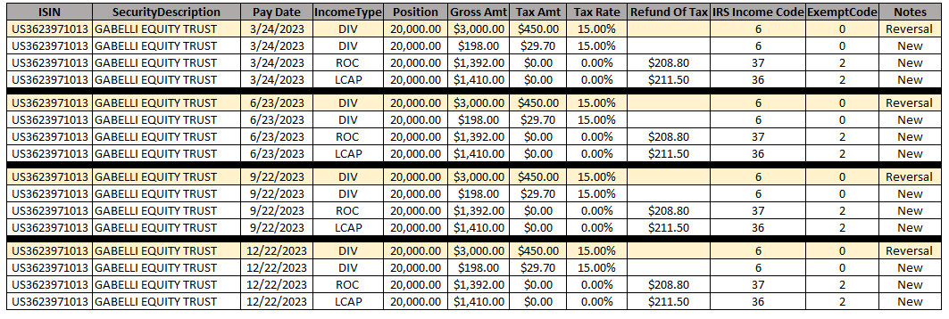

OUTBOUND MT 564 SWIFT MESSAGE

