CA525 – Pagination for seev.031, 035, 036
Change in GMP1

Pagination and Linkages for multi-parts MT564 (seev.031 / seev.035) & linked MT 568 Announcements
.

3.7.5.1 Scenario 1 – Multiple Paginated MT 564 (seev.031 / seev.035)
For long notification or movement preliminary advice messages for which the length would overcome the maximum network payload size limit (for instance 10K characters on SWIFTNet FIN or 100 KB on SwiftNet Interact or FINplus for the payload), a pagination mechanism is available through the use of the Pagination element (filed :28E: for ISO 15022) present at the top of these messages.
This could occur for instance if there are 10s or 100s of different options to choose from within a given event or if a long list of 100s or 1000s of account and account owners must be provided or if very long narrative text must be provided.
In this case, accounts or options or long narrative information could eventually be split amongst several multi-parts linked notification or movement preliminary advice messages.
The splitting of the information contents within the notification or movement preliminary advice should follow the following guidelines (see section 1.4 for references to ISO 20022 sequences identification):
- If sequence B2 has too much account information (i.e. account bulking - many accounts repetitions of seq. B2)
- Fill the notification or movement preliminary advice with all A, B, D, E and F sequences and add as many B2 sequences that can fit, and
- send all A, B, D, E and F sequences as in the first notification or movement preliminary advice plus the additional B2 sequences in the following notification or movement preliminary advice(s) messages)

- If sequence E has too much options information (many Options present)
- fill the notification or movement preliminary advice with all A, B, D and F sequences and add as many E sequences that can fit, and (i.e. seq. A+B+D+E¹+F)
- send all A, B, D and F sequences as in the first notification or movement preliminary advice plus the additional E sequences in the next MT564(s) (i.e. seq. A+B+D+E²+F followed by A+B+D+E³+F etc…).

- If there are both too much accounts repetition and options information, it is recommended not to bulk on an account level.

- The Page Number field (in :28E:Page Number/Continuation Indicator in MT 564 sequence A or in the seev.031 / seev.035 in the Pagination/PageNumber element) must start at page “1” and must be incremented by 1 for each subsequent pages.

In addition, all notification or movement preliminary advice messages in the multi-parts chain of notification or movement preliminary advice messages must link back to the previous notification or movement preliminary advice message in the chain using the Previous Notification Identification (PREV reference) and all notification or movement preliminary advice message in the multi-parts chain of MT564 must also be linked through the usage of the Pagination (28E) field.
With the exception of the first notification or movement preliminary advice message in the chain of multipart notification or movement preliminary advice message, all other notification or movement preliminary advice message (REPL or REPE) messages that are part of the multi-parts chain of notification or movement preliminary advice message must NOT link back to the MT564 chain sent previously.
The way these messages are linked is illustrated here:
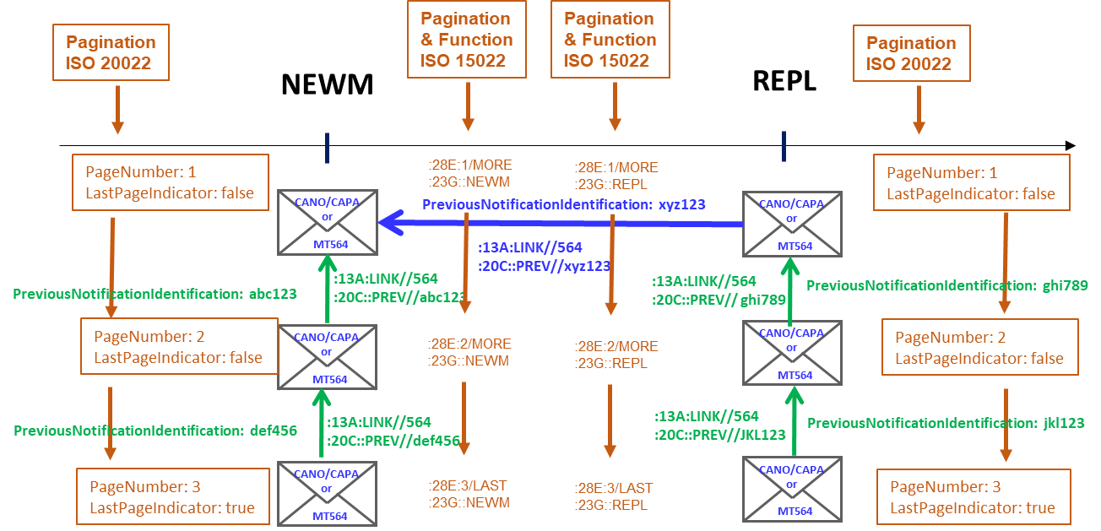

ISO 15022 |  | ISO 20022
MT 564 / A / 28E |  | seev.031 / see.035 – Pagination / PageNumber
Decision Date | Implement. Date |  | Update Date | Open Item Ref.
Aug. 2011 | Nov. 2012 |  | Feb.. 2022 | CA232, CA485, CA525

Scenario 2 - One MT564 with Multiple Linked MT568
Note: This section is not applicable to ISO 20022 since there is no MX messages matching the functionality of the MT 568 Narrative
For long MT568 messages for which the length would overcome the 10K character limit on SWIFTNet FIN, a pagination mechanism is available through the use of the 28E field present at the top of the messages:

The MT564 message and the first MT568 in the chain of multi-parts MT568 must be linked via the CORP reference (i.e. forward link as illustrated below with red arrows) –.
All MT568 messages that are part of the multi-parts MT 568 chain must all be linked via the PREV reference to their linked MT564 (i.e. backward link as illustrated below with green arrows) – as per section 3.7.3 MP.
All MT 568 in the chain of multi-parts MT568 are linked through the use of the Pagination (28E) field (as illustrated below with orange arrows)
A MT564 REPL or REPE must be linked to the previous MT 564 sent via the PREV reference (as illustrated below with a blue arrow) – as per section 3.7.2 MP.
MT 568 REPL or REPE messages that are part of the multi-parts chain of MT568 must NOT link back to the MT568 chain sent previously.
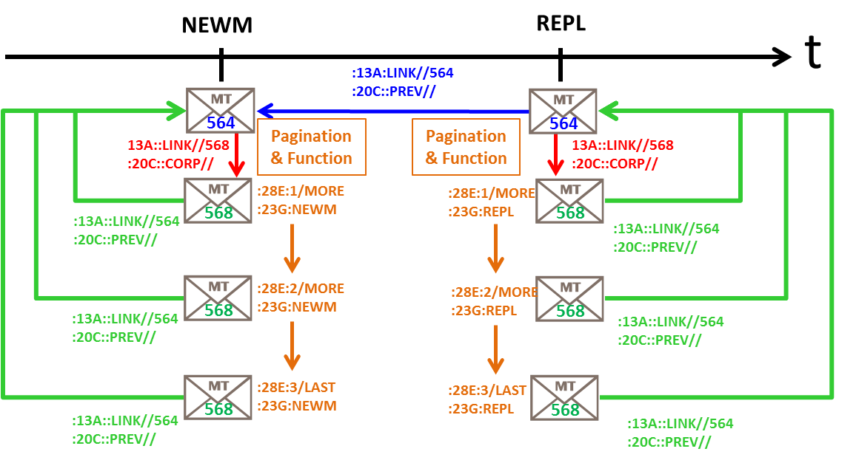

Linkage Scenario 3 – Multiple Linked MT564 with Multiple Linked MT568
Note: This section is not applicable to ISO 20022 since there is no MX messages matching the functionality of the MT 568 Narrative
The only difference between this scenario 3 and the previous scenario 2 is the addition of the multi-parts chain of MT564.
All guidelines provided for scenario 1 also apply in this case.

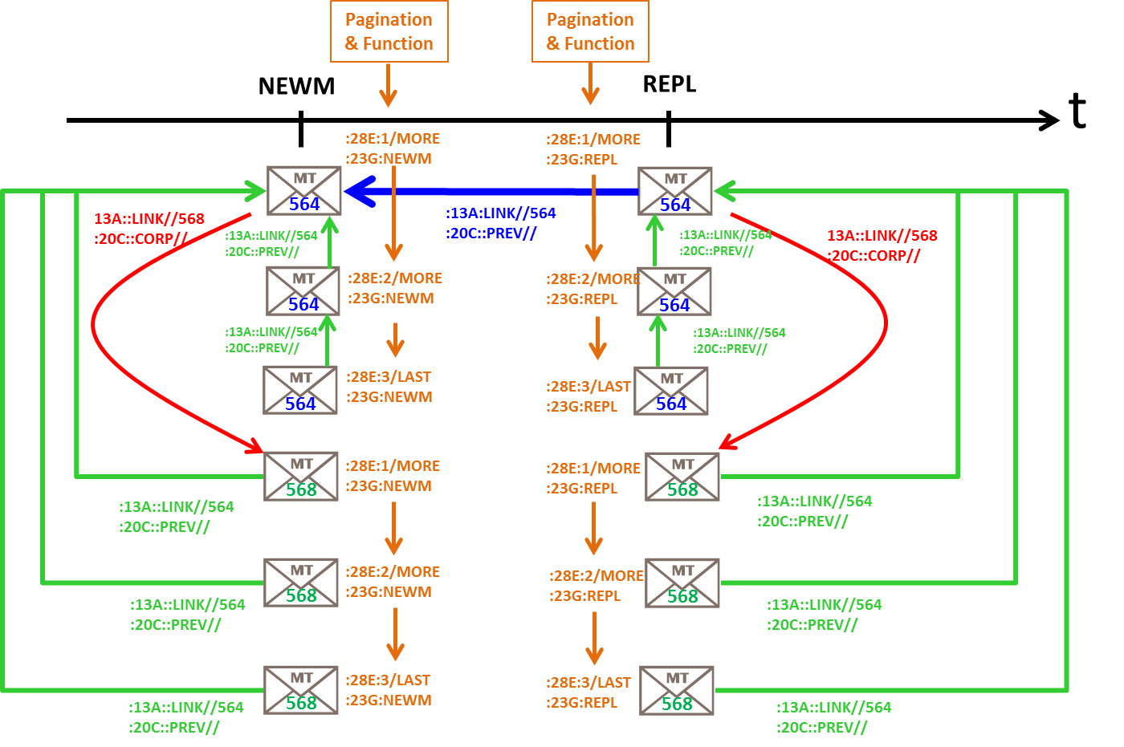
ISO 15022 |  | ISO 20022
MT 564 / A / 28E  MT 564 / A1 / 13A / LINK  MT 564 / A1 / 20C / PREV |  | NA
Decision Date | Implement. Date |  | Update Date | Open Item Ref.
May. 2015 | Nov. 2015 |  |  | CA297

