Change Request
for the update of ISO 20022 financial repository items
- Origin of the request:
SMPG
Jacques Littre, Jacques.LITTRE@swift.com, Tel: +32 2 655 43 35
FUMAGALLI Mariangela, mariangela.fumagalli@bnpparibas.com
Christine Strandberg, christine.strandberg@seb.se
(Submitted by Hendrik Melchior hendrik.melchior@clearstream.com, P +49 69 211-13263 as per SMPG meeting held on 27.04.2022)

- Related messages:
Semt.001 (Securities Message Rejection)
- Description of the change request:
No rejection message for seev. exist, but there is a message within the securities message set. When no new seev. Securties Event Rejection message will be development, the semt.001 should be updated as follows:

Message Description Change is required to add the business purpose (red colored):
Securities Message Rejection V03 (semt.001.001.0x) - Documentation
Scope An account servicer, for example, a registrar, transfer agent, first intermediary or custodian bank, sends the SecuritiesMessageRejection message to the sender (e.g. account owner, for example, an investor, an issuer or its authorised agent), to reject a previously received message on which action cannot be taken. The message may also be sent by an executing party, for example, transfer agent to the instructing party, for example, investment manager or its authorised representative to reject a previously received message on which action cannot be taken. Usage The SecuritiesMessageRejection message is used for the following reasons: - the executing party does not recognise the linked reference, so the executing party cannot process the message - the instructing party should not have sent the message. Reasons that a receiver does not expect a message include no SLA in place between the Sender and the Receiver. The sender doesn’t comply with minimum requirements to allow processing at first intermediary level (e.g. seev.045, seev.001, seev.031). The SecuritiesMessageRejection message must not be used to reject an instruction message (e.g. sese.023, seev.004, seev.047, seev.033) that cannot be processed for business reasons, for example, if information is missing in an instruction message or because securities are not available for settlement.

Add a new mandatory field (length 8 characters) where the message type of the related message must be mentioned (e.g. seev.045, seev.001, seev.031).
A network validation rule should check that the message exists.

The description of reason NALO (Not allowed request) should be changed
From: Instructing party is not allowed to ask for a status for that specific order.
To: Sending party is not allowed to send this request

- Purpose of the change:
Message can be used from a first intermediary to reject an inbound message that doesn’t meet the minimum requirements of the SRDII (e.g. disclosure seev.045, Corporate Actions seev.009/031, General Meetings seev.001).

- Urgency of the request:
SR2023

- Business examples:
Current:
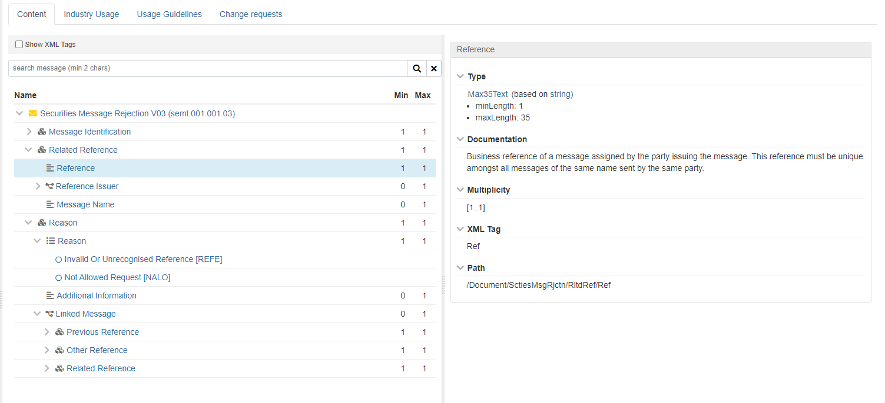

New:
Related Reference 1 1
Reference 1 1
Related message 1 1 (Length 8)
Reference Issuer 0 1
Message Name 0 1

Example: Sender sent a seev.045 message (ref.123456678901234567890) that will be rejected by the receiver with a semt.001:

Semt.001
….
/Document/SctiesMsgRjctn/RltdRef/Ref: 123456678901234567890
/Document/SctiesMsgRjctn/RltdRef/RelMes: seev.045
/Document/SctiesMsgRjctn/Rsn/Rsn NALO
….

- SEG/TSG recommendation:
This section is not to be taken care of by the submitter of the change request. It will be completed in due time by the SEG(s) in charge of the related ISO 20022 messages or the TSG for changes related to the BAH.

Consider |  |  | Timing
- Next yearly cycle: 2022/2023
(the change will be considered for implementation in the yearly maintenance cycle which starts in 2022 and completes with the publication of new message versions in the spring of 2023)
- At the occasion of the next maintenance of the messages
(the change will be considered for implementation, but does not justify maintenance of the messages in its own right – will be pending until more critical change requests are received for the messages)
- Urgent unscheduled
(the change justifies an urgent implementation outside of the normal yearly cycle)
 |  |  | - Other timing:
Comments:

Reject
Reason for rejection:

