Maintenance Change Request
for the update of ISO 20022 financial repository items
Note: the purpose of this document is to give guidelines to submitting organisations that will develop a new version of existing ISO 20022 messages based on change requests screened by the Standards Evaluation Group(s). Such development is subject to the approval of a Maintenance Change Request which must include a detailed description of the impact of each change on the related messages. The Maintenance Change Request must start with a general chapter covering topics related to the whole maintenance effort and a specific chapter for each change request, as described below. Please consult the iso20022.org website for additional details on the maintenance process.
The Maintenance Change Requests for this ISO 20022 maintenance will follow the fast track process and will be sent to iso20022ra@iso20022.org by May 1st 2019.

- Name of the request:
Proxy Voting Messages Maintenance for year 2019/2020
- Submitting organization(s):
SWIFT, SMPG
- Related messages:
Under this project, all the following ISO 20022 Proxy Voting messages would be maintained:
 | Message Name | Identifier
1 | MeetingNotificationV05 | seev.001.001.05
2 | MeetingCancellationV05 | seev.002.001.05
3 | MeetingEntitlementNotificationV05 | seev.003.001.05
4 | MeetingInstructionV05 | seev.004.001.05
5 | MeetingInstructionCancellationRequestV05 | seev.005.001.05
6 | MeetingInstructionStatusV05 | seev.006.001.05
7 | MeetingVoteExecutionConfirmationV05 | seev.007.001.05
8 | MeetingResultDisseminationV05 | seev.008.001.05
- Commitments of the submitting organization:
SWIFT and SMPG confirms that it can and will:
- undertake the development of the new version of the candidate ISO 20022 message models that it will submit to the RA for compliance review and evaluation by July 15, 2019.
- provide a new version of part 1 of the Message Definition Report (MDR) by October 1, 2019 and new examples of valid message instances of each message by October 1 at the latest.
- address any queries related to the description of the new models and messages as published by the RA on the ISO 20022 website.
SWIFT confirms that it intends to organize the actual implementation of the new version of the messages on its SWIFTNet network once the related documentation has been published by the RA.

The submitting organisations confirm their knowledge and acceptance of the ISO 20022 Intellectual Property Rights policy for contributing organisations, as follows.
“Organisations that contribute information to be incorporated into the ISO 20022 Repository shall keep any Intellectual Property Rights (IPR) they have on this information. A contributing organisation warrants that it has sufficient rights on the contributed information to have it published in the ISO 20022 Repository through the ISO 20022 Registration Authority in accordance with the rules set in ISO 20022. To ascertain a widespread, public and uniform use of the ISO 20022 Repository information, the contributing organisation grants third parties a non-exclusive, royalty-free license to use the published information”.

- Contact persons:
Christine Strandberg – christine.strandberg@seb.se – phone: +46 8 763 6074
Mari Fumagalli – mariangela.fumagalli@bnpparibas.com – phone: +44 207 595 4988
Jacques Littré – jacques.littre@swift.com – phone: +32 2 655 43 35
ISO 20022 Proxy Voting Messages Maintenance 2019/2020

Table of Contents

1 CR1: Add new elements required by the SRD2 Directive in the Meeting Notification 4
2 CR2: Add new element Voting Rights Threshhold in Resolution 10
3 CR3: Remove element Entitlement in EntitlementSpecification sequence 13
4 CR4: Remove all STP Deadlines 16
5 CR5: Move All Elements from EntitlementSpecification sequence to the Meeting sequence 20
6 CR6: Align Meeting Type and Classification with ISO 15022 Meeting Types 24
7 CR7: Remove Vote InstructionType in Vote Sequence 27
8 CR8: Align Meeting Notification Type and Status with the CA Notification Structure 30
9 CR9: Align Meeting Linkages with CA Notification Linkages 33
10 CR10: Add new elements required by the SRD2 Directive in the Meeting Entitlement Notification 36
11 CR11: Add new elements required by the SRD2 Directive in the Meeting Instruction 41
12 CR12: Add new elements required by the SRD2 Directive in the Meeting Instruction Status 48
13 CR13: Add new elements required by the SRD2 Directive in the Meeting Vote Execution Confirmation 52
14 CR14: Amend the Scope of the Meeting Vote Execution Confirmation Message 57
15 CR15: Replace All Obsolete Comoponents with New or Latest Version 60
16 CR16: Rename PreviousReference in Meeting Instruction Cancellation Request 64
17 CR17: Rename all RightsHolder elements as Shareholder in all Messages 67
18 CRXXX: Add LEI in Issuer,…. 70

CR1: Add new elements required by the SRD2 Directive in the Meeting Notification
- Origin of the request:
A.1 Submitter: SWIFT, SMPG
A.2 Contact person:
Christine Strandberg – christine.strandberg@seb.se – phone: +46 8 763 6074
Mari Fumagalli – mariangela.fumagalli@bnpparibas.com – phone: +44 207 595 4988
Jacques Littré – jacques.littre@swift.com – phone: +32 2 655 43 35
A.3 Sponsors: N/A

- Related messages:
List of ISO 20022 Proxy Voting messages which would be impacted by the change:
seev.001.001.05 MeetingNotificationV05

- Description of the change request:
- In MeetingDetails sequence, add an optional and non-repeatable URLAddress as a virtual address for general meetings.
- (IR table 3.C item 4 in implementation regulation)
- In the Meeting sequence, add the new optional and repeatable sequence “Attendance“ containing the new mandatory element “AttendanceMethod”, the new mandatory element “IssuerDeadlineForVoting” and the existing optional elements AttendanceConfirmationDeadline and AttendanceConfirmationMarketDeadline. The attendance method must contain the values: Virtual participation, in person, through Proxy, by correspondence, participation in person but not voting.
- (IR table 3.D items 1 and 3 in implementation regulation)
- In the Resolution sequence, add a new optional non-repeatable URLAddress element.
- (IR table 3.E item 3 in implementation regulation)
- In the Resolution sequence, add a new optional and non-repeatable element VoteType after the element “ForInformationOnly” in order to specify if it is a binding vote or an advisory vote.
- (IR table 3.E item 4 in implementation regulation)
- In the Resolution and Vote sequences, for the VoteInstructionType element, in the VoteInstructionCode, add a new vote instruction type codes “BLNK (Blank)” (vote is cast as “empty” but the vote is counted) and “Other” paired with a narrative element and amend the definition of the “NoAction” code.
- (IR table 3.E item 5 in implementation regulation)
- Purpose of the change:
This change is required by the European Commission Shareholders Rights Directive implementing regulation (EU) 2018/1212 of 3 September 2018 (see regulation table references in the description above).
- Urgency of the request:
This maintenance change request for the proxy-voting messages follows the ISO 20022 fast track maintenance process so as to publish a new version of those messages around end of Q3 2019.
- Business examples:
NA
- SEG recommendation:
This section is not to be taken care of by the submitter of the change request. It will be completed in due time by the SEG(s) in charge of the related ISO 20022 messages.

Consider |  |  | Timing
 |  |  | - Next yearly cycle: 2019/2020  (the change will be considered for implementation in the yearly maintenance cycle which starts in 2019 and completes with the publication of new message versions in the spring of 2020) |  |  | Priority:  high  medium  low
- At the occasion of the next maintenance of the messages
(the change will be considered for implementation, but does not justify maintenance of the messages in its own right – will be pending until more critical change requests are received for the messages)
 |  |  | - Urgent unscheduled  (the change justifies an urgent implementation outside of the normal yearly cycle) |  | X
 |  |  | - Other timing:
Comments:

Reject
Reason for rejection:

- Impact analysis:
This change request impacts the following messages:
seev.001.001.05 MeetingNotificationV05
- Proposed implementation:

- Add URL Address in Meeting Details
In the seev.001 (MENO – MeetingNotification) message, in the MeetingDetails sequence, add a new optional and non-repeatable element URLAddress typed by Max256Text as illustrated below:
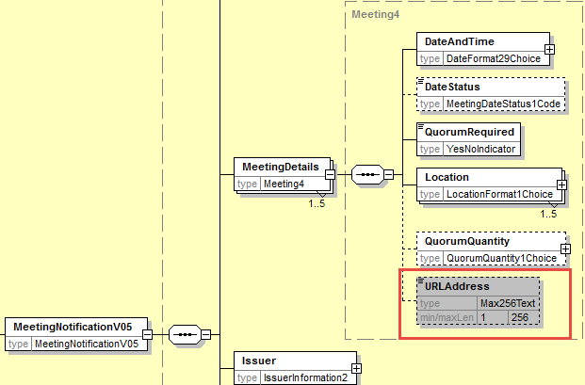

- Add new Attendance component in the Meeting sequence
In the seev.001 (MENO – MeetingNotification) message, in the Meeting sequence, add a new optional and repeatable element Attendance typed by a component containing:
- a new mandatory element AttendanceMethod typed by a code with the values: Virtual participation, in person, through Proxy, by correspondence, participation in person but not voting and a proprietary element.
- a new optional and non-repeatable element IssuerDeadlineForVoting typed by DateFormat29Choice
- the existing optional AttendanceConfirmationDeadline element typed by DateFormat29Choice (from the Meeting sequence).
- the existing optional AttendanceConfirmationMarketDeadline element typed by DateFormat29Choice (from the Meeting sequence).
as illustrated below:
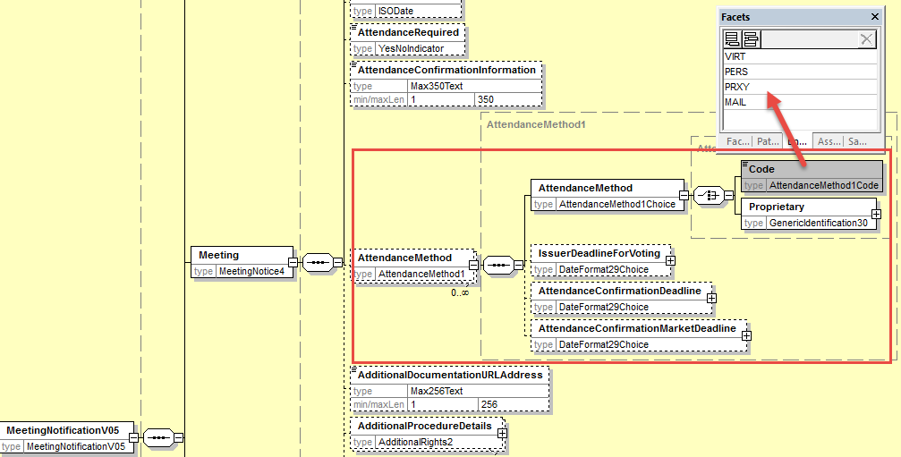

- Add URL address in Resolution sequence
In the seev.001 (MENO – MeetingNotification) message, in the Resolution sequence, add a new optional and non-repeatable element URLAddress typed by Max256Text as illustrated below:
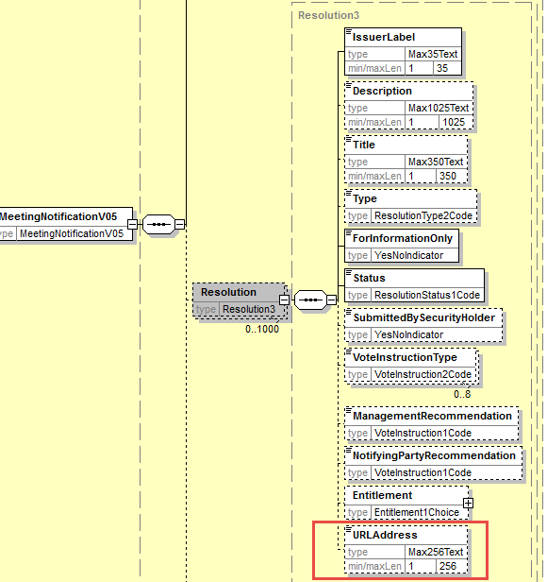
- Add Vote Type in Resolution
In the seev.001 (MENO – MeetingNotification) message, in the Resolution sequence, add a new optional and non-repeatable element VoteType typed by a code with values “Binding Vote” and “Advisory Vote” as illustrated below in e).

- Add new code value to VoteInstructionCode
In the seev.001 (MENO – MeetingNotification) message, in the Resolution and in the Vote sequences, for the element VoteInstructionType, replace the data type by a choice between
- a predefined code list typed by VoteInstruction2code and add the new code values “BLNK (Blank)” (vote is cast as “empty” but the vote is counted) and amend the definition of the “NoAction” code to read “Do not vote”.
- and a proprietary code value to cover the other type of votes.
- Also add a narrative element to explain what the proprietary code is all about if used and add a textual rules so that AdditionalInformation may only be present if a proprietary vote instruction type code is provided.
as illustrated below:
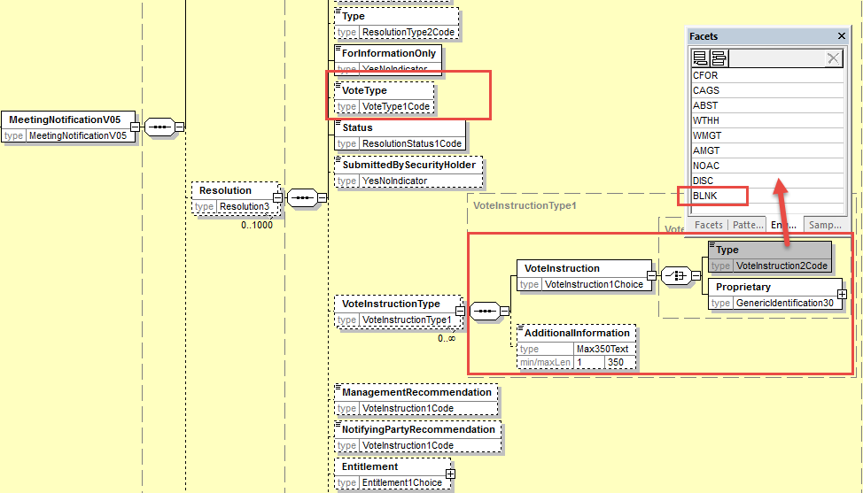
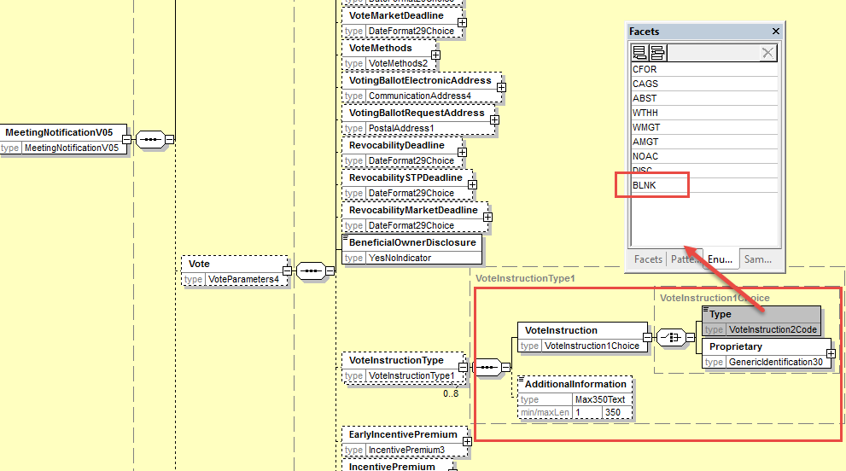
- Proposed timing:
The submitting organization confirms that it can implement the requested changes in the requested timing

Timing | - As requested

- Final decision of the SEG(s):

Approve
Comments:

Reject
Reason for rejection:

CR2: Add new element Voting Rights Threshhold in Resolution
- Origin of the request:
A.1 Submitter: SWIFT, SMPG
A.2 Contact person:
Christine Strandberg – christine.strandberg@seb.se – phone: +46 8 763 6074
Mari Fumagalli – mariangela.fumagalli@bnpparibas.com – phone: +44 207 595 4988
Jacques Littré – jacques.littre@swift.com – phone: +32 2 655 43 35
A.3 Sponsors: N/A

- Related messages:
List of ISO 20022 Proxy Voting messages which would be impacted by the change:
seev.001.001.05 MeetingNotificationV05

- Description of the change request:
In the Resolution sequence, add a new optional non repeatable element VotingRightsThresholdForApproval in quantity or percentage.

- Purpose of the change:
Providing the possibility to specify for each resolution the voting rights threshold required in percentage or in quantity to have the resolution approved.

- Urgency of the request:
This maintenance change request for the proxy-voting messages follows the ISO 20022 fast track maintenance process so as to publish a new version of those messages around end of Q3 2019.
- Business examples:
NA
- SEG recommendation:
This section is not to be taken care of by the submitter of the change request. It will be completed in due time by the SEG(s) in charge of the related ISO 20022 messages.

Consider |  |  | Timing
 |  |  | - Next yearly cycle: 2019/2020  (the change will be considered for implementation in the yearly maintenance cycle which starts in 2019 and completes with the publication of new message versions in the spring of 2020) |  |  | Priority:  high  medium  low
- At the occasion of the next maintenance of the messages
(the change will be considered for implementation, but does not justify maintenance of the messages in its own right – will be pending until more critical change requests are received for the messages)
 |  |  | - Urgent unscheduled  (the change justifies an urgent implementation outside of the normal yearly cycle) |  | X
 |  |  | - Other timing:
Comments:

Reject
Reason for rejection:

- Impact analysis:
This change request impacts the following messages:
seev.001.001.05 MeetingNotificationV05
- Proposed implementation:
In the seev.001 (MENO – MeetingNotification) message, in the Resolution sequence, add a new optional and non-repeatable element VotingRightsThresholdForApproval typed by a choice component between a percentage and an absolute number as illustrated below:
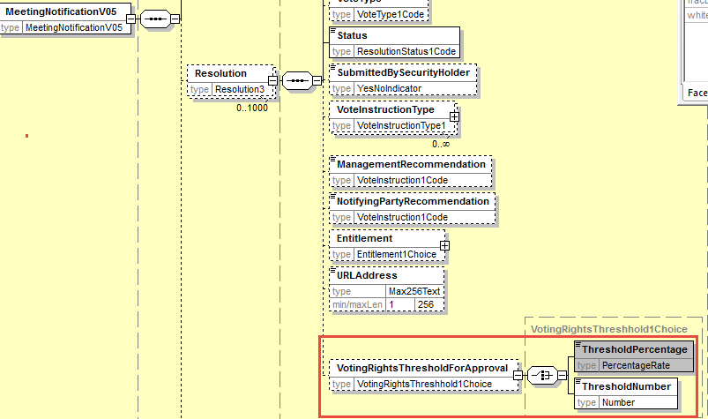

- Proposed timing:
The submitting organization confirms that it can implement the requested changes in the requested timing

Timing | - As requested

- Final decision of the SEG(s):

Approve
Comments:

Reject
Reason for rejection:

CR3: Remove element Entitlement in EntitlementSpecification sequence
- Origin of the request:
A.1 Submitter: SWIFT, SMPG
A.2 Contact person:
Christine Strandberg – christine.strandberg@seb.se – phone: +46 8 763 6074
Mari Fumagalli – mariangela.fumagalli@bnpparibas.com – phone: +44 207 595 4988
Jacques Littré – jacques.littre@swift.com – phone: +32 2 655 43 35
A.3 Sponsors: N/A

- Related messages:
List of ISO 20022 Proxy Voting messages which would be impacted by the change:
seev.001.001.05 MeetingNotificationV05

- Description of the change request:
In the EntitlementSpecification sequence, remove the optional element Entitlement.

- Purpose of the change:
The exact same element and data types are already present in the Resolution sequence, the element is therefore fully redundant and can be deleted.

- Urgency of the request:
This maintenance change request for the proxy-voting messages follows the ISO 20022 fast track maintenance process so as to publish a new version of those messages around end of Q3 2019.
- Business examples:
NA
- SEG recommendation:
This section is not to be taken care of by the submitter of the change request. It will be completed in due time by the SEG(s) in charge of the related ISO 20022 messages.

Consider |  |  | Timing
 |  |  | - Next yearly cycle: 2019/2020  (the change will be considered for implementation in the yearly maintenance cycle which starts in 2019 and completes with the publication of new message versions in the spring of 2020) |  |  | Priority:  high  medium  low
- At the occasion of the next maintenance of the messages
(the change will be considered for implementation, but does not justify maintenance of the messages in its own right – will be pending until more critical change requests are received for the messages)
 |  |  | - Urgent unscheduled  (the change justifies an urgent implementation outside of the normal yearly cycle) |  | X
 |  |  | - Other timing:
Comments:

Reject
Reason for rejection:

- Impact analysis:
This change request impacts the following messages:
seev.001.001.05 MeetingNotificationV05
- Proposed implementation:
In the seev.001 (MENO – MeetingNotification) message, in the EntitlementSpecification sequence, remove the optional element Entitlement typed by a choice component between EntitlementRatio and EntitlementDescription as illustrated below:

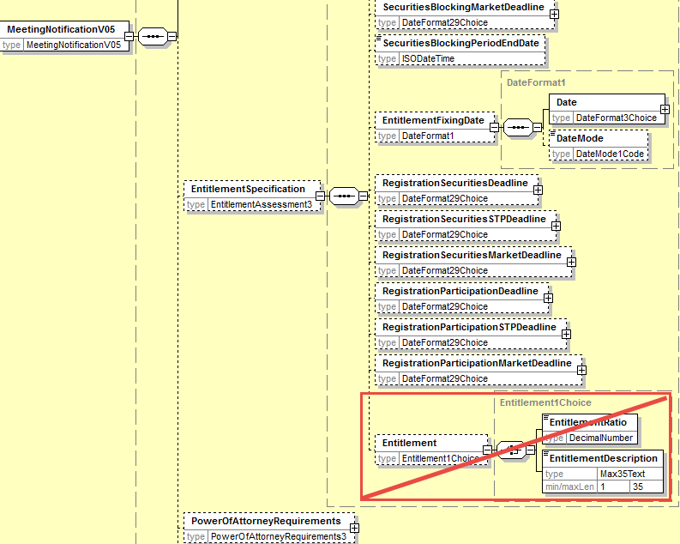
- Proposed timing:
The submitting organization confirms that it can implement the requested changes in the requested timing

Timing | - As requested

- Final decision of the SEG(s):

Approve
Comments:

Reject
Reason for rejection:

CR4: Remove all STP Deadlines
- Origin of the request:
A.1 Submitter: SWIFT, SMPG
A.2 Contact person:
Christine Strandberg – christine.strandberg@seb.se – phone: +46 8 763 6074
Mari Fumagalli – mariangela.fumagalli@bnpparibas.com – phone: +44 207 595 4988
Jacques Littré – jacques.littre@swift.com – phone: +32 2 655 43 35
A.3 Sponsors: N/A

- Related messages:
List of ISO 20022 Proxy Voting messages which would be impacted by the change:
seev.001.001.05 MeetingNotificationV05

- Description of the change request:
Remove the following STP deadline elements from the meeting notification message:
- AttendanceConfirmationSTPDeadline,
- STPDeadline (in ProxyChoice)
- VoteSTPDeadline,
- RevocabilitySTPDeadline,
- VoteWithPremiumSTPDeadline,
- SecuritiesBlockingSTPDeadline,
- RegistrationSecuritiesSTPDeadline,
- RegistrationParticipationSTPDeadline
- Purpose of the change:
It is confusing and potentially misleading to make a difference between STP deadlines and non-STP deadlines in the message. To avoid confusion, we recommend to remove the STP deadlines that are redundant with the non-STP deadlines.
- Urgency of the request:
This maintenance change request for the proxy-voting messages follows the ISO 20022 fast track maintenance process so as to publish a new version of those messages around end of Q3 2019.
- Business examples:
NA
- SEG recommendation:
This section is not to be taken care of by the submitter of the change request. It will be completed in due time by the SEG(s) in charge of the related ISO 20022 messages.

Consider |  |  | Timing
 |  |  | - Next yearly cycle: 2019/2020  (the change will be considered for implementation in the yearly maintenance cycle which starts in 2019 and completes with the publication of new message versions in the spring of 2020) |  |  | Priority:  high  medium  low
- At the occasion of the next maintenance of the messages
(the change will be considered for implementation, but does not justify maintenance of the messages in its own right – will be pending until more critical change requests are received for the messages)
 |  |  | - Urgent unscheduled  (the change justifies an urgent implementation outside of the normal yearly cycle) |  | X
 |  |  | - Other timing:
Comments:

Reject
Reason for rejection:

- Impact analysis:
This change request impacts the following messages:
seev.001.001.05 MeetingNotificationV05
- Proposed implementation:
In the seev.001 (MENO – MeetingNotification) message, remove the following elements with STP deadlines:
- AttendanceConfirmationSTPDeadline - in Meeting sequence
- STPDeadline - in Meeting/ProxyChoice/Proxy sequence
- VoteSTPDeadline - in Vote sequence
- RevocabilitySTPDeadline - in Vote sequence
- VoteWithPremiumSTPDeadline - in Vote sequence
- SecuritiesBlockingSTPDeadline - in EntitlementSpecification sequence
- RegistrationSecuritiesSTPDeadline - in EntitlementSpecification sequence
- RegistrationParticipationSTPDeadline - in EntitlementSpecification sequence

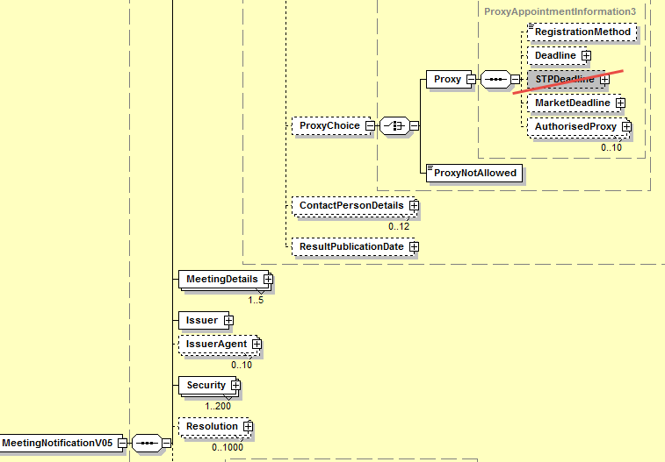
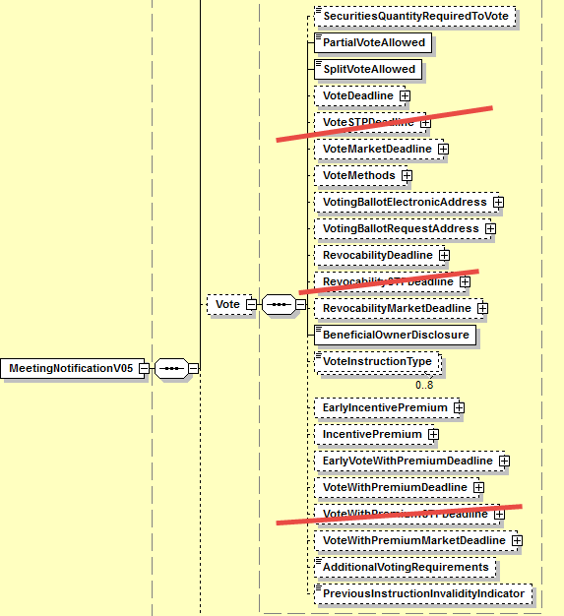

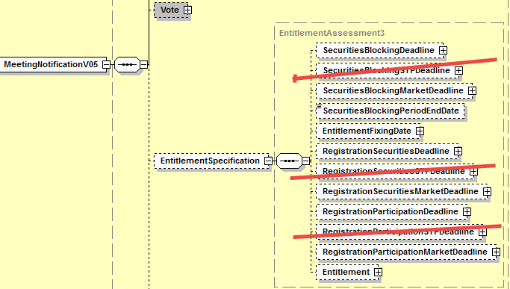

- Proposed timing:
The submitting organization confirms that it can implement the requested changes in the requested timing

Timing | - As requested

- Final decision of the SEG(s):

Approve
Comments:

Reject
Reason for rejection:

CR5: Move All Elements from EntitlementSpecification sequence to the Meeting sequence
- Origin of the request:
A.1 Submitter: SWIFT, SMPG
A.2 Contact person:
Christine Strandberg – christine.strandberg@seb.se – phone: +46 8 763 6074
Mari Fumagalli – mariangela.fumagalli@bnpparibas.com – phone: +44 207 595 4988
Jacques Littré – jacques.littre@swift.com – phone: +32 2 655 43 35
A.3 Sponsors: N/A

- Related messages:
List of ISO 20022 Proxy Voting messages which would be impacted by the change:
seev.001.001.05 MeetingNotificationV05

- Description of the change request:
In the EntitlementSpecification sequence, move all elements to the Meeting sequence and delete EntitlementSpecification.

- Purpose of the change:
If the “Entitlement” element of the EntitlementSpecification sequence is removed (via one of the preceding change request), most of the remaining elements in the EntitlementSpecification sequence are more related to general meeting information than to Entitlement. Therefore it would make more sense to regroup all detailed meeting information at the same place in the same sequence and remove that sequence.

- Urgency of the request:
This maintenance change request for the proxy-voting messages follows the ISO 20022 fast track maintenance process so as to publish a new version of those messages around end of Q3 2019.
- Business examples:
NA
- SEG recommendation:
This section is not to be taken care of by the submitter of the change request. It will be completed in due time by the SEG(s) in charge of the related ISO 20022 messages.

Consider |  |  | Timing
 |  |  | - Next yearly cycle: 2019/2020  (the change will be considered for implementation in the yearly maintenance cycle which starts in 2019 and completes with the publication of new message versions in the spring of 2020) |  |  | Priority:  high  medium  low
- At the occasion of the next maintenance of the messages
(the change will be considered for implementation, but does not justify maintenance of the messages in its own right – will be pending until more critical change requests are received for the messages)
 |  |  | - Urgent unscheduled  (the change justifies an urgent implementation outside of the normal yearly cycle) |  | X
 |  |  | - Other timing:
Comments:

Reject
Reason for rejection:

- Impact analysis:
This change request impacts the following messages:
seev.001.001.05 MeetingNotificationV05
- Proposed implementation:
In the seev.001 (MENO – MeetingNotification) message, in the EntitlementSpecification sequence, move all elements to the Meeting sequence and remove the EntitlementSpecification sequence itself as illustrated below:

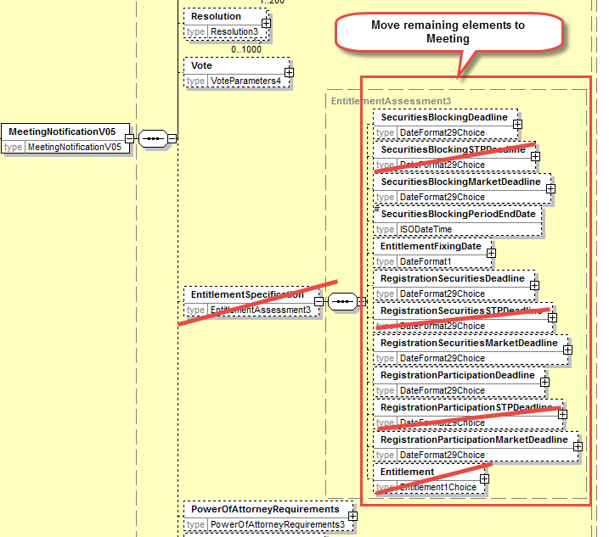

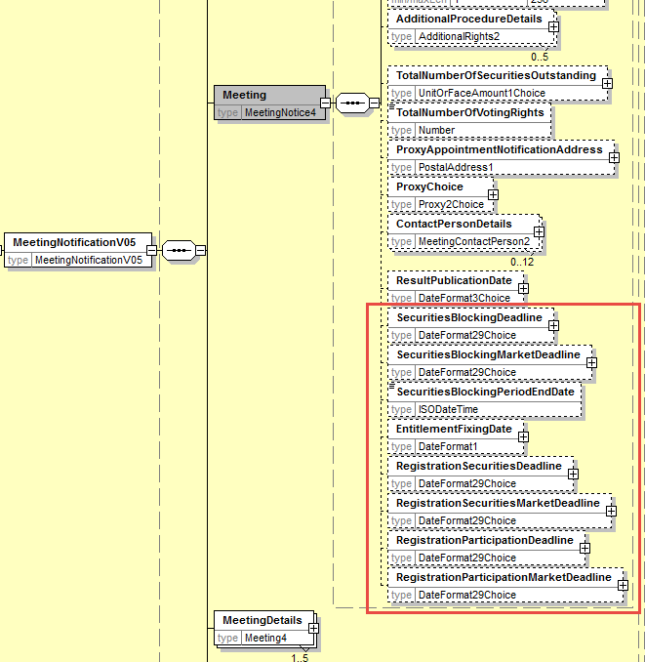
- Proposed timing:
The submitting organization confirms that it can implement the requested changes in the requested timing

Timing | - As requested

- Final decision of the SEG(s):

Approve
Comments:

Reject
Reason for rejection:

CR6: Align Meeting Type and Classification with ISO 15022 Meeting Types
- Origin of the request:
A.1 Submitter: SWIFT, SMPG
A.2 Contact person:
Christine Strandberg – christine.strandberg@seb.se – phone: +46 8 763 6074
Mari Fumagalli – mariangela.fumagalli@bnpparibas.com – phone: +44 207 595 4988
Jacques Littré – jacques.littre@swift.com – phone: +32 2 655 43 35
A.3 Sponsors: N/A
- Related messages:
List of ISO 20022 Proxy Voting messages which would be impacted by the change:
seev.001.001.05 MeetingNotificationV05
seev.002.001.05 MeetingCancellationV05
seev.003.001.05 MeetingEntitlementNotificationV05
seev.004.001.05 MeetingInstructionV05
seev.005.001.05 MeetingInstructionCancellationRequestV05
seev.006.001.05 MeetingInstructionStatusV05
seev.007.001.05 MeetingVoteExecutionConfirmationV05
seev.008.001.05 MeetingResultDisseminationV05

- Description of the change request:
Align the meeting “Type” code values of the proxy voting ISO 20022 messages with those defined in ISO 15022 56x messages for meetings i.e. bond holder meeting (BMET), court meeting (CMET), annual general meeting (MEET), ordinary general meeting (OMET), extraordinary or special general meeting XMET).
- Purpose of the change:
There is a necessity to align both ISO Standards for the types of meetings used for a long time by the community.
- Urgency of the request:
This maintenance change request for the proxy-voting messages follows the ISO 20022 fast track maintenance process so as to publish a new version of those messages around end of Q3 2019.
- Business examples:
NA
- SEG recommendation:
This section is not to be taken care of by the submitter of the change request. It will be completed in due time by the SEG(s) in charge of the related ISO 20022 messages.

Consider |  |  | Timing
 |  |  | - Next yearly cycle: 2019/2020  (the change will be considered for implementation in the yearly maintenance cycle which starts in 2019 and completes with the publication of new message versions in the spring of 2020) |  |  | Priority:  high  medium  low
- At the occasion of the next maintenance of the messages
(the change will be considered for implementation, but does not justify maintenance of the messages in its own right – will be pending until more critical change requests are received for the messages)
 |  |  | - Urgent unscheduled  (the change justifies an urgent implementation outside of the normal yearly cycle) |  | X
 |  |  | - Other timing:
Comments:

Reject
Reason for rejection:

- Impact analysis:
This change request impacts the following messages:
seev.001.001.05 MeetingNotificationV05
seev.002.001.05 MeetingCancellationV05
seev.003.001.05 MeetingEntitlementNotificationV05
seev.004.001.05 MeetingInstructionV05
seev.005.001.05 MeetingInstructionCancellationRequestV05
seev.006.001.05 MeetingInstructionStatusV05
seev.007.001.05 MeetingVoteExecutionConfirmationV05
seev.008.001.05 MeetingResultDisseminationV05
- Proposed implementation:
In the seev.001 (MENO – MeetingNotification) message, delete the optional element Meeting/Classification and in all other messages (seev.002 to seev.008 messages), delete the optional element MeetingReference/Classification.
In the Meeting/Type element (in the seev.001) and in the MeetingReference/type element in all other seev.002 to seev.008 messages) replace the data type by a choice component giving the choice between meeting type code values and proprietary values.
In the data type of the Meeting/Type element (in the seev.001) and in the MeetingReference/type element in all other seev.002 to seev.008 messages), add the meeting type value code CMET for Court Meeting, MEET for Annual General Meeting and OMET for Ordinary General Meeting and remove the code values GMET General meeting , MIXD for Mixed meeting, SPCL for Special meeting as illustrated below:
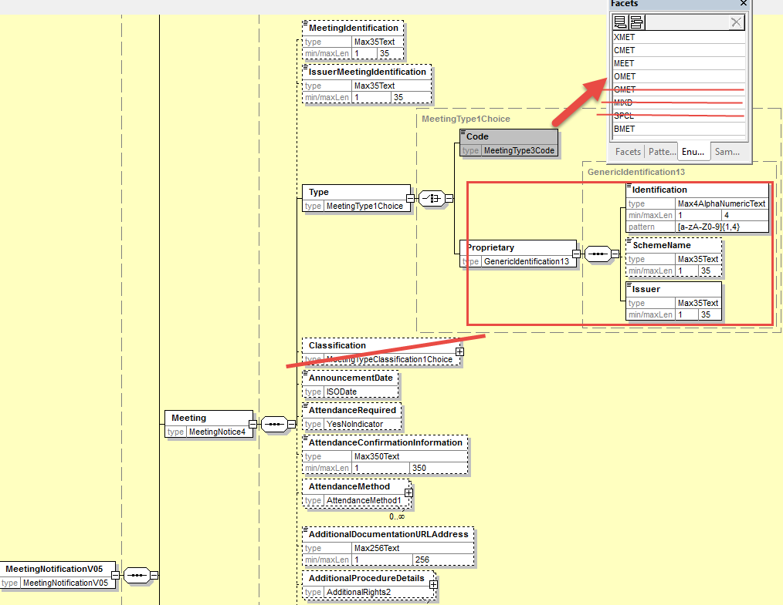
- Proposed timing:
The submitting organization confirms that it can implement the requested changes in the requested timing

Timing | - As requested

- Final decision of the SEG(s):

Approve
Comments:

Reject
Reason for rejection:

CR7: Remove Vote InstructionType in Vote Sequence
- Origin of the request:
A.1 Submitter: SWIFT, SMPG
A.2 Contact person:
Christine Strandberg – christine.strandberg@seb.se – phone: +46 8 763 6074
Mari Fumagalli – mariangela.fumagalli@bnpparibas.com – phone: +44 207 595 4988
Jacques Littré – jacques.littre@swift.com – phone: +32 2 655 43 35
A.3 Sponsors: N/A
- Related messages:
List of ISO 20022 Proxy Voting messages which would be impacted by the change:
seev.001.001.05 MeetingNotificationV05
- Description of the change request:
Remove the element optional and repeatable VoteInstructionType in the sequence Vote.
- Purpose of the change:
Fully redundant with VoteInstructionType in the sequence Resolution.
- Urgency of the request:
This maintenance change request for the proxy-voting messages follows the ISO 20022 fast track maintenance process so as to publish a new version of those messages around end of Q3 2019.
- Business examples:
NA
- SEG recommendation:
This section is not to be taken care of by the submitter of the change request. It will be completed in due time by the SEG(s) in charge of the related ISO 20022 messages.

Consider |  |  | Timing
 |  |  | - Next yearly cycle: 2019/2020  (the change will be considered for implementation in the yearly maintenance cycle which starts in 2019 and completes with the publication of new message versions in the spring of 2020) |  |  | Priority:  high  medium  low
- At the occasion of the next maintenance of the messages
(the change will be considered for implementation, but does not justify maintenance of the messages in its own right – will be pending until more critical change requests are received for the messages)
 |  |  | - Urgent unscheduled  (the change justifies an urgent implementation outside of the normal yearly cycle) |  | X
 |  |  | - Other timing:
Comments:

Reject
Reason for rejection:

- Impact analysis:
This change request impacts the following messages:
seev.001.001.05 MeetingNotificationV05
- Proposed implementation:
In the seev.001 (MENO – MeetingNotification) message, delete the optional and non-repeatable Vote/VoteInstructionType element as illustrated below:
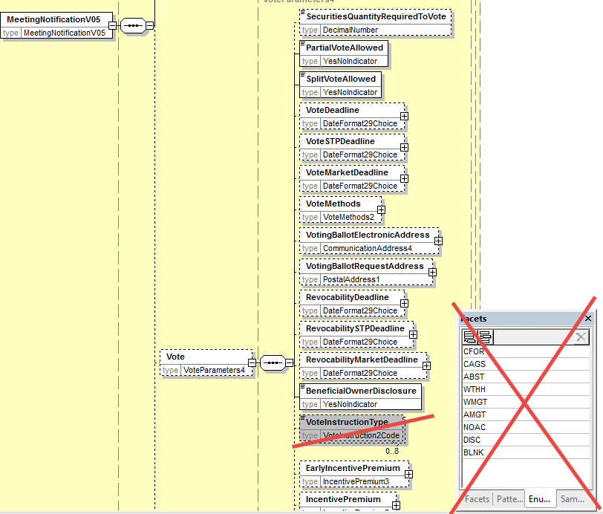
- Proposed timing:
The submitting organization confirms that it can implement the requested changes in the requested timing.

Timing | - As requested

- Final decision of the SEG(s):

Approve
Comments:

Reject
Reason for rejection:

CR8: Align Meeting Notification Type and Status with the CA Notification Structure
- Origin of the request:
A.1 Submitter: SWIFT, SMPG
A.2 Contact person:
Christine Strandberg – christine.strandberg@seb.se – phone: +46 8 763 6074
Mari Fumagalli – mariangela.fumagalli@bnpparibas.com – phone: +44 207 595 4988
Jacques Littré – jacques.littre@swift.com – phone: +32 2 655 43 35
A.3 Sponsors: N/A
- Related messages:
List of ISO 20022 Proxy Voting messages which would be impacted by the change:
seev.001.001.05 MeetingNotificationV05

- Description of the change request:
Add a new mandatory and non-repeatable sequence NotificationGeneralInformation” and add a new mandatory element “NotificationType” with codes New and Replacement.
Move the element NotificationStatus from the root of the message to the new NotificationGeneralInformation sequence.
Rename “Amendment” as NotificationUpdate.
- Purpose of the change:
Align the proxy voting meeting notification with the CA notifications for notification types (New and Replacement).
- Urgency of the request:
This maintenance change request for the proxy-voting messages follows the ISO 20022 fast track maintenance process so as to publish a new version of those messages around end of Q3 2019.
- Business examples:
NA
- SEG recommendation:
This section is not to be taken care of by the submitter of the change request. It will be completed in due time by the SEG(s) in charge of the related ISO 20022 messages.

Consider |  |  | Timing
 |  |  | - Next yearly cycle: 2019/2020  (the change will be considered for implementation in the yearly maintenance cycle which starts in 2019 and completes with the publication of new message versions in the spring of 2020) |  |  | Priority:  high  medium  low
- At the occasion of the next maintenance of the messages
(the change will be considered for implementation, but does not justify maintenance of the messages in its own right – will be pending until more critical change requests are received for the messages)
 |  |  | - Urgent unscheduled  (the change justifies an urgent implementation outside of the normal yearly cycle) |  | X
 |  |  | - Other timing:
Comments:

Reject
Reason for rejection:

- Impact analysis:
This change request impacts the following messages:
seev.001.001.05 MeetingNotificationV05
- Proposed implementation:
In the seev.001 (MENO – MeetingNotification) message, add a new mandatory and non-repeatable sequence NotificationGeneralInformation” and add a new mandatory element “NotificationType” with codes New and Replacement.
Move the element NotificationStatus from the root of the message to the new NotificationGeneralInformation sequence.
Rename “Amendment” sequence as NotificationUpdate and rename its element PreviousReference as PreviousNotificationIdentification.
Add also a new cross element rule at the root of the message in order to condition the presence of the element NotificationUpdate/PrevioustNotificationIdentification when NotificationGeneralInformation/NotificationType value is REPL (Replacement).

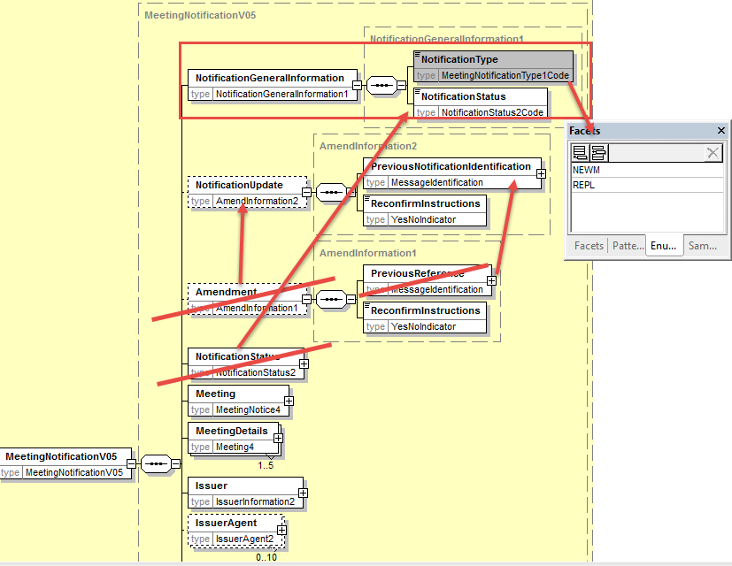

- Proposed timing:
The submitting organization confirms that it can implement the requested changes in the requested timing

Timing | - As requested

- Final decision of the SEG(s):

Approve
Comments:

Reject
Reason for rejection:

CR9: Align Meeting Linkages with CA Notification Linkages
- Origin of the request:
A.1 Submitter: SWIFT, SMPG
A.2 Contact person:
Christine Strandberg – christine.strandberg@seb.se – phone: +46 8 763 6074
Mari Fumagalli – mariangela.fumagalli@bnpparibas.com – phone: +44 207 595 4988
Jacques Littré – jacques.littre@swift.com – phone: +32 2 655 43 35
A.3 Sponsors: N/A

- Related messages:
List of ISO 20022 Proxy Voting messages which would be impacted by the change:
seev.001.001.05 MeetingNotificationV05

- Description of the change request:
Add a new linkages sequence in the meeting notification - similarly to what is done in the corporate action notification message (seev.031) - with an identification of linked meeting identification or a linked Issuer meeting identification.
- Purpose of the change:
Align the proxy voting meeting notification with the CA notifications for linkages as there are no Linkages capabilities in the current message.
- Urgency of the request:
This maintenance change request for the proxy-voting messages follows the ISO 20022 fast track maintenance process so as to publish a new version of those messages around end of Q3 2019.
- Business examples:
NA
- SEG recommendation:
This section is not to be taken care of by the submitter of the change request. It will be completed in due time by the SEG(s) in charge of the related ISO 20022 messages.

Consider |  |  | Timing
 |  |  | - Next yearly cycle: 2019/2020  (the change will be considered for implementation in the yearly maintenance cycle which starts in 2019 and completes with the publication of new message versions in the spring of 2020) |  |  | Priority:  high  medium  low
- At the occasion of the next maintenance of the messages
(the change will be considered for implementation, but does not justify maintenance of the messages in its own right – will be pending until more critical change requests are received for the messages)
 |  |  | - Urgent unscheduled  (the change justifies an urgent implementation outside of the normal yearly cycle) |  | X
 |  |  | - Other timing:
Comments:

Reject
Reason for rejection:

- Impact analysis:
This change request impacts the following messages:
seev.001.001.05 MeetingNotificationV05
- Proposed implementation:
In the seev.001 (MENO – MeetingNotification) message, add a new optional and repeatable sequence EventsLinkages with a mandatory and non-repeatable element EventIdentification typed by a Choice component with the elements LinkedIssuerMeetingIdentification and LinkedMeetingIdentification both typed by Max35Text.
The EventsLinkages sequence contain also an optional and non-repeatable element LinkageType typed by the code ProcessingPosition3Codes with the four values, After, Before, With and Information.
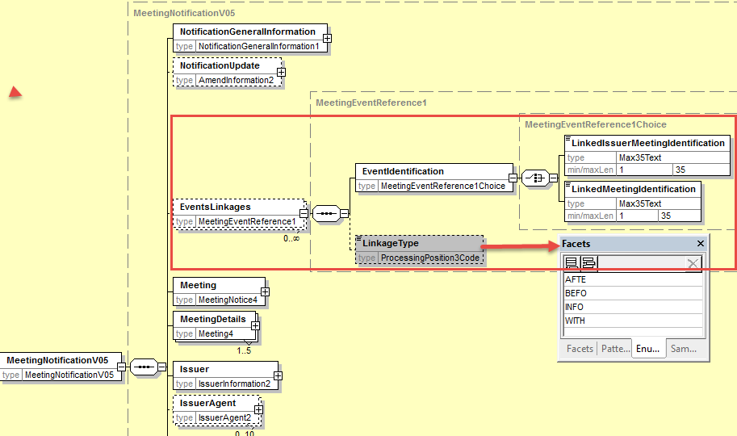

- Proposed timing:
The submitting organization confirms that it can implement the requested changes in the requested timing

Timing | - As requested

- Final decision of the SEG(s):

Approve
Comments:

Reject
Reason for rejection:

CR10: Add new elements required by the SRD2 Directive in the Meeting Entitlement Notification
- Origin of the request:
A.1 Submitter: SWIFT, SMPG
A.2 Contact person:
Christine Strandberg – christine.strandberg@seb.se – phone: +46 8 763 6074
Mari Fumagalli – mariangela.fumagalli@bnpparibas.com – phone: +44 207 595 4988
Jacques Littré – jacques.littre@swift.com – phone: +32 2 655 43 35
A.3 Sponsors: N/A

- Related messages:
List of ISO 20022 Proxy Voting messages which would be impacted by the change:
seev.003.001.05 MeetingEntitlementNotificationV05
- Description of the change request:
- Add the new mandatory and non-repeatable element “Issuer” in the message (same as the one in meeting notification) right before the “Security” element.
(IR table 4.A item 2 in implementation regulation)
- Add a new mandatory element “NotificationType” with codes New and Replacement at the root of the message before RelatedReference and rename RelatedReference as “PreviousEntitlementNotificationIdentification”.
(IR table 4.A item 4 in implementation regulation)
- Add new mandatory non-repeatable element “AccountHolder” after the Eligibility element with identification and name of either a legal or a natural person (as defined in the ShareholderIdentificationDisclosureResponse message.
(IR table 4.C item 1 and 2 in implementation regulation)
- Add new optional and non-repeatable elements “MeetingAttendee” and “Proxy” after the Eligibility element with identification and name of either a legal or a natural person (as defined in the ShareholderIdentificationDisclosureResponse message.
(IR table 4.C item 3 and 4 in implementation regulation)

- Purpose of the change:
This change is required by the European Commission Shareholders Rights Directive implementing regulation (EU) 2018/1212 of 3 September 2018 (see regulation table references in the description above).
- Urgency of the request:
This maintenance change request for the proxy-voting messages follows the ISO 20022 fast track maintenance process so as to publish a new version of those messages around end of Q3 2019.
- Business examples:

- SEG recommendation:
This section is not to be taken care of by the submitter of the change request. It will be completed in due time by the SEG(s) in charge of the related ISO 20022 messages.

Consider |  |  | Timing
 |  |  | - Next yearly cycle: 2019/2020  (the change will be considered for implementation in the yearly maintenance cycle which starts in 2019 and completes with the publication of new message versions in the spring of 2020) |  |  | Priority:  high  medium  low
- At the occasion of the next maintenance of the messages
(the change will be considered for implementation, but does not justify maintenance of the messages in its own right – will be pending until more critical change requests are received for the messages)
 |  |  | - Urgent unscheduled  (the change justifies an urgent implementation outside of the normal yearly cycle) |  | X
 |  |  | - Other timing:
Comments:

Reject
Reason for rejection:

- Impact analysis:
This change request impacts the following messages:
seev.003.001.05 MeetingEntitlementNotificationV05

- Proposed implementation:

- Add Issuer Identification
In the seev.003 (MENT – MeetingEntitlementNotification) message, add a new mandatory and non-repeatable element IssuerIdentification typed by the same PartyIdentificationChoice component used in the MeetingNotification message as illustrated below:
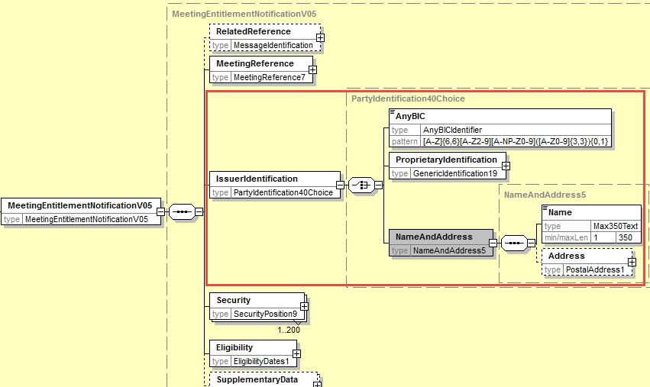

- Add Notification Type
In the seev.003 (MENT – MeetingEntitlementNotification) message, add at the root of the message as a first element, a new mandatory and non-repeatable element NotificationType typed by the code list MeetingNotificationType1Code used in the MeetingNotification message and rename also the RelatedReference element as PreviousEntitlementNotificationIdentification as illustrated below:
Add also a new cross element rule at the root of the message in order to condition the presence of the element PreviousEntitlementNotificationIdentification when NotificationType value is REPL (Replacement).
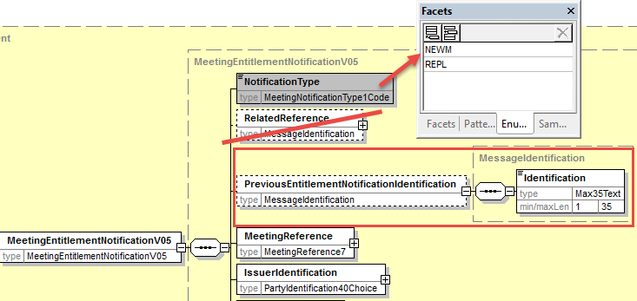

- Add Account Holder Identification
In the seev.003 (MENT – MeetingEntitlementNotification) message, add at the root of the message after the Eligibility element a new mandatory and non-repeatable element AccountHolder typed with the PartyIdentification for a Legal and a natural person as defined in the ShareholderIdentificationDisclosureResponse message and as illustrated below:

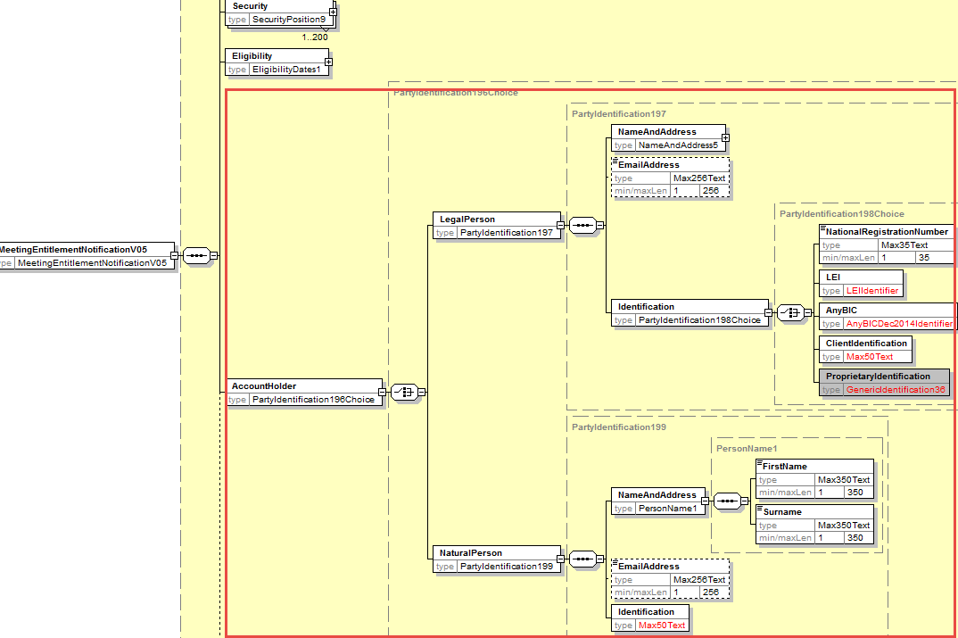

- Add Proxy and MeetingAttendee Identification
In the seev.003 (MENT – MeetingEntitlementNotification) message, add at the root of the message after the Eligibility element the new optional and non-repeatable elements MeetingAttendee and Proxy typed with the PartyIdentification for a Legal and a natural person as defined in the ShareholderIdentificationDisclosureResponse message and as illustrated below:
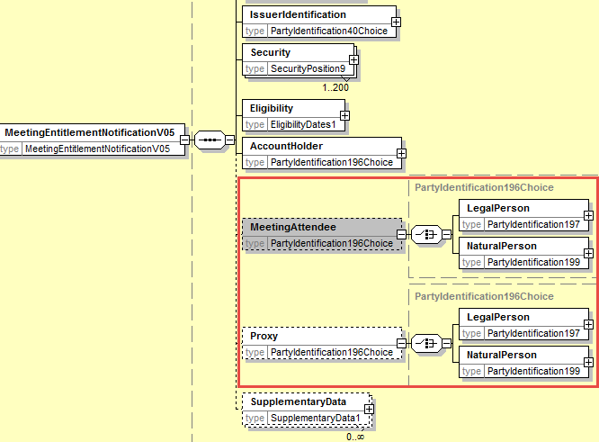

- Proposed timing:
The submitting organization confirms that it can implement the requested changes in the requested timing

Timing | - As requested

- Final decision of the SEG(s):

Approve
Comments:

Reject
Reason for rejection:

CR11: Add new elements required by the SRD2 Directive in the Meeting Instruction
- Origin of the request:
A.1 Submitter: SWIFT, SMPG
A.2 Contact person:
Christine Strandberg – christine.strandberg@seb.se – phone: +46 8 763 6074
Mari Fumagalli – mariangela.fumagalli@bnpparibas.com – phone: +44 207 595 4988
Jacques Littré – jacques.littre@swift.com – phone: +32 2 655 43 35
A.3 Sponsors: N/A

- Related messages:
List of ISO 20022 Proxy Voting messages which would be impacted by the change:
seev.004.001.05 MeetingInstructionV05
- Description of the change request:
- In the Instruction/SpecificInstructionRequest sequence, replace the ParticipantRegistration indicator element by the new optional and repeatable AttendanceMethod with the code values: Virtual participation, in person, through Proxy, by correspondence, participation in person but not voting (same as the one defined in the meeting notification message).
Add a rule so that the Instruction/Proxy and Instruction/MeetingAttendee are only used if the Instruction/SpecificInstructionRequest/AttendanceMethod specifies Proxy or InPerson.
(IR table 5.B items 1 in implementation regulation)
- In element Instruction/MeetingAttendee, align the identification of the meeting attendee with the AccountHolder Legal or Natural person names and identifications defined in the ShareholderIdentificationDisclosureResponse message. Rename the element MeetingAttendee as Shareholder.
(IR table 5.B items 2, 3(a) and 3(b) in implementation regulation)
- In element Instruction/Proxy/PersonDetails align the name and identification of the Proxy with the AccountHolder Legal or Natural person names and identifications defined in the ShareholderIdentificationDisclosureResponse message.
(IR table 5.B items 2, 3(a) and 3(b), 4 and 5 in implementation regulation)
- In the Instruction/VoteDetails/ VoteInstructionForAgendaResolution and VoteInstructionForMeetingResolution sequences, , add a new vote instruction element “BLNK (Blank)” (vote is cast as “empty” but the vote is counted) and a new element Proprietary so as to be able to provide the number of votes for the proprietary vode code defined and amend the definition of the “NoAction” element.
(IR table 3.E item 5 in implementation regulation)

- Purpose of the change:
This change is required by the European Commission Shareholders Rights Directive implementing regulation (EU) 2018/1212 of 3 September 2018 (see regulation table references in the description above).
- Urgency of the request:
This maintenance change request for the proxy-voting messages follows the ISO 20022 fast track maintenance process so as to publish a new version of those messages around end of Q3 2019.
- Business examples:
NA
- SEG recommendation:
This section is not to be taken care of by the submitter of the change request. It will be completed in due time by the SEG(s) in charge of the related ISO 20022 messages.

Consider |  |  | Timing
 |  |  | - Next yearly cycle: 2019/2020  (the change will be considered for implementation in the yearly maintenance cycle which starts in 2019 and completes with the publication of new message versions in the spring of 2020) |  |  | Priority:  high  medium  low
- At the occasion of the next maintenance of the messages
(the change will be considered for implementation, but does not justify maintenance of the messages in its own right – will be pending until more critical change requests are received for the messages)
 |  |  | - Urgent unscheduled  (the change justifies an urgent implementation outside of the normal yearly cycle) |  | X
 |  |  | - Other timing:
Comments:

Reject
Reason for rejection:

- Impact analysis:
This change request impacts the following messages:
seev.004.001.05 MeetingInstructionV05
- Proposed implementation:
- Add AttendanceMethod in the Instruction
In the seev.004 (MEIN – MeetingInstruction) message, rename the element Instruction/SpecificInstructionRequest/ParticipationRegistration as AttendanceMethod and make the element repeatable and change the current data type “YesNoIndicator” by the code list AttendanceMethod1Choice as with a code element with 4 code values as follows (Virtual participation, in person, through Proxy, by correspondence, participation in person but not voting) and a proprietary code as illustrated below:

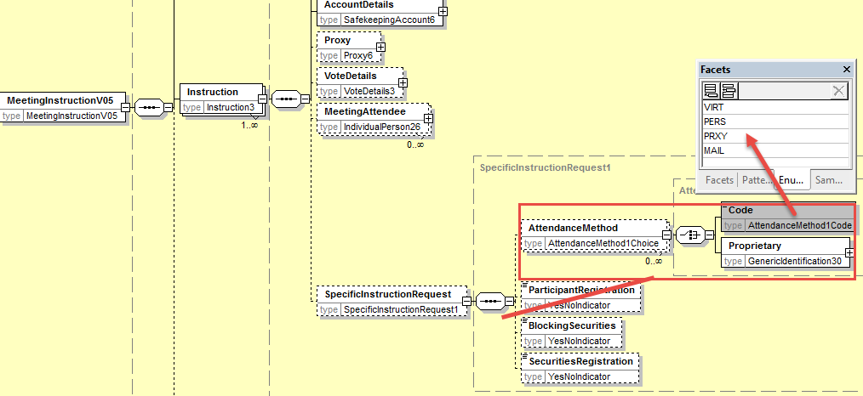

- Align MeetingAttendee Identification with the ShareholderIdentificationDisclosureResponse message
In the seev.004 (MEIN – MeetingInstruction) message, in the sequence Instruction/MeetingAttendee, replace the elements Birthname, GivenName, Identification and Address by the mandatory element Identification typed with the PartyIdentificationChoice component used in the ShareholderIdentificationDisclosureResponse message for AccountHolder to identify a legal and natural person and rename the element MeetingAttendee as Shareholder as illustrated below:

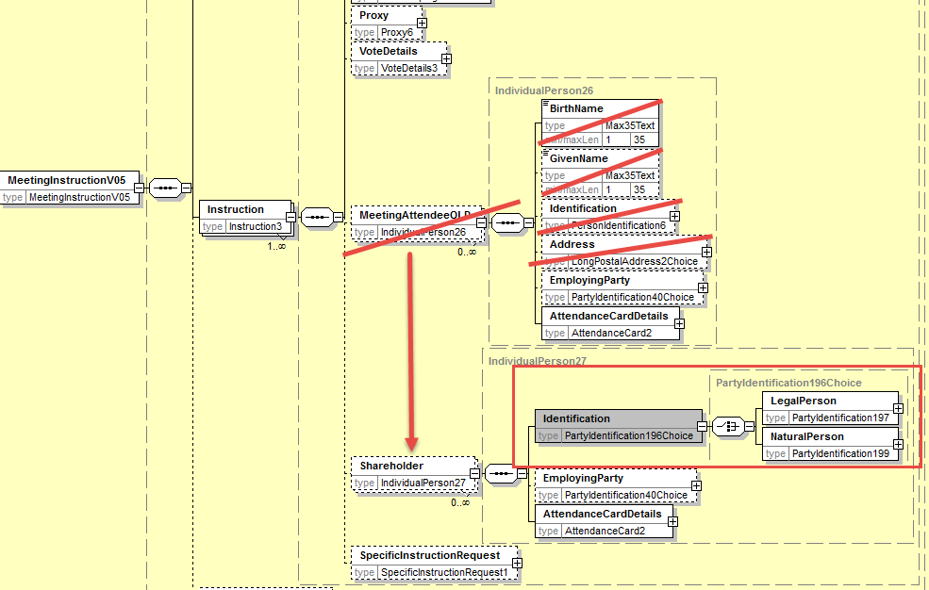

- Align Proxy Identification with the ShareholderIdentificationDisclosureResponse message
In the seev.004 (MEIN – MeetingInstruction) message, in the sequence Instruction/Proxy, replace the elements Birthname, GivenName, Identification and Address by the mandatory element Identification typed with the PartyIdentificationChoice component used in the ShareholderIdentificationDisclosureResponse message for AccountHolder to identify a legal and natural person as illustrated below:
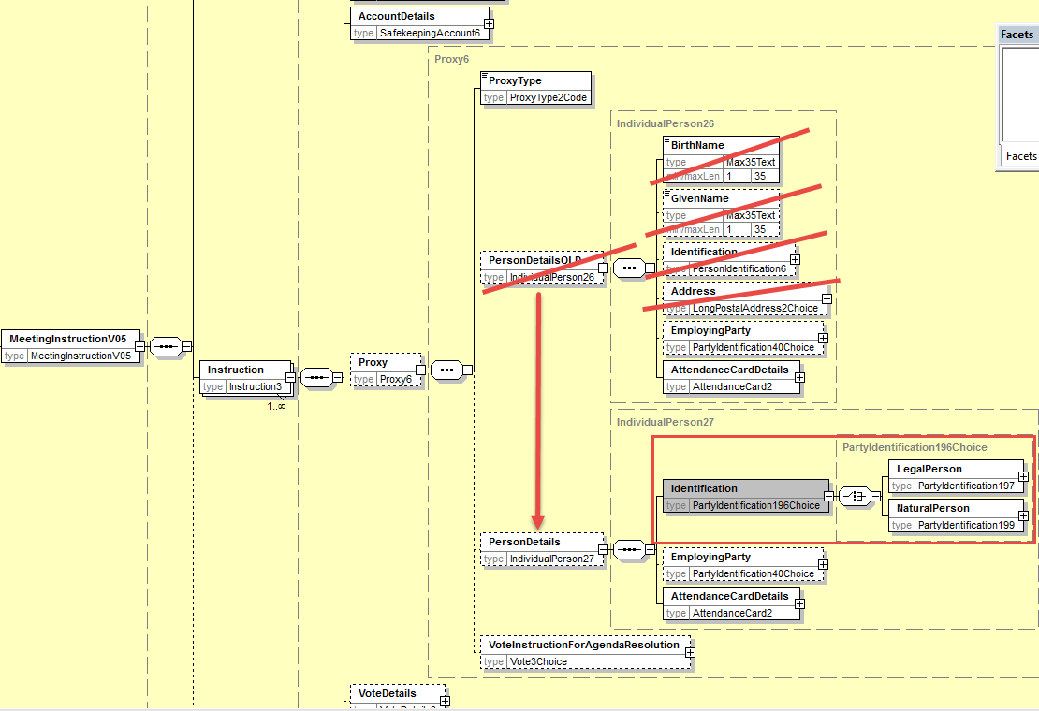

- Add rule on
Add a cross element rule in Instruction component so that the Instruction/Proxy and/or Instruction/MeetingAttendee are only present if the Instruction/SpecificInstructionRequest/AttendanceMethod specifies respectively Proxy and/or In Person.
- Add new Vote Instruction Blank in all sequence where VoteInstruction is present
In the seev.004 (MEIN – MeetingInstruction) message, in the Instruction/VoteDetails/VoteInstructionForAgendaResolution/VoteInstruction sequence, amend the definition of the “NoAction” element to read “Do not vote” and add the new optional and non-repeatable element “Blank” typed by “Number” data type and add a new optional and repeatable sequence “Proprietary” with a mandatory element VoteCode typed by Exact4AlphaNumericText and the mandatory element Number as illustrated below:
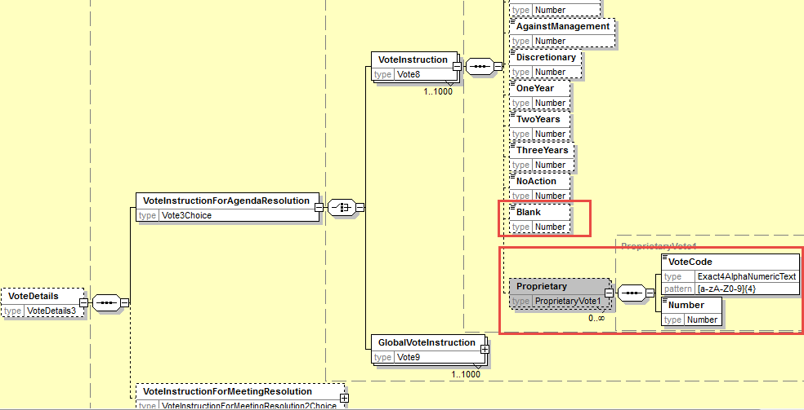

In the seev.004 (MEIN – MeetingInstruction) message, in the Instruction/VoteDetails/VoteInstructionForAgendaResolution/GlobalVoteInstruction, replace the data type of the VoteOption element by a choice component with a choice between the Vote with a code to which the “Blank” vote has been added and a proprietary code code as illustrated below:
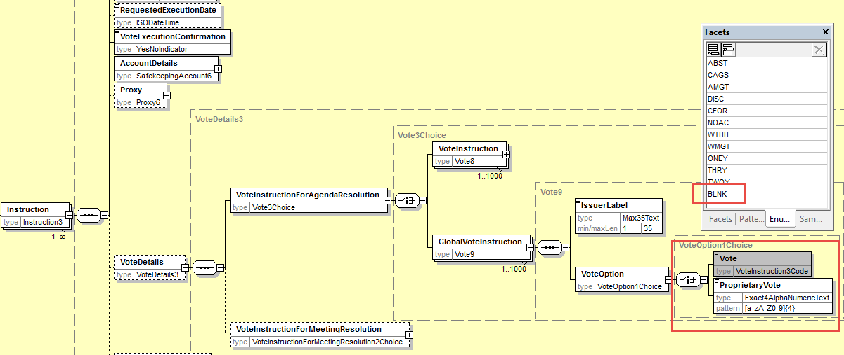

In the seev.004 (MEIN – MeetingInstruction) message, in the Instruction/VoteDetails/VoteInstructionForMeetingResolution sequence, replace the data type of the VoteIndication element by a choice component with a choice between the Vote with a code to which the “Blank” vote has been added and a proprietary code code as illustrated below:

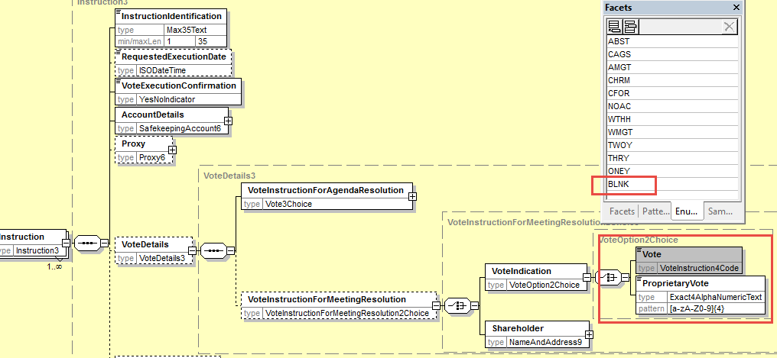

- Proposed timing:
The submitting organization confirms that it can implement the requested changes in the requested timing

Timing | - As requested

- Final decision of the SEG(s):

Approve
Comments:

Reject
Reason for rejection:

CR12: Add new elements required by the SRD2 Directive in the Meeting Instruction Status
- Origin of the request:
A.1 Submitter: SWIFT, SMPG
A.2 Contact person:
Christine Strandberg – christine.strandberg@seb.se – phone: +46 8 763 6074
Mari Fumagalli – mariangela.fumagalli@bnpparibas.com – phone: +44 207 595 4988
Jacques Littré – jacques.littre@swift.com – phone: +32 2 655 43 35
A.3 Sponsors: N/A

- Related messages:
List of ISO 20022 Proxy Voting messages which would be impacted by the change:
seev.006.001.05 MeetingInstructionStatusV05

- Description of the change request:
- add a new mandatory non-repeatable element IssuerName at the root of the message to provide the name of the issuer.
(IR table 6 item 6 in implementation regulation)
- add a new mandatory non-repeatable element ConfirmingParty at the root of the message to provide the name (legal or natural person name) of the ConfirmingParty.
(IR table 6 item 7 in implementation regulation)
- add a new mandatory non-repeatable element VoteCastingParty at the root of the message to provide the name (legal or natural person name) of the VoteCastingParty.
(IR table 6 item 8 in implementation regulation)
- add a new optional non-repeatable element RightsHolder at the root of the message to provide the name (legal or natural person name) of the Shareholder.
(IR table 6 item 9 in implementation regulation)
- Modify the status codes of the Status element in the sequence InstructionTypeStatus/InstructionStatus/GlobalInstructionStatus/ProcessingStatus and in sequence InstructionTypeStatus/InstructionStatus/DetailedInstructionStatus/InstructionStatus/ProcessingStatus as follows:
  - Add the new status code: “Accepted And Sent Along the Chain”
  - Remove statuses: “Completed” (COMP) and “NotReceived” (NOIN)
(IR Article 9.5 in implementation regulation)

- Purpose of the change:
This change is required by the European Commission Shareholders Rights Directive implementing regulation (EU) 2018/1212 of 3 September 2018 (see regulation table references in the description above).
- Urgency of the request:
This maintenance change request for the proxy-voting messages follows the ISO 20022 fast track maintenance process so as to publish a new version of those messages around end of Q3 2019.
- Business examples:
NA
- SEG recommendation:
This section is not to be taken care of by the submitter of the change request. It will be completed in due time by the SEG(s) in charge of the related ISO 20022 messages.

Consider |  |  | Timing
 |  |  | - Next yearly cycle: 2019/2020  (the change will be considered for implementation in the yearly maintenance cycle which starts in 2019 and completes with the publication of new message versions in the spring of 2020) |  |  | Priority:  high  medium  low
- At the occasion of the next maintenance of the messages
(the change will be considered for implementation, but does not justify maintenance of the messages in its own right – will be pending until more critical change requests are received for the messages)
 |  |  | - Urgent unscheduled  (the change justifies an urgent implementation outside of the normal yearly cycle) |  | X
 |  |  | - Other timing:
Comments:

Reject
Reason for rejection:

- Impact analysis:
This change request impacts the following messages:
seev.006.001.05 MeetingInstructionStatusV05
- Proposed implementation:

- Add new party Identifications

In the seev.006 (MEIS – MeetingInstructionStatus) message, add a new mandatory and non-repeatable element IssuerIdentification typed by the same PartyIdentificationChoice component used in the MeetingNotification message and a new mandatory and non-repeatable element ConfirmationParty, a new mandatory and non-repeatable element VoteCastingParty and a new optional and non-repeatable element RightsHolder (or Shareholder ?) typed by the same PartyIdentificationChoice component used to identify a legal and a natural person as illustrated below:
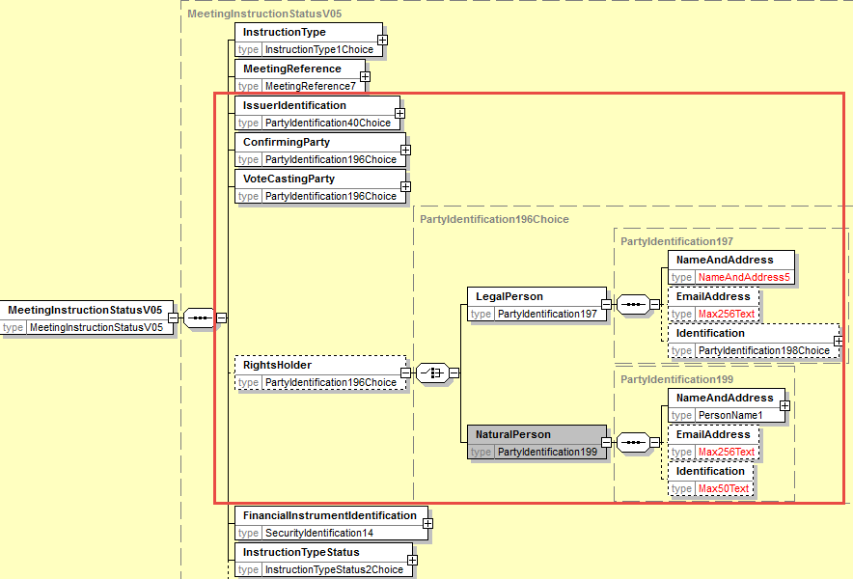

- Amend the ProcessingStatus code values
In the seev.006 (MEIS – MeetingInstructionStatus) message, in the status code of the Status element in the sequence InstructionTypeStatus/InstructionStatus/GlobalInstructionStatus/ProcessingStatus and in sequence InstructionTypeStatus/InstructionStatus/DetailedInstructionStatus/InstructionStatus/ProcessingStatus, remove the code values NotReceived (NOIN) and Completed (COMP) and add the values “Accepted and sent along the chain” (FRWD).
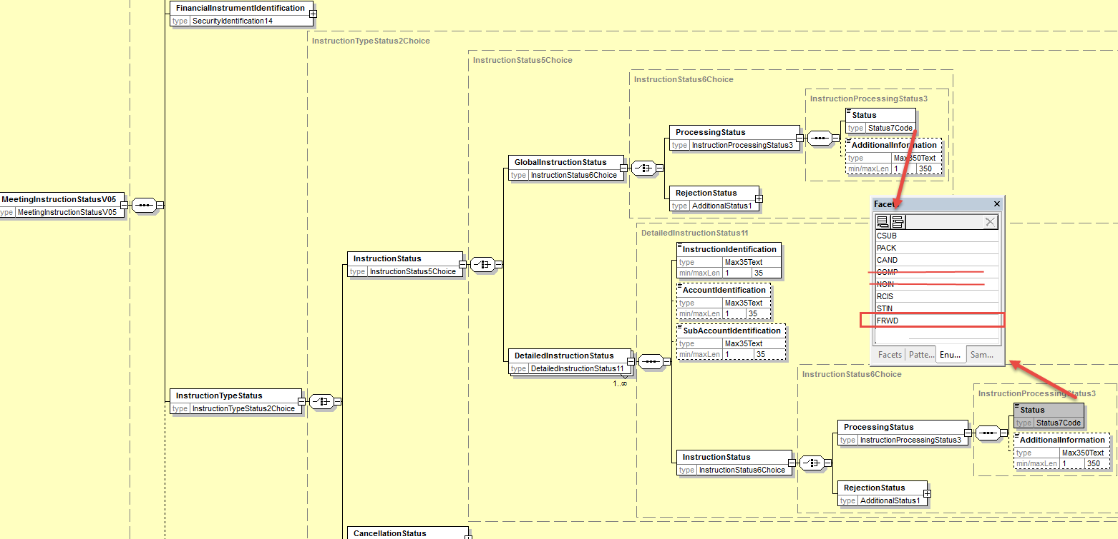
- Proposed timing:
The submitting organization confirms that it can implement the requested changes in the requested timing

Timing | - As requested

- Final decision of the SEG(s):

Approve
Comments:

Reject
Reason for rejection:

CR13: Add new elements required by the SRD2 Directive in the Meeting Vote Execution Confirmation
- Origin of the request:
A.1 Submitter: SWIFT, SMPG
A.2 Contact person:
Christine Strandberg – christine.strandberg@seb.se – phone: +46 8 763 6074
Mari Fumagalli – mariangela.fumagalli@bnpparibas.com – phone: +44 207 595 4988
Jacques Littré – jacques.littre@swift.com – phone: +32 2 655 43 35
A.3 Sponsors: N/A

- Related messages:
List of ISO 20022 Proxy Voting messages which would be impacted by the change:
seev.007.001.05 MeetingVoteExecutionConfirmationV05

- Description of the change request:
- add a new mandatory non-repeatable element IssuerIdentification at the root of the message to provide the name of the issuer.
(IR table 7 item 6 in implementation regulation)
- Adapt the element VoteInstructions/RightsHolder to provide the name (legal or natural person name) of the Shareholder.
(IR table 7 item 7 in implementation regulation)
- add a new optional non-repeatable element Asset Manager or Proxy party (?) (Third Party nominated by the shareholder) in the sequence VoteInstructions to provide the name (legal or natural person name) of the third party nominated by the shareholder.
(IR table 7 item 8 in implementation regulation)
- add a new mandatory non-repeatable element ModalityOfCounting in the sequence VoteInstructions to provide the modality through which the votes that have been recorded and counted were received by the issuer i.e. Paper vote ahead of the meeting, Electronic ahead of the meeting, Electronic at the meeting, Physical at the meeting
(IR table 7 item 9 in implementation regulation)
- add a new optional and non-repeatable element VoteReceiptDateAndTime in the sequence VoteInstructions to provide the date and time at which the votes that have been recorded and counted were received.
(IR table 7 item 10 in implementation regulation)

- Purpose of the change:
This change is required by the European Commission Shareholders Rights Directive implementing regulation (EU) 2018/1212 of 3 September 2018 (see regulation table references in the description above).
- Urgency of the request:
This maintenance change request for the proxy-voting messages follows the ISO 20022 fast track maintenance process so as to publish a new version of those messages around end of Q3 2019.
- Business examples:
NA
- SEG recommendation:
This section is not to be taken care of by the submitter of the change request. It will be completed in due time by the SEG(s) in charge of the related ISO 20022 messages.

Consider |  |  | Timing
 |  |  | - Next yearly cycle: 2019/2020  (the change will be considered for implementation in the yearly maintenance cycle which starts in 2019 and completes with the publication of new message versions in the spring of 2020) |  |  | Priority:  high  medium  low
- At the occasion of the next maintenance of the messages
(the change will be considered for implementation, but does not justify maintenance of the messages in its own right – will be pending until more critical change requests are received for the messages)
 |  |  | - Urgent unscheduled  (the change justifies an urgent implementation outside of the normal yearly cycle) |  | X
 |  |  | - Other timing:
Comments:

Reject
Reason for rejection:

- Impact analysis:
This change request impacts the following messages:
seev.007.001.05 MeetingVoteExecutionConfirmationV05
- Proposed implementation:

- Add Issuer Identification
In the seev.007 (MECO – MeetingVoteExecutionConfirmation) message, in the root of the message, add a new mandatory and non-repeatable element IssuerIdentification yped by the same PartyIdentificationChoice component used in the MeetingNotification message as illustrated below:
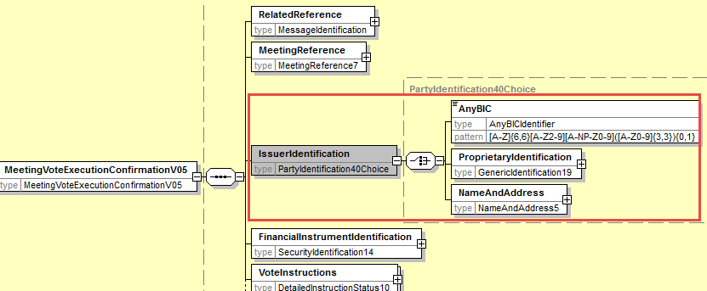

- Amend the RightsHolder Identification component
In the seev.007 (MECO – MeetingVoteExecutionConfirmation) message, in the VoteInstructions sequence, change the data type of the RightHolder element so as to identify a legal or a natural person with a PartyIdentificationChoice component as illustrated below:
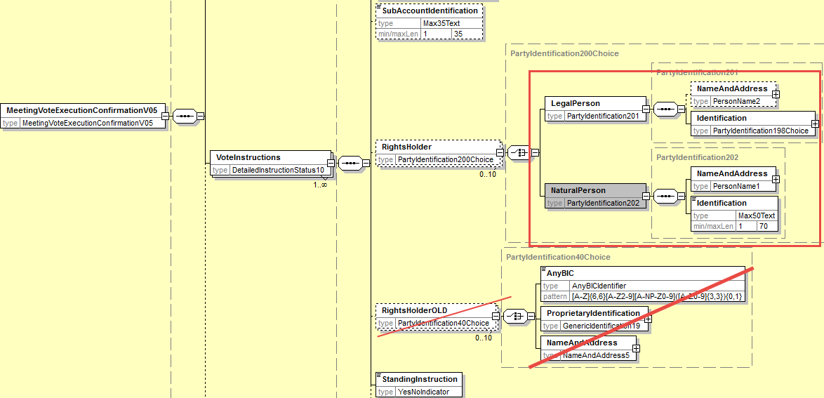

- Add a new AssetManager/(Proxy ?) Party Component
In the seev.007 (MECO – MeetingVoteExecutionConfirmation) message, in the VoteInstruction sequence, add a new optional and non-repeatable element AssetManager (or Proxy ?) typed by PartyIdentificationChoice to provide the name of a legal or natural person as illustrated below:
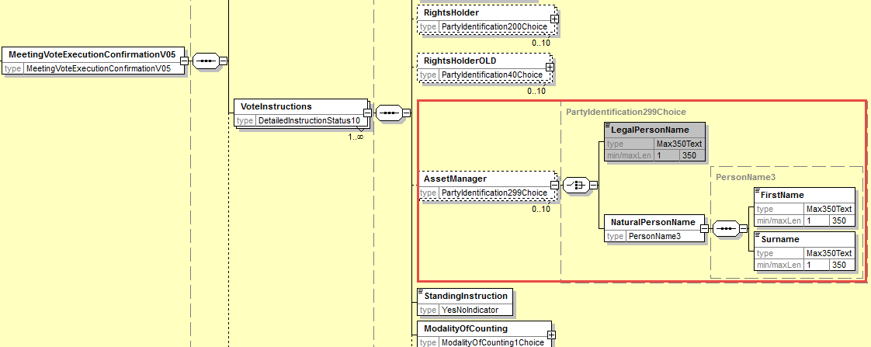

- Add new element ModalityOfCounting
In the seev.007 (MECO – MeetingVoteExecutionConfirmation) message, in the sequence VoteInstruction, add a new mandatory non-repeatable element ModalityOfCounting typed by a Choice between a proprietary Identification and a a new code list with the 4 following code values: Paper vote ahead of the meeting (PVBM), Electronic vote before the meeting (EVBM) , Electronic vote at the meeting (EVAM) , Physical vote at the meeting (PVAM) as illustrated below:
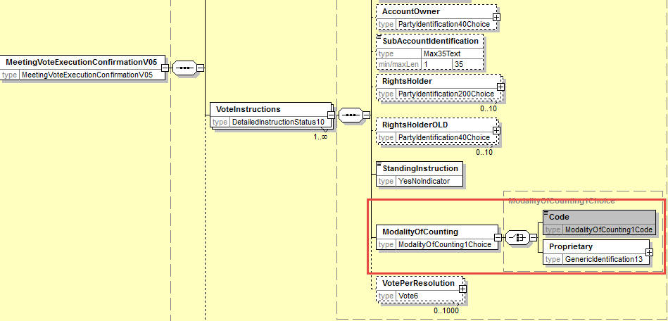

- Add new element VoteReceiptDateTime
In the seev.007 (MECO – MeetingVoteExecutionConfirmation) message, in the sequence VoteInstruction, add a new optional and non-repeatable element VoteReceiptDateTime typed by a ISODateTime data type as illustrated below:
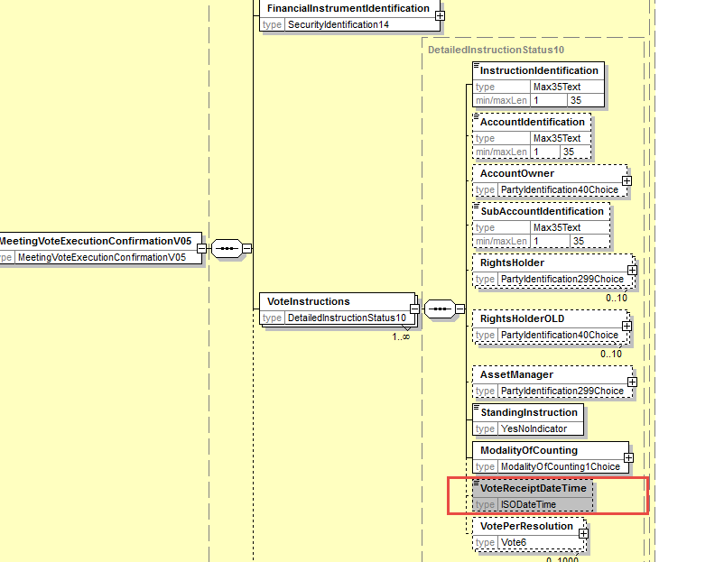

- Proposed timing:
The submitting organization confirms that it can implement the requested changes in the requested timing

Timing | - As requested

- Final decision of the SEG(s):

Approve
Comments:

Reject
Reason for rejection:

CR14: Amend the Scope of the Meeting Vote Execution Confirmation Message
- Origin of the request:
A.1 Submitter: SWIFT, SMPG
A.2 Contact person:
Christine Strandberg – christine.strandberg@seb.se – phone: +46 8 763 6074
Mari Fumagalli – mariangela.fumagalli@bnpparibas.com – phone: +44 207 595 4988
Jacques Littré – jacques.littre@swift.com – phone: +32 2 655 43 35
A.3 Sponsors: N/A

- Related messages:
List of ISO 20022 Proxy Voting messages which would be impacted by the change:
seev.007.001.05 MeetingVoteExecutionConfirmationV05

- Description of the change request:
Amend the scope/usage of the seev.007 message to specify that the message originates from the issuer as a confirmation of the vote execution and is forwarded by the intermediaries.
- Purpose of the change:
Clarify the exact usage of the message and confirm that the vote execution confirmation originates directly from the issuer.
- Urgency of the request:
This maintenance change request for the proxy-voting messages follows the ISO 20022 fast track maintenance process so as to publish a new version of those messages around end of Q3 2019.
- Business examples:
NA
- SEG recommendation:
This section is not to be taken care of by the submitter of the change request. It will be completed in due time by the SEG(s) in charge of the related ISO 20022 messages.

Consider |  |  | Timing
 |  |  | - Next yearly cycle: 2019/2020  (the change will be considered for implementation in the yearly maintenance cycle which starts in 2019 and completes with the publication of new message versions in the spring of 2020) |  |  | Priority:  high  medium  low
- At the occasion of the next maintenance of the messages
(the change will be considered for implementation, but does not justify maintenance of the messages in its own right – will be pending until more critical change requests are received for the messages)
 |  |  | - Urgent unscheduled  (the change justifies an urgent implementation outside of the normal yearly cycle) |  | X
 |  |  | - Other timing:
Comments:

Reject
Reason for rejection:

- Impact analysis:
This change request impacts the following messages:
seev.007.001.05 MeetingVoteExecutionConfirmationV05
- Proposed implementation:
Current scope/usage:
Scope
An issuer, its agent or an intermediary sends the MeetingVoteExecutionConfirmation message to confirm to the Sender of the MeetingInstruction message, the execution of their voting instruction.
Usage
This message is sent after the shareholders meeting has taken place. The Sender of this message
confirms the execution of the vote at the meeting and confirms that the vote has been processed as instructed via the MeetingInstruction message.
Amended Scope/Usage
Scope
An issuer, its agent or an intermediary sends the MeetingVoteExecutionConfirmation message to confirm to the Sender of the MeetingInstruction message, the execution of their voting instruction by the issuer.
Usage
This message is sent after the shareholders meeting has taken place. The Sender of this message confirms the execution of the vote at the meeting and confirms that the vote has been processed as instructed via the MeetingInstruction message

- Proposed timing:
The submitting organization confirms that it can implement the requested changes in the requested timing

Timing | - As requested

- Final decision of the SEG(s):

Approve
Comments:

Reject
Reason for rejection:

CR15: Replace All Obsolete Comoponents with New or Latest Version
- Origin of the request:
A.1 Submitter: SWIFT, SMPG
A.2 Contact person:
Christine Strandberg – christine.strandberg@seb.se – phone: +46 8 763 6074
Mari Fumagalli – mariangela.fumagalli@bnpparibas.com – phone: +44 207 595 4988
Jacques Littré – jacques.littre@swift.com – phone: +32 2 655 43 35
A.3 Sponsors: N/A

- Related messages:
List of ISO 20022 Proxy Voting messages which would be impacted by the change:
seev.001.001.05 MeetingNotificationV05
seev.002.001.05 MeetingCancellationV05
seev.003.001.05 MeetingEntitlementNotificationV05
seev.004.001.05 MeetingInstructionV05
seev.005.001.05 MeetingInstructionCancellationRequestV05
seev.006.001.05 MeetingInstructionStatusV05
seev.007.001.05 MeetingVoteExecutionConfirmationV05
seev.008.001.05 MeetingResultDisseminationV05

- Description of the change request:
Replace the obsolete message components and data types as follows in all related messages:

Obsolete Component | To be replaced with | Messages impacted
AnyBICIdentifier | AnyBICDec2014Identifier | All except seev.006
DateAndDateTimeChoice | DateAndDateTime2Choice | see.001
ISINIdentifier | ISINOct2015Identifier | All
AdditionalRights2 | New to be created | seev.001
DateFormat29Choice | New to be created | see.001
DetailedInstructionStatus10 | New to be created | seev.007
EligiblePosition5 | New to be created | seev.001,002,008
EligiblePosition6 | New to be created | seev.003
EntitlementAssessment3 | New to be created | seev.001
GenericIdentification19 | GenericIdentification36 | All except seev.006
GenericIdentification20 | GenericIdentification30 | All except seev.006, 007
GenericIdentification21 | GenericIdentification78 | All except seev.006, 007
HoldingBalance7 | New to be created | All except seev.004, 005, 006, 007
HoldingBalance8 | New to be created | seev.004, 005
IncentivePremium3 | New to be created | seev.001
IndividualPerson25 | New to be created | seev.001
IndividualPerson26 | New to be created | seev.004
Instruction3 | New to be created | seev.004
IssuerAgent2 | New to be created | seev.001
IssuerInformation2 | New to be created | seev.001
Meeting4 | New to be created | seev.001
MeetingContactPerson2 | New to be created | seev.001
MeetingNotice4 | New to be created | seev.001
PartyIdentification40Choice | PartyIdentification120Choice | All except seev.006
PartyIdentification71 | New to be created | Seev.001
PowerOfAttorneyRequirements3 | New to be created | Seev.001
PriceRateOrAmountChoice | PriceRateOrAmount3Choice | Seev.001
Proxy2Choice | New to be created | Seev.001
Proxy5 | New to be created | Seev.001
Proxy6 | New to be created | Seev.004
ProxyAppointmentInformation3 | New to be created | Seev.001
SafekeepingAccount6 | New to be created | Seev.004, 005
SafekeepingPlaceFormat2Choice | SafekeepingPlaceFormat28Choice | All except seev.006, 007
SafekeepingPlaceTypeAndText2 | SafekeepingPlaceTypeAndText6 | All except seev.006, 007
SecurityIdentification14 | SecurityIdentification19 | All
SecurityPosition8 | New to be created | Seev.001,002,008
SecurityPosition9 | New to be created | Seev.003
VoteParameter4 | New to be created | Seev.001

- Purpose of the change:
Replace all ISO 20022 Message components and data types which have become “Obsolete” in the ISO 20022 repository with the latest version/evolution of the component in the repository or a new one if a new version is not available.
- Urgency of the request:
This maintenance change request for the proxy-voting messages follows the ISO 20022 fast track maintenance process so as to publish a new version of those messages around end of Q3 2019.
- Business examples:

- SEG recommendation:
This section is not to be taken care of by the submitter of the change request. It will be completed in due time by the SEG(s) in charge of the related ISO 20022 messages.

Consider |  |  | Timing
 |  |  | - Next yearly cycle: 2019/2020  (the change will be considered for implementation in the yearly maintenance cycle which starts in 2019 and completes with the publication of new message versions in the spring of 2020) |  |  | Priority:  high  medium  low
- At the occasion of the next maintenance of the messages
(the change will be considered for implementation, but does not justify maintenance of the messages in its own right – will be pending until more critical change requests are received for the messages)
 |  |  | - Urgent unscheduled  (the change justifies an urgent implementation outside of the normal yearly cycle) |  | X
 |  |  | - Other timing:
Comments:

Reject
Reason for rejection:

- Impact analysis:
This change request impacts the following messages:
seev.001.001.05 MeetingNotificationV05
seev.002.001.05 MeetingCancellationV05
seev.003.001.05 MeetingEntitlementNotificationV05
seev.004.001.05 MeetingInstructionV05
seev.005.001.05 MeetingInstructionCancellationRequestV05
seev.006.001.05 MeetingInstructionStatusV05
seev.007.001.05 MeetingVoteExecutionConfirmationV05
seev.008.001.05 MeetingResultDisseminationV05
- Proposed implementation:
For each obsolete component, replace it with the existing latest version or a new one to be created as per the table list here above.
- Proposed timing:
The submitting organization confirms that it can implement the requested changes in the requested timing

Timing | - As requested

- Final decision of the SEG(s):

Approve
Comments:

Reject
Reason for rejection:

CR16: Rename PreviousReference in Meeting Instruction Cancellation Request
- Origin of the request:
A.1 Submitter: SWIFT, SMPG
A.2 Contact person:
Christine Strandberg – christine.strandberg@seb.se – phone: +46 8 763 6074
Mari Fumagalli – mariangela.fumagalli@bnpparibas.com – phone: +44 207 595 4988
Jacques Littré – jacques.littre@swift.com – phone: +32 2 655 43 35
A.3 Sponsors: N/A

- Related messages:
List of ISO 20022 Proxy Voting messages which would be impacted by the change:
seev.005.001.05 MeetingInstructionCancellationRequestV05
- Description of the change request:
Rename the message element PreviousReference as MeetingInstructionIdentification.
- Purpose of the change:
Align the naming of the reference to the previously sent MeetingInstruction message that is being cancelled with the ISO 20022 naming principles for message references.
- Urgency of the request:
This maintenance change request for the proxy-voting messages follows the ISO 20022 fast track maintenance process so as to publish a new version of those messages around end of Q3 2019.
- Business examples:
NA
- SEG recommendation:
This section is not to be taken care of by the submitter of the change request. It will be completed in due time by the SEG(s) in charge of the related ISO 20022 messages.

Consider |  |  | Timing
 |  |  | - Next yearly cycle: 2019/2020  (the change will be considered for implementation in the yearly maintenance cycle which starts in 2019 and completes with the publication of new message versions in the spring of 2020) |  |  | Priority:  high  medium  low
- At the occasion of the next maintenance of the messages
(the change will be considered for implementation, but does not justify maintenance of the messages in its own right – will be pending until more critical change requests are received for the messages)
 |  |  | - Urgent unscheduled  (the change justifies an urgent implementation outside of the normal yearly cycle) |  | X
 |  |  | - Other timing:
Comments:

Reject
Reason for rejection:

- Impact analysis:
This change request impacts the following messages:
seev.005.001.05 MeetingInstructionCancellationRequestV05
- Proposed implementation:
Rename the element PreviousReference at the root of the message as MeetingInstructionIdentification and change the date type Identification by Max35Text.
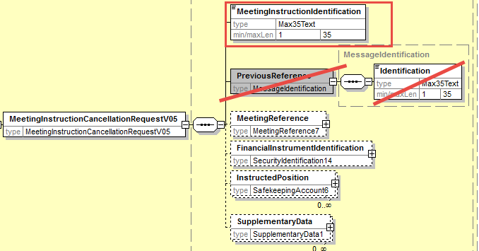
- Proposed timing:
The submitting organization confirms that it can implement the requested changes in the requested timing

Timing | - As requested

- Final decision of the SEG(s):

Approve
Comments:

Reject
Reason for rejection:

CR17: Rename all RightsHolder elements as Shareholder in all Messages
- Origin of the request:
A.1 Submitter: SWIFT, SMPG
A.2 Contact person:
Christine Strandberg – christine.strandberg@seb.se – phone: +46 8 763 6074
Mari Fumagalli – mariangela.fumagalli@bnpparibas.com – phone: +44 207 595 4988
Jacques Littré – jacques.littre@swift.com – phone: +32 2 655 43 35
A.3 Sponsors: N/A

- Related messages:
List of ISO 20022 Proxy Voting messages which would be impacted by the change:
seev.001.001.05 MeetingNotificationV05
seev.002.001.05 MeetingCancellationV05
seev.003.001.05 MeetingEntitlementNotificationV05
seev.004.001.05 MeetingInstructionV05
seev.005.001.05 MeetingInstructionCancellationRequestV05
seev.006.001.05 MeetingInstructionStatusV05
seev.007.001.05 MeetingVoteExecutionConfirmationV05
seev.008.001.05 MeetingResultDisseminationV05

- Description of the change request:
Rename all elements “RightsHolder” as “Shareholder”.
- Purpose of the change:
To be completed
- Urgency of the request:
This maintenance change request for the proxy-voting messages follows the ISO 20022 fast track maintenance process so as to publish a new version of those messages around end of Q3 2019.
- Business examples:
NA
- SEG recommendation:
This section is not to be taken care of by the submitter of the change request. It will be completed in due time by the SEG(s) in charge of the related ISO 20022 messages.

Consider |  |  | Timing
 |  |  | - Next yearly cycle: 2019/2020  (the change will be considered for implementation in the yearly maintenance cycle which starts in 2019 and completes with the publication of new message versions in the spring of 2020) |  |  | Priority:  high  medium  low
- At the occasion of the next maintenance of the messages
(the change will be considered for implementation, but does not justify maintenance of the messages in its own right – will be pending until more critical change requests are received for the messages)
 |  |  | - Urgent unscheduled  (the change justifies an urgent implementation outside of the normal yearly cycle) |  | X
 |  |  | - Other timing:
Comments:

Reject
Reason for rejection:

- Impact analysis:
This change request impacts the following messages:
seev.001.001.05 MeetingNotificationV05
seev.002.001.05 MeetingCancellationV05
seev.003.001.05 MeetingEntitlementNotificationV05
seev.004.001.05 MeetingInstructionV05
seev.005.001.05 MeetingInstructionCancellationRequestV05
seev.006.001.05 MeetingInstructionStatusV05
seev.007.001.05 MeetingVoteExecutionConfirmationV05
seev.008.001.05 MeetingResultDisseminationV05

- Proposed implementation:
In all seev.001 to seev.008 messages, rename all “RightsHolder” elements as “Shareholder” as illustrated below:
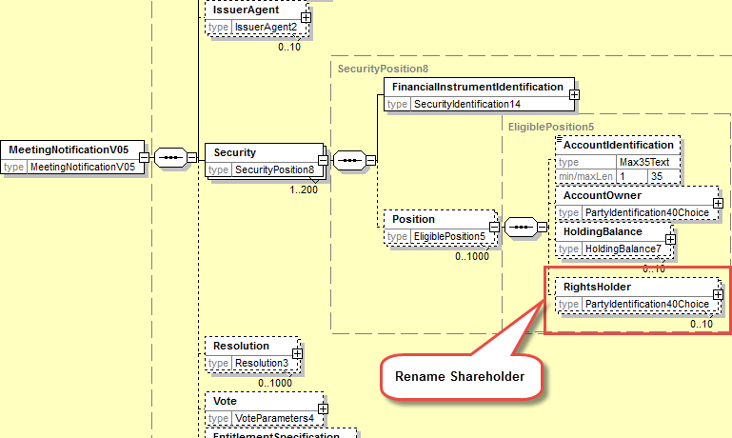
- Proposed timing:
The submitting organization confirms that it can implement the requested changes in the requested timing

Timing | - As requested

- Final decision of the SEG(s):

Approve
Comments:

Reject
Reason for rejection:

CRXXX:
- Origin of the request:
A.1 Submitter: SWIFT, SMPG
A.2 Contact person:
Christine Strandberg – christine.strandberg@seb.se – phone: +46 8 763 6074
Mari Fumagalli – mariangela.fumagalli@bnpparibas.com – phone: +44 207 595 4988
Jacques Littré – jacques.littre@swift.com – phone: +32 2 655 43 35
A.3 Sponsors: N/A

- Related messages:
List of ISO 20022 Proxy Voting messages which would be impacted by the change:
seev.001.001.05 MeetingNotificationV05
seev.002.001.05 MeetingCancellationV05
seev.003.001.05 MeetingEntitlementNotificationV05
seev.004.001.05 MeetingInstructionV05
seev.005.001.05 MeetingInstructionCancellationRequestV05
seev.006.001.05 MeetingInstructionStatusV05
seev.007.001.05 MeetingVoteExecutionConfirmationV05
seev.008.001.05 MeetingResultDisseminationV05

- Description of the change request:

- Purpose of the change:
This change is required by the European Commission Shareholders Rights Directive implementing regulation (EU) 2018/1212 of 3 September 2018 (see regulation table references in the description above).
- Urgency of the request:
This maintenance change request for the proxy-voting messages follows the ISO 20022 fast track maintenance process so as to publish a new version of those messages around end of Q3 2019.
- Business examples:

- SEG recommendation:
This section is not to be taken care of by the submitter of the change request. It will be completed in due time by the SEG(s) in charge of the related ISO 20022 messages.

Consider |  |  | Timing
 |  |  | - Next yearly cycle: 2019/2020  (the change will be considered for implementation in the yearly maintenance cycle which starts in 2019 and completes with the publication of new message versions in the spring of 2020) |  |  | Priority:  high  medium  low
- At the occasion of the next maintenance of the messages
(the change will be considered for implementation, but does not justify maintenance of the messages in its own right – will be pending until more critical change requests are received for the messages)
 |  |  | - Urgent unscheduled  (the change justifies an urgent implementation outside of the normal yearly cycle) |  | X
 |  |  | - Other timing:
Comments:

Reject
Reason for rejection:

- Impact analysis:
This change request impacts the following messages:
seev.007.001.05 MeetingVoteExecutionConfirmationV05
- Proposed implementation:

- Proposed timing:
The submitting organization confirms that it can implement the requested changes in the requested timing

Timing | - As requested

- Final decision of the SEG(s):

Approve
Comments:

Reject
Reason for rejection:

