Maintenance Change Request
for the update of ISO 20022 financial repository items
Note: the purpose of this document is to give guidelines to submitting organisations that will develop a new version of existing ISO 20022 messages based on change requests screened by the Standards Evaluation Group(s). Such development is subject to the approval of a Maintenance Change Request which must include a detailed description of the impact of each change on the related messages. The Maintenance Change Request must start with a general chapter covering topics related to the whole maintenance effort and a specific chapter for each change request, as described below. Please consult the iso20022.org website for additional details on the maintenance process.
The Maintenance Change Requests for this ISO 20022 maintenance will follow the fast track process and will be sent to iso20022ra@iso20022.org by June 14 2019.

- Name of the request:
Proxy Voting Messages Maintenance for year 2019/2020
- Submitting organization(s):
SWIFT, SMPG
- Related messages:
Under this project, all the following ISO 20022 Proxy Voting messages would be maintained:
 | Message Name | Identifier
1 | MeetingNotificationV05 | seev.001.001.05
2 | MeetingCancellationV05 | seev.002.001.05
3 | MeetingEntitlementNotificationV05 | seev.003.001.05
4 | MeetingInstructionV05 | seev.004.001.05
5 | MeetingInstructionCancellationRequestV05 | seev.005.001.05
6 | MeetingInstructionStatusV05 | seev.006.001.05
7 | MeetingVoteExecutionConfirmationV05 | seev.007.001.05
8 | MeetingResultDisseminationV05 | seev.008.001.05
- Commitments of the submitting organization:
SWIFT and SMPG confirm that it can and will:
- undertake the development of the new version of the candidate ISO 20022 message models that it will submit to the RA for compliance review and evaluation by August 15, 2019.
- provide a new version of part 1 of the Message Definition Report (MDR) by October 1, 2019 and new examples of valid message instances of each message by October 1 at the latest.
- address any queries related to the description of the new models and messages as published by the RA on the ISO 20022 website.
SWIFT confirms that it intends to organize the actual implementation of the new version of the messages on its SWIFTNet network once the related documentation has been published by the RA.

The submitting organisations confirm their knowledge and acceptance of the ISO 20022 Intellectual Property Rights policy for contributing organisations, as follows.
“Organisations that contribute information to be incorporated into the ISO 20022 Repository shall keep any Intellectual Property Rights (IPR) they have on this information. A contributing organisation warrants that it has sufficient rights on the contributed information to have it published in the ISO 20022 Repository through the ISO 20022 Registration Authority in accordance with the rules set in ISO 20022. To ascertain a widespread, public and uniform use of the ISO 20022 Repository information, the contributing organisation grants third parties a non-exclusive, royalty-free license to use the published information”.

- Contact persons:
Christine Strandberg – christine.strandberg@seb.se – phone: +46 8 763 6074
Mari Fumagalli – mariangela.fumagalli@bnpparibas.com – phone: +44 207 595 4988
Jacques Littré – jacques.littre@swift.com – phone: +32 2 655 43 35
ISO 20022 Proxy Voting Messages Maintenance 2019/2020

Table of Contents

1 CR1: Add new elements required by the SRD2 Directive in the Meeting Notification 4
2 CR2: Add AttendanceConditions in Meeting Sequence 11
3 CR3: Remove Date Status Quorum and Cancelled in MeetingDetails 14
4 CR4: Add new element Voting Rights Threshhold in Resolution 17
5 CR5: Remove element Entitlement in EntitlementSpecification sequence 20
6 CR6: Remove all STP Deadlines 23
7 CR7: Move All Elements from EntitlementSpecification sequence to the Meeting sequence 28
8 CR8: PromoteCourt Meeting from Meeting Classification Type to Meeting Type 32
9 CR9: Remove Vote InstructionType in Vote Sequence 35
10 CR10: Align Amendments with Meeting Notification Type and Status with the CA Notification Design 38
11 CR11: Align Meeting Linkages with CA Notification Linkages 42
12 CR12: Add new elements required by the SRD2 Directive in the Meeting Entitlement Notification 45
13 CR13: Set Balance Elements as Mandatory in Meeting EntitlementNotification 51
14 CR14: Add new elements required by the SRD2 Directive in the Meeting Instruction 54
15 CR15: Align Vote Instruction Type Codes Between the Meeting Notification and Instruction 61
16 CR16: Rename PreviousReference in Meeting Instruction Cancellation Request 66
17 CR17: Enable Cancellation of a Single Instruction within an Instruction Message 69
18 CR18: Add new elements required by the SRD2 Directive in the Meeting Instruction Status 72
19 CR19: Add new Pending Status in the Meeting Instruction Status Message and Align Other Status/reason Codes With CA Statuses 78
20 CR20: Add new elements required by the SRD2 Directive in the Meeting Vote Execution Confirmation 82
21 CR21: Set StandingInstructionOrder Optional in the Meeting Vote Execution Confirmation 87
22 CR22: Align the Meeting Result Dissemination Message Design with Similar Changes in Other Messages 90
23 CR23: Replace All Obsolete Components with New or Latest Version 94
24 CR24: Align all RightsHolder Identification Data type in all Messages 98
25 CR25: Amend Message Definitions Scope And Usage 101
26 CR26: Rename Message Set to “General Meeting” 106
27 CR27: In the instruction, add code QALL as a Quantity to Vote in All Type Of Vote in VotePerAgendaResolution 108
28 CR28: In the instruction, Allow to Vote for All Resolutions with a Single Vote 112

CR1: Add new elements required by the SRD2 Directive in the Meeting Notification
- Origin of the request:
A.1 Submitter: SWIFT, SMPG
A.2 Contact person:
Christine Strandberg – christine.strandberg@seb.se – phone: +46 8 763 6074
Mari Fumagalli – mariangela.fumagalli@bnpparibas.com – phone: +44 207 595 4988
Jacques Littré – jacques.littre@swift.com – phone: +32 2 655 43 35
A.3 Sponsors: N/A

- Related messages:
List of ISO 20022 Proxy Voting messages which would be impacted by the change:
seev.001.001.05 MeetingNotificationV05

- Description of the change request:
- In MeetingDetails sequence, add an optional and non-repeatable URLAddress as a virtual address for general meetings with a Max2048Text size.
- (IR table 3.C item 4 in implementation regulation)
- In the Meeting sequence, add the new optional and repeatable sequence “Participation“ containing the new mandatory element “ParticipationMethod”, the new mandatory element “IssuerDeadlineForVoting”. The ParticipationMethod element must contain the code values: Virtual participation, in person, through Proxy, by electronic vote, by physical correspondence/post1 updated, participation in person but not voting.
- (IR table 3.D items 1 and 3 in implementation regulation)
In the meeting sequence, make the element "AdditionalDocumentationURLAddress" repeatable.

- In the Resolution sequence, add a new optional non-repeatable URLAddress element.
- (IR table 3.E item 3 in implementation regulation)
- In the Resolution sequence, add a new optional and non-repeatable element VoteType after the element “ForInformationOnly” in order to specify if it is a binding vote or an advisory vote.
- (IR table 3.E item 4 in implementation regulation)
- In the Resolution and Vote sequences, for the VoteInstructionType element, in the VoteInstructionCode, add a new vote instruction type codes “BLNK (Blank)” (vote is cast as “empty” but the vote is counted) and “Other” paired with a narrative element and amend the definition of the “NoAction” code.
- (IR table 3.E item 5 in implementation regulation)
- Amend the Issuer/Identification component to accommodate an LEI similarly to the CA messages.
- Purpose of the change:
This change is required by the European Commission Shareholders Rights Directive implementing regulation (EU) 2018/1212 of 3 September 2018 (see regulation table references in the description above).
- Urgency of the request:
This maintenance change request for the proxy-voting messages follows the ISO 20022 fast track maintenance process so as to publish a new version of those messages around end of Q3 2019.
- Business examples:
NA
- SEG recommendation:
This section is not to be taken care of by the submitter of the change request. It will be completed in due time by the SEG(s) in charge of the related ISO 20022 messages.

Consider |  |  | Timing
 |  |  | - Next yearly cycle: 2019/2020  (the change will be considered for implementation in the yearly maintenance cycle which starts in 2019 and completes with the publication of new message versions in the spring of 2020) |  |  | Priority:  high  medium  low
- At the occasion of the next maintenance of the messages
(the change will be considered for implementation, but does not justify maintenance of the messages in its own right – will be pending until more critical change requests are received for the messages)
 |  |  | - Urgent unscheduled  (the change justifies an urgent implementation outside of the normal yearly cycle) |  | X
 |  |  | - Other timing:
Comments:

Reject
Reason for rejection:

- Impact analysis:
This change request impacts the following messages:
seev.001.001.05 MeetingNotificationV05
- Proposed implementation:

- Add URL Address in Meeting Details
In the seev.001 (MENO – MeetingNotification) message, in the MeetingDetails sequence, add a new optional and non-repeatable element URLAddress typed by Max256Text as illustrated below:
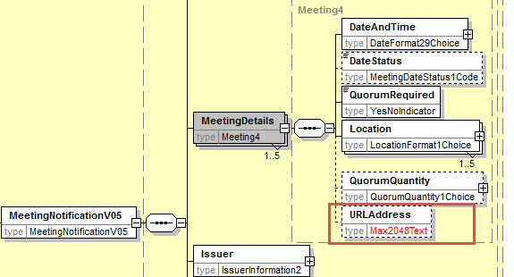

Also, align all URL address size in the seev.001 with Max2048Text.

- Add new Attendance component in the Meeting sequence
In the seev.001 (MENO – MeetingNotification) message, in the Meeting sequence, add a new optional and repeatable element Participation typed by a component containing:
- a new mandatory element ParticipationMethod typed by a code with the values: Virtual participation, in person, through Proxy, by correspondence, participation in person but not voting and a proprietary element.
- a new mandatory and non-repeatable element IssuerDeadlineForVoting typed by DateFormat29Choice

Remove the optional element in the Meeting sequence named AttendanceRequired since it can be covered via the above participation method “In Person” being the only participation method provided.
as illustrated below:
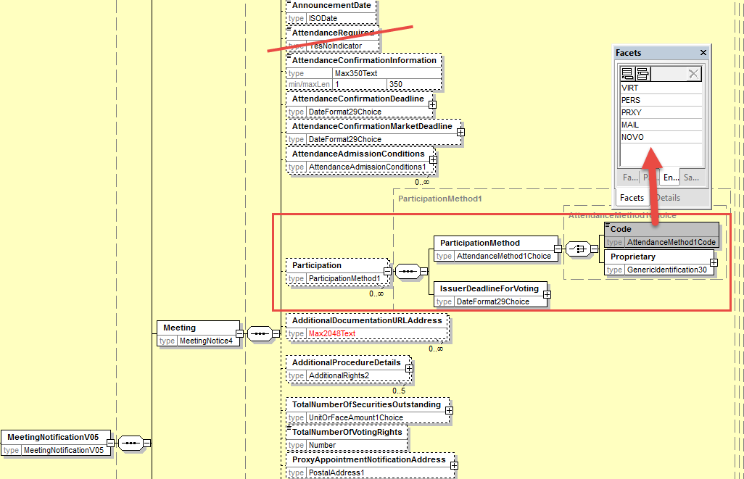

Make the "AdditionalDocumentationURLAddress" element repeatable and increase the size to Max2048Text as illustrated here below:

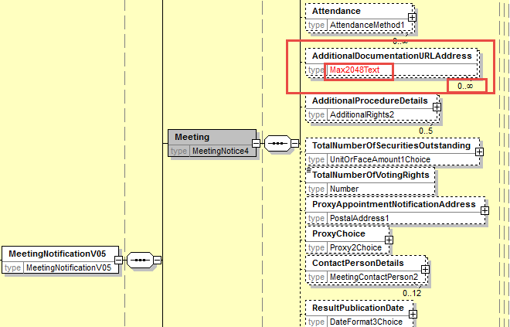
- Add URL address in Resolution sequence
In the seev.001 (MENO – MeetingNotification) message, in the Resolution sequence, add a new optional and non-repeatable element URLAddress typed by Max2048Text as illustrated below:
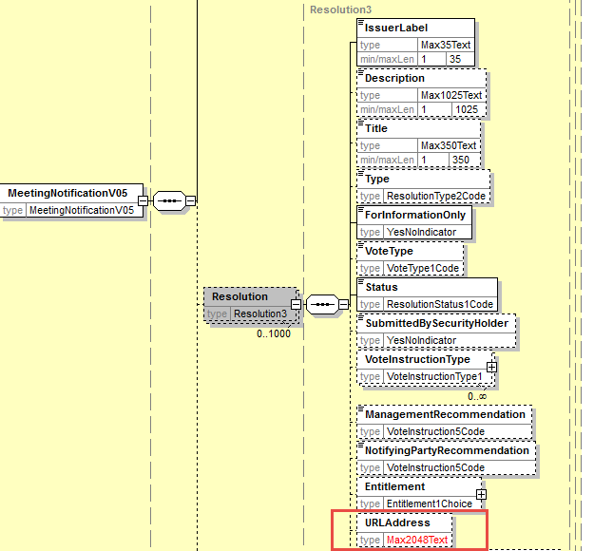
- Add Vote Type in Resolution
In the seev.001 (MENO – MeetingNotification) message, in the Resolution sequence, add a new optional and non-repeatable element VoteType typed by a code with values “Binding Vote” and “Advisory Vote” as illustrated below in e).

- Add new code value to VoteInstructionCode
In the seev.001 (MENO – MeetingNotification) message, in the Resolution and in the Vote sequences, for the element VoteInstructionType, replace the data type by a choice between
- a predefined code list typed by VoteInstruction2code and add the new code values “BLNK (Blank)” (vote is cast as “empty” but the vote is counted) and amend the definition of the “NoAction” code to read “Indicates an intention of not casting a vote.”.
- and a proprietary code value to cover the other type of votes.
- Set the multiplicity of the VoteInstructionType in the Vote sequence to [0..n]
- Also add a narrative element to explain what the proprietary code is all about if used and add a cross element rule so that AdditionalInformation may only be present if a proprietary vote instruction type code is provided.
as illustrated below:
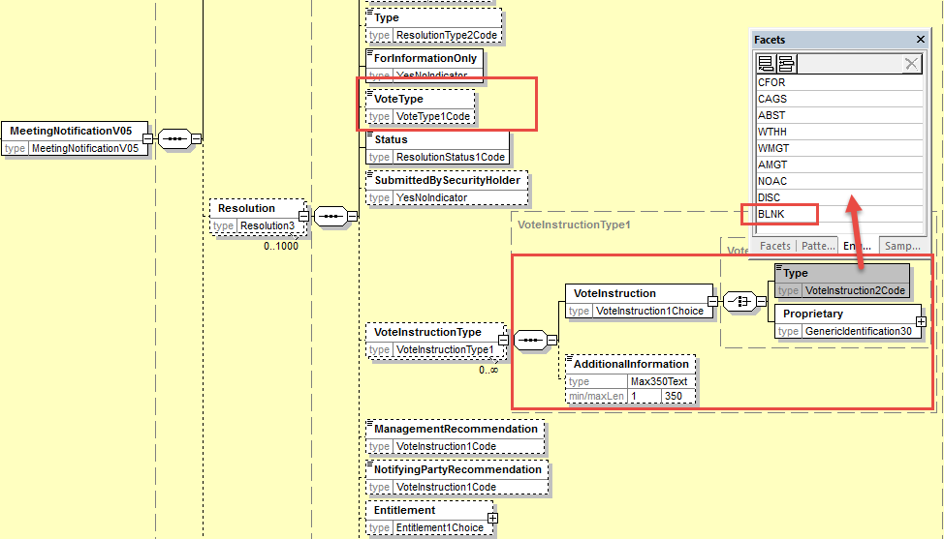
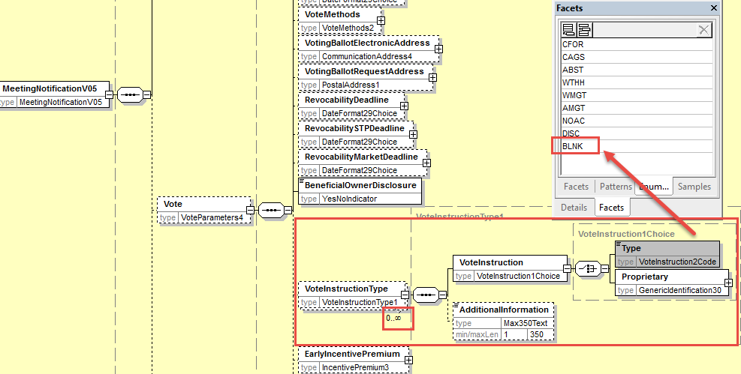

- Issuer Identification
In the Issuer/Identification element, replace the PartyIdentification40Choice component by the PatrtyIdentification129Choice as used in the CA messages for the identification of the Issuer.
Also, Increase the size of the URLAddress to Max2048Text.
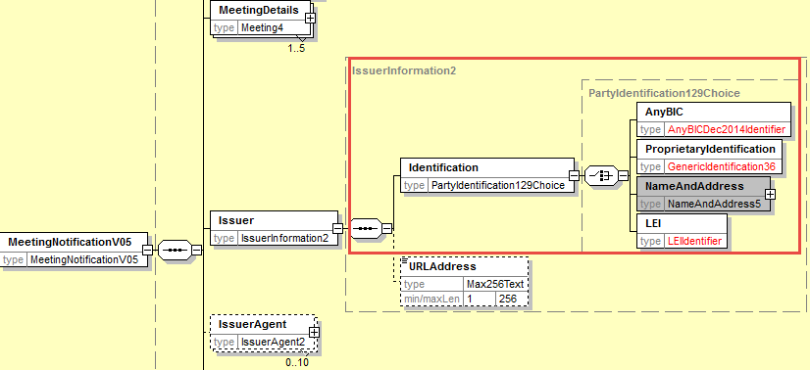
- Proposed timing:
The submitting organization confirms that it can implement the requested changes in the requested timing

Timing | - As requested

- Final decision of the SEG(s):

Approve
Comments:

Reject
Reason for rejection:

CR2: Add AttendanceConditions in Meeting Sequence
- Origin of the request:
A.1 Submitter: SWIFT, SMPG
A.2 Contact person:
Christine Strandberg – christine.strandberg@seb.se – phone: +46 8 763 6074
Mari Fumagalli – mariangela.fumagalli@bnpparibas.com – phone: +44 207 595 4988
Jacques Littré – jacques.littre@swift.com – phone: +32 2 655 43 35
A.3 Sponsors: N/A

- Related messages:
List of ISO 20022 Proxy Voting messages which would be impacted by the change:
seev.001.001.05 MeetingNotificationV05

- Description of the change request:
Add a new optional and repeatable element AttendanceAdmissionConditions in the Meeting sequence with predefined code values and a narrative part.
The predefined code values are:
- MALR - Meeting attendance allowed - attendees will be placed on a attendee list or issued with a Letter of Representation, and must bring photographic ID with them.
- MAAL - Meeting attendance allowed – attendees will be placed on a attendee list and must bring photographic ID with them.
- MATK - Meeting attendance allowed – attendees will be issued an admission ticket and must bring photographic ID with them.
- MAHI - Meeting attendance allowed - attendees must request proof of holding and register for attendance directly with Issuer.
- MAPO - Meeting attendance allowed - attendees acting on behalf of registered holder must have a valid PoA and/or proof of holding.
- MASH - Meeting attendance allowed but any attendee must be a shareholder themselves.
- MANP - Meeting attendance is not possible.

- Purpose of the change:
There is a need to specify what are the attendance admission conditions with predefined values and the possibility to give a narrative description as well.
- Urgency of the request:
This maintenance change request for the proxy-voting messages follows the ISO 20022 fast track maintenance process so as to publish a new version of those messages around end of Q3 2019.
- Business examples:
N/A
- SEG recommendation:
This section is not to be taken care of by the submitter of the change request. It will be completed in due time by the SEG(s) in charge of the related ISO 20022 messages.

Consider |  |  | Timing
 |  |  | - Next yearly cycle: 2019/2020  (the change will be considered for implementation in the yearly maintenance cycle which starts in 2019 and completes with the publication of new message versions in the spring of 2020) |  |  | Priority:  high  medium  low
- At the occasion of the next maintenance of the messages
(the change will be considered for implementation, but does not justify maintenance of the messages in its own right – will be pending until more critical change requests are received for the messages)
 |  |  | - Urgent unscheduled  (the change justifies an urgent implementation outside of the normal yearly cycle) |  | X
 |  |  | - Other timing:
Comments:

Reject
Reason for rejection:

- Impact analysis:
This change request impacts the following messages:
seev.001.001.05 MeetingNotificationV05

- Proposed implementation:
In the seev.001 (MENO – MeetingNotification) message, in the Meeting sequence, add a new optional and non-repeatable sequence named Attendance containing:
- the new optional and repeatable (up to 7) element AdmissionConditions typed by a component with a choice of code values or a narrative
And move in the new Attendance sequence the existing elements AttendanceConfirmationInformation, AttendanceConfirmationDeadline, AttendanceConfirmationMarketDeadline as illustrated below:
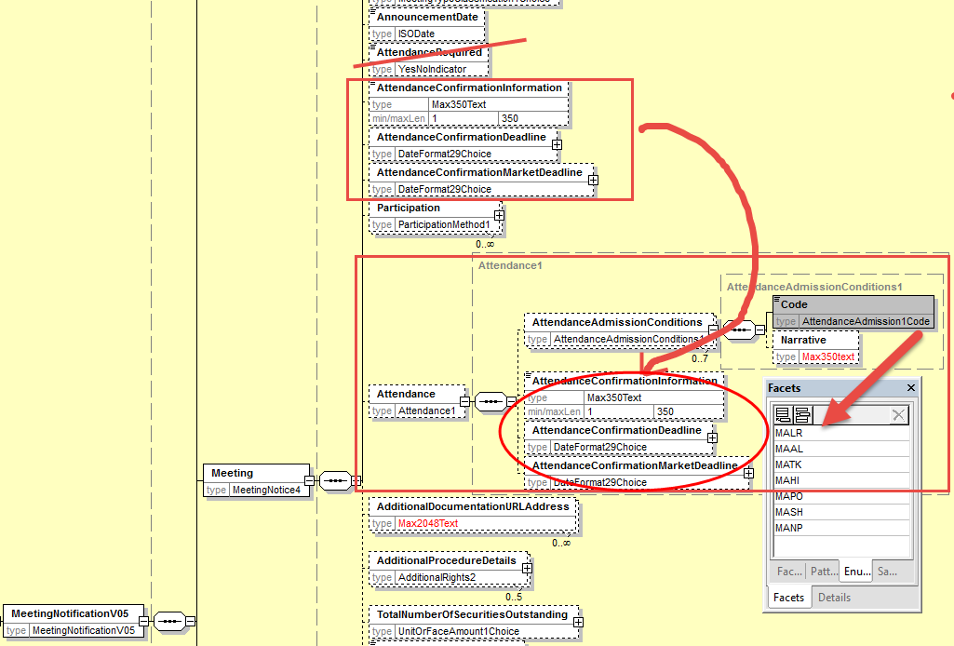

- Proposed timing:

The submitting organization confirms that it can implement the requested changes in the requested timing

Timing | - As requested

- Final decision of the SEG(s):

Approve
Comments:

Reject
Reason for rejection:

CR3: Remove Date Status Quorum and Cancelled in MeetingDetails
- Origin of the request:
A.1 Submitter: SWIFT, SMPG
A.2 Contact person:
Christine Strandberg – christine.strandberg@seb.se – phone: +46 8 763 6074
Mari Fumagalli – mariangela.fumagalli@bnpparibas.com – phone: +44 207 595 4988
Jacques Littré – jacques.littre@swift.com – phone: +32 2 655 43 35
A.3 Sponsors: N/A

- Related messages:
List of ISO 20022 Proxy Voting messages which would be impacted by the change:
seev.001.001.05 MeetingNotificationV05

- Description of the change request:
The code values NoQuorum (NOQO) and Cancelled (CANC) are inappropriate at this stage in the DateStatus and should be removed from the MeetingDateStatus1Code in the element MeetingDetails/DateStatus.
- Purpose of the change:
The code values NoQuorum (NOQO) appears already as a cancellation reason in the cancellation message (seev.002) and the Cancelled (CANC) status is inappropriate as it is the role of the cancellation message itself.
- Urgency of the request:
This maintenance change request for the proxy-voting messages follows the ISO 20022 fast track maintenance process so as to publish a new version of those messages around end of Q3 2019.
- Business examples:
N/A
- SEG recommendation:
This section is not to be taken care of by the submitter of the change request. It will be completed in due time by the SEG(s) in charge of the related ISO 20022 messages.

Consider |  |  | Timing
 |  |  | - Next yearly cycle: 2019/2020  (the change will be considered for implementation in the yearly maintenance cycle which starts in 2019 and completes with the publication of new message versions in the spring of 2020) |  |  | Priority:  high  medium  low
- At the occasion of the next maintenance of the messages
(the change will be considered for implementation, but does not justify maintenance of the messages in its own right – will be pending until more critical change requests are received for the messages)
 |  |  | - Urgent unscheduled  (the change justifies an urgent implementation outside of the normal yearly cycle) |  | X
 |  |  | - Other timing:
Comments:

Reject
Reason for rejection:

- Impact analysis:
This change request impacts the following messages:
seev.001.001.05 MeetingNotificationV05

- Proposed implementation:
In the seev.001 (MENO – MeetingNotification) message, in the MeetingDateStatus1Code the data type of the element MeetingDetails/DateStatus, remove the code values NOQO and CANC as illustrated below:
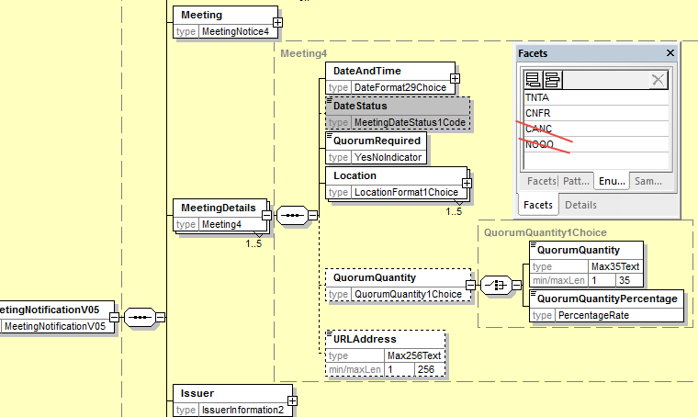

- Proposed timing:
The submitting organization confirms that it can implement the requested changes in the requested timing

Timing | - As requested

- Final decision of the SEG(s):

Approve
Comments:

Reject
Reason for rejection:

CR4: Add new element Voting Rights Threshhold in Resolution
- Origin of the request:
A.1 Submitter: SWIFT, SMPG
A.2 Contact person:
Christine Strandberg – christine.strandberg@seb.se – phone: +46 8 763 6074
Mari Fumagalli – mariangela.fumagalli@bnpparibas.com – phone: +44 207 595 4988
Jacques Littré – jacques.littre@swift.com – phone: +32 2 655 43 35
A.3 Sponsors: N/A

- Related messages:
List of ISO 20022 Proxy Voting messages which would be impacted by the change:
seev.001.001.05 MeetingNotificationV05

- Description of the change request:
In the Resolution sequence, add a new optional non repeatable element VotingRightsThresholdForApproval in quantity or percentage.

- Purpose of the change:
Providing the possibility to specify for each resolution the voting rights threshold required in percentage or in quantity to have the resolution approved.

- Urgency of the request:
This maintenance change request for the proxy-voting messages follows the ISO 20022 fast track maintenance process so as to publish a new version of those messages around end of Q3 2019.
- Business examples:
NA
- SEG recommendation:
This section is not to be taken care of by the submitter of the change request. It will be completed in due time by the SEG(s) in charge of the related ISO 20022 messages.

Consider |  |  | Timing
 |  |  | - Next yearly cycle: 2019/2020  (the change will be considered for implementation in the yearly maintenance cycle which starts in 2019 and completes with the publication of new message versions in the spring of 2020) |  |  | Priority:  high  medium  low
- At the occasion of the next maintenance of the messages
(the change will be considered for implementation, but does not justify maintenance of the messages in its own right – will be pending until more critical change requests are received for the messages)
 |  |  | - Urgent unscheduled  (the change justifies an urgent implementation outside of the normal yearly cycle) |  | X
 |  |  | - Other timing:
Comments:

Reject
Reason for rejection:

- Impact analysis:
This change request impacts the following messages:
seev.001.001.05 MeetingNotificationV05
- Proposed implementation:
In the seev.001 (MENO – MeetingNotification) message, in the Resolution sequence, add a new optional and non-repeatable element VotingRightsThresholdForApproval typed by a choice component between a percentage and an absolute number as illustrated below:
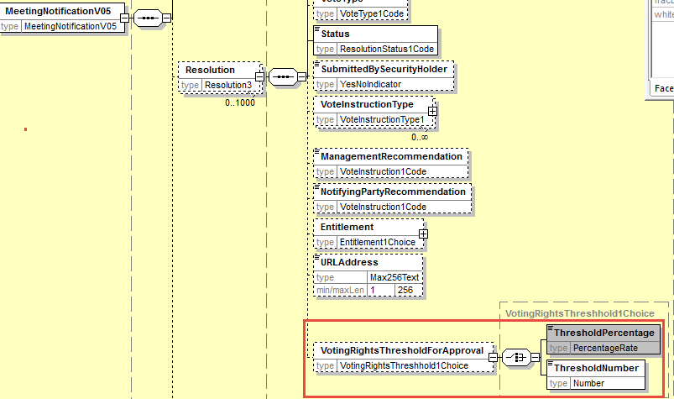

- Proposed timing:
The submitting organization confirms that it can implement the requested changes in the requested timing

Timing | - As requested

- Final decision of the SEG(s):

Approve
Comments:

Reject
Reason for rejection:

CR5: Remove element Entitlement in EntitlementSpecification sequence
- Origin of the request:
A.1 Submitter: SWIFT, SMPG
A.2 Contact person:
Christine Strandberg – christine.strandberg@seb.se – phone: +46 8 763 6074
Mari Fumagalli – mariangela.fumagalli@bnpparibas.com – phone: +44 207 595 4988
Jacques Littré – jacques.littre@swift.com – phone: +32 2 655 43 35
A.3 Sponsors: N/A

- Related messages:
List of ISO 20022 Proxy Voting messages which would be impacted by the change:
seev.001.001.05 MeetingNotificationV05

- Description of the change request:
In the EntitlementSpecification sequence, remove the optional element Entitlement.

- Purpose of the change:
The exact same element and data types are already present in the Resolution sequence, the element is therefore fully redundant and can be deleted.

- Urgency of the request:
This maintenance change request for the proxy-voting messages follows the ISO 20022 fast track maintenance process so as to publish a new version of those messages around end of Q3 2019.
- Business examples:
NA
- SEG recommendation:
This section is not to be taken care of by the submitter of the change request. It will be completed in due time by the SEG(s) in charge of the related ISO 20022 messages.

Consider |  |  | Timing
 |  |  | - Next yearly cycle: 2019/2020  (the change will be considered for implementation in the yearly maintenance cycle which starts in 2019 and completes with the publication of new message versions in the spring of 2020) |  |  | Priority:  high  medium  low
- At the occasion of the next maintenance of the messages
(the change will be considered for implementation, but does not justify maintenance of the messages in its own right – will be pending until more critical change requests are received for the messages)
 |  |  | - Urgent unscheduled  (the change justifies an urgent implementation outside of the normal yearly cycle) |  | X
 |  |  | - Other timing:
Comments:

Reject
Reason for rejection:

- Impact analysis:
This change request impacts the following messages:
seev.001.001.05 MeetingNotificationV05
- Proposed implementation:
In the seev.001 (MENO – MeetingNotification) message, in the EntitlementSpecification sequence, remove the optional element Entitlement typed by a choice component between EntitlementRatio and EntitlementDescription as illustrated below:

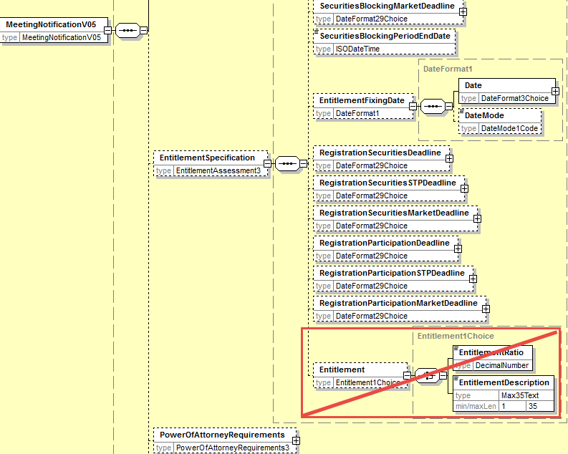
- Proposed timing:
The submitting organization confirms that it can implement the requested changes in the requested timing

Timing | - As requested

- Final decision of the SEG(s):

Approve
Comments:

Reject
Reason for rejection:

CR6: Remove all STP Deadlines
- Origin of the request:
A.1 Submitter: SWIFT, SMPG
A.2 Contact person:
Christine Strandberg – christine.strandberg@seb.se – phone: +46 8 763 6074
Mari Fumagalli – mariangela.fumagalli@bnpparibas.com – phone: +44 207 595 4988
Jacques Littré – jacques.littre@swift.com – phone: +32 2 655 43 35
A.3 Sponsors: N/A

- Related messages:
List of ISO 20022 Proxy Voting messages which would be impacted by the change:
seev.001.001.05 MeetingNotificationV05
seev.004.001.05 MeetingInstructionV05

- Description of the change request:
Remove the following STP deadline elements from the meeting notification message:
- AttendanceConfirmationSTPDeadline,
- STPDeadline (in ProxyChoice)
- VoteSTPDeadline,
- RevocabilitySTPDeadline,
- VoteWithPremiumSTPDeadline,
- SecuritiesBlockingSTPDeadline,
- RegistrationSecuritiesSTPDeadline,
- RegistrationParticipationSTPDeadline
And remove the two following deadlines because there are redundant with the SecuritiesBlockingPeriodEndDate:
- SecuritiesBlockingDeadline,
- SecuritiesBlockingMarketDeadline,
Remove the “BlockingSecurities” indicator in the sequence Instruction/SpecificInstructionRequest.
- Purpose of the change:
It is confusing and potentially misleading to make a difference between STP deadlines and non-STP deadlines in the message. To avoid confusion, we recommend to remove the STP deadlines that are redundant with the non-STP deadlines.
- Urgency of the request:
This maintenance change request for the proxy-voting messages follows the ISO 20022 fast track maintenance process so as to publish a new version of those messages around end of Q3 2019.
- Business examples:
NA
- SEG recommendation:
This section is not to be taken care of by the submitter of the change request. It will be completed in due time by the SEG(s) in charge of the related ISO 20022 messages.

Consider |  |  | Timing
 |  |  | - Next yearly cycle: 2019/2020  (the change will be considered for implementation in the yearly maintenance cycle which starts in 2019 and completes with the publication of new message versions in the spring of 2020) |  |  | Priority:  high  medium  low
- At the occasion of the next maintenance of the messages
(the change will be considered for implementation, but does not justify maintenance of the messages in its own right – will be pending until more critical change requests are received for the messages)
 |  |  | - Urgent unscheduled  (the change justifies an urgent implementation outside of the normal yearly cycle) |  | X
 |  |  | - Other timing:
Comments:

Reject
Reason for rejection:

- Impact analysis:
This change request impacts the following messages:
seev.001.001.05 MeetingNotificationV05
seev.004.001.05 MeetingInstructionV05

- Proposed implementation:
In the seev.001 (MENO – MeetingNotification) message, remove the following elements with STP deadlines:
- AttendanceConfirmationSTPDeadline - in Meeting sequence
- STPDeadline - in Meeting/ProxyChoice/Proxy sequence
- VoteSTPDeadline - in Vote sequence
- RevocabilitySTPDeadline - in Vote sequence
- VoteWithPremiumSTPDeadline - in Vote sequence
- SecuritiesBlockingSTPDeadline - in EntitlementSpecification sequence
- RegistrationSecuritiesSTPDeadline - in EntitlementSpecification sequence
- RegistrationParticipationSTPDeadline - in EntitlementSpecification sequence
- SecuritiesBlockingDeadline – in EntitlementSpecification sequence
- SecuritiesBlockingMarketDeadline - in EntitlementSpecification sequence

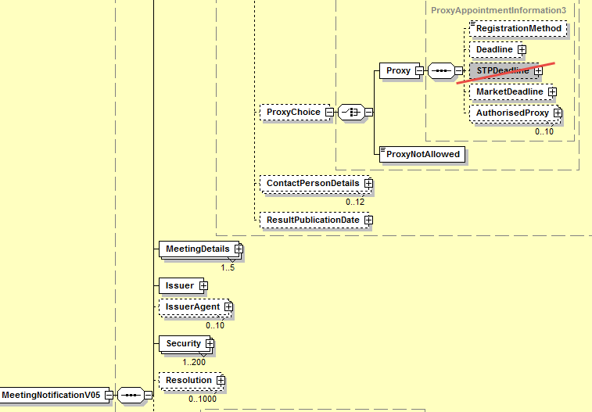
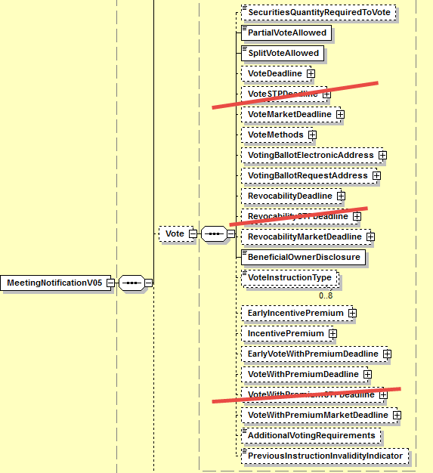

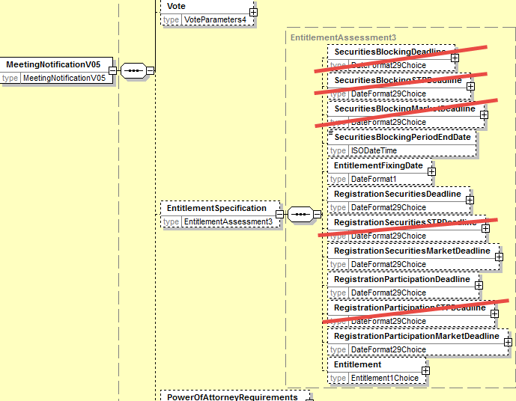

In the seev.004 MeetingInstruction message, in sequence Instruction/SpecificInstructionRequest, remove the “BlockingSecurities” indicator as illustrated below:
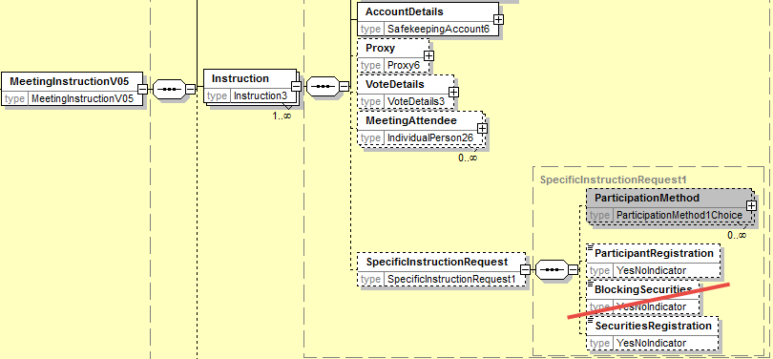

- Proposed timing:
The submitting organization confirms that it can implement the requested changes in the requested timing

Timing | - As requested

- Final decision of the SEG(s):

Approve
Comments:

Reject
Reason for rejection:

CR7: Move All Elements from EntitlementSpecification sequence to the Meeting sequence
- Origin of the request:
A.1 Submitter: SWIFT, SMPG
A.2 Contact person:
Christine Strandberg – christine.strandberg@seb.se – phone: +46 8 763 6074
Mari Fumagalli – mariangela.fumagalli@bnpparibas.com – phone: +44 207 595 4988
Jacques Littré – jacques.littre@swift.com – phone: +32 2 655 43 35
A.3 Sponsors: N/A

- Related messages:
List of ISO 20022 Proxy Voting messages which would be impacted by the change:
seev.001.001.05 MeetingNotificationV05

- Description of the change request:
In the EntitlementSpecification sequence, move all elements to the Meeting sequence and delete EntitlementSpecification.

- Purpose of the change:
If the “Entitlement” element of the EntitlementSpecification sequence is removed (via one of the preceding change request), most of the remaining elements in the EntitlementSpecification sequence are more related to general meeting information than to Entitlement. Therefore it would make more sense to regroup all detailed meeting information at the same place in the same sequence and remove that sequence.

- Urgency of the request:
This maintenance change request for the proxy-voting messages follows the ISO 20022 fast track maintenance process so as to publish a new version of those messages around end of Q3 2019.
- Business examples:
NA
- SEG recommendation:
This section is not to be taken care of by the submitter of the change request. It will be completed in due time by the SEG(s) in charge of the related ISO 20022 messages.

Consider |  |  | Timing
 |  |  | - Next yearly cycle: 2019/2020  (the change will be considered for implementation in the yearly maintenance cycle which starts in 2019 and completes with the publication of new message versions in the spring of 2020) |  |  | Priority:  high  medium  low
- At the occasion of the next maintenance of the messages
(the change will be considered for implementation, but does not justify maintenance of the messages in its own right – will be pending until more critical change requests are received for the messages)
 |  |  | - Urgent unscheduled  (the change justifies an urgent implementation outside of the normal yearly cycle) |  | X
 |  |  | - Other timing:
Comments:

Reject
Reason for rejection:
- Impact analysis:
This change request impacts the following messages:
seev.001.001.05 MeetingNotificationV05
- Proposed implementation:
In the seev.001 (MENO – MeetingNotification) message, in the EntitlementSpecification sequence, move all elements to the Meeting sequence and remove the EntitlementSpecification sequence itself as illustrated below:

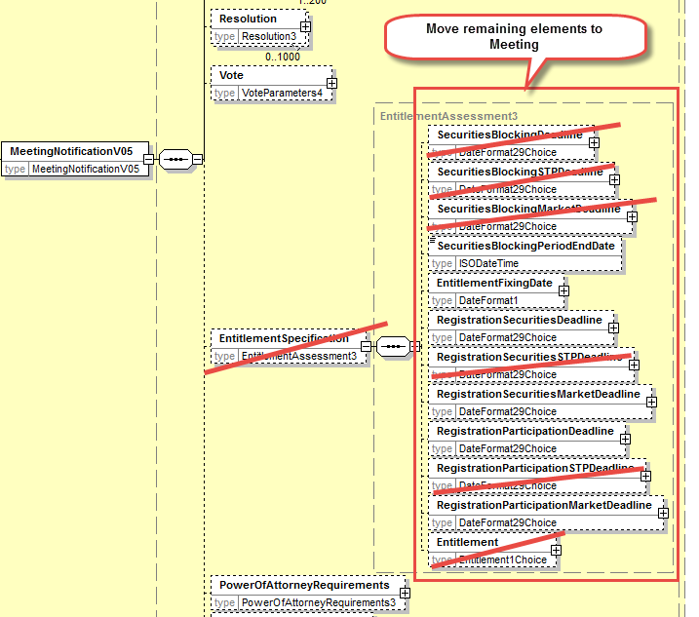

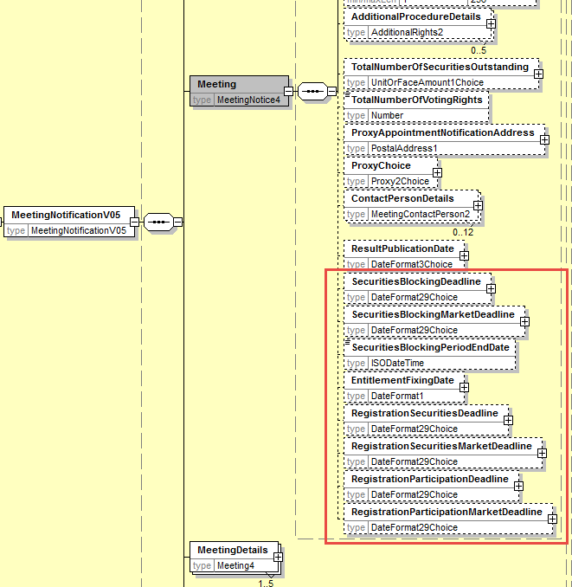
- Proposed timing:
The submitting organization confirms that it can implement the requested changes in the requested timing

Timing | - As requested

- Final decision of the SEG(s):

Approve
Comments:

Reject
Reason for rejection:

CR8: PromoteCourt Meeting from Meeting Classification Type to Meeting Type
- Origin of the request:
A.1 Submitter: SWIFT, SMPG
A.2 Contact person:
Christine Strandberg – christine.strandberg@seb.se – phone: +46 8 763 6074
Mari Fumagalli – mariangela.fumagalli@bnpparibas.com – phone: +44 207 595 4988
Jacques Littré – jacques.littre@swift.com – phone: +32 2 655 43 35
A.3 Sponsors: N/A
- Related messages:
List of ISO 20022 Proxy Voting messages which would be impacted by the change:
seev.001.001.05 MeetingNotificationV05
seev.002.001.05 MeetingCancellationV05
seev.003.001.05 MeetingEntitlementNotificationV05
seev.004.001.05 MeetingInstructionV05
seev.005.001.05 MeetingInstructionCancellationRequestV05
seev.006.001.05 MeetingInstructionStatusV05
seev.007.001.05 MeetingVoteExecutionConfirmationV05
seev.008.001.05 MeetingResultDisseminationV05

- Description of the change request:
Move the “Court Meeting” (CORT) code value from the meeting “Classification” type code to the meeting Type code.
- Purpose of the change:
The Court meeting must be considered as one of the main types of shareholder meeting and not as a classification type of another meeting type.
- Urgency of the request:
This maintenance change request for the proxy-voting messages follows the ISO 20022 fast track maintenance process so as to publish a new version of those messages around end of Q3 2019.
- Business examples:
NA
- SEG recommendation:
This section is not to be taken care of by the submitter of the change request. It will be completed in due time by the SEG(s) in charge of the related ISO 20022 messages.

Consider |  |  | Timing
 |  |  | - Next yearly cycle: 2019/2020  (the change will be considered for implementation in the yearly maintenance cycle which starts in 2019 and completes with the publication of new message versions in the spring of 2020) |  |  | Priority:  high  medium  low
- At the occasion of the next maintenance of the messages
(the change will be considered for implementation, but does not justify maintenance of the messages in its own right – will be pending until more critical change requests are received for the messages)
 |  |  | - Urgent unscheduled  (the change justifies an urgent implementation outside of the normal yearly cycle) |  | X
 |  |  | - Other timing:
Comments:

Reject
Reason for rejection:

- Impact analysis:
This change request impacts the following messages:
seev.001.001.05 MeetingNotificationV05
seev.002.001.05 MeetingCancellationV05
seev.003.001.05 MeetingEntitlementNotificationV05
seev.004.001.05 MeetingInstructionV05
seev.005.001.05 MeetingInstructionCancellationRequestV05
seev.006.001.05 MeetingInstructionStatusV05
seev.007.001.05 MeetingVoteExecutionConfirmationV05
seev.008.001.05 MeetingResultDisseminationV05
- Proposed implementation:
In the seev.001 (MENO – MeetingNotification) message, in the data type MeetingType3Code of the Meeting/Type/code element and of the MeetingReference/Type element in all other seev.002 to seev.008 messages, add the code value “Court Meeting” (CMET) and delete the “Court Meeting” (CORT) code value from the MeetingTypeClassification1Code data type of the element Code in the MeetingReference/Classification sequence as illustrated below:

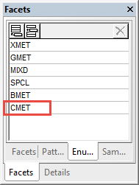

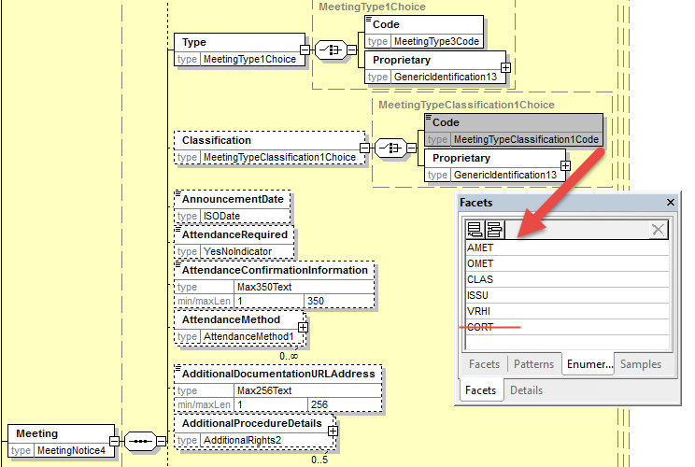

- Proposed timing:
The submitting organization confirms that it can implement the requested changes in the requested timing

Timing | - As requested

- Final decision of the SEG(s):

Approve
Comments:

Reject
Reason for rejection:

CR9: Remove Vote InstructionType in Vote Sequence
- Origin of the request:
A.1 Submitter: SWIFT, SMPG
A.2 Contact person:
Christine Strandberg – christine.strandberg@seb.se – phone: +46 8 763 6074
Mari Fumagalli – mariangela.fumagalli@bnpparibas.com – phone: +44 207 595 4988
Jacques Littré – jacques.littre@swift.com – phone: +32 2 655 43 35
A.3 Sponsors: N/A
- Related messages:
List of ISO 20022 Proxy Voting messages which would be impacted by the change:
seev.001.001.05 MeetingNotificationV05
- Description of the change request:
Remove the element optional and repeatable VoteInstructionType in the sequence Vote.
- Purpose of the change:
Fully redundant with VoteInstructionType in the sequence Resolution.
- Urgency of the request:
This maintenance change request for the proxy-voting messages follows the ISO 20022 fast track maintenance process so as to publish a new version of those messages around end of Q3 2019.
- Business examples:
NA
- SEG recommendation:
This section is not to be taken care of by the submitter of the change request. It will be completed in due time by the SEG(s) in charge of the related ISO 20022 messages.

Consider |  |  | Timing
 |  |  | - Next yearly cycle: 2019/2020  (the change will be considered for implementation in the yearly maintenance cycle which starts in 2019 and completes with the publication of new message versions in the spring of 2020) |  |  | Priority:  high  medium  low
- At the occasion of the next maintenance of the messages
(the change will be considered for implementation, but does not justify maintenance of the messages in its own right – will be pending until more critical change requests are received for the messages)
 |  |  | - Urgent unscheduled  (the change justifies an urgent implementation outside of the normal yearly cycle) |  | X
 |  |  | - Other timing:
Comments:

Reject
Reason for rejection:

- Impact analysis:
This change request impacts the following messages:
seev.001.001.05 MeetingNotificationV05
- Proposed implementation:
In the seev.001 (MENO – MeetingNotification) message, delete the optional and non-repeatable Vote/VoteInstructionType element as illustrated below:
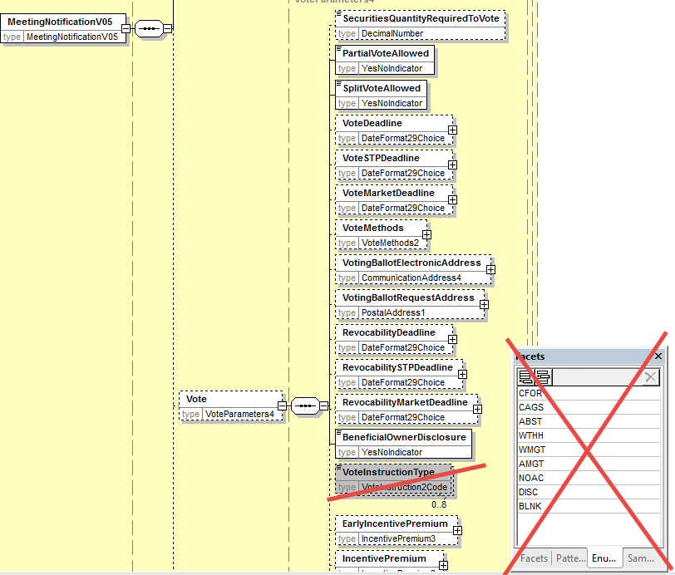
- Proposed timing:
The submitting organization confirms that it can implement the requested changes in the requested timing.

Timing | - As requested

- Final decision of the SEG(s):

Approve
Comments:

Reject
Reason for rejection:

CR10: Align Amendments with Meeting Notification Type and Status with the CA Notification Design
- Origin of the request:
A.1 Submitter: SWIFT, SMPG
A.2 Contact person:
Christine Strandberg – christine.strandberg@seb.se – phone: +46 8 763 6074
Mari Fumagalli – mariangela.fumagalli@bnpparibas.com – phone: +44 207 595 4988
Jacques Littré – jacques.littre@swift.com – phone: +32 2 655 43 35
A.3 Sponsors: N/A
- Related messages:
List of ISO 20022 Proxy Voting messages which would be impacted by the change:
seev.001.001.05 MeetingNotificationV05

- Description of the change request:
Add a new mandatory and non-repeatable sequence NotificationGeneralInformation” and add a new mandatory element “NotificationType” with codes New, Reminder and Replacement.
Move the element NotificationStatus from the root of the message to the new NotificationGeneralInformation sequence and add a status on the completeness (complete/incomplete) of the notification in addition to the Confirmation status similarly to what exist already in the seev.031 CA Notification message.
Rename “Amendment” as NotificationUpdate.
- Purpose of the change:
Align the proxy voting meeting notification with the CA notifications for notification types (New and Replacement).
- Urgency of the request:
This maintenance change request for the proxy-voting messages follows the ISO 20022 fast track maintenance process so as to publish a new version of those messages around end of Q3 2019.
- Business examples:
NA
- SEG recommendation:
This section is not to be taken care of by the submitter of the change request. It will be completed in due time by the SEG(s) in charge of the related ISO 20022 messages.

Consider |  |  | Timing
 |  |  | - Next yearly cycle: 2019/2020  (the change will be considered for implementation in the yearly maintenance cycle which starts in 2019 and completes with the publication of new message versions in the spring of 2020) |  |  | Priority:  high  medium  low
- At the occasion of the next maintenance of the messages
(the change will be considered for implementation, but does not justify maintenance of the messages in its own right – will be pending until more critical change requests are received for the messages)
 |  |  | - Urgent unscheduled  (the change justifies an urgent implementation outside of the normal yearly cycle) |  | X
 |  |  | - Other timing:
Comments:

Reject
Reason for rejection:

- Impact analysis:
This change request impacts the following messages:
seev.001.001.05 MeetingNotificationV05
- Proposed implementation:
In the seev.001 (MENO – MeetingNotification) message, add a new mandatory and non-repeatable sequence NotificationGeneralInformation” and add a new mandatory element “NotificationType” with codes New, Reminder and Replacement.
Move the element NotificationStatus from the root of the message to the new NotificationGeneralInformation sequence.
In the NotificationStatus sequence add a new SecuritiesEventStatus1 component with the new mandatory and non-repeatable element EventConfirmationStatus typed by EventConfirmationStatus1Code with code values Confirmed (CONF) and Unconfirmed (UCON) - so that code values are identical to those defined in the CA Notification seev.031 message - and the new mandatory and non-repeatable element EventCompletenessStatus typed by EventCompletenessStatus1Code with code values Complete (COMP) and Incomplete (INCO).
Rename “Amendment” sequence as NotificationUpdate and rename its element PreviousReference as PreviousNotificationIdentification as illustrated below.
Add also a new cross element rule at the root of the message in order to condition the presence of the element NotificationUpdate/PreviousNotificationIdentification when NotificationGeneralInformation/NotificationType value is REPL (Replacement).

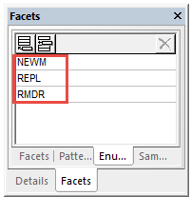
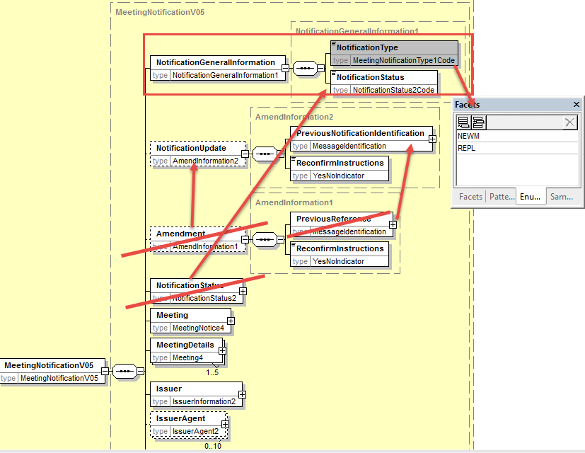

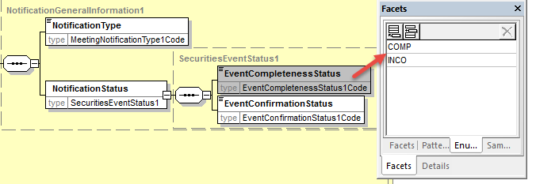
- Proposed timing:
The submitting organization confirms that it can implement the requested changes in the requested timing
Timing | - As requested

- Final decision of the SEG(s):
Approve
Comments:

Reject
Reason for rejection:

CR11: Align Meeting Linkages with CA Notification Linkages
- Origin of the request:
A.1 Submitter: SWIFT, SMPG
A.2 Contact person:
Christine Strandberg – christine.strandberg@seb.se – phone: +46 8 763 6074
Mari Fumagalli – mariangela.fumagalli@bnpparibas.com – phone: +44 207 595 4988
Jacques Littré – jacques.littre@swift.com – phone: +32 2 655 43 35
A.3 Sponsors: N/A

- Related messages:
List of ISO 20022 Proxy Voting messages which would be impacted by the change:
seev.001.001.05 MeetingNotificationV05

- Description of the change request:
Add a new linkages sequence in the meeting notification - similarly to what is done in the corporate action notification message (seev.031) - with an identification of linked meeting identification or a linked Issuer meeting identification.
- Purpose of the change:
Align the proxy voting meeting notification with the CA notifications for linkages as there are no Linkages capabilities in the current message.
- Urgency of the request:
This maintenance change request for the proxy-voting messages follows the ISO 20022 fast track maintenance process so as to publish a new version of those messages around end of Q3 2019.
- Business examples:
NA
- SEG recommendation:
This section is not to be taken care of by the submitter of the change request. It will be completed in due time by the SEG(s) in charge of the related ISO 20022 messages.

Consider |  |  | Timing
 |  |  | - Next yearly cycle: 2019/2020  (the change will be considered for implementation in the yearly maintenance cycle which starts in 2019 and completes with the publication of new message versions in the spring of 2020) |  |  | Priority:  high  medium  low
- At the occasion of the next maintenance of the messages
(the change will be considered for implementation, but does not justify maintenance of the messages in its own right – will be pending until more critical change requests are received for the messages)
 |  |  | - Urgent unscheduled  (the change justifies an urgent implementation outside of the normal yearly cycle) |  | X
 |  |  | - Other timing:
Comments:

Reject
Reason for rejection:

- Impact analysis:
This change request impacts the following messages:
seev.001.001.05 MeetingNotificationV05
- Proposed implementation:
In the seev.001 (MENO – MeetingNotification) message, add a new optional and repeatable sequence EventsLinkages with a mandatory and non-repeatable element EventIdentification typed by a Choice component with the elements LinkedIssuerMeetingIdentification and LinkedMeetingIdentification both typed by Max35Text.
The EventsLinkages sequence contain also an optional and non-repeatable element LinkageType typed by the code ProcessingPosition3Codes with the four values, After, Before, With and Information.
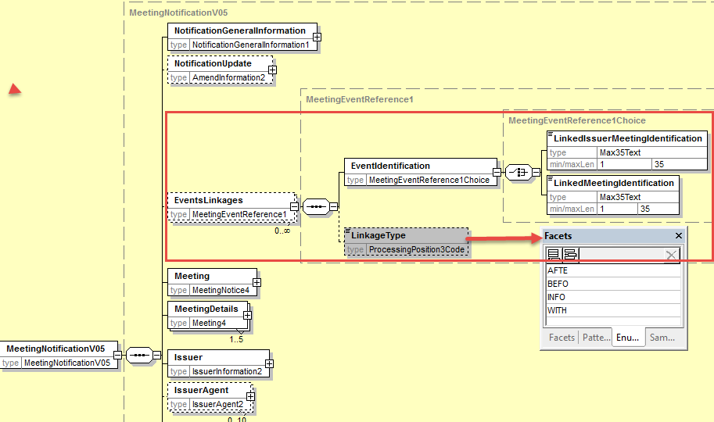

- Proposed timing:
The submitting organization confirms that it can implement the requested changes in the requested timing

Timing | - As requested

- Final decision of the SEG(s):

Approve
Comments:

Reject
Reason for rejection:

CR12: Add new elements required by the SRD2 Directive in the Meeting Entitlement Notification
- Origin of the request:
A.1 Submitter: SWIFT, SMPG
A.2 Contact person:
Christine Strandberg – christine.strandberg@seb.se – phone: +46 8 763 6074
Mari Fumagalli – mariangela.fumagalli@bnpparibas.com – phone: +44 207 595 4988
Jacques Littré – jacques.littre@swift.com – phone: +32 2 655 43 35
A.3 Sponsors: N/A

- Related messages:
List of ISO 20022 Proxy Voting messages which would be impacted by the change:
seev.003.001.05 MeetingEntitlementNotificationV05
- Description of the change request:
- Add the new mandatory and non-repeatable element “Issuer” in the message (same as the one in meeting notification) right before the “Security” element.
(IR table 4.A item 2 in implementation regulation)
- Add a new mandatory element “NotificationType” with codes New and Replacement at the root of the message before RelatedReference and rename RelatedReference as “PreviousEntitlementNotificationIdentification”.
(IR table 4.A item 4 in implementation regulation)
- Add new mandatory non-repeatable element “AccountHolder” after the Eligibility element with identification and name of either a legal or a natural person (as defined in the ShareholderIdentificationDisclosureResponse message.
(IR table 4.C item 1 and 2 in implementation regulation)
- Adapt the data type of the RightsHolder Identification element to the Identification specifications required in the IR Table 4.C.
(IR table 4.C item 1 and 2 in implementation regulation)
- Add new optional and non-repeatable elements “MeetingAttendee” and “Proxy” after the Eligibility element with identification and name of either a legal or a natural person (as defined in the ShareholderIdentificationDisclosureResponse message.
(IR table 4.C item 3 and 4 in implementation regulation)

- Purpose of the change:
This change is required by the European Commission Shareholders Rights Directive implementing regulation (EU) 2018/1212 of 3 September 2018 (see regulation table references in the description above).
- Urgency of the request:
This maintenance change request for the proxy-voting messages follows the ISO 20022 fast track maintenance process so as to publish a new version of those messages around end of Q3 2019.
- Business examples:

- SEG recommendation:
This section is not to be taken care of by the submitter of the change request. It will be completed in due time by the SEG(s) in charge of the related ISO 20022 messages.

Consider |  |  | Timing
 |  |  | - Next yearly cycle: 2019/2020  (the change will be considered for implementation in the yearly maintenance cycle which starts in 2019 and completes with the publication of new message versions in the spring of 2020) |  |  | Priority:  high  medium  low
- At the occasion of the next maintenance of the messages
(the change will be considered for implementation, but does not justify maintenance of the messages in its own right – will be pending until more critical change requests are received for the messages)
 |  |  | - Urgent unscheduled  (the change justifies an urgent implementation outside of the normal yearly cycle) |  | X
 |  |  | - Other timing:
Comments:

Reject
Reason for rejection:

- Impact analysis:
This change request impacts the following messages:
seev.003.001.05 MeetingEntitlementNotificationV05

- Proposed implementation:

- Add Issuer Identification
In the seev.003 (MENT – MeetingEntitlementNotification) message, add a new mandatory and non-repeatable element Issuer typed by the same PartyIdentificationChoice component used in the CorporateAction message with the component PartyIdentification129Choice containing an LEI identification as illustrated below:
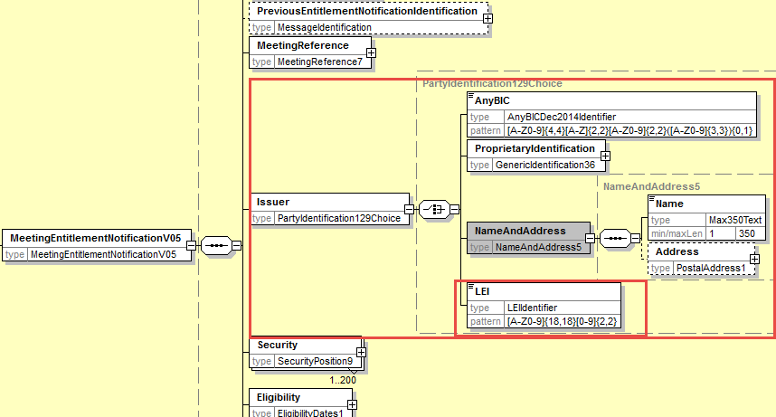

- Add Notification Type
In the seev.003 (MENT – MeetingEntitlementNotification) message, add at the root of the message as a first element, a new mandatory and non-repeatable element NotificationType typed by the code list MeetingNotificationType1Code used in the MeetingNotification message and rename also the RelatedReference element as PreviousEntitlementNotificationIdentification as illustrated below:
Add also a new cross element rule at the root of the message in order to condition the presence of the element PreviousEntitlementNotificationIdentification when NotificationType value is REPL (Replacement).
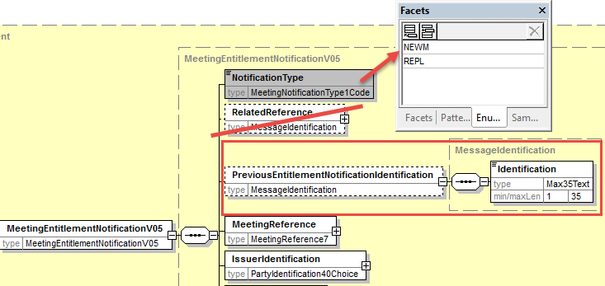

- Add Account Holder Identification
In the seev.003 (MENT – MeetingEntitlementNotification) message, add at the root of the message after the Eligibility element a new mandatory and non-repeatable element AccountHolder typed with the PartyIdentification for a Legal and a natural person similar to what is defined in the ShareholderIdentificationDisclosureResponse message with the “Identification” elements of both the natural and legal Person as optional as illustrated below:
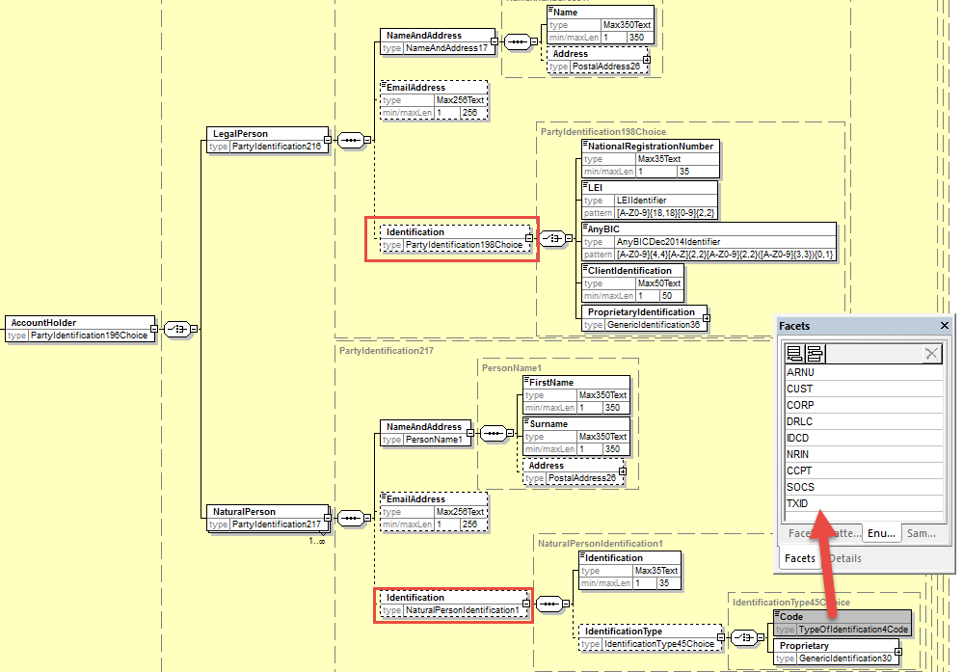

- Adapt RightsHolder Identification
Change the current Data type PartyIdentification40Choice of the element Security/Position/RightHolder/Identification by the same Data type used to identify the AccountHolder and Proxy but with both the Identification elements as mandatory in natural and legal person.

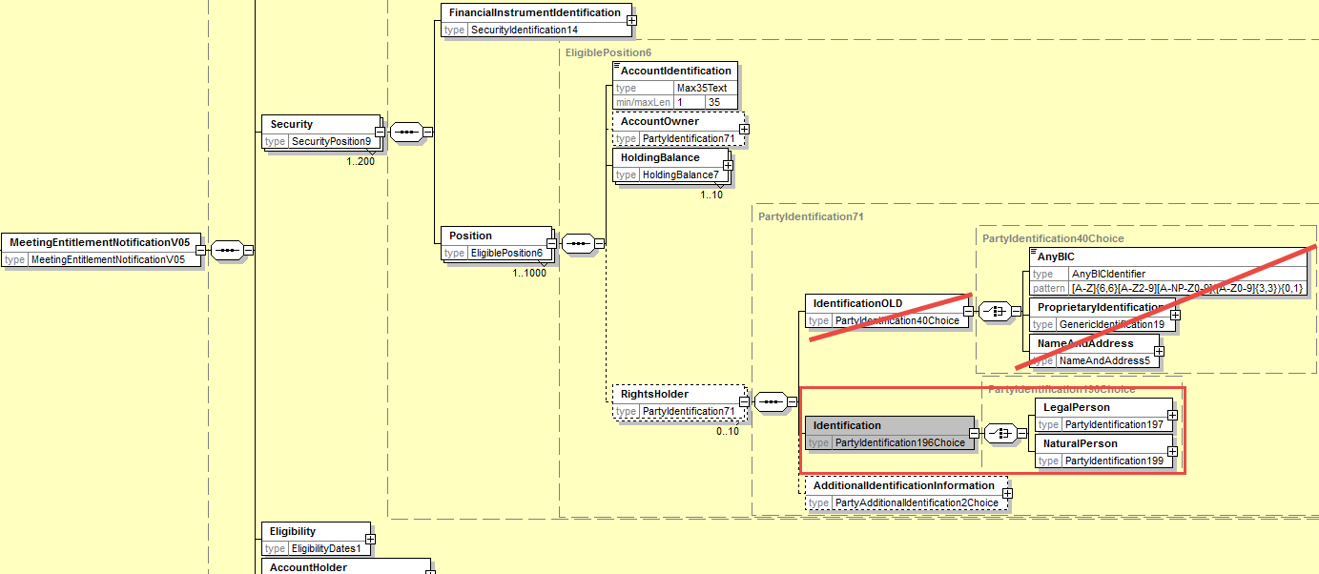

- Add Proxy and MeetingAttendee Identification
In the seev.003 (MENT – MeetingEntitlementNotification) message, add at the root of the message after the Eligibility element the new optional and non-repeatable elements MeetingAttendee and Proxy typed with the PartyIdentification for a Legal and a natural person as defined for the RightsHolder party here above and as illustrated below:
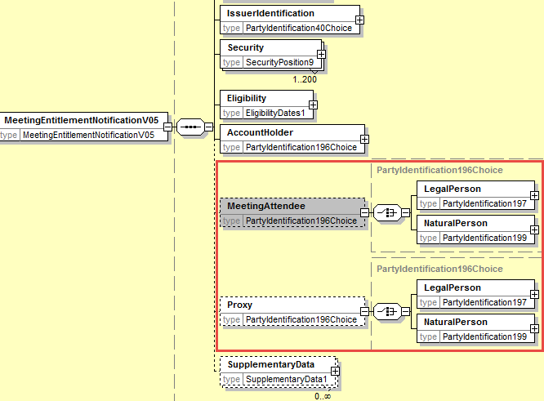

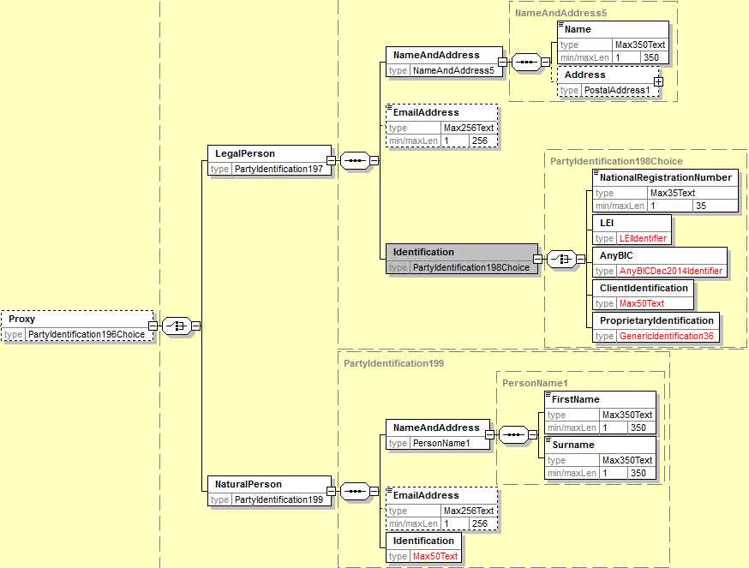

- Proposed timing:
The submitting organization confirms that it can implement the requested changes in the requested timing

Timing | - As requested

- Final decision of the SEG(s):

Approve
Comments:

Reject
Reason for rejection:

CR13: Set Balance Elements as Mandatory in Meeting EntitlementNotification
- Origin of the request:
A.1 Submitter: SWIFT, SMPG
A.2 Contact person:
Christine Strandberg – christine.strandberg@seb.se – phone: +46 8 763 6074
Mari Fumagalli – mariangela.fumagalli@bnpparibas.com – phone: +44 207 595 4988
Jacques Littré – jacques.littre@swift.com – phone: +32 2 655 43 35
A.3 Sponsors: N/A

- Related messages:
List of ISO 20022 Proxy Voting messages which would be impacted by the change:
seev.003.001.05 MeetingEntitlementNotificationV05
seev.001.001.05 MeetingNotificationV05
seev.002.001.05 MeetingCancellationV05
seev.008.001.05 MeetingResultDisseminationV05
- Description of the change request:
The following path and element in the message must be made mandatory:
- Security / Position / HoldingBalance / Balance
- Security / Position / AccountIdentification
- Security / Position / HoldingBalance / BalanceType
as those elements should always be present in the message.
Add a new textual rule on the “HoldingBalance” sequence to require the presence of the “Eligible” code in BalanceType in one occurrence if several occurrences are present.
Apply the same change in the seev.001, 002 and 008 messages.
- Purpose of the change:
Sending an entitlement message without a balance and identification of the account is not consistent.
- Urgency of the request:
This maintenance change request for the proxy-voting messages follows the ISO 20022 fast track maintenance process so as to publish a new version of those messages around end of Q3 2019.
- Business examples:

- SEG recommendation:
This section is not to be taken care of by the submitter of the change request. It will be completed in due time by the SEG(s) in charge of the related ISO 20022 messages.

Consider |  |  | Timing
 |  |  | - Next yearly cycle: 2019/2020  (the change will be considered for implementation in the yearly maintenance cycle which starts in 2019 and completes with the publication of new message versions in the spring of 2020) |  |  | Priority:  high  medium  low
- At the occasion of the next maintenance of the messages
(the change will be considered for implementation, but does not justify maintenance of the messages in its own right – will be pending until more critical change requests are received for the messages)
 |  |  | - Urgent unscheduled  (the change justifies an urgent implementation outside of the normal yearly cycle) |  | X
 |  |  | - Other timing:
Comments:

Reject
Reason for rejection:
- Impact analysis:
This change request impacts the following messages:
seev.003.001.05 MeetingEntitlementNotificationV05
seev.001.001.05 MeetingNotificationV05
seev.002.001.05 MeetingCancellationV05
seev.008.001.05 MeetingResultDisseminationV05

- Proposed implementation:
In the seev.003 (MENT – MeetingEntitlementNotification) message, set the following elements and paths as mandatory as illustrated below:
- Security / Position / HoldingBalance / Balance
- Security / Position / AccountIdentification
- Security / Position / HoldingBalance / BalanceType

Amend the multiplicity of the HoldingBalance sequence from [0..10] into [0..15] as there are 15 balance types that can potentially be used.
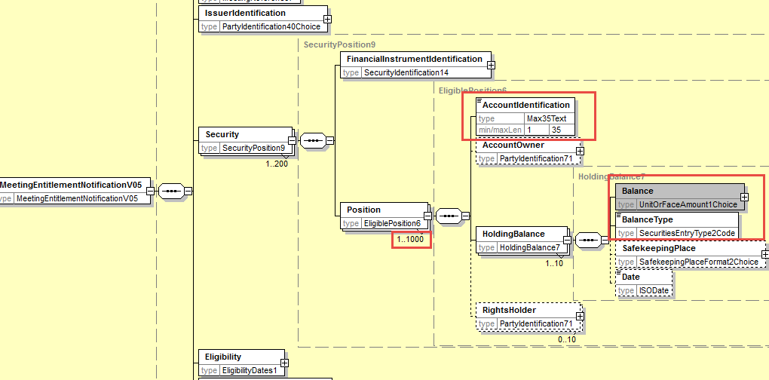
In the Security/Position/HoldingBalance sequence, add the following HoldingBalanceType() textual rule:
In all occurrences of HoldingBalance, one and only one BalanceType element must have a balance type code value equal to ELIG (Eligible).

Apply the same changes above in the seev.001, 002 and 008 messages since the same component is reused..

- Proposed timing:
The submitting organization confirms that it can implement the requested changes in the requested timing

Timing | - As requested

- Final decision of the SEG(s):

Approve
Comments:

Reject
Reason for rejection:

CR14: Add new elements required by the SRD2 Directive in the Meeting Instruction
- Origin of the request:
A.1 Submitter: SWIFT, SMPG
A.2 Contact person:
Christine Strandberg – christine.strandberg@seb.se – phone: +46 8 763 6074
Mari Fumagalli – mariangela.fumagalli@bnpparibas.com – phone: +44 207 595 4988
Jacques Littré – jacques.littre@swift.com – phone: +32 2 655 43 35
A.3 Sponsors: N/A

- Related messages:
List of ISO 20022 Proxy Voting messages which would be impacted by the change:
seev.004.001.05 MeetingInstructionV05
- Description of the change request:
- In the Instruction/SpecificInstructionRequest sequence, replace the ParticipantRegistration indicator element by the new optional and repeatable ParticipationMethod with the code values: Virtual participation, in person, through Proxy, by correspondence, participation in person but not voting (same as the one defined in the meeting notification message).
Add a rule so that the Instruction/Proxy and Instruction/MeetingAttendee are only used if the Instruction/SpecificInstructionRequest/ParticipationMethod specifies Proxy or InPerson.
(IR table 5.B items 1 in implementation regulation)
- In element Instruction/MeetingAttendee, align the identification of the meeting attendee with the AccountHolder Legal or Natural person names and identifications defined in the ShareholderIdentificationDisclosureResponse message.
(IR table 5.B items 2, 3(a) and 3(b) in implementation regulation)
- In element Instruction/Proxy/PersonDetails align the name and identification of the Proxy with the AccountHolder Legal or Natural person names and identifications defined in the ShareholderIdentificationDisclosureResponse message.
(IR table 5.B items 2, 3(a) and 3(b), 4 and 5 in implementation regulation)
- In the Instruction/VoteDetails/ VoteInstructionForAgendaResolution and VoteInstructionForMeetingResolution sequences, , add a new vote instruction element “BLNK (Blank)” (vote is cast as “empty” but the vote is counted) and a new element Proprietary so as to be able to provide the number of votes for the proprietary vote code defined and amend the definition of the “NoAction” element.
(IR table 3.E item 5 in implementation regulation)

- Purpose of the change:
This change is required by the European Commission Shareholders Rights Directive implementing regulation (EU) 2018/1212 of 3 September 2018 (see regulation table references in the description above).
- Urgency of the request:
This maintenance change request for the proxy-voting messages follows the ISO 20022 fast track maintenance process so as to publish a new version of those messages around end of Q3 2019.
- Business examples:
NA
- SEG recommendation:
This section is not to be taken care of by the submitter of the change request. It will be completed in due time by the SEG(s) in charge of the related ISO 20022 messages.

Consider |  |  | Timing
 |  |  | - Next yearly cycle: 2019/2020  (the change will be considered for implementation in the yearly maintenance cycle which starts in 2019 and completes with the publication of new message versions in the spring of 2020) |  |  | Priority:  high  medium  low
- At the occasion of the next maintenance of the messages
(the change will be considered for implementation, but does not justify maintenance of the messages in its own right – will be pending until more critical change requests are received for the messages)
 |  |  | - Urgent unscheduled  (the change justifies an urgent implementation outside of the normal yearly cycle) |  | X
 |  |  | - Other timing:
Comments:

Reject
Reason for rejection:

- Impact analysis:
This change request impacts the following messages:
seev.004.001.05 MeetingInstructionV05
- Proposed implementation:
- Add AttendanceMethod in the Instruction
In the seev.004 (MEIN – MeetingInstruction) message, rename the element Instruction/SpecificInstructionRequest/ParticipationRegistration as ParticipationMethod and make the element repeatable and change the current data type “YesNoIndicator” by the code list ParticipationMethod1Choice as with a code element with 5 code values as follows (Virtual participation, in person, through Proxy, by correspondence, participation in person but not voting) and a proprietary code as illustrated below:
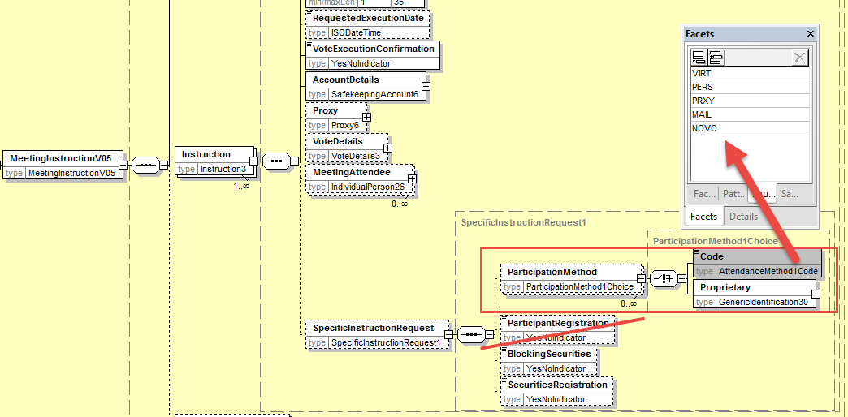

- Align MeetingAttendee Identification with the ShareholderIdentificationDisclosureResponse message
In the seev.004 (MEIN – MeetingInstruction) message, in the sequence Instruction/MeetingAttendee, replace the elements Birthname, GivenName, Identification and Address by the mandatory element Identification typed with the PartyIdentificationChoice component used in the ShareholderIdentificationDisclosureResponse message for AccountHolder to identify a legal and natural person as illustrated below:
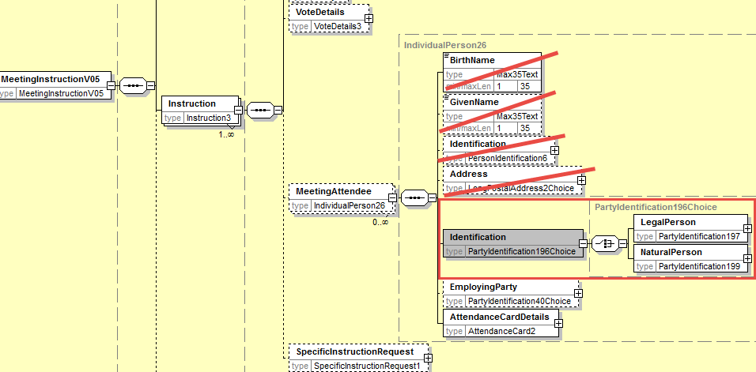
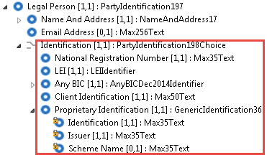
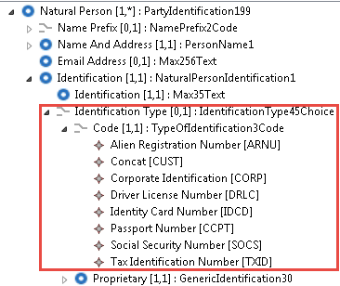

- Align Proxy Identification with the ShareholderIdentificationDisclosureResponse message
In the seev.004 (MEIN – MeetingInstruction) message, in the sequence Instruction/Proxy, replace the elements Birthname, GivenName, Identification and Address by the mandatory element Identification typed with the PartyIdentificationChoice component used in the ShareholderIdentificationDisclosureResponse message for AccountHolder to identify a legal and natural person (however, with the Identification element of both the LegalPerson and NaturalPerson being optional) as illustrated below:
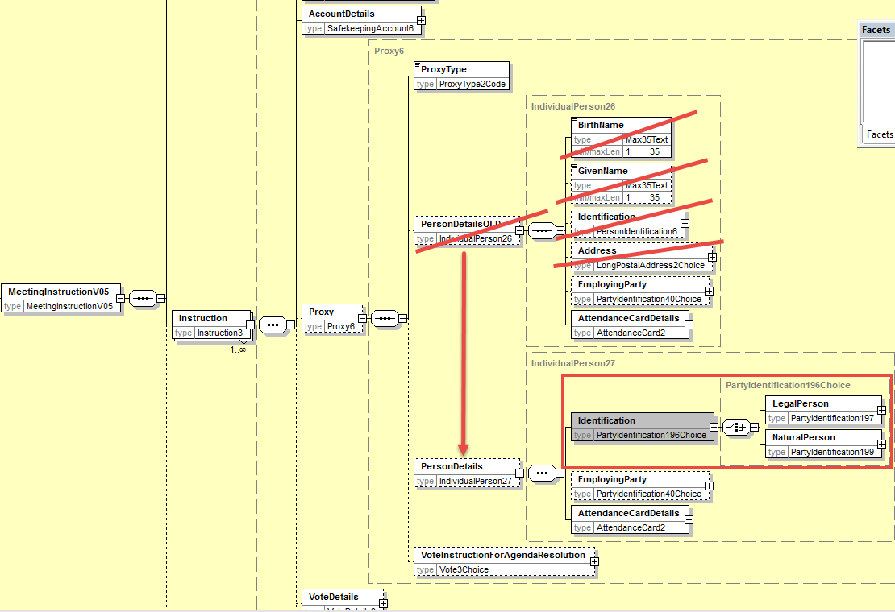

- Add rule on
Add a cross element rule in Instruction component so that the Instruction/Proxy and/or Instruction/MeetingAttendee are only present if the Instruction/SpecificInstructionRequest/AttendanceMethod specifies respectively Proxy and/or In Person.
- Add new Vote Instruction Blank in all sequence where VoteInstruction is present
In the seev.004 (MEIN – MeetingInstruction) message, in the Instruction/VoteDetails/VoteInstructionForAgendaResolution/VoteInstruction sequence, amend the definition of the “NoAction” element to read “Vote is cast as empty but the vote is counted” and add the new optional and non-repeatable element “Blank” typed by “Number” data type and add a new optional and repeatable sequence “Proprietary” with a mandatory element VoteCode typed by GenericIdentification30 and the mandatory element Number as illustrated below:
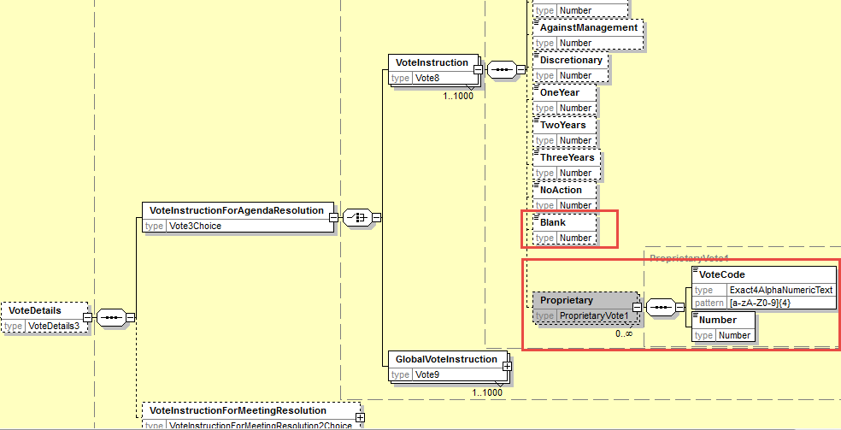

In the seev.004 (MEIN – MeetingInstruction) message, in the Instruction/VoteDetails/VoteInstructionForAgendaResolution/GlobalVoteInstruction, replace the data type of the VoteOption element by a choice component with a choice between the Vote with a code to which the “Blank” vote has been added and a proprietary code as illustrated below:
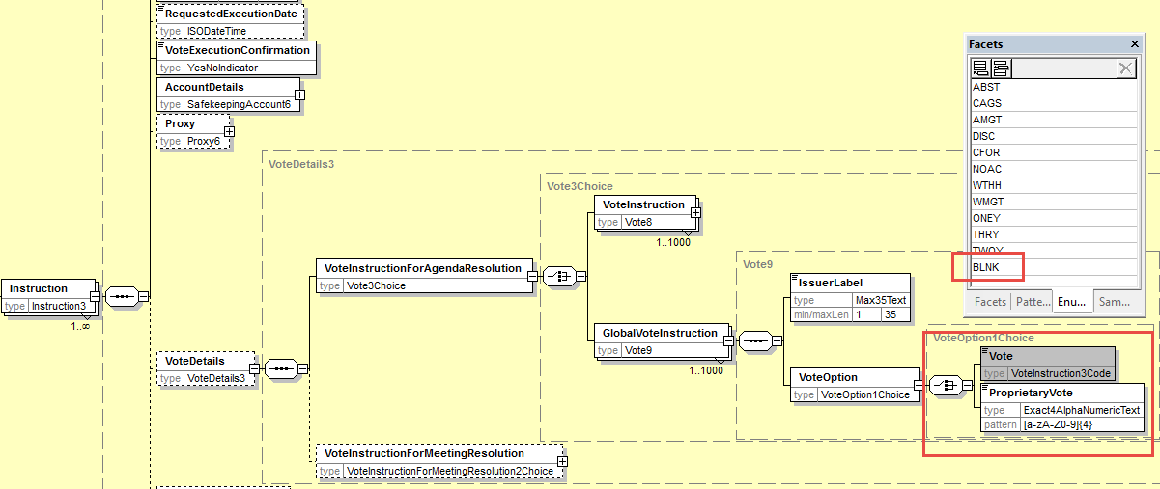

In the seev.004 (MEIN – MeetingInstruction) message, in the Instruction/VoteDetails/VoteInstructionForMeetingResolution sequence, replace the data type of the VoteIndication element by a choice component with a choice between the Vote with a code to which the “Blank” vote has been added and a proprietary code as illustrated below:

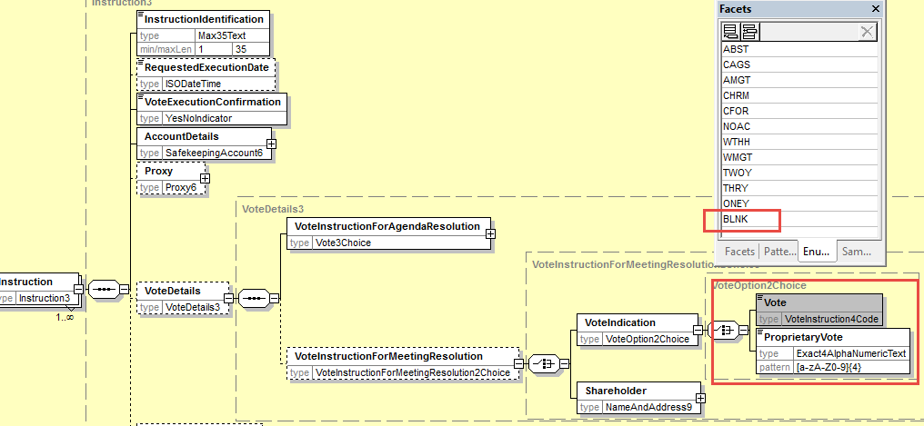

- Amend the multiplicity of the InstructedBalance sequence from [0..10] into [0..15] as there are 15 balance types that can potentially be used and apply the same change in the seev.005 message instruction cancellation message)

- Proposed timing:
The submitting organization confirms that it can implement the requested changes in the requested timing

Timing | - As requested

- Final decision of the SEG(s):

Approve
Comments:

Reject
Reason for rejection:

CR15: Align Vote Instruction Type Codes Between the Meeting Notification and Instruction
- Origin of the request:
A.1 Submitter: SWIFT, SMPG
A.2 Contact person:
Christine Strandberg – christine.strandberg@seb.se – phone: +46 8 763 6074
Mari Fumagalli – mariangela.fumagalli@bnpparibas.com – phone: +44 207 595 4988
Jacques Littré – jacques.littre@swift.com – phone: +32 2 655 43 35
A.3 Sponsors: N/A

- Related messages:
List of ISO 20022 Proxy Voting messages which would be impacted by the change:
seev.001.001.05 MeetingNotificationV05
seev.004.001.05 MeetingInstructionV05

- Description of the change request:
In the MeetingNotification and MeetingInstruction messages, replace the data type codes VoteInstruction2Code and VoteInstruction3Code and VoteInstruction4Code by a new code list consolidating all code values and change VoteInstruction1Code by a new code list similar to VoteInstruction4Code but without the WMGT, AMGT and DISC code values and adding a new code value “No Recommendation” (NREC).
- Purpose of the change:
In ISO 20022, there are 4 VoteInstructionCode lists that can be used to list the voting options in the 2 messages as follows (code differences are coloured in red):
- “VoteInstruction1Code” – CFOR, CAGS, ABST, WTHH, NOAC (used in seev.001 for the elements Resolution/ManagementRecommendation and ResolutionNotyfyingPartyRecommendation)
- “VoteInstruction2Code” – CFOR, CAGS, ABST, WTHH, WMGT, AMGT, NOAC, DISC (used in seev.001 for VoteInstructionType)
- “VoteInstruction3Code” – ABST, CAGS, AMGT, DISC, CFOR, NOAC, WTHH, WMGT, ONEY, THRY, TWOY (Used in seev.004 for Proxy/GlobalVoteInstruction)
- “VoteInstruction4Code” – ABST, CAGS, AMGT, CHRM, CFOR, NOAC, WTHH, WMGT, ONEY, THRY, TWOY (Used in seev.004 in VoteDetails/VoteForMeetingResolution)
We have not found a business justification to have a difference between the last 3 code lists therefore it is proposed to align/merge these last 3 codes on VoteInstruction4Code consolidating all voting types.
The code list VoteInstruction1Code should however contain all other code values except WMGT, AMGT and DISC used as management recommendations.
- Urgency of the request:
This maintenance change request for the proxy-voting messages follows the ISO 20022 fast track maintenance process so as to publish a new version of those messages around end of Q3 2019.
- Business examples:
N/A
- SEG recommendation:
This section is not to be taken care of by the submitter of the change request. It will be completed in due time by the SEG(s) in charge of the related ISO 20022 messages.

Consider |  |  | Timing
 |  |  | - Next yearly cycle: 2019/2020  (the change will be considered for implementation in the yearly maintenance cycle which starts in 2019 and completes with the publication of new message versions in the spring of 2020) |  |  | Priority:  high  medium  low
- At the occasion of the next maintenance of the messages
(the change will be considered for implementation, but does not justify maintenance of the messages in its own right – will be pending until more critical change requests are received for the messages)
 |  |  | - Urgent unscheduled  (the change justifies an urgent implementation outside of the normal yearly cycle) |  | X
 |  |  | - Other timing:
Comments:

Reject
Reason for rejection:

- Impact analysis:
This change request impacts the following messages:
seev.001.001.05 MeetingNotificationV05
seev.004.001.05 MeetingInstructionV05
- Proposed implementation:
In the seev.001 (MENO – MeetingNotification) message, in Resolution/ManagementRecommendation and Resolution/NotyfyingPartyRecommendation replace the VoteInstruction1Code data type by a new VoteInstruction5 Code containing the following code values CFOR, CAGS, ABST, WTHH, NOAC, CHRM, ONEY, TWOY, THRY, NREC and BLANK as illustrated below :

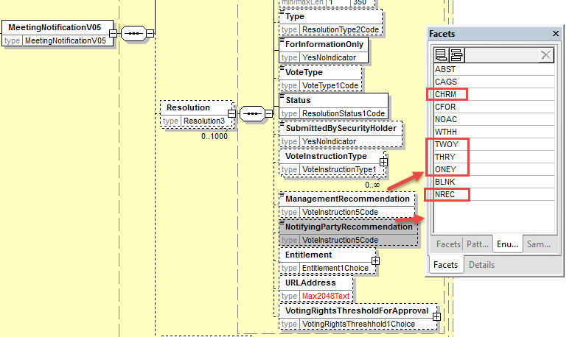

In the seev.001 (MENO – MeetingNotification) message, in Resolution/VoteInstructionType/VoteInstruction/Type, replace the VoteInstruction2Code data type by a new VoteInstruction6Code containing the following code values CFOR, CAGS, ABST, WTHH, NOAC, WMGT, AMGT , DISC, CHRM, ONEY, TWOY, THRY and BLANK and allow the possibility to add a proprietary vote type as well as illustrated below :

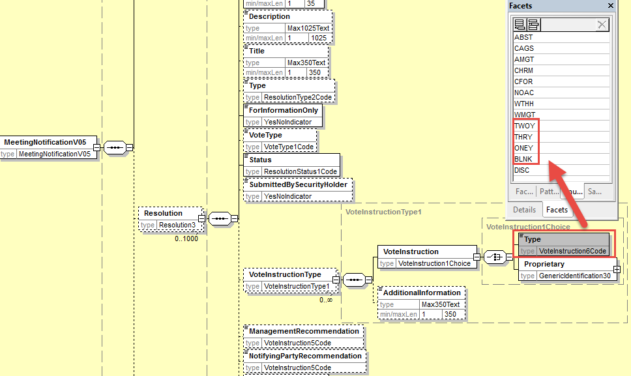

In the seev.004 (MEIN – MeetingInstruction) message, in the element Instruction/Proxy/VoteInstructionForAgendaResolution/GlobalVoteIntruction/VoteOption/Vote, replace the VoteInstruction3Code data type by a new VoteInstruction6 Code containing the following code values CFOR, CAGS, ABST, WTHH, NOAC, WMGT, AMGT , DISC, CHRM, ONEY, TWOY, THRY and BLANK and allow the possibility to add a proprietary vote type as well as illustrated below :
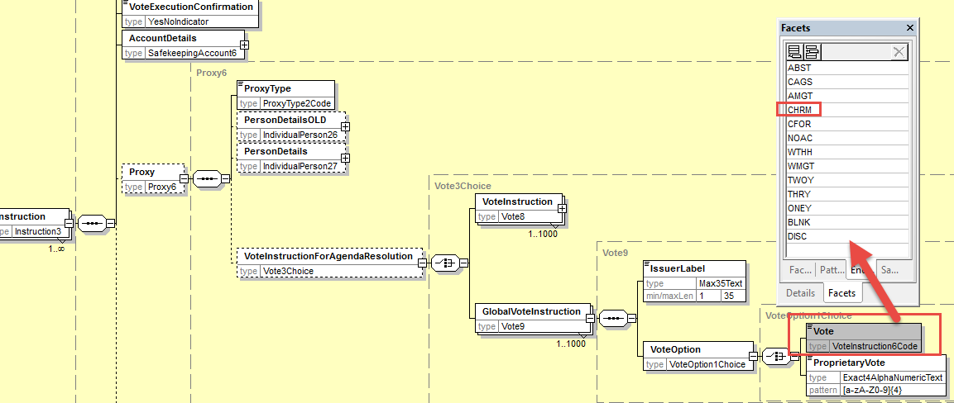

In the seev.004 (MEIN – MeetingInstruction) message, in the element Instruction/VoteDetails/VoteInstructionForAgendaResolution/GlobalVoteIntruction/VoteOption/Vote, and in the element Instruction/VoteDetails/VoteInstructionForMeetingResolution/VoteIndication/Vote replace the VoteInstruction4Code data type by a new VoteInstruction6 Code containing the following code values CFOR, CAGS, ABST, WTHH, NOAC, WMGT, AMGT , DISC, CHRM, ONEY, TWOY, THRY and BLANK and allow the possibility to add a proprietary vote type as well as illustrated below :
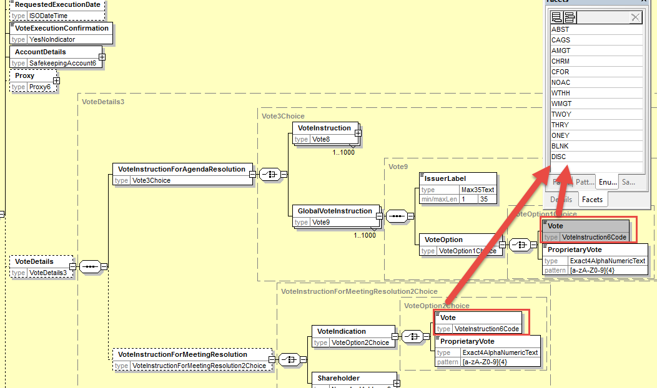

- Proposed timing:
The submitting organization confirms that it can implement the requested changes in the requested timing

Timing | - As requested

- Final decision of the SEG(s):

Approve
Comments:

Reject
Reason for rejection:

CR16: Rename PreviousReference in Meeting Instruction Cancellation Request
- Origin of the request:
A.1 Submitter: SWIFT, SMPG
A.2 Contact person:
Christine Strandberg – christine.strandberg@seb.se – phone: +46 8 763 6074
Mari Fumagalli – mariangela.fumagalli@bnpparibas.com – phone: +44 207 595 4988
Jacques Littré – jacques.littre@swift.com – phone: +32 2 655 43 35
A.3 Sponsors: N/A

- Related messages:
List of ISO 20022 Proxy Voting messages which would be impacted by the change:
seev.005.001.05 MeetingInstructionCancellationRequestV05
- Description of the change request:
Rename the message element PreviousReference as MeetingInstructionIdentification.
- Purpose of the change:
Align the naming of the reference to the previously sent MeetingInstruction message that is being cancelled with the ISO 20022 naming principles for message references.
- Urgency of the request:
This maintenance change request for the proxy-voting messages follows the ISO 20022 fast track maintenance process so as to publish a new version of those messages around end of Q3 2019.
- Business examples:
NA
- SEG recommendation:
This section is not to be taken care of by the submitter of the change request. It will be completed in due time by the SEG(s) in charge of the related ISO 20022 messages.

Consider |  |  | Timing
 |  |  | - Next yearly cycle: 2019/2020  (the change will be considered for implementation in the yearly maintenance cycle which starts in 2019 and completes with the publication of new message versions in the spring of 2020) |  |  | Priority:  high  medium  low
- At the occasion of the next maintenance of the messages
(the change will be considered for implementation, but does not justify maintenance of the messages in its own right – will be pending until more critical change requests are received for the messages)
 |  |  | - Urgent unscheduled  (the change justifies an urgent implementation outside of the normal yearly cycle) |  | X
 |  |  | - Other timing:
Comments:

Reject
Reason for rejection:

- Impact analysis:
This change request impacts the following messages:
seev.005.001.05 MeetingInstructionCancellationRequestV05
- Proposed implementation:
Rename the element PreviousReference at the root of the message as MeetingInstructionIdentification and change the date type Identification by MessageIdentification Component.

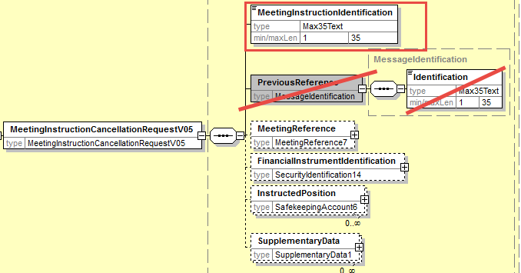
- Proposed timing:
The submitting organization confirms that it can implement the requested changes in the requested timing

Timing | - As requested

- Final decision of the SEG(s):

Approve
Comments:

Reject
Reason for rejection:

CR17: Enable Cancellation of a Single Instruction within an Instruction Message
- Origin of the request:
A.1 Submitter: SWIFT, SMPG
A.2 Contact person:
Christine Strandberg – christine.strandberg@seb.se – phone: +46 8 763 6074
Mari Fumagalli – mariangela.fumagalli@bnpparibas.com – phone: +44 207 595 4988
Jacques Littré – jacques.littre@swift.com – phone: +32 2 655 43 35
A.3 Sponsors: N/A

- Related messages:
List of ISO 20022 Proxy Voting messages which would be impacted by the change:
seev.005.001.05 MeetingInstructionCancellationRequestV05

- Description of the change request:
In the instruction cancellation request message, add the possibility to cancel one or more individual instructions sent in an instruction message when the instruction message contained several individual instructions.
- Purpose of the change:
The instruction message allows to send several single individual instructions simultaneously in the same message whilst the cancellation message (seev.005) only allows to cancel a previously sent instruction message, not individual instructions. On the other hand, the meeting status message (seev.006) allows also to either sending a confirmation at global (message) or single instruction level.
This change request will allow to align the instruction cancellation message with the instruction and instruction status messages in terms of being able to manage individual instructions.
- Urgency of the request:
This maintenance change request for the proxy-voting messages follows the ISO 20022 fast track maintenance process so as to publish a new version of those messages around end of Q3 2019.
- Business examples:
NA
- SEG recommendation:
This section is not to be taken care of by the submitter of the change request. It will be completed in due time by the SEG(s) in charge of the related ISO 20022 messages.

Consider |  |  | Timing
 |  |  | - Next yearly cycle: 2019/2020  (the change will be considered for implementation in the yearly maintenance cycle which starts in 2019 and completes with the publication of new message versions in the spring of 2020) |  |  | Priority:  high  medium  low
- At the occasion of the next maintenance of the messages
(the change will be considered for implementation, but does not justify maintenance of the messages in its own right – will be pending until more critical change requests are received for the messages)
 |  |  | - Urgent unscheduled  (the change justifies an urgent implementation outside of the normal yearly cycle) |  | X
 |  |  | - Other timing:
Comments:

Reject
Reason for rejection:

- Impact analysis:
This change request impacts the following messages:
seev.005.001.05 MeetingInstructionCancellationRequestV05
- Proposed implementation:
In the seev.005, create a new optional and repeatable “ToBeCancelledInstruction” sequence containing the new optional and non-repeatable element SingleInstructionIdentification and the optional and non-repeatable sequence InstructedPosition moved from the root of the message to the ToBECancelledInstruction sequence as illustrated here below:
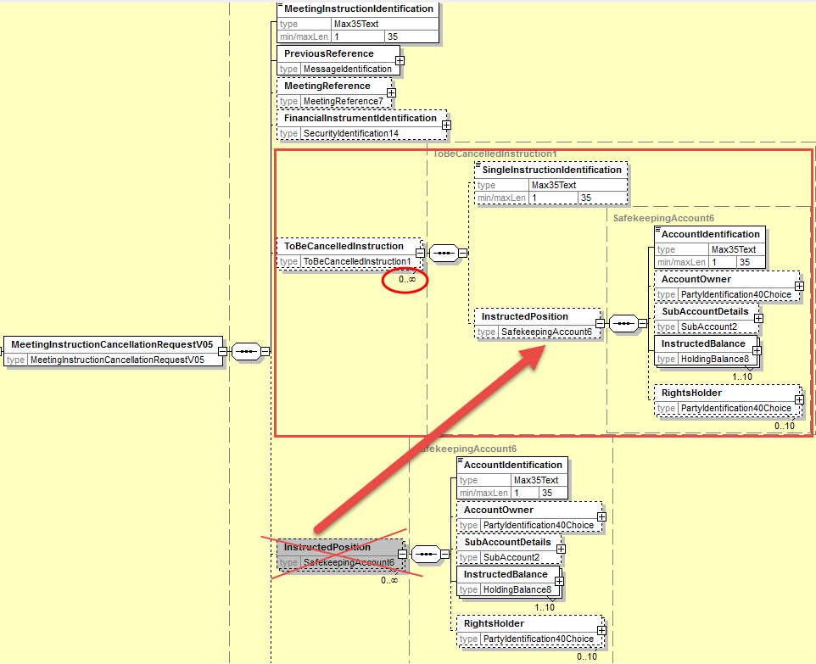
- Proposed timing:
The submitting organization confirms that it can implement the requested changes in the requested timing

Timing | - As requested

- Final decision of the SEG(s):

Approve
Comments:

Reject
Reason for rejection:

CR18: Add new elements required by the SRD2 Directive in the Meeting Instruction Status
- Origin of the request:
A.1 Submitter: SWIFT, SMPG
A.2 Contact person:
Christine Strandberg – christine.strandberg@seb.se – phone: +46 8 763 6074
Mari Fumagalli – mariangela.fumagalli@bnpparibas.com – phone: +44 207 595 4988
Jacques Littré – jacques.littre@swift.com – phone: +32 2 655 43 35
A.3 Sponsors: N/A

- Related messages:
List of ISO 20022 Proxy Voting messages which would be impacted by the change:
seev.006.001.05 MeetingInstructionStatusV05

- Description of the change request:
- add a new mandatory non-repeatable element IssuerName at the root of the message to provide the name of the issuer.
(IR table 6 item 6 in implementation regulation)
- add a new mandatory non-repeatable element ConfirmingParty at the root of the message to provide the name (legal or natural person name) of the ConfirmingParty.
(IR table 6 item 7 in implementation regulation)
- add a new mandatory non-repeatable element VoteCastingParty at the root of the message to provide the name (legal or natural person name) of the VoteCastingParty.
(IR table 6 item 8 in implementation regulation)
- add a new optional non-repeatable element RightsHolder at the root of the message to provide the name (legal or natural person name) of the Shareholder.
(IR table 6 item 9 in implementation regulation)
- Modify the status codes of the Status element in the sequence InstructionTypeStatus/InstructionStatus/GlobalInstructionStatus/ProcessingStatus and in sequence InstructionTypeStatus/InstructionStatus/DetailedInstructionStatus/InstructionStatus/ProcessingStatus as follows:
  - Add the new status code: “Accepted And Sent Along the Chain”
  - Remove statuses: “Completed” (COMP) and “NotReceived” (NOIN)
(IR Article 9.5 in implementation regulation)
- Purpose of the change:
This change is required by the European Commission Shareholders Rights Directive implementing regulation (EU) 2018/1212 of 3 September 2018 (see regulation table references in the description above).
- Urgency of the request:
This maintenance change request for the proxy-voting messages follows the ISO 20022 fast track maintenance process so as to publish a new version of those messages around end of Q3 2019.
- Business examples:
NA
- SEG recommendation:
This section is not to be taken care of by the submitter of the change request. It will be completed in due time by the SEG(s) in charge of the related ISO 20022 messages.

Consider |  |  | Timing
 |  |  | - Next yearly cycle: 2019/2020  (the change will be considered for implementation in the yearly maintenance cycle which starts in 2019 and completes with the publication of new message versions in the spring of 2020) |  |  | Priority:  high  medium  low
- At the occasion of the next maintenance of the messages
(the change will be considered for implementation, but does not justify maintenance of the messages in its own right – will be pending until more critical change requests are received for the messages)
 |  |  | - Urgent unscheduled  (the change justifies an urgent implementation outside of the normal yearly cycle) |  | X
 |  |  | - Other timing:
Comments:

Reject
Reason for rejection:

- Impact analysis:
This change request impacts the following messages:
seev.006.001.05 MeetingInstructionStatusV05
- Proposed implementation:

- Add new party Identifications

In the seev.006 (MEIS – MeetingInstructionStatus) message, add a new mandatory and non-repeatable element Issuer typed by the same PartyIdentificationChoice component used in the MeetingNotification message and a new mandatory and non-repeatable element ConfirmingParty, a new mandatory and non-repeatable element VoteCastingParty and a new optional and non-repeatable element RightsHolder typed by the same PartyIdentificationChoice component used to identify a legal and a natural person but with the Identification element being optional as illustrated below:
For RightsHolder, the NaturalPerson element must be repeatable.

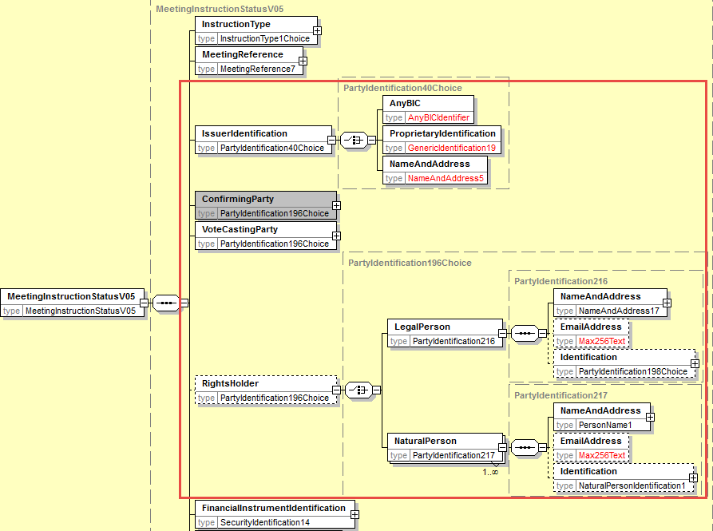
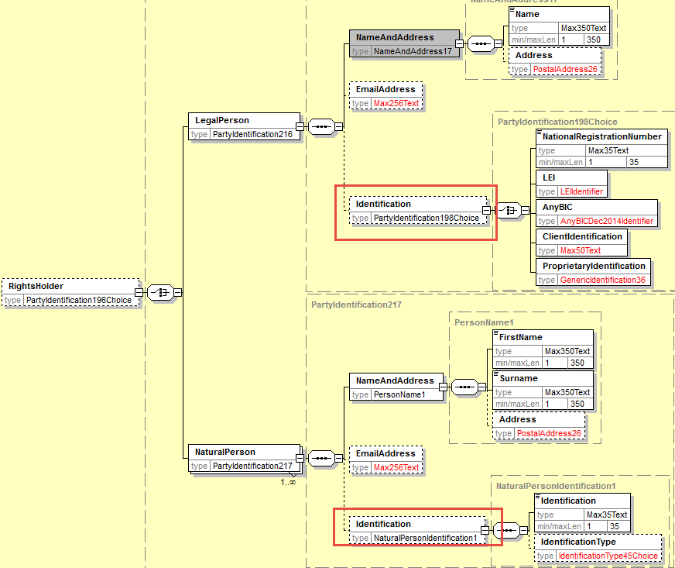
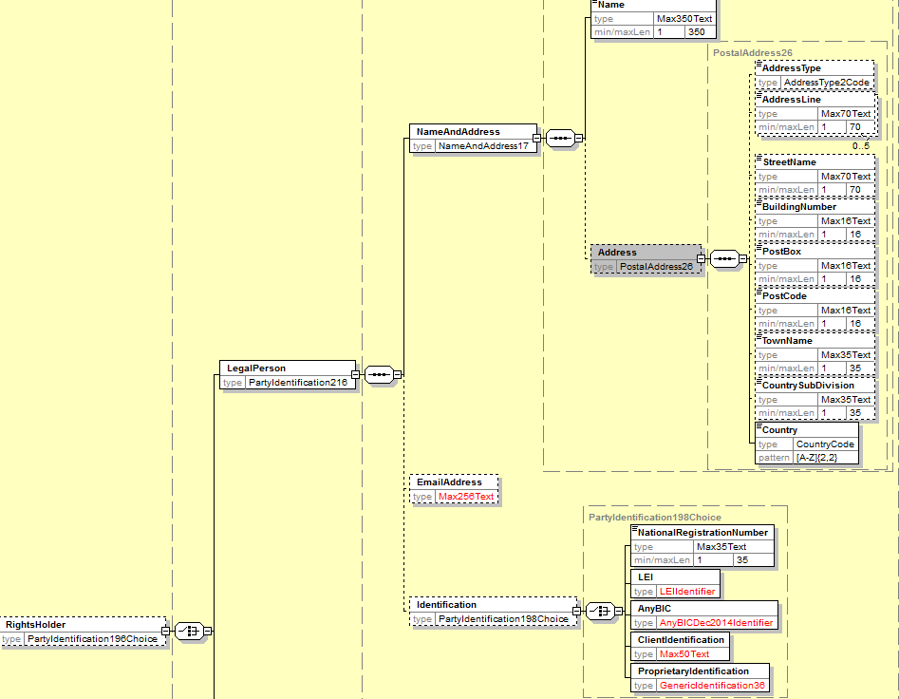
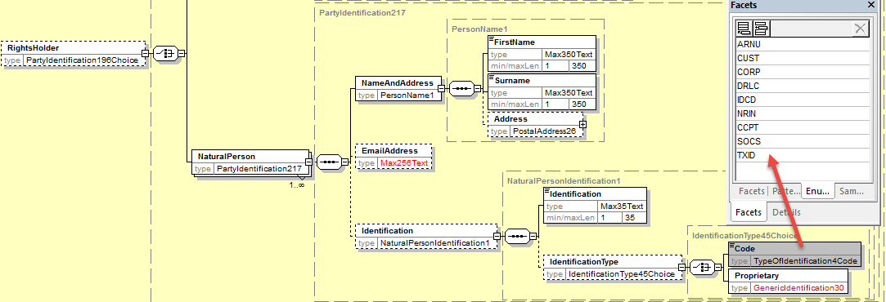

- Amend the ProcessingStatus code values
In the seev.006 (MEIS – MeetingInstructionStatus) message, in the status code of the Status element in the sequence InstructionTypeStatus/InstructionStatus/GlobalInstructionStatus/ProcessingStatus and in sequence InstructionTypeStatus/InstructionStatus/DetailedInstructionStatus/InstructionStatus/ProcessingStatus, remove the code values NotReceived (NOIN) and Completed (COMP) and add the values “Accepted and sent along the chain” (FRWD) and review the definition between P
ACK and FRWD.

- Amend the definition of the RCIS (ReceivedByIssuerOrRegistrar) status reason code to read “Instruction has been received by the issuer, equivalent to the confirmation of receipt of votes cast electronically.”

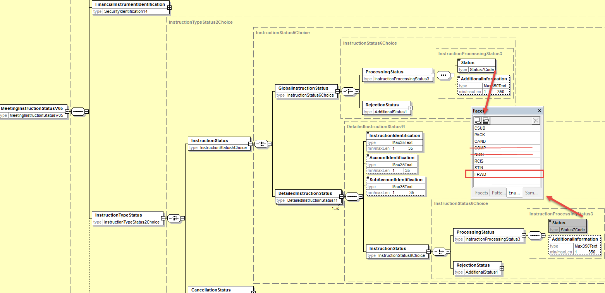
- Proposed timing:
The submitting organization confirms that it can implement the requested changes in the requested timing

Timing | - As requested

- Final decision of the SEG(s):

Approve
Comments:

Reject
Reason for rejection:

CR19: Add new Pending Status in the Meeting Instruction Status Message and Align Other Status/reason Codes With CA Statuses
- Origin of the request:
A.1 Submitter: SWIFT, SMPG
A.2 Contact person:
Christine Strandberg – christine.strandberg@seb.se – phone: +46 8 763 6074
Mari Fumagalli – mariangela.fumagalli@bnpparibas.com – phone: +44 207 595 4988
Jacques Littré – jacques.littre@swift.com – phone: +32 2 655 43 35
A.3 Sponsors: N/A

- Related messages:
List of ISO 20022 Proxy Voting messages which would be impacted by the change:
seev.006.001.05 MeetingInstructionStatusV05

- Description of the change request:
Add a new pending Status in the MeetingInstructionStatus Message with reason codes similar those used in CA Instruction Status message and align status reason codes of rejection status with those existing in CA Instruction Status message.
- Purpose of the change:
Pending Status is missing and alignment with CA statuses and reason codes.
- Urgency of the request:
This maintenance change request for the proxy-voting messages follows the ISO 20022 fast track maintenance process so as to publish a new version of those messages around end of Q3 2019.
- Business examples:
N/A
- SEG recommendation:
This section is not to be taken care of by the submitter of the change request. It will be completed in due time by the SEG(s) in charge of the related ISO 20022 messages.

Consider |  |  | Timing
 |  |  | - Next yearly cycle: 2019/2020  (the change will be considered for implementation in the yearly maintenance cycle which starts in 2019 and completes with the publication of new message versions in the spring of 2020) |  |  | Priority:  high  medium  low
- At the occasion of the next maintenance of the messages
(the change will be considered for implementation, but does not justify maintenance of the messages in its own right – will be pending until more critical change requests are received for the messages)
 |  |  | - Urgent unscheduled  (the change justifies an urgent implementation outside of the normal yearly cycle) |  | X
 |  |  | - Other timing:
Comments:

Reject
Reason for rejection:

- Impact analysis:
This change request impacts the following messages:
seev.006.001.05 MeetingInstructionStatusV05
- Proposed implementation:
- In the seev.006 (MEIS – MeetingInstructionStatus) message, in the sequence InstructionTypeStatus/InstructionStatus/GlobalInstructionStatus and in sequence InstructionTypeStatus/InstructionStatus/DetailedInstructionStatus/InstructionStatus, add a new PendingStatus sequence with a specific reason code list and proprietary reason codes together with an optional and non-repeatable AdditionalInformation element as illustrated below:
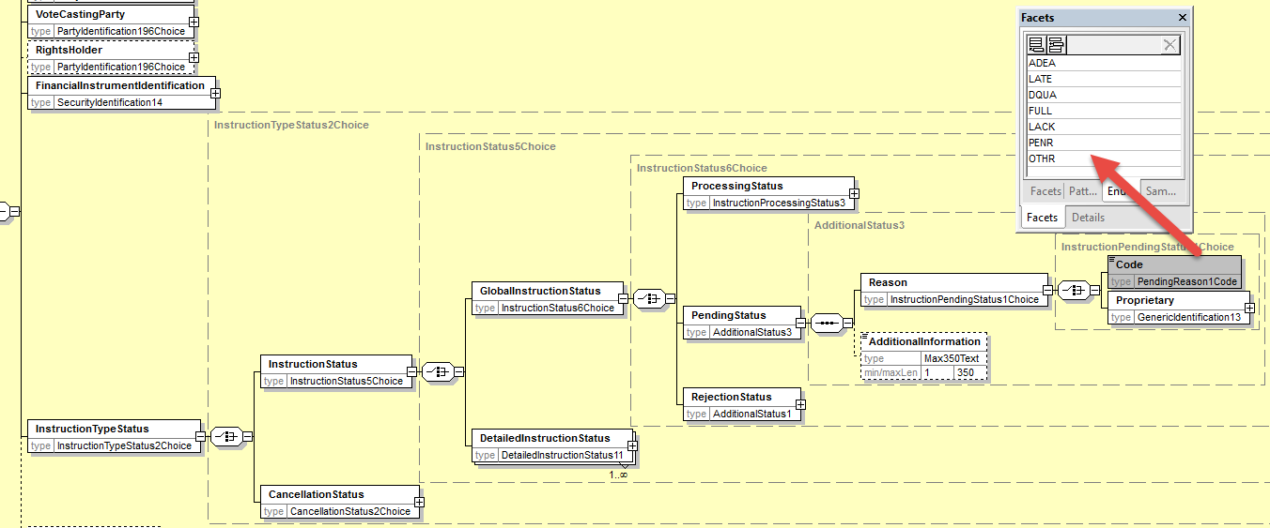
The following pending status reason codes coming from CA messages (seev.034) will be added: OTHR, ADEA, LATE, DQUA, FULL, LACK, PENR.

- In the sequence InstructionTypeStatus/InstructionStatus/GlobalInstructionStatus/RejectionStatus/Reason/Code and in sequence InstructionTypeStatus/InstructionStatus/DetailedInstructionStatus/InstructionStatus/ RejectionStatus/Reason/Code,
and in sequence InstructionTypeStatus/InstructionStatus/GlobalInstructionStatus/ ProcessingStatus/Status
and in sequence InstructionTypeStatus/InstructionStatus/DetailedInstructionStatus/InstructionStatus/ ProcessingStatus/Status
add a new reason code “OTHR”.

- In the sequence InstructionTypeStatus/InstructionStatus/GlobalInstructionStatus/RejectionStatus/Reason/Code
and in sequence InstructionTypeStatus/InstructionStatus/DetailedInstructionStatus/InstructionStatus/ RejectionStatus/Rejection/Code

add a new reason code “FULL”.
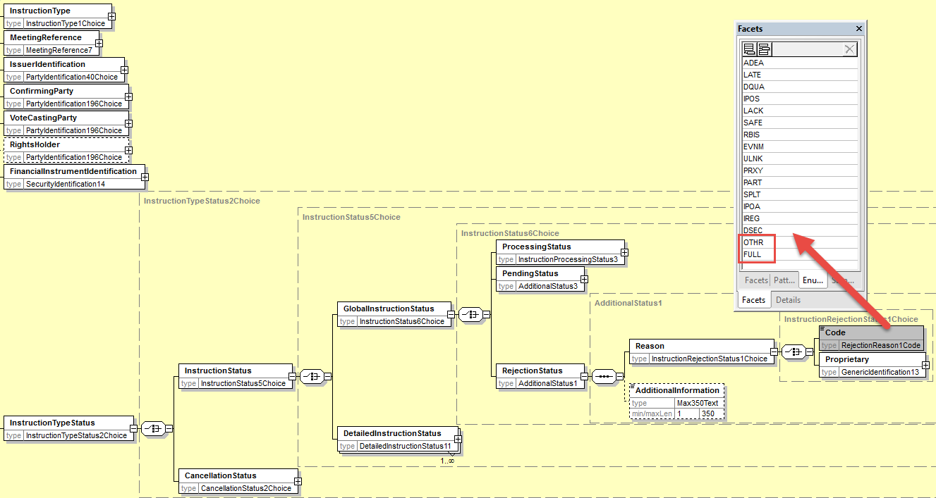

b) In the existing ISO 20022 RejectionReason1Code, correct the following typos:
- IPOS - “Insufficient Treshold Position” should be “Insufficient Threshold Position”
- LACK - “Lackof Securities“ should be “Lack Of Securities”

The status reason codes will be aligned with the table below:
Legend
 | Code Present today in the seev.006 or in the related CR (to be added)
 | New code proposed to be added by CH in the list
Code | Code present today in the Seev.006 message and missing in the Excel list
Code | New code value proposed by CH
Instruction and Cancellation Status Reason Code Matrix for PV Messages |  | Usage
 |  | IPRC |  | CPRC
Code | Description | PEND | REJT | CANP | REJT
ADEA | Account Servicer Deadline Missed | Yes | Yes | Yes | Yes
ADDM | Additional Documentation Missing | Yes | Yes
(CANC) MCAN | Meeting Event Cancelled |  | Yes
DQUA | Disagreement On Quantity | Yes |  | Yes
 | Quantity Rejection |  | Yes |  | Yes
DCAN | Rejected Since Already Cancelled |  |  |  | Yes
DREM | Deadline To Register Missed | Yes | Yes
DPRG | Rejected Since in Progress |  |  |  | Yes
DSEC | Invalid Security |  | Yes |  | Yes
EVNM | Unrecognized Identification |  | Yes |  | Yes
FULL | Missing Beneficial Owner Details | Yes | Yes
INIR | Instruction Irrevocable |  |  |  | Yes
IPOA | Missing Or Invalid POA | Yes | Yes
IPOS | Insufficient Threshold Position | Yes | Yes
IREG | Registration Discrepancy | Yes | Yes
LACK | Lack Of Securities | Yes | Yes
LATE | Market Deadline Missed | Yes | Yes | Yes | Yes
(NORE) NPOS | Insufficient Or No Registered Position | Yes | Yes
OTHR | Other Reason | Yes | Yes | Yes | Yes
PART | Partial Vote Not Allowed |  | Yes
PRXY | Proxy Card Discrepancy | Yes | Yes
RBIS | Rejected By Issuer Or Registrar |  | Yes |  | Yes
RESN | Resolution Number Discrepancy |  | Yes
SAFE | Safekeeping Account Rejection |  | Yes |  | Yes
SPLT | Split Vote Not Allowed |  | Yes
ULNK | Invalid Reference |  | Yes |  | Yes
(VOPT) OPTY | Invalid (Voting) OptionType |  | Yes
PENR | Pending Receipt | Yes
- Proposed timing:
The submitting organization confirms that it can implement the requested changes in the requested timing

Timing | - As requested

- Final decision of the SEG(s):

Approve
Comments:

Reject
Reason for rejection:

CR20: Add new elements required by the SRD2 Directive in the Meeting Vote Execution Confirmation
- Origin of the request:
A.1 Submitter: SWIFT, SMPG
A.2 Contact person:
Christine Strandberg – christine.strandberg@seb.se – phone: +46 8 763 6074
Mari Fumagalli – mariangela.fumagalli@bnpparibas.com – phone: +44 207 595 4988
Jacques Littré – jacques.littre@swift.com – phone: +32 2 655 43 35
A.3 Sponsors: N/A

- Related messages:
List of ISO 20022 Proxy Voting messages which would be impacted by the change:
seev.007.001.05 MeetingVoteExecutionConfirmationV05

- Description of the change request:
- add a new mandatory non-repeatable element IssuerIdentification at the root of the message to provide the name of the issuer.
(IR table 7 item 6 in implementation regulation)
- Adapt the element VoteInstructions/RightsHolder to provide the name (legal or natural person name) of the Shareholder.
(IR table 7 item 7 in implementation regulation)
- add a new optional non-repeatable element or Proxy party (Third Party nominated by the shareholder) in the sequence VoteInstructions to provide the name (legal or natural person name) of the third party nominated by the shareholder.
(IR table 7 item 8 in implementation regulation)
- add a new mandatory non-repeatable element ModalityOfCounting in the sequence VoteInstructions to provide the modality through which the votes that have been recorded and counted were received by the issuer i.e. Paper vote ahead of the meeting, Electronic ahead of the meeting, Electronic at the meeting, Physical at the meeting
(IR table 7 item 9 in implementation regulation)
- add a new optional and non-repeatable element VoteReceiptDateAndTime in the sequence VoteInstructions to provide the date and time at which the votes that have been recorded and counted were received.
(IR table 7 item 10 in implementation regulation)
- add a new optional and non-repeatable element in the message to enable to provision of a web site URL address where the vote execution confirmations can be found (source: from Italian transposition law of the SRD2 IR).

- Purpose of the change:
This change is required by the European Commission Shareholders Rights Directive implementing regulation (EU) 2018/1212 of 3 September 2018 (see regulation table references in the description above).
- Urgency of the request:
This maintenance change request for the proxy-voting messages follows the ISO 20022 fast track maintenance process so as to publish a new version of those messages around end of Q3 2019.
- Business examples:
NA
- SEG recommendation:
This section is not to be taken care of by the submitter of the change request. It will be completed in due time by the SEG(s) in charge of the related ISO 20022 messages.

Consider |  |  | Timing
 |  |  | - Next yearly cycle: 2019/2020  (the change will be considered for implementation in the yearly maintenance cycle which starts in 2019 and completes with the publication of new message versions in the spring of 2020) |  |  | Priority:  high  medium  low
- At the occasion of the next maintenance of the messages
(the change will be considered for implementation, but does not justify maintenance of the messages in its own right – will be pending until more critical change requests are received for the messages)
 |  |  | - Urgent unscheduled  (the change justifies an urgent implementation outside of the normal yearly cycle) |  | X
 |  |  | - Other timing:
Comments:

Reject
Reason for rejection:

- Impact analysis:
This change request impacts the following messages:
seev.007.001.05 MeetingVoteExecutionConfirmationV05
- Proposed implementation:

- Add Issuer Identification
In the seev.007 (MECO – MeetingVoteExecutionConfirmation) message, in the root of the message, add a new mandatory and non-repeatable element Issuer typed by the same PartyIdentificationChoice component used in the MeetingNotification message as illustrated below:
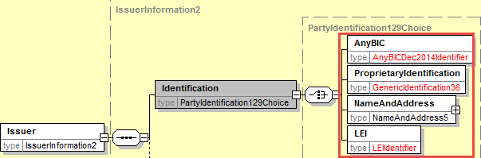

- Amend the RightsHolder Identification component
In the seev.007 (MECO – MeetingVoteExecutionConfirmation) message, in the VoteInstructions sequence, change the data type of the RightHolder element so as to identify a legal or a natural person with a PartyIdentificationChoice component with the name as mandatory and the identification as optional as illustrated below:
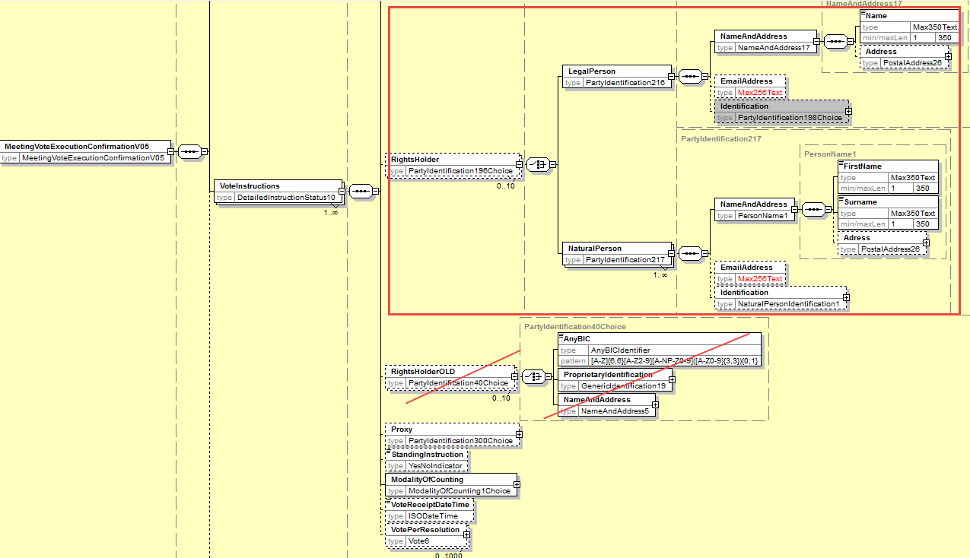

- Add a new Proxy Party Component
In the seev.007 (MECO – MeetingVoteExecutionConfirmation) message, in the VoteInstruction sequence, add a new optional and non-repeatable element Proxy typed by PartyIdentificationChoice to provide the name of a legal or natural person as illustrated below:
Reuse same component as the one used in the Instruction message for Proxy with Identification elements as optional.
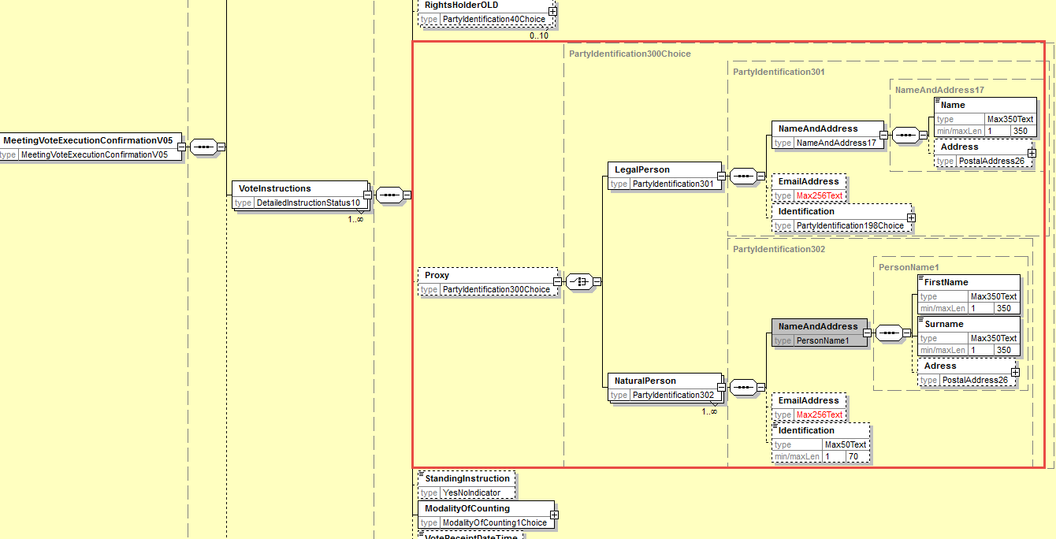

- Add new element ModalityOfCounting
In the seev.007 (MECO – MeetingVoteExecutionConfirmation) message, in the sequence VoteInstruction, add a new mandatory non-repeatable element ModalityOfCounting typed by a Choice between a proprietary Identification and a new code list with the 4 following code values: Paper vote ahead of the meeting (PVBM), Electronic vote before the meeting (EVBM) , Electronic vote at the meeting (EVAM) , Physical vote at the meeting (PVAM) as illustrated below:
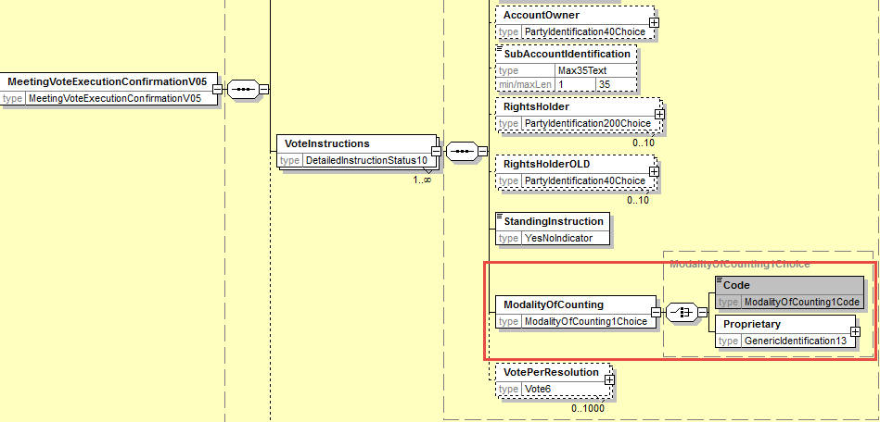

- Add new element VoteReceiptDateTime
In the seev.007 (MECO – MeetingVoteExecutionConfirmation) message, in the sequence VoteInstruction, add a new optional and non-repeatable element VoteReceiptDateTime typed by a DateAndDateTime1Choice data type as illustrated below:
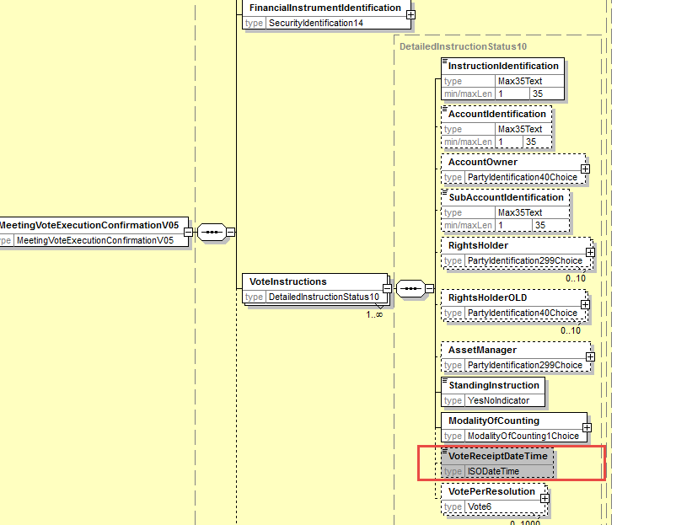

- Add new URL address for vote execution information
At the root of the message, add an optional and non-repeatable element to provide a URL address and set VoteInstruction sequence to optional i.e. to [0..*] as illustrated below:
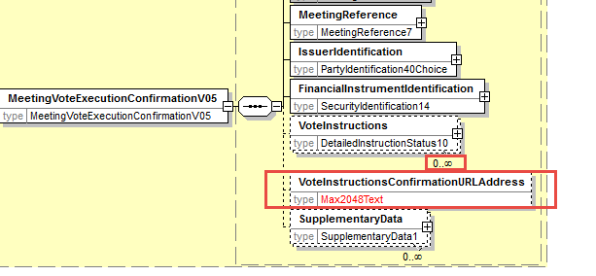

- Proposed timing:
The submitting organization confirms that it can implement the requested changes in the requested timing

Timing | - As requested

- Final decision of the SEG(s):

Approve
Comments:

Reject
Reason for rejection:

CR21: Set StandingInstructionOrder Optional in the Meeting Vote Execution Confirmation
- Origin of the request:
A.1 Submitter: SWIFT, SMPG
A.2 Contact person:
Christine Strandberg – christine.strandberg@seb.se – phone: +46 8 763 6074
Mari Fumagalli – mariangela.fumagalli@bnpparibas.com – phone: +44 207 595 4988
Jacques Littré – jacques.littre@swift.com – phone: +32 2 655 43 35
A.3 Sponsors: N/A

- Related messages:
List of ISO 20022 Proxy Voting messages which would be impacted by the change:
seev.007.001.05 MeetingVoteExecutionConfirmationV05

- Description of the change request:
In the VoteInstruction sequence, set the StandingInstruction indicator element as optional instead of mandatory.
- Purpose of the change:
Having the standing instruction indicator mandatory does not make sense at this stage of the process.
- Urgency of the request:
This maintenance change request for the proxy-voting messages follows the ISO 20022 fast track maintenance process so as to publish a new version of those messages around end of Q3 2019.
- Business examples:
NA
- SEG recommendation:
This section is not to be taken care of by the submitter of the change request. It will be completed in due time by the SEG(s) in charge of the related ISO 20022 messages.

Consider |  |  | Timing
 |  |  | - Next yearly cycle: 2019/2020  (the change will be considered for implementation in the yearly maintenance cycle which starts in 2019 and completes with the publication of new message versions in the spring of 2020) |  |  | Priority:  high  medium  low
- At the occasion of the next maintenance of the messages
(the change will be considered for implementation, but does not justify maintenance of the messages in its own right – will be pending until more critical change requests are received for the messages)
 |  |  | - Urgent unscheduled  (the change justifies an urgent implementation outside of the normal yearly cycle) |  | X
 |  |  | - Other timing:
Comments:

Reject
Reason for rejection:

- Impact analysis:
This change request impacts the following messages:
seev.007.001.05 MeetingVoteExecutionConfirmationV05
- Proposed implementation:
In the seev.007 (MECO – MeetingVoteExecutionConfirmation) message, change the multiplicity of the element VoteInstructions/StandingInstruction to optional as illustrated below:
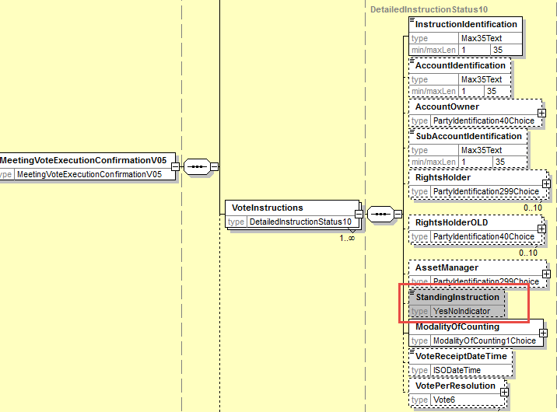
- Proposed timing:
The submitting organization confirms that it can implement the requested changes in the requested timing

Timing | - As requested

- Final decision of the SEG(s):

Approve
Comments:

Reject
Reason for rejection:

CR22: Align the Meeting Result Dissemination Message Design with Similar Changes in Other Messages
- Origin of the request:
A.1 Submitter: SWIFT, SMPG
A.2 Contact person:
Christine Strandberg – christine.strandberg@seb.se – phone: +46 8 763 6074
Mari Fumagalli – mariangela.fumagalli@bnpparibas.com – phone: +44 207 595 4988
Jacques Littré – jacques.littre@swift.com – phone: +32 2 655 43 35
A.3 Sponsors: N/A

- Related messages:
List of ISO 20022 Proxy Voting messages which would be impacted by the change:
seev.008.001.05 MeetingResultDisseminationV05

- Description of the change request:
Align the Amendments component with the similar change in the MeetingNotificationType in the MeetingNotification message.
Align the list of vote instruction types in the vote results with the additional vote instruction types “Blank” and Proprietary vote updated in the MeetingNotification and MeetingInstruction.
Extend the size of the URL Address element in the AdditionalInformation sequence to Max2048Text.

- Purpose of the change:
Align the messages with similar changes and updates done in the other Meeting messages.
- Urgency of the request:
This maintenance change request for the proxy-voting messages follows the ISO 20022 fast track maintenance process so as to publish a new version of those messages around end of Q3 2019.
- Business examples:
N/A
- SEG recommendation:
This section is not to be taken care of by the submitter of the change request. It will be completed in due time by the SEG(s) in charge of the related ISO 20022 messages.

Consider |  |  | Timing
 |  |  | - Next yearly cycle: 2019/2020  (the change will be considered for implementation in the yearly maintenance cycle which starts in 2019 and completes with the publication of new message versions in the spring of 2020) |  |  | Priority:  high  medium  low
- At the occasion of the next maintenance of the messages
(the change will be considered for implementation, but does not justify maintenance of the messages in its own right – will be pending until more critical change requests are received for the messages)
 |  |  | - Urgent unscheduled  (the change justifies an urgent implementation outside of the normal yearly cycle) |  | X
 |  |  | - Other timing:
Comments:

Reject
Reason for rejection:

- Impact analysis:
This change request impacts the following messages:
seev.008.001.05 MeetingResultDisseminationV05
- Proposed implementation:
Align Amendment Component
In the seev.008 (MERD– MeetingResultDissemination) message, at the root of the message, add:
- a new mandatory and non-repeatable element MeetingResultsDisseminationType typed with a code list with values New and Replacement;
- a new optional and non-repeatable element named PreviousMeetingResultDisseminationIdentification typed by the Message Identification data type.
- a cross element rule in order to condition the presence of the element PreviousMeetingResultDisseminationIdentification when MeetingResultDisseminationType value is REPL (Replacement).
Remove the “Amendment” sequence.
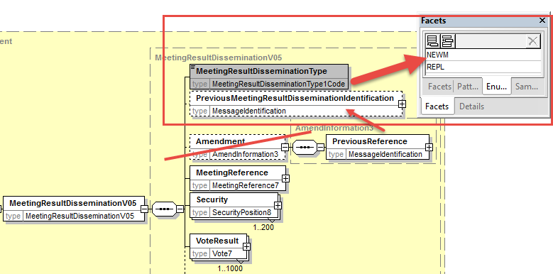
Align Vote Instruction Types
In the seev.008 (MERD– MeetingResultDissemination) message, in VoteResult sequence, add the new optional and non-repeatable element “Blank” typed by the data type Number and a new optional and repeatable element Proprietary typed by ProprietaryVote1 as illustrated below:
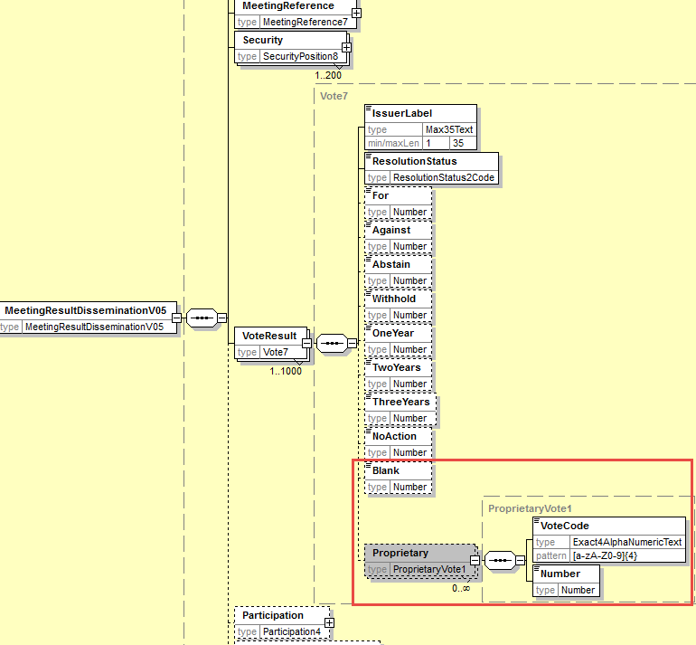
Extend the size of the URL Address element in the AdditionalInformation sequence to Max2048Text.
Align also with the All Vote Types missing like WithManagement, AgainstManagement, Discretionary.

- Proposed timing:
The submitting organization confirms that it can implement the requested changes in the requested timing

Timing | - As requested

- Final decision of the SEG(s):

Approve
Comments:

Reject
Reason for rejection:

CR23: Replace All Obsolete Components with New or Latest Version
- Origin of the request:
A.1 Submitter: SWIFT, SMPG
A.2 Contact person:
Christine Strandberg – christine.strandberg@seb.se – phone: +46 8 763 6074
Mari Fumagalli – mariangela.fumagalli@bnpparibas.com – phone: +44 207 595 4988
Jacques Littré – jacques.littre@swift.com – phone: +32 2 655 43 35
A.3 Sponsors: N/A

- Related messages:
List of ISO 20022 Proxy Voting messages which would be impacted by the change:
seev.001.001.05 MeetingNotificationV05
seev.002.001.05 MeetingCancellationV05
seev.003.001.05 MeetingEntitlementNotificationV05
seev.004.001.05 MeetingInstructionV05
seev.005.001.05 MeetingInstructionCancellationRequestV05
seev.006.001.05 MeetingInstructionStatusV05
seev.007.001.05 MeetingVoteExecutionConfirmationV05
seev.008.001.05 MeetingResultDisseminationV05

- Description of the change request:
Replace the obsolete message components and data types as follows in all related messages:

Obsolete Component | To be replaced with | Messages impacted
AnyBICIdentifier | AnyBICDec2014Identifier | All except seev.006
DateAndDateTimeChoice | DateAndDateTime2Choice | see.001
ISINIdentifier | ISINOct2015Identifier | All
AdditionalRights2 | New to be created | seev.001
DateFormat29Choice | New to be created | see.001
DetailedInstructionStatus10 | New to be created | seev.007
EligiblePosition5 | New to be created | seev.001,002,008
EligiblePosition6 | New to be created | seev.003
EntitlementAssessment3 | New to be created | seev.001
GenericIdentification19 | GenericIdentification36 | All except seev.006
GenericIdentification20 | GenericIdentification30 | All except seev.006, 007
GenericIdentification21 | GenericIdentification78 | All except seev.006, 007
HoldingBalance7 | New to be created | All except seev.004, 005, 006, 007
HoldingBalance8 | New to be created | seev.004, 005
IncentivePremium3 | New to be created | seev.001
IndividualPerson25 | New to be created | seev.001
IndividualPerson26 | New to be created | seev.004
Instruction3 | New to be created | seev.004
IssuerAgent2 | New to be created | seev.001
IssuerInformation2 | New to be created | seev.001
Meeting4 | New to be created | seev.001
MeetingContactPerson2 | New to be created | seev.001
MeetingNotice4 | New to be created | seev.001
PartyIdentification40Choice | PartyIdentification120Choice | All except seev.006
PartyIdentification71 | New to be created | Seev.001
PowerOfAttorneyRequirements3 | New to be created | Seev.001
PriceRateOrAmountChoice | PriceRateOrAmount3Choice | Seev.001
Proxy2Choice | New to be created | Seev.001
Proxy5 | New to be created | Seev.001
Proxy6 | New to be created | Seev.004
ProxyAppointmentInformation3 | New to be created | Seev.001
SafekeepingAccount6 | New to be created | Seev.004, 005
SafekeepingPlaceFormat2Choice | SafekeepingPlaceFormat28Choice | All except seev.006, 007
SafekeepingPlaceTypeAndText2 | SafekeepingPlaceTypeAndText6 | All except seev.006, 007
SecurityIdentification14 | SecurityIdentification19 | All
SecurityPosition8 | New to be created | Seev.001,002,008
SecurityPosition9 | New to be created | Seev.003
VoteParameter4 | New to be created | Seev.001

- Purpose of the change:
Replace all ISO 20022 Message components and data types which have become “Obsolete” in the ISO 20022 repository with the latest version/evolution of the component in the repository or a new one if a new version is not available.
- Urgency of the request:
This maintenance change request for the proxy-voting messages follows the ISO 20022 fast track maintenance process so as to publish a new version of those messages around end of Q3 2019.
- Business examples:

- SEG recommendation:
This section is not to be taken care of by the submitter of the change request. It will be completed in due time by the SEG(s) in charge of the related ISO 20022 messages.

Consider |  |  | Timing
 |  |  | - Next yearly cycle: 2019/2020  (the change will be considered for implementation in the yearly maintenance cycle which starts in 2019 and completes with the publication of new message versions in the spring of 2020) |  |  | Priority:  high  medium  low
- At the occasion of the next maintenance of the messages
(the change will be considered for implementation, but does not justify maintenance of the messages in its own right – will be pending until more critical change requests are received for the messages)
 |  |  | - Urgent unscheduled  (the change justifies an urgent implementation outside of the normal yearly cycle) |  | X
 |  |  | - Other timing:
Comments:

Reject
Reason for rejection:

- Impact analysis:
This change request impacts the following messages:
seev.001.001.05 MeetingNotificationV05
seev.002.001.05 MeetingCancellationV05
seev.003.001.05 MeetingEntitlementNotificationV05
seev.004.001.05 MeetingInstructionV05
seev.005.001.05 MeetingInstructionCancellationRequestV05
seev.006.001.05 MeetingInstructionStatusV05
seev.007.001.05 MeetingVoteExecutionConfirmationV05
seev.008.001.05 MeetingResultDisseminationV05
- Proposed implementation:
For each obsolete component, replace it with the existing latest version or a new one to be created as per the table list here above.
- Proposed timing:
The submitting organization confirms that it can implement the requested changes in the requested timing

Timing | - As requested

- Final decision of the SEG(s):

Approve
Comments:

Reject
Reason for rejection:

CR24: Align all RightsHolder Identification Data type in all Messages
- Origin of the request:
A.1 Submitter: SWIFT, SMPG
A.2 Contact person:
Christine Strandberg – christine.strandberg@seb.se – phone: +46 8 763 6074
Mari Fumagalli – mariangela.fumagalli@bnpparibas.com – phone: +44 207 595 4988
Jacques Littré – jacques.littre@swift.com – phone: +32 2 655 43 35
A.3 Sponsors: N/A

- Related messages:
List of ISO 20022 Proxy Voting messages which would be impacted by the change:
seev.001.001.05 MeetingNotificationV05
seev.002.001.05 MeetingCancellationV05

seev.004.001.05 MeetingInstructionV05
seev.005.001.05 MeetingInstructionCancellationRequestV05

seev.008.001.05 MeetingResultDisseminationV05

- Description of the change request:
The RightsHolder party has been redesigned in the seev.003 entitlement message in CR12 and in the seev.006 status message in CR 18 and in the seev.007 execution confirmation message in CR20. The way the RightsHolder party is defined is the same to the exception of the identifications of the legal and natural persons which are mandatory in the seev.003 entitlement message and optional in the 2 other seev.006 and seev.007 messages.
We must also align the way of identifying “RightsHolder” in all remaining messages in the same way it is defined in the seev.006 and seev.007 messages i.e. with the identifications elements as optional.
- Purpose of the change:
Ensure all identification for the same element be the same across the PV messages.
- Urgency of the request:
This maintenance change request for the proxy-voting messages follows the ISO 20022 fast track maintenance process so as to publish a new version of those messages around end of Q3 2019.
- Business examples:
NA
- SEG recommendation:
This section is not to be taken care of by the submitter of the change request. It will be completed in due time by the SEG(s) in charge of the related ISO 20022 messages.

Consider |  |  | Timing
 |  |  | - Next yearly cycle: 2019/2020  (the change will be considered for implementation in the yearly maintenance cycle which starts in 2019 and completes with the publication of new message versions in the spring of 2020) |  |  | Priority:  high  medium  low
- At the occasion of the next maintenance of the messages
(the change will be considered for implementation, but does not justify maintenance of the messages in its own right – will be pending until more critical change requests are received for the messages)
 |  |  | - Urgent unscheduled  (the change justifies an urgent implementation outside of the normal yearly cycle) |  | X
 |  |  | - Other timing:
Comments:

Reject
Reason for rejection:

- Impact analysis:
This change request impacts the following messages:
seev.001.001.05 MeetingNotificationV05
seev.002.001.05 MeetingCancellationV05

seev.004.001.05 MeetingInstructionV05
seev.005.001.05 MeetingInstructionCancellationRequestV05

seev.008.001.05 MeetingResultDisseminationV05

- Proposed implementation:
In all seev messages listed above, change the current data type PartyIdentification40Choice of RightsHolder by PartyIdentificationxxxChoice as illustrated below:

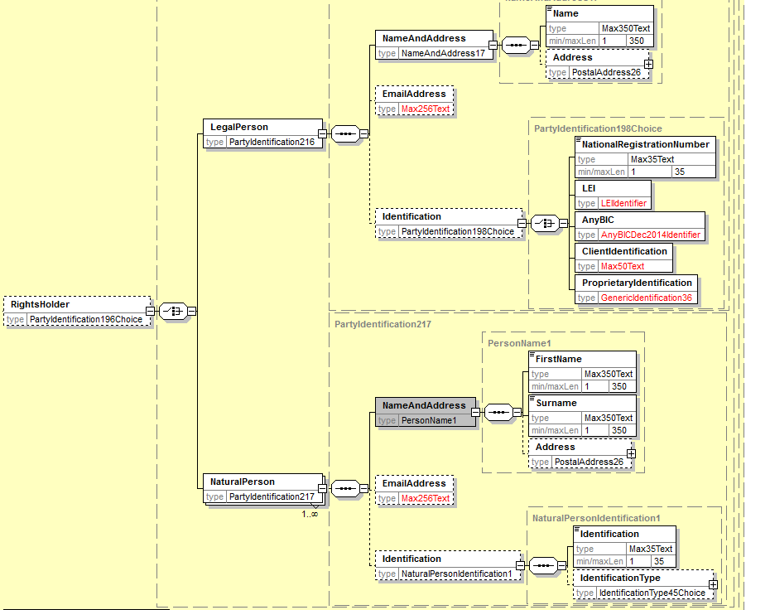
- Proposed timing:
The submitting organization confirms that it can implement the requested changes in the requested timing

Timing | - As requested

- Final decision of the SEG(s):

Approve
Comments:

Reject
Reason for rejection:

CR25: Amend Message Definitions Scope And Usage
- Origin of the request:
A.1 Submitter: SWIFT, SMPG
A.2 Contact person:
Christine Strandberg – christine.strandberg@seb.se – phone: +46 8 763 6074
Mari Fumagalli – mariangela.fumagalli@bnpparibas.com – phone: +44 207 595 4988
Jacques Littré – jacques.littre@swift.com – phone: +32 2 655 43 35
A.3 Sponsors: N/A

- Related messages:
List of ISO 20022 Proxy Voting messages which would be impacted by the change:
seev.001.001.05 MeetingNotificationV05
seev.002.001.05 MeetingCancellationV05
seev.003.001.05 MeetingEntitlementNotificationV05
seev.004.001.05 MeetingInstructionV05
seev.005.001.05 MeetingInstructionCancellationRequestV05
seev.006.001.05 MeetingInstructionStatusV05
seev.007.001.05 MeetingVoteExecutionConfirmationV05
seev.008.001.05 MeetingResultDisseminationV05

- Description of the change request:
Amend the message definitions of all proxy voting messages to align them with the ISO 20022 style using the passive voice for the description of the scope and update the usage sections in order to align them with the changes in message flows required by the Shareholder Rights implementing regulation.
Amend also the usage of the seev.006 message to specify that the message can also be used to confirm that the related vote instruction sent is cast.
Amend also the scope of the seev.007 message to specify that the message originates from the issuer as a confirmation of the vote execution and is forwarded by the intermediaries.
Please refer to the proposed implementation section T below for an illustration of the changes.
- Purpose of the change:
Adapt the definition and scope / usage of the messages to the updated message functionalities required by the European Commission Shareholders Rights Directive implementing regulation (EU) 2018/1212 of 3 September 2018 (see regulation table references in the description above).
For the MeetingVoteExecutionConfirmation messgage, clarify the exact usage of the message and confirm that the vote execution confirmation originates directly from the issuer.

- Urgency of the request:
This maintenance change request for the proxy-voting messages follows the ISO 20022 fast track maintenance process so as to publish a new version of those messages around end of Q3 2019.
- Business examples:
N/A
- SEG recommendation:
This section is not to be taken care of by the submitter of the change request. It will be completed in due time by the SEG(s) in charge of the related ISO 20022 messages.

Consider |  |  | Timing
 |  |  | - Next yearly cycle: 2019/2020  (the change will be considered for implementation in the yearly maintenance cycle which starts in 2019 and completes with the publication of new message versions in the spring of 2020) |  |  | Priority:  high  medium  low
- At the occasion of the next maintenance of the messages
(the change will be considered for implementation, but does not justify maintenance of the messages in its own right – will be pending until more critical change requests are received for the messages)
 |  |  | - Urgent unscheduled  (the change justifies an urgent implementation outside of the normal yearly cycle) |  | X
 |  |  | - Other timing:
Comments:

Reject
Reason for rejection:

- Impact analysis:
This change request impacts the following messages:
seev.001.001.05 MeetingNotificationV05
seev.002.001.05 MeetingCancellationV05
seev.003.001.05 MeetingEntitlementNotificationV05
seev.004.001.05 MeetingInstructionV05
seev.005.001.05 MeetingInstructionCancellationRequestV05
seev.006.001.05 MeetingInstructionStatusV05
seev.007.001.05 MeetingVoteExecutionConfirmationV05
seev.008.001.05 MeetingResultDisseminationV05
- Proposed implementation:
The following scope and usage are proposed on the message definitions:
Seev.001 – Meeting Notification
Scope
The MeetingNotification message is sent by a notifying party, for example, an issuer, its agent or an intermediary to another intermediary, a party holding the right to vote, a registered security holder or to a beneficial holder to announce a meeting.
Usage
The MeetingNotification message is used to announce a meeting, for example, it provides information on the participation details and requirements for the meeting, the vote parameters and the resolutions. The MeetingNotification message may also be used to announce an update.
This message definition is intended for use with the Business Application Header (head.001.001.01).
Seev.002 – Meeting Cancellation
Scope
The MeetingCancellation message is sent by the party that sent the MeetingNotification message to the original receiver. It is sent to cancel a previously announced meeting or to advise the withdrawal of a meeting.
Usage
The MeetingCancellation message is used to advise that the meeting has been cancelled by the account servicer or withdrawn by the Issuer.
This message definition is intended for use with the Business Application Header (head.001.001.01).
Seev.003 – Meeting Entitlement Notification
Scope
The MeetingEntitlementNotification is sent by an account servicer to an account owner to advise the entitlement in relation to a meeting.
Usage
This message is sent to advise the quantity of securities held by an account owner. The balance is specified for the securities for which the meeting is taking place. The message is also used to amend a previously sent MeetingEntitlementNotification.
The MeetingEntitlementNotification message may be sent either before receiving a voting instruction to confirm the entitlement; or after having received a voting instruction to confirm details of the person attending the meeting.
The message may also be used in place of an attendance card or to confirm entitlements in case of bearer shares.
This message definition is intended for use with the Business Application Header (head.001.001.01).
Seev.004 – Meeting Instruction
Scope
The MeetingInstruction message is sent by a party holding the right to vote to an intermediary, the issuer or its agent to request the receiving party to act upon one or several instructions.
Usage
The MeetingInstruction message is used to vote, require attendance to a meeting, request registration of securities and assign a proxy. One of multiple instructions can be carried within the same message.
Once the message is sent, it cannot be modified. It must be cancelled by a MeetingInstructionCancellationRequest. Only after receipt of a confirmed cancelled status via the
MeetingInstructionStatus message, a new MeetingInstruction message can be sent.
This message definition is intended for use with the Business Application Header (head.001.001.01).
Seev.005 – Instruction Cancellation Request
Scope
The MeetingInstructionCancellationRequest message is sent by the same party that sent the
MeetingInstruction message. It is sent to request the cancellation of one, some or all of the instructions included in the original the MeetingInstruction message.
Usage
This message must be answered by a MeetingInstructionStatus message.
This message definition is intended for use with the Business Application Header (head.001.001.01).
Seev.006 – MeetingInstructionStatusV05
Scope
The MeetingInstructionStatus message is sent by an intermediary to the sender of an instruction to confirm the status of such an instruction. The message gives the status of a complete message or of one or more specific instructions within the message.
The message may also be sent by the Issuer or the intermediary to confirm that a vote has been cast.

Usage
The MeetingInstructionStatus message is used for four purposes.
First, it is used to provide a global processing or rejection status of a MeetingInstruction message.
Second, it provides the status on the processing of a MeetingInstructionCancellationRequest message, for example, whether the request message is rejected or accepted.
Third, it is used to provide a detailed processing or rejection status of one or more instructions within the MeetingInstruction message, for example, for each instruction in the MeetingInstruction message the processing or rejection status is individually reported by using the InstructionIdentification element. This identification allows the receiver of the status message to link the status confirmation to its original instruction.
Fourth, it is used to confirm that the related vote instruction has been confirmed as cast by the issuer or its agent.
This message definition is intended for use with the Business Application Header (head.001.001.01).

Seev.007 – MeetingVote Execution Confirmation
Scope
The MeetingVoteExecutionConfirmation message is sent by an issuer, its agent or an intermediary to another intermediary, a party holding the right to vote, a registered security holder or to a beneficial holder to confirm, to the Sender of the MeetingInstruction message, that their vote has been recorded and counted by the Issuer.
Usage
This message is sent after the shareholders meeting has taken place. The Sender of this message confirms the execution of the vote at the meeting.
This messages is sent if the Sender of the MeetingInstruction message has requested such a confirmation or if market practice or regulation stipulates the need for a full audit trail.
This message definition is intended for use with the Business Application Header (head.001.001.01).
Seev.008 - Meeting Results dissemination
Scope
The MeetingResultDissemination message is sent by an issuer, its agent or an intermediary to another intermediary, a party holding the right to vote, a registered security holder or to a beneficial holder to provide information on the voting results of a shareholders meeting.
Usage
The MeetingResultDissemination message is used to provide the vote results per resolution. It may also provide information on the level of participation.
This message is also used to notify an update or amendment to a previously sent MeetingResultDissemination message.
This message definition is intended for use with the Business Application Header (head.001.001.01).

- Proposed timing:
The submitting organization confirms that it can implement the requested changes in the requested timing

Timing | - As requested

- Final decision of the SEG(s):

Approve
Comments:

Reject
Reason for rejection:

CR26: Rename Message Set to “General Meeting”
- Origin of the request:
A.1 Submitter: SWIFT, SMPG
A.2 Contact person:
Christine Strandberg – christine.strandberg@seb.se – phone: +46 8 763 6074
Mari Fumagalli – mariangela.fumagalli@bnpparibas.com – phone: +44 207 595 4988
Jacques Littré – jacques.littre@swift.com – phone: +32 2 655 43 35
A.3 Sponsors: N/A

- Related messages:
List of ISO 20022 Proxy Voting messages which would be impacted by the change: None
No message design impact.
- Description of the change request:
Change the name of the “Proxy Voting” message set to “General Meeting”.
- Purpose of the change:
The term "proxy" is not really appropriate, it does not reflect well the scope of functions being covered by the messages the and therefore may be confusing.
- Urgency of the request:
This maintenance change request for the proxy-voting messages follows the ISO 20022 fast track maintenance process so as to publish a new version of those messages around end of Q3 2019.
- Business examples:
N/A
- SEG recommendation:
This section is not to be taken care of by the submitter of the change request. It will be completed in due time by the SEG(s) in charge of the related ISO 20022 messages.

Consider |  |  | Timing
 |  |  | - Next yearly cycle: 2019/2020  (the change will be considered for implementation in the yearly maintenance cycle which starts in 2019 and completes with the publication of new message versions in the spring of 2020) |  |  | Priority:  high  medium  low
- At the occasion of the next maintenance of the messages
(the change will be considered for implementation, but does not justify maintenance of the messages in its own right – will be pending until more critical change requests are received for the messages)
 |  |  | - Urgent unscheduled  (the change justifies an urgent implementation outside of the normal yearly cycle) |  | X
 |  |  | - Other timing:
Comments:

Reject
Reason for rejection:

- Impact analysis:
This change request has no impacts on the messages.

- Proposed implementation:
Change the name in the message documentation and in the ISO 20022 web site.

- Proposed timing:
The submitting organization confirms that it can implement the requested changes in the requested timing

Timing | - As requested

- Final decision of the SEG(s):

Approve
Comments:

Reject
Reason for rejection:

CR27: In the instruction, add code QALL as a Quantity to Vote in All Type Of Vote in VotePerAgendaResolution
- Origin of the request:
A.1 Submitter: SWIFT, SMPG
A.2 Contact person:
Christine Strandberg – christine.strandberg@seb.se – phone: +46 8 763 6074
Mari Fumagalli – mariangela.fumagalli@bnpparibas.com – phone: +44 207 595 4988
Jacques Littré – jacques.littre@swift.com – phone: +32 2 655 43 35
A.3 Sponsors: N/A

- Related messages:
List of ISO 20022 Proxy Voting messages which would be impacted by the change:
seev.004.001.05 MeetingInstructionV05

- Description of the change request:
Add quantity vote code QALL for the vote instruction for agenda resolutions as a choice in all vote types.
- Purpose of the change:
Allow to vote with quantity QALL instead of having to provide a exact quantity.
- Urgency of the request:
This maintenance change request for the proxy-voting messages follows the ISO 20022 fast track maintenance process so as to publish a new version of those messages around end of Q3 2019.
- Business examples:
N/A
- SEG recommendation:
This section is not to be taken care of by the submitter of the change request. It will be completed in due time by the SEG(s) in charge of the related ISO 20022 messages.

Consider |  |  | Timing
 |  |  | - Next yearly cycle: 2019/2020  (the change will be considered for implementation in the yearly maintenance cycle which starts in 2019 and completes with the publication of new message versions in the spring of 2020) |  |  | Priority:  high  medium  low
- At the occasion of the next maintenance of the messages
(the change will be considered for implementation, but does not justify maintenance of the messages in its own right – will be pending until more critical change requests are received for the messages)
 |  |  | - Urgent unscheduled  (the change justifies an urgent implementation outside of the normal yearly cycle) |  | X
 |  |  | - Other timing:
Comments:

Reject
Reason for rejection:

- Impact analysis:
This change request impacts the following messages:
seev.004.001.05 MeetingInstructionV05
- Proposed implementation:
In the seev.004 (MEIN – MeetingInstruction) message, in the sequence Instruction/VoteDetails/VoteInstructionForAgendaResolution/VoteInstruction and in sequence Instruction/Proxy/VoteInstructionForAgendaResolution/VoteInstruction,, for all types of votes, replace the data type “Number” by a QuantityOrCode1Choice component which is a choice between “Number” and the code value QALL as illustrated below:
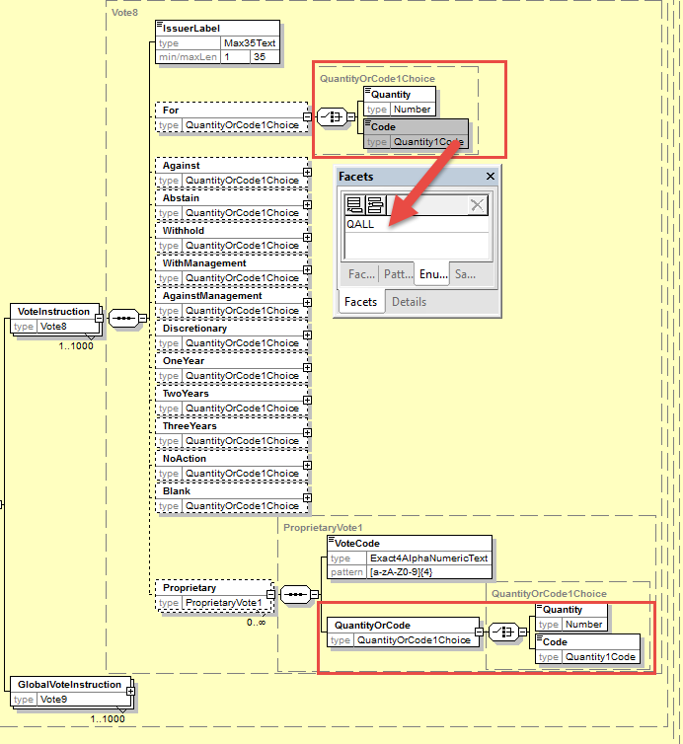
- Proposed timing:
The submitting organization confirms that it can implement the requested changes in the requested timing

Timing | - As requested

- Final decision of the SEG(s):

Approve
Comments:

Reject
Reason for rejection:

CR28: In the instruction, Allow to Vote for All Resolutions with a Single Vote
- Origin of the request:
A.1 Submitter: SWIFT, SMPG
A.2 Contact person:
Christine Strandberg – christine.strandberg@seb.se – phone: +46 8 763 6074
Mari Fumagalli – mariangela.fumagalli@bnpparibas.com – phone: +44 207 595 4988
Jacques Littré – jacques.littre@swift.com – phone: +32 2 655 43 35
A.3 Sponsors: N/A

- Related messages:
List of ISO 20022 Proxy Voting messages which would be impacted by the change:
seev.004.001.05 MeetingInstructionV05

- Description of the change request:
In the sequence “VoteInstructionForAgendaResolution” in the Instruction/VoteDetails sequence, add a new choice sequence with a choice between a new element VotrePerResolution typed by the existing Vote3Choice component and a new element “VoteForAllResolution” typed by VoteOption1Choice
- Purpose of the change:
The vote instruction message should be updated so that it is possible also to vote with the same vote type for all agenda resolutions at once.
- Urgency of the request:
This maintenance change request for the proxy-voting messages follows the ISO 20022 fast track maintenance process so as to publish a new version of those messages around end of Q3 2019.
- Business examples:
N/A
- SEG recommendation:
This section is not to be taken care of by the submitter of the change request. It will be completed in due time by the SEG(s) in charge of the related ISO 20022 messages.

Consider |  |  | Timing
 |  |  | - Next yearly cycle: 2019/2020  (the change will be considered for implementation in the yearly maintenance cycle which starts in 2019 and completes with the publication of new message versions in the spring of 2020) |  |  | Priority:  high  medium  low
- At the occasion of the next maintenance of the messages
(the change will be considered for implementation, but does not justify maintenance of the messages in its own right – will be pending until more critical change requests are received for the messages)
 |  |  | - Urgent unscheduled  (the change justifies an urgent implementation outside of the normal yearly cycle) |  | X
 |  |  | - Other timing:
Comments:

Reject
Reason for rejection:

- Impact analysis:
This change request impacts the following messages:
seev.004.001.05 MeetingInstructionV05
- Proposed implementation:
In the seev.004 (MEIN – MeetingInstruction) message, in the sequence “VoteInstructionForAgendaResolution” in the Instruction/VoteDetails sequence, add a new choice sequence with a choice between a new element VotrePerAgendaResolution typed by the existing Vote3Choice component and a new element “VoteForAllAgendaResolution” typed by VoteOption1Choice as illustrated below:
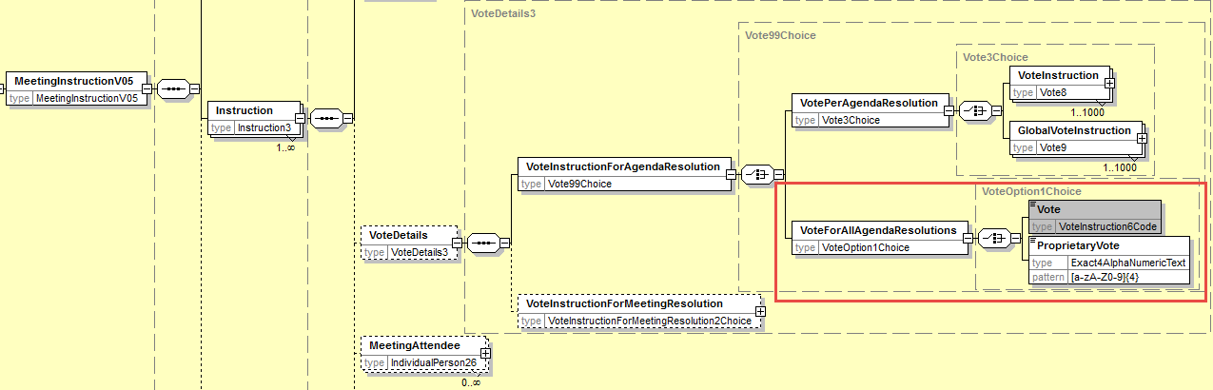

- Proposed timing:
The submitting organization confirms that it can implement the requested changes in the requested timing

Timing | - As requested

- Final decision of the SEG(s):

Approve
Comments:

Reject
Reason for rejection:

