Shareholders Identification Disclosure messages
Market Practice

The Securities Market Practice Group is a group of experts that represents local markets or market infrastructures and who devote their time on a voluntary basis to define global and local market practices for the benefit of the securities industry. The time spent is sponsored by the market players. The market practice documentation and recommendations produced by this organisation are intended to solve common problems across the securities industry, from which financial institutions can derive clear benefits, to harmonise business processes and to facilitate the usage of message protocols ISO 15022 and ISO 20022. While the Securities Market Practice Group encourages the implementation of the market practices it develops it is up to the financial institutions within each market to implement the market practices according to their needs and agreements with their business counterparts to support their businesses as efficiently as possible. For more information on the MP release cycle please refer to the SMPG by-laws document section 4 on www.smpg.info.

Status: Final v1.0
Preparation Date: Nov. 2019 - Feb 2020
Update date: 20 March 2020
Implementation Date: 3 September 2020
Author: SMPG CA-WG

I. Introduction: 4
II. Scope and definitions: 4
III. Actors and Roles: 5
IV. Activity Diagram: 6
V. Message Flows illustrations: 7
VI. Shareholders Identification Disclosure Request 12
A. Scope. 12
B. Common mandatory business data requirements. 12
C. Optional business data requirements. 13
VII. Shareholders Identification Disclosure Request Cancellation Advice 14
A. Scope. 14
B. Common mandatory business data requirements. 14
C. Optional business data requirements. 15
VIII. Shareholders Identification Disclosure Response 16
A. Scope. 16
B. Common mandatory business data requirements. 16
C. Optional business data requirements. 19
IX. Shareholders Identification Disclosure Response Cancellation Advice 20
A. Scope. 20
B. Common mandatory business data requirements. 20
C. Optional business data requirements. 21
X. Shareholders Identification Disclosure Response Status Advice 22
A. Scope. 22
B. Common mandatory business data requirements. 22
C. Optional business data requirements. 23

Changes to previous versions

Introduction:
The amended Shareholders Rights Directive (EU) 2017/828 (hereinafter “SRD II”) and Implementing Regulation (EU) 2018/1212 (hereinafter “SRD II IR”) aim to encourage long-term shareholder engagement and to improve corporate governance in EU/EEA companies traded on EU/EEA regulated markets by enabling shareholders to exercise their voting rights and rights to information across borders. In SRD II, EU/EEA issuers of shares traded on regulated markets are also given the right to identify their shareholders. Exercise of this right confers obligations on intermediaries.

The market practice described in this document is based on SRD II and SRD II IR, as well as the Market Standards for Shareholder Identification produced by the Shareholder Identification Task Force.

As the SRD II IR is very specific and detailed on the data elements to be used, the SMPG would like to highlight that only the ISO 20022 messages designed for SRD II Shareholder Identification Disclosure listed in the scope and Definition section are compliant with the IR.

The use of the corporate action notifications and instructions messages (in ISO 15022 or ISO 20022 formats) with corporate action event type code DSCL/Disclosure, is not compliant with SRD II, but will remain in the ISO standards for other disclosure processes/purposes.

Scope and definitions:
The scope of this document is to describe the market practice for using the Shareholders Identification Disclosure messages, as per SRD II and SRD II IR.
The market practices described in this document are meant to be used exclusively with the following ISO 20022 messages and the business application header (BAH) - head.001.001.0x:
MessageDefinition | Abbreviated Name | Message Identifier
ShareholderIdentificationDisclosureRequest | SIDR | seev.045.001.02
ShareholderIdentificationDisclosureRequestCancellationAdvice | SIDC | seev.046.001.01
ShareholderIdentificationDisclosureResponse | SIRE | seev.047.001.01
ShareholderIdentificationDisclosureResponseCancellationAdvice | SIRC | seev.048.001.01
ShareholderIdentificationDisclosureResponseStatusAdvice | SIRS | seev.049.001.01

All documentation related to shareholder identification messages is available in the UHB on-line page on swift.com in the Knowledge Centre: https://www2.swift.com/knowledgecentre/products/Standards%20MX

The 5 new shareholder identification messages are available on MyStandard at: https://www2.swift.com/mystandards/#/ISO20022?businessDomain=Securities in the “securities events” section. Both PDF or Excel or schemas (with an MS license) can be exported. The documentation and schemas are also available on the www.ISO20022.org web site: https://www.iso20022.org/securities_messages.page under the “ShareholderIdentificationDisclosure” title.

Actors and Roles:
The main roles involved in this process:
- Issuer
The party that has issued the shares and is requesting the identity of its Shareholders.
In the SRD II IR, the definition of issuer is: a company which has its registered office in a Member State and the shares of which are admitted to trading on a regulated market situated or operating within a Member State or a third party nominated by such a company for the tasks set out in this Regulation.
- Third party/issuer agent
The third party that the issuer has delegated responsibility for receiving responses to the request. This is an optional role; the issuer may elect to receive responses itself. The issuer CSD can also act as the third party.
- Issuer CSD
The issuer CSD is the CSD in which the shares have been issued. The issuer CSD is the primary register for the issuance, unless this function is performed by another party such as a registrar. The issuer CSD is in many markets the first intermediary, and it may also be the last intermediary, i.e. for a CSD member’s proprietary account or for various types of end investors, in direct-holding markets.
In the SRD II IR, the definition of issuer CSD is: the central securities depository which provides the core service as defined in points 1 or 2 of Section A of the Annex to Regulation (EU) No 909/2014 of the European Parliament and of the Council with respect to the shares traded on a regulated market.
In the SRD II IR, the definition of first intermediary is: the issuer CSD or other intermediary nominated by the issuer, who maintains the share records of the issuer by book-entry at top tier level with respect to the shares traded on a regulated market or holds those shares at top tier level on behalf of the shareholders of the issuer.
- Local custodian
The party that acts as CSD member, holding assets on behalf of clients in one or more securities accounts in the books and records of the issuer CSD. The local custodian may be the last intermediary, i.e. a client may be the end investor/shareholder.
- Global custodian
The party that acts as client of the CSD member, in turn holding assets on behalf of clients in one or more securities accounts in the books and records of the local custodian. The global custodian may be the last intermediary, i.e. a client may be the end investor/shareholder.

There may be additional intermediaries. We will limit the market practice to the main roles and actors.

Activity Diagram:
Possible alternative flow:
Direct disclosure request to Intermediary
Legend
Possible alternative flow:
Response through Chain
Issuer
Request
Response
First
Intermediary
Last Intermediary
Disclosure Request
Initiator / Response Recipient
- Disclosure Request
- Cancellation Advice
Shareholder
- Disclosure Response
- Response Cancellation
- Disclosure Response Status
- Disclosure Response
- Response Cancellation
- Disclosure Response Status
- Disclosure Response
- Response Cancellation
- Disclosure Response Status
- Disclosure Request
- Cancellation Advice
- Disclosure Request
- Cancellation Advice
- Disclosure Request
- Cancellation Advice
- Disclosure Request
- Cancellation Advice
ISO Messaging Solution Scope
Intermediary
X+1
Intermediary X

Message Flows illustrations:
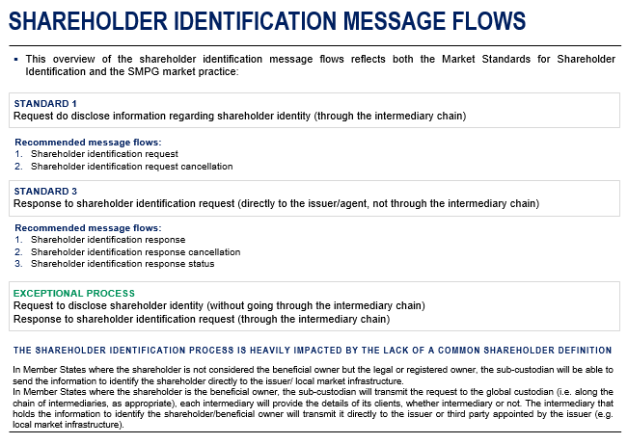

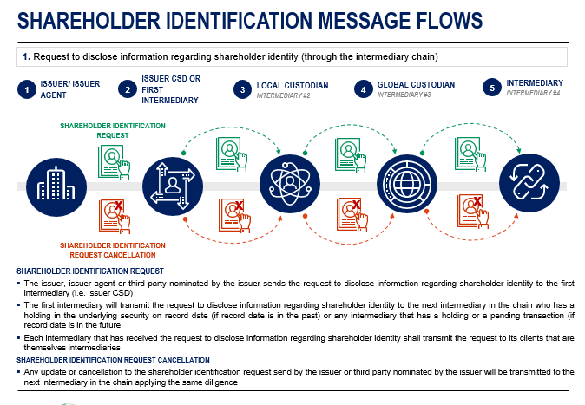

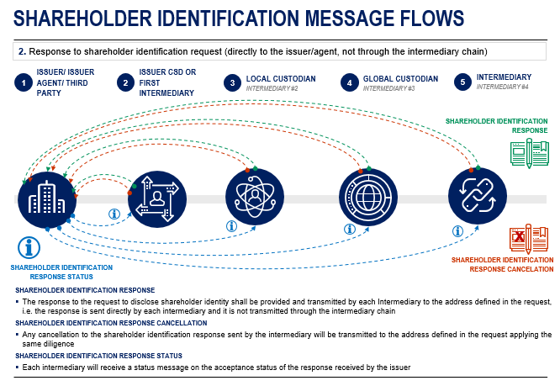

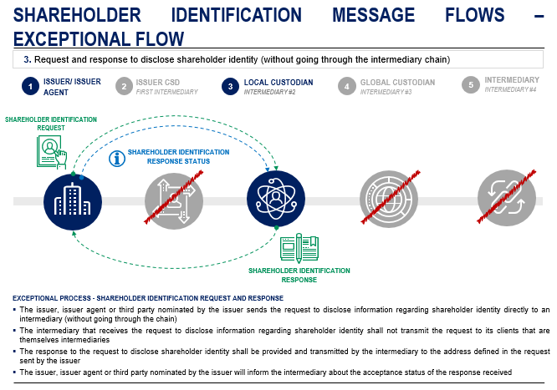

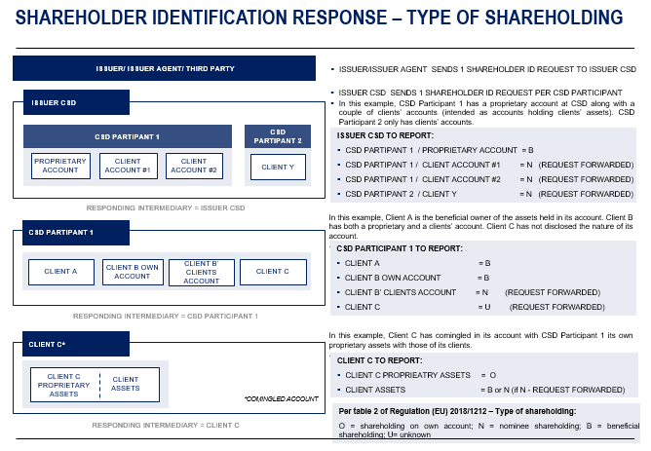

Shareholders Identification Disclosure Request

Scope.
For the above-described different communication needs, the following business data are required. Focus is on the processes described in the MP,

Common mandatory business data requirements.
The SMPG recommends that all the below optional and mandatory elements be present in all Shareholders Identification Disclosure Request messages. M / C / O identifies whether the business data is mandatory, conditional or optional in the ISO 20022 standards.

Common mandatory elements | Place | Detailed usage | M/C/O | SRD II reference
From, <Fr> | BAH | The sender from a business context, which can be different than the actual sender in the transport header (similar to MEOR in MT). BICFI is the preferred format | M
To, <To> | BAH | The receiver from a business context, which can be different than the actual receiver in the transport header (similar to MERE in MT). BICFI is the preferred format | M
BusinessMessageIdentifier, <BizMsgIdr> | BAH | The sender’s unique ID/reference of the message | M
MessageDefinitionIdentifier, <MsgDefIdr> | BAH | Contains the MessageIdentifier that defines the BusinessMessage, e.g. seev.045.001.01 | M
CreationDate, <CreDt> | BAH | Date and time, using ISONormalisedDateTime format | M
Issuer Disclosure Request Identification, <IssrDsclsrReqId> | Document |  | M | Table 1 – A1
Disclosure Request Type, <DsclsrReqTp> | Document | A REPL message should only be sent in case of a change in the issuer deadline of a previously announced request.  In case any other element in the request changes, the request should be withdrawn/cancelled. | M | Table 1 – A2
Forward Request Indicator, <FwdReqInd> | Document | This indicator should always be present to avoid any misunderstanding. | O | Table 1 – A3
ShareholderRightsDirectiveIndicator <ShrhldrRghtsDrctvInd> | Document | This indicator should be set by the issuer CSD or first intermediary. It should be set to YES (value “true”) only when the request is in scope of SRD II and the request has been received from the issuer.  When the indicator is set to NO, the request is to be intended as in scope of SRDII the issuer CSD or first intermediary did not receive it from the issuer.  Any other intermediary in the chain should report the value of this indicator as per the value received from the previous intermediary.  If the shareholder identification request is outside the scope of SRD II, this indicator should not be populated. | C
Financial Instrument Identification, <FinInstrmId> | Document | ISIN is the preferred format | M | Table 1 – A4
Shareholders Disclosure Record Date, <ShrhldrsDsclsrRcrdDt> | Document | Date (YYYY-MM-DD) is the preferred format | M | Table 1 – A5
Disclosure Response Recipient - Identification, <Id> | Document | LEI is the preferred format | M | Table 1 – B1
Disclosure Response Recipient - Recipient Name, <RcptNm> | Document |  | M | Table 1 – B2
Disclosure Response Recipient -Response Recipient Address, <RspnRcptAdr> | Document | AnyBIC is the preferred format | M | Table 1 – B3
Issuer Disclosure Deadline, <IssrDsclsrDdln> | Document | DateTime in UTC format is the preferred format (YYYY-MM-DDThh:mm:ss.sssZ (Z means Zulu Time ≡ UTC time ≡ zero UTC offset)) | M | Table 1 – A6

Optional business data requirements.
The below optional elements may be provided in a Shareholders Identification Disclosure Request message but are optional. If used, they must be used as described in the “Detailed usage” column. It is to be noted that most of the usage rules are standards rules, not market practice recommendations.
Any other elements not mentioned above or below are considered NOT needed for this specific type of message. If used, they will be market-specific.

Common optional elements | Place | Detailed usage | M/C/O | SRD II reference
Response Through Chain Indicator, <RspnThrghChainInd> | Document | In line with the shareholder identification market standards, the shareholder identification response should be sent directly to the issuer or the third party appointed by the issuer.  This indicator should ONLY be present when the response has to go through the chain. | O
Shares Quantity Threshold, <ShrsQtyThrshld> | Document | If used, it has to be provided by the issuer as a quantity of shares | O | Table 1 – A7
Request Share Held Date, <ReqShrHeldDt> | Document | In line with the shareholder identification market standards, this indicator should NOT be used.  If present, the issuer must also specify the method to be used to calculate the date and the description | O | Table 1 – A8
Date Calculation Method, <DtClctnMtd> | Document | Only to be used if the Request Share Held Date is present | C
Disclosure Response Deadline <DsclsrRspnDdln> | Document | Only to be used if the response is to be sent through the chain as indicated in Response Through Chain Indicator | O

Once received, it is recommended that each intermediary sends one request per downstream intermediary (N or U), as per their stated BIC/DN for the message type.

Shareholders Identification Disclosure Request Cancellation Advice

Scope.
For the above-described different communication needs, the following business data are required. Focus is on the processes described in the MP.

Common mandatory business data requirements.
The SMPG recommends that all the below optional and mandatory elements be present in all Shareholders Identification Disclosure Request Cancellation Advice messages. M / C / O identifies whether the business data is mandatory, conditional or optional in the ISO 20022 standards.

Common mandatory elements | Place | Detailed usage | M/C/O | SRD II reference
From, <Fr> | BAH | The sender from a business context, which can be different than the actual sender in the transport header (similar to MEOR in MT). BICFI is the preferred format | M
To, <To> | BAH | The receiver from a business context, which can be different than the actual receiver in the transport header (similar to MERE in MT). BICFI is the preferred format | M
BusinessMessageIdentifier, <BizMsgIdr> | BAH | The sender’s unique ID/reference of the message | M
MessageDefinitionIdentifier, <MsgDefIdr> | BAH | Contains the MessageIdentifier that defines the BusinessMessage, e.g. seev.046.001.01 | M
CreationDate, <CreDt> | BAH | Date and time, using ISONormalisedDateTime format | M
Issuer Disclosure Request Identification, <IssrDsclsrReqId> | Document |  | M
Financial Instrument Identification, <FinInstrmId> | Document | ISIN is the preferred format | M
Shareholders Disclosure Record Date, <ShrhldrsDsclsrRcrdDt> | Document | Date (YYYY-MM-DD) is the preferred format | M
CancellationReason, <CxlRsn> | Document | WITH is ONLY to be used in case of a cancellation triggered by the issuer or the third party appointed by the issuer. | O

Optional business data requirements.
The below optional elements may be provided in a Shareholders Identification Disclosure Request Cancellation Advice message but are optional. If used, they must be used as described in the “Detailed usage” column. It is to be noted that most of the usage rules are standards rules, not market practice recommendations.
Any other elements not mentioned above or below are considered NOT needed for this specific type of message. If used, they will be market-specific.

Common optional elements | Place | Detailed usage | M/C/O | SRD II reference
Related – From, <Fr> | BAH | Optional block in the BAH, for the related message: the sender from a business context, which can be different than the actual sender in the transport header (similar to MEOR in MT). BICFI is the preferred format | C*
Related – To, <To> | BAH | Optional block in the BAH, for the related message: the receiver from a business context, which can be different than the actual receiver in the transport header (similar to MERE in MT). BICFI is the preferred format | C*
Related – BusinessMessageIdentifier, <BizMsgIdr> | BAH | Optional block in the BAH, for the related message: the sender’s unique ID/reference of the message | C*
Related – MessageDefinitionIdentifier, <MsgDefIdr> | BAH | Optional block in the BAH, for the related message: contains the MessageIdentifier that defines the BusinessMessage, e.g. seev.045.001.01 | C*
Related – CreationDate, <CreDt> | BAH | Optional block in the BAH, for the related message: date and time, using ISONormalisedDateTime format | C*

C*: The block is optional, but if the block is included, the element is mandatory.

Shareholders Identification Disclosure Response

Scope.
For the above-described different communication needs, the following business data are required. Focus is on the processes described in the MP:

Common mandatory business data requirements.
The SMPG recommends that all the below optional and mandatory elements be present in all Shareholders Identification Disclosure Response messages. M / C / O identifies whether the business data is mandatory, conditional or optional in the ISO 20022 standards.

Common mandatory elements | Place | Detailed usage | M/C/O | SRD II reference
From, <Fr> | BAH | The sender from a business context, which can be different than the actual sender in the transport header (similar to MEOR in MT). BICFI is the preferred format | M
To, <To> | BAH | The receiver from a business context, which can be different than the actual receiver in the transport header (similar to MERE in MT). BICFI is the preferred format | M
BusinessMessageIdentifier, <BizMsgIdr> | BAH | The sender’s unique ID/reference of the message | M
MessageDefinitionIdentifier, <MsgDefIdr> | BAH | Contains the MessageIdentifier that defines the BusinessMessage, e.g. seev.047.001.01 | M
CreationDate, <CreDt> | BAH | Date and time, using ISONormalisedDateTime format | M
Pagination | Document | Recommended to be used even if the response only include one page | O
Issuer Disclosure Request Identification, <IssrDsclsrReqId> | Document |  | M | Table 2 – A1
Financial Instrument Identification, <FinInstrmId> | Document | ISIN is the preferred format | M | Table 2 – A4
Shareholders Disclosure Record Date, <ShrhldrsDsclsrRcrdDt> | Document | Date (YYYY-MM-DD) is the preferred format | M | Table 2 – A5
Disclosure Response Identification, <DsclsrRspnId> | Document |  | M | Table 2 – A2
Responding Intermediary – Name, <Nm> | Document |  | M | Table 2 – B2
Responding Intermediary – Identification, <Id> | Document | LEI is the preferred format | M | Table 2 – B1
Responding Intermediary – Contact Person, <CtctPrsn> | Document | Name and email address are recommended | O
Safekeeping Account, <SfkpgAcct> | Document | Safekeeping account that the responding intermediary has with the intermediary up the chain.  The first intermediary should use N/A. | M | Table 2 – B7
Account Servicer, <AcctSvcr> | Document | Intermediary up the chain from the responding intermediary – LEI is the preferred format.  The first intermediary should use the Scheme field set to N/A in the Proprietary ID of the identifier. | M | Table 2 – B6
Shareholding Balance On Own Account, <ShrhldgBalOnOwnAcct> | Document | Quantity of securities held by the responding intermediary for its own account | M | Table 2 – B4
Shareholding Balance On Client Account, <ShrhldgBalOnClntAcct> | Document | Quantity of securities held by the responding intermediary on behalf of clients | M | Table 2 – B5
Total Shareholding Balance, <TtlShrhldgBal> | Document | Sum of the securities quantity held by the responding intermediary for its own account and of securities quantity held on behalf of clients | M | Table 2 – B3
Safekeeping Account, <SfkpgAcct> | Document | The account number at the responding intermediary.  Recommended to be included to facilitate the issuer’s reconciliation.  The account should be a real account (no narrative or institution names). | O
Account Holder – Legal Person – Name And Address, <NmAndAdr> | Document |  | M | Table 2 – C2(a) and C3-9
Account Holder – Legal Person – Identification, <Id> | Document | LEI or national registration number are the preferred formats | M | Table 2 – C1(a)
Account Holder – Natural Person – Name And Address, <NmAndAdr> | Document |  | M | Table 2 – C2(b) and C3-9
Account Holder – Natural Person – Identification, <Id> | Document | See attachment | M | Table 2 – C1(b)
Shareholding Type, <ShrhldgTp> | Document |  | M | Table 2 – C10
Quantity, <Qty> | Document |  | M | Table 2 – C11

Optional business data requirements.
The below optional fields may be provided in a Shareholders Identification Disclosure Response message but are optional. If used, they must be used as described in the “Detailed usage” column. It is to be noted that most of the usage rules are standards rules, not market practice recommendations.
Any other fields not mentioned above or below are considered NOT needed for this specific type of message. If used, they will be market-specific.

Common optional elements | Place | Detailed usage | M/C/O | SRD II reference
Non Disclosed Shareholding Quantity, <NonDscldShrhldgQty> | Document | This element is to be used to indicate any securities quantity held by clients of the responding intermediary who have prohibited disclosure | O
Below Threshold Shareholding Quantity, <BlwThrshldShrhldgQty> | Document | This element is to be used to indicate any securities quantity held by clients of the responding intermediary having a balance below threshold | O
Initial Date Of Shareholding, <InitlDtOfShrhldg> | Document | To be reported only if and as requested in the SI request.  Date (YYYY-MM-DD) is the preferred format | C | Table 2 – C12
Third Party – Role, <Role> | Document | To be used with code DECM, to report the details of the third party who is authorised to take investment decisions on behalf of the shareholder | O | Table 2 – C13
Third Party – Name, <Nm> | Document | To be used to report the name of the third party | O | Table 2 – C13
Third Party – Identification, <Id> | Document | To be used to report the ID of the third party  LEI is the preferred format | O | Table 2 – C14

Shareholders Identification Disclosure Response Cancellation Advice

Scope.
For the above-described different communication needs, the following business data are required. Focus is on the processes described in the MP:

Common mandatory business data requirements.
The SMPG recommends that all the below optional and mandatory elements be present in all Shareholders Identification Disclosure Response Cancellation Advice messages. M / C / O identifies whether the business data is mandatory, conditional or optional in the ISO 20022 standards.

Common mandatory elements | Place | Detailed usage | M/C/O | SRD II reference
From, <Fr> | BAH | The sender from a business context, which can be different than the actual sender in the transport header (similar to MEOR in MT). BICFI is the preferred format | M
To, <To> | BAH | The receiver from a business context, which can be different than the actual receiver in the transport header (similar to MERE in MT). BICFI is the preferred format | M
BusinessMessageIdentifier, <BizMsgIdr> | BAH | The sender’s unique ID/reference of the message | M
MessageDefinitionIdentifier, <MsgDefIdr> | BAH | Contains the MessageIdentifier that defines the BusinessMessage, e.g. seev.048.001.01 | M
CreationDate, <CreDt> | BAH | Date and time, using ISONormalisedDateTime format | M
Disclosure Response Identification, <DsclsrRspnId> | Document |  | M
Issuer Disclosure Request Identification, <IssrDsclsrReqId> | Document |  | M
Financial Instrument Identification, <FinInstrmId> | Document | ISIN is the preferred format | M
Shareholders Disclosure Record Date, <ShrhldrsDsclsrRcrdDt> | Document | Date (YYYY-MM-DD) is the preferred format | M
Responding Intermediary – Name, <Nm> | Document |  | M
Responding Intermediary – Identification, <Id> | Document | LEI is the preferred format | M

Optional business data requirements.
The below optional elements may be provided in a Shareholders Identification Disclosure Response Cancellation Advice message but are optional. If used, they must be used as described in the “Detailed usage” column. It is to be noted that most of the usage rules are standards rules, not market practice recommendations.
Any other elements not mentioned above or below are considered NOT needed for this specific type of message. If used, they will be market-specific.

Common optional elements | Place | Detailed usage | M/C/O | SRD II reference
Related – From, <Fr> | BAH | Optional block in the BAH, for the related message: the sender from a business context, which can be different than the actual sender in the transport header (similar to MEOR in MT). BICFI is the preferred format | C*
Related – To, <To> | BAH | Optional block in the BAH, for the related message: the receiver from a business context, which can be different than the actual receiver in the transport header (similar to MERE in MT). BICFI is the preferred format | C*
Related – BusinessMessageIdentifier, <BizMsgIdr> | BAH | Optional block in the BAH, for the related message: the sender’s unique ID/reference of the message | C*
Related – MessageDefinitionIdentifier, <MsgDefIdr> | BAH | Optional block in the BAH, for the related message: contains the MessageIdentifier that defines the BusinessMessage, e.g. seev.047.001.01 | C*
Related – CreationDate, <CreDt> | BAH | Optional block in the BAH, for the related message: date and time, using ISONormalisedDateTime format | C*

C*: The block is optional, but if the block is included, the element is mandatory.

Shareholders Identification Disclosure Response Status Advice

Scope.
For the above-described different communication needs, the following business data are required. Focus is on the processes described in the MP:

Common mandatory business data requirements.
The SMPG recommends that all the below optional and mandatory elements be present in all Shareholders Identification Disclosure Response Status Advice messages. M / C / O identifies whether the business data is mandatory, conditional or optional in the ISO 20022 standards.

Common mandatory elements | Place | Detailed usage | M/C/O | SRD II reference
From, <Fr> | BAH | The sender from a business context, which can be different than the actual sender in the transport header (similar to MEOR in MT). BICFI is the preferred format | M
To, <To> | BAH | The receiver from a business context, which can be different than the actual receiver in the transport header (similar to MERE in MT). BICFI is the preferred format | M
BusinessMessageIdentifier, <BizMsgIdr> | BAH | The sender’s unique ID/reference of the message | M
MessageDefinitionIdentifier, <MsgDefIdr> | BAH | Contains the MessageIdentifier that defines the BusinessMessage, e.g. seev.049.001.01 | M
CreationDate, <CreDt> | BAH | Date and time, using ISONormalisedDateTime format | M
Disclosure Response Identification, <DsclsrRspnId> | Document |  | M
Issuer Disclosure Request Identification, <IssrDsclsrReqId> | Document |  | M
Financial Instrument Identification, <FinInstrmId> | Document | ISIN is the preferred format | M
Shareholders Disclosure Record Date, <ShrhldrsDsclsrRcrdDt> | Document | Date (YYYY-MM-DD) is the preferred format | M
Responding Intermediary – Name, <Nm> | Document |  | M
Responding Intermediary – Identification, <Id> | Document | LEI is the preferred format | M
Response Reception Status, <RspnRcptnSts> | Document | It can only contain the status as “accepted” or “rejected”. In case of a rejection, a rejection reason can be specified | M

Optional business data requirements.
The below optional elements may be provided in a Shareholders Identification Disclosure Response Status Advice message but are optional. If used, they must be used as described in the “Detailed usage” column. It is to be noted that most of the usage rules are standards rules, not market practice recommendations.
Any other elements not mentioned above or below are considered NOT needed for this specific type of message. If used, they will be market-specific.

Common optional elements | Place | Detailed usage | M/C/O | SRD II reference
Related – From, <Fr> | BAH | Optional block in the BAH, for the related message: the sender from a business context, which can be different than the actual sender in the transport header (similar to MEOR in MT). BICFI is the preferred format | C*
Related – To, <To> | BAH | Optional block in the BAH, for the related message: the receiver from a business context, which can be different than the actual receiver in the transport header (similar to MERE in MT). BICFI is the preferred format | C*
Related – BusinessMessageIdentifier, <BizMsgIdr> | BAH | Optional block in the BAH, for the related message: the sender’s unique ID/reference of the message | C*
Related – MessageDefinitionIdentifier, <MsgDefIdr> | BAH | Optional block in the BAH, for the related message: contains the MessageIdentifier that defines the BusinessMessage, e.g. seev.047.001.01 | C*
Related – CreationDate, <CreDt> | BAH | Optional block in the BAH, for the related message: date and time, using ISONormalisedDateTime format | C*

C*: The block is optional, but if the block is included, the element is mandatory.

