Athens - SMPG meeting: April 24 – 26, 2012
Meeting Venue:

DIVANI PALACE ACROPOLIS Hotel
19-25 Parthenonos str.
117 42 Athens - Greece

Tuesday 24th of April
Morning
 |  | 09:00 – 09:30 |  | Welcome Coffee + Registration
 |  | 09:30 – 10:45 |  | General Session  1. Welcome address (Karla Mc Kenna - Chair)  2. Meeting schedule overview (Jacques Littré – General Secretary)  3. Regional updates - ABMF Status Reporting (Taketoshi Mori – APAC Regional Director)  4. Regulatory update (reporting / trade repository mechanisms) and LEI Progress Status (Rudolf Siebel - Vice Chair)
 |  | 10:45 – 11:00 |  | Coffee Break
 |  | 11:00 – 12:30 |  | General Session (Continued)  5. SMPG By-laws update presentation and Q&A (Karla McKenna – Chair & Armin Borries – EMEA Regional Director)  6. Next SMPG meeting in Fall – Feedback on proposed dates (Karla Mc Kenna – Chair & Rudolf Siebel – Vice Chair)
 | 12:30 – 13:30 |  |  | Lunch
Afternoon
 |  | 13:30 – 15:15 |  | General Session (Continued)  7. “MyStandards” SMPG adoption - tool demonstration and Q&A (Janice Chapman / Evelyne Piron / Jacques Littré – WG Facilitators)
 |  | 15:15 – 15:30 |  | Coffee Break
 |  | 15:30 – 17:30 |  | Corporate Action | Settlement and Reconciliation | Investment Funds

Wednesday 25th of April
Morning
 | 09:00 – 10:30 | Corporate Action | Settlement and Reconciliation | Investment Funds
 | 10:30 – 10:45 | Coffee Break
 | 10:45 – 12:15 | Corporate Action | Settlement and Reconciliation | Investment Funds
 | 12:15 – 13:15 | Lunch
Afternoon
 | 13:15 – 15:15 | Potentially Common Session (if needed) or separate sessions
 | 15:15 – 15:30 | Coffee Break
 | 15:30 – 17:30 | Corporate Action | Settlement and Reconciliation | Investment Funds
Evening
 | 19:00 - | Coktail Dinner hosted by the Hellenic Bank Association  (attendance confirmation required)

Thursday 26th of April
Morning
 | 09:00 – 10:30 | Corporate Action | Settlement and Reconciliation | Investment Funds
 | 10:30 – 10:45 | Coffee Break
 | 10:45 – 12:15 | Corporate Action | Settlement and Reconciliation | Investment Funds
 | 12:15 – 13:15 | Lunch
Afternoon
 | 13:15 – 14:30 | Corporate Action | Settlement and Reconciliation | Investment Funds
 | 14:30 | End of meeting

Dress Code: Business Casual

SMPG meeting registration form
Deadline for registration is March 20th.
Late registration requests will be accepted if room permits.

Please return your registration form to: info@smpg.info
NMPGs are asked to send maximum 3 representatives (one for each WG). Extra country representative registraions will have to be justified and subject to consideration on a case by case basis to grant approval.

NAME: |  |  | First Name:
Country:
Institution:
E-Mail address:
Tel/Mobile:

I will attend (tick the appropriate boxes):
Tuesday 24th of April
Morning general session
Afternoon general session
Afternoon Corporate Action
OR
Afternoon Settlement and Reconciliation
OR
Afternoon Investment Funds

Wednesday 25th of April
Morning Corporate Action
OR
Morning Settlement and Reconciliation
OR
Morning Investment Funds
Afternoon Corporate Action
OR
Afternoon Settlement and Reconciliation
OR
Afternoon Investment Funds
Evening Event

Thursday 26th of April
Morning Corporate Action
OR
Morning Settlement and Reconciliation
OR
Morning Investment Funds
Afternoon Corporate Action
OR
Afternoon Settlement and Reconciliation
OR
Afternoon Investment Funds

Hotel Room Booking and Other Useful Information

SMPG ATHENS MEETING
24th-26th April 2012
Athens, Greece

* ACCOMMODATION *

For your accommodation bookings please contact the following hotel, where the SMPG Athens meeting will be held (see Hotel booking form at the end of this document page 6):

DIVANI PALACE ACROPOLIS
Address: 19-25 Parthenonos str., 117 42 Athens Greece
Tel: +30 210 92 80 100
Fax: + 30 210 92 14 993
Website: www.divaniacropolis.gr

Special rates (including American buffet breakfast, services and taxes) apply for all SMPG participants as follows:
Single room € 80,00/night
Double room € 90,00/night

Important notes:
- For your bookings, please complete the attached “Hotel Registration Form” and send it directly to the hotel.
- Special rates apply for overnights from 23rd April to 27th April and are valid for bookings made until March 20th. After that date, all reservations will be made upon request, depending on hotel availability.
- For payment details and cancellation policy please refer to the attached “Hotel Registration Form”.

* HOTEL/AIRPORT ACCESS *

The Divani Palace Acropolis is situated just below the shadow of Acropolis hill. Centrally located, in the heart of Athens, it is very close to the New Archaeological Museum of Acropolis, the old quarter of Plaka, the well know Herodion theatre and Syntagma square.

Ways of accessing the hotel:

- Taxi service: By hiring a taxi at the Athens International Airport Eleftherios Venizelos (Arrivals’ Level).

- Metro: At the airport, you embark on the metro line 3 “Airport-Egaleo” (blue line) and get off at “Syntagma” Station. There, you switch to metro line 2 “Ag.Antonios-Ag.Dimitrios” (red line) in the direction of Ag. Dimitrios and you get off at "Acropolis” Station.
The Hotel is within walking distance from the metro station (see map).

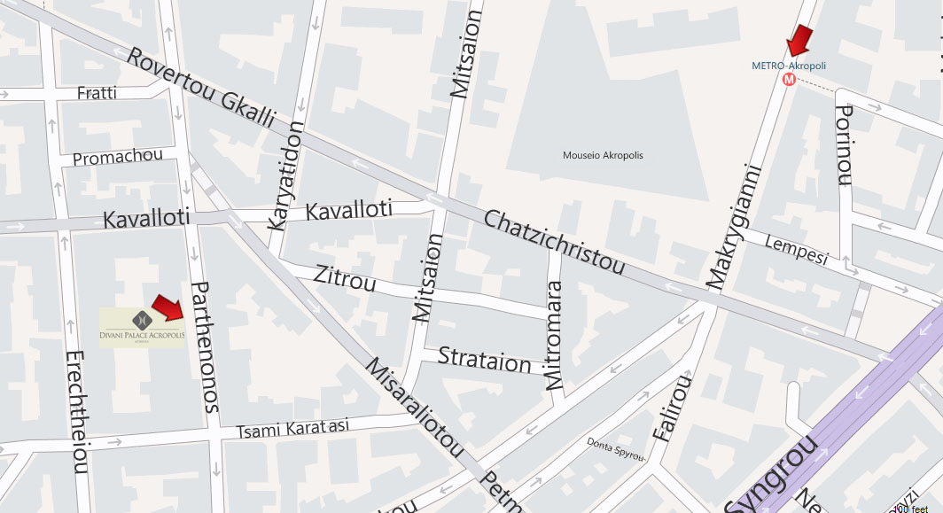

* WEATHER *

Greece has a Mediterranean climate with plenty of sunshine, mild temperatures and a limited amount of rainfall.
The average temperature in Athens for the month of April is expected to be 16°C.

* SOCIAL EVENTS *
Lunch
Lunch will be offered at the Divani Palace Acropolis Hotel to all participants during the 3 days of the meeting.

Dinner
Wednesday 25th April, 19.00 hrs at Hellenic Bank Association Premises.
Cocktail dinner, hosted by the Hellenic Bank Association, will be offered to all participants. The suggested dress code is smart casual attire.
Participants are kindly requested to confirm their attendance via the meeting registration form on page 2.

Hotel Registration Form
“SMPG Athens Meeting”
From Tuesday, April 24th, 2012 till Thursday, April 26th, 2012
Please ensure the Hotel Registration Form is faxed or mailed to the

DIVANI PALACE ACROPOLIS
19-25, Parthenonos str.
117 42, Athens, Greece
Fax: +30 210 921 4993
Tel.: +30 210 928 0100
E-mail: reservations@divaniacropolis.gr

For guaranteed reservations, you are kindly requested to fill in the present form with your Credit Card number and return it to us duly signed. In order to secure space, registration forms should be sent to our reservations fax number 0030 210 92 14 993, till March 20th, 2012.

Family Name: ____________________________________ First Name: _________________________

Tel:________________________________________Fax: ____________________________________

E-mail:_____________________________________________________________________________

A special room rate has been negotiated for this event. Delegates, wishing to make a reservation should contact the Hotel directly and refer to their participation to the “SMPG Athens Meeting”

Room rates are inclusive of American Buffet Breakfast, services and current taxes (7.033%)
Single Room : € 80,00--
Double Room : € 90,00--

Room type required: Single occupancy ____________________ Double occupancy ___________________
Arrival Date: _____________________ Departure Date: __________________ Total: ___________ nights
Arrival time at Athens Airport: ______________________

By signing this form you kindly state your full acceptance and authorization for us to charge your credit card as per terms and conditions indicated hereunder.

Credit Card Type: _____________________ Number: ______________________ Expiring Date: _______
Cardholder’s Name: _______________________________________________________________________
Signature: _______________________________________________ Date: ___________________________

NON-SHOW: In case of non-show one (1) night cancellation fees will apply.

Please send this booking form before March 20th, 2012.
After this date, the reservation can only be confirmed upon availability.

After your request, the hotel will send you a confirmation. If you don’t receive it, please advise the reservation office to be sure that we received your booking.

We thank you and are looking forward to welcoming you in our Hotel “Divani Palace Acropolis”.

Note that working sessions are on going. Individual attendees should register to only one set (eg, Corporate Action) of working group sessions, not a mix.

