FRANKFURT Germany - SMPG meeting: Apr. 23 – 25, 2013
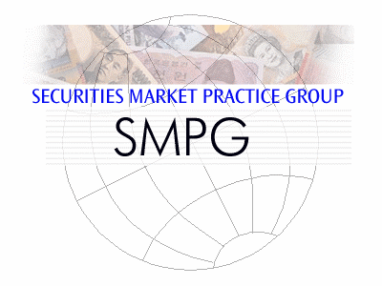
Meeting Venue:

European Central Bank
Eurotower room CI 36th floor
Kaiserstraße 29
Frankfurt am Main, Germany
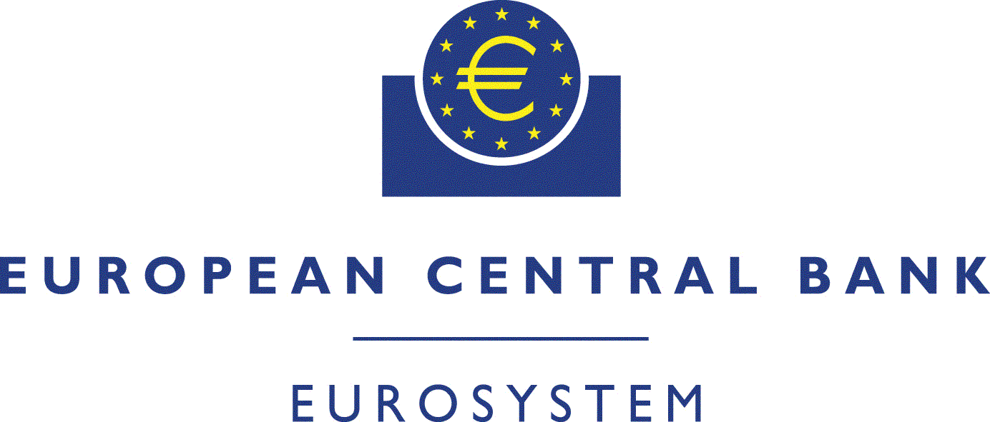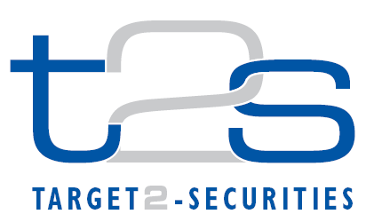

Dress Code: Business Casual

Tuesday 23rd of April
Morning
 |  | 08:30 – 09:30 |  | Registration at ECB ground floor
 |  | 09:30 – 10:45 |  | General Session (Room CI 36th floor)  1. Welcome address (Karla Mc Kenna – Citi, SMPG Chair & Marc Bayle - ECB, T2S Programme Manager)  2. Meeting schedule overview (Jacques Littré – General Secretary)  3. Regional Updates  - T2S – Status update/harmonisation progresses (Marc Bayle - ECB, T2S Programme Manager)  - CA JWG and General Meetings principles/market practices and E-MIG progress (Christine Strandberg – SEB, SMPG EMEA Regional Director)  - New Financial Transaction Taxes, operational challenges from an SMPG perspective (Axelle Wurmser - BP2S & Rudolf Siebel – BVI, SMPG Vice-Chair)
 |  | 10:45 – 11:00 |  | Coffee Break
 |  | 11:00 – 12:30 |  | General Session (Continued)  SMPG Steering Committee members election for Vice-Chair, EMEA, Americas, and APAC regional Directors
 | 12:30 – 14:00 |  |  | Lunch (Foyer CI 36th floor)
Afternoon
 |  | 14:00 – 15:15 |  | Investment Funds WG  (Room MCG05 - Ground floor) |  | Corporate Action WG  (Room CI – 36th floor) |  | Settlement and Reconciliation WG  (Room MCG07 - Ground floor)
 |  | 15:15 – 15:30 |  | Coffee Break
 |  | 15:30 – 17:30 |  | Investment Funds WG |  |  | Corporate Action WG |  | Settlement and Reconciliation WG
Evening
 |  |  | 18:00 – 20:00 |  | - SMPG Event Ebbelwoi-Expreß -  Offered by Clearstream

Wednesday 24th of April
Morning
 | 09:00 – 10:45 | Investment Funds WG  (Room CVI.2 - 2nd floor) | Corporate Action WG  (Room CVI.1 - 2nd floor) | Settlement and Reconciliation WG  (Room CI - 36th floor)
 | 10:45 – 11:00 | Coffee Break
 | 11:00 – 12:30 | Investment Funds WG | Corporate Action WG | Settlement and Reconciliation WG
 | 12:30 – 13:30 | Lunch (Foyer CI 36th floor)
Afternoon
 | 13:30 – 15:15 | Investment Funds WG | Corporate Action WG | Settlement and Reconciliation WG
 | 15:15 – 15:30 | Coffee Break
 | 15:30 – 17:30 | Investment Funds WG | Corporate Action WG | Settlement and Reconciliation WG

Thursday 25th of April
Morning
 | 09:00 – 10:45 | Investment Funds WG (Room MCG02 - Ground floor) | Corporate Action WG  Room CI - 36th floor | Settlement and Reconciliation WG Room MCG07 -  Ground floor
 | 10:45 – 11:00 | Coffee Break
 | 11:00 – 12:30 | Investment Funds WG | Corporate Action WG | Settlement and Reconciliation WG
 | 12:30 – 13:30 | Lunch (Foyer CI 36th floor)
 |  | End of meeting

SMPG Meeting Registration Procedure

Note: NMPGs are asked to send maximum 3 representatives (one for each WG). Extra country representatives registrations will have to be justified and subject to consideration on a case by case basis to grant approval. Approval must be requested to jacques.littre@swift.com before March 27, 2013.

Registration must be completed before March 27, 2013 using exclusively the ECB on-line meeting registration tool at the following address:
https://www.ecb.europa.eu/secure/registrationforms/login.html

Please note that this procedure is mandatory to get access to the ECB premises !

- Once you have reached the page (illustrated below), enter the following credentials:

User ID: 33390
Password: AD5956

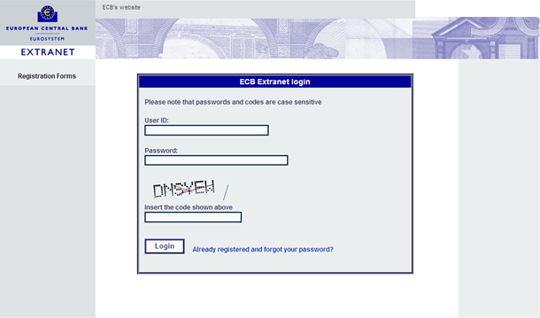

- When you have reached the login page (illustrated below), click on the “Register for event” button on the top left hand side.

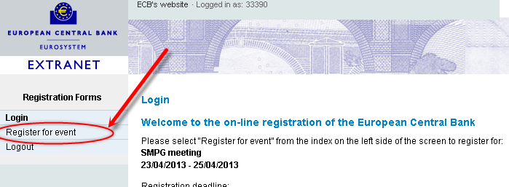

- In the registration form, fill-in the required information.
- Further to the mandatory fields, please fill in the “Comments” field with the following information separated by the slash “/” character:
- the Working Group you will participate in: enter “CA” for Corporate Action or “S&R” for Settlement and Reconciliation or “IF” for Investment funds (Mandatory)
- “YES” or “NO” will you participate to the dinner/evening event (SMPG Event Ebbelwoi-Expreß) on April 25 (Mandatory)
- Food allergies if any (Optional)
- “YES” or “NO” will your partner/spouse also attend the dinner (Optional)

Examples of entry in the comments field:
Example 1: participating to the Funds WG, to the evening/dinner event, allergic to shrimps and partner/spouse joining evening /dinner event:
Comments: | IF / YES / Shrimps’ / YES
Example 2:participating to corporate action WG, to the evening/dinner event and partner /spouse joining evening /dinner event:
Comments: | CA / YES //YES

Hotel Room Booking

A number of rooms have been blocked by the ECB in the following two hotels nearby. You have to take care of the room reservation by yourself by contacting one of the two selected hotels below.
You may register for the hotels up to 7 days before the event at the latest (i.e no later than April 15) !

HOTEL 1
Steigenberger Frankfurter Hof *****
Am Kaiserplatz
D-60311 Frankfurt am Main
Tel: +49 69 215 920 Fax: +49 69 215 902
Email: reservation@frankfurter-hof.steigenberger.de
Located 2 minutes walk from the ECB meeting place
Code for reservation: European Central Bank + 33390 (Meeting ID number)
Rates: Standard ECB rate of €218 (breakfast included)
HOTEL 2
Le Meridien Parkhotel*****
Wiesenhüttenplatz 28 - 38
D-60329 Frankfurt am Main
Tel: +49 69 2697 832 Fax: +49 69 2697 812
Email: reservations.frankfurt@lemeridien.com
Located 12 minutes walk from the ECB meeting place
Code for reservation: European Central Bank + 33390 (Meeting ID number)
Rates: Standard ECB rate of €158 (breakfast included)

