Johannesburg - SMPG meeting: Nov. 12 - 14, 2013
- SMPG Global Agenda -
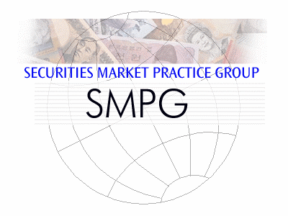

Meeting Venue:
FNB Conference & Learning Centre
114 Grayston Drive, Sandown, Sandton
South Africa
Sponsors:
Dress Code: Business Casual

Tuesday 12th of November
Morning
 |  | 8:30 - 09:00 |  | Members registration and welcome coffee
 |  | 09:00 – 10:30 |  | General Session  1. Welcome address (Karla Mc Kenna – SMPG Chair, Citi)  2. Welcome address from South African Market / Community  3. Meeting schedule overview (Jacques Littré – General Secretary, SWIFT)  4. Updates from the Regions  - Americas (Jason Brasile – SMPG Regional Director - State Street)  - Asia Pacific (Taketoshi Mori, SMPG Regional Director, BTMU and Jyi-Chen Chueh, Standard Chartered Bank)  - EMEA (Christine Strandberg, SMPG Regional Director, SEB and Armin Borries, SMPG Regional Director, Clearstream)  5. Southern African Development Community – Single currency settlement (Arthur Cousins, ‎International Payments Framework Association (IPFA))
 |  | 10:30 – 10:45 |  | Coffee Break
 |  | 10:45 – 12:00 |  | General Session (Continued)  6. Cooperation amongst BRICS Exchanges (John Burke)
 |  | 12:00 – 12:30 |  | Corporate Action WG | Settlement and Reconciliation WG
 | 12:30 – 13:30 |  |  | Lunch
Afternoon
 |  | 13:30 – 15:15 | Corporate Action WG |  | Settlement and Reconciliation WG
 |  | 15:15 – 15:30 | Coffee Break
 |  | 15:30 – 17:30 | Corporate Action WG |  | Settlement and Reconciliation WG
 |  | 18:00 – 19:00 | Cocktail Party Offered by the Hosts

Wednesday 13th of November
Morning
 | 09:00 – 10:45 | Corporate Action WG | Settlement and Reconciliation WG
 | 10:45 – 11:00 | Coffee Break
 | 11:00 – 12:30 | Corporate Action WG | Settlement and Reconciliation WG
 | 12:30 – 13:30 | Lunch
Afternoon
 | 13:30 – 15:15 | Corporate Action WG |  | Settlement and Reconciliation WG
 | 15:15 – 15:30 | Coffee Break
 | 15:30 – 16:30 | Corporate Action WG | Settlement and Reconciliation WG
 | 16:30 – 17:30 | Common S&R and CA session  on MyStandards Usage Guidelines Best practices for SMPG MPs
Evening
 | 18:00 – 22:00 | Sightseeing and Dinner Offered by the Hosts  Dinner at Sakhumzi Restaurant, Vilakazi Street, Soweto (transport has been arranged from conference venue)

Thursday 14th of November
Morning
 | 09:00 – 10:45 | Corporate Action WG | Settlement and Reconciliation WG
 | 10:45 – 11:00 | Coffee Break
 | 11:00 – 12:30 | Corporate Action WG | Settlement and Reconciliation WG
 | 12:30 – 13:30 | Lunch
 |  | End of meeting

